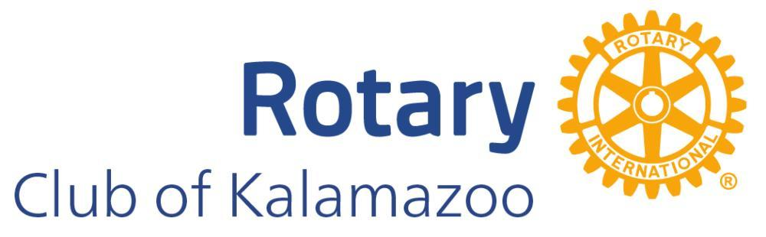
PRESS RELEASE
March 23, 2024
ROTARIANS TO CLEAN UP KALAMAZOO RIVER & RIVER TRAIL
It’s A Community-wide Event.
In celebration of Earth Day, Rotary Club of Kalamazoo will be undertaking the area’s largest volunteer initiative of its type. Rotary is seeking the help of 200 to 400 volunteers to clear the Kalamazoo River and River Trail between Comstock and Parchment of litter, trash, and other debris.
Sandy Bleisener, former club president and president of OCBA Landscape Architects shares, “The Kalamazoo River is very important to us for many reasons. How we care for our waterways is a reflection of our community and how we value our environment. Additionally, this river has our city’s namesake, it deserves our best care.”
Rotary is taking a community-wide approach, seeking the support of business and industry, schools and churches, civic and social clubs, families, and individuals. To assist in their effort they’re partnering with Michigan Waterways Stewards who have led similar campaigns in our capital city and East Lansing.
Michael Stout, president and founder of Michigan Waterways Stewards says, “I have been very impressed by the enthusiastic response by the greater Kalamazoo area, and in particular with local and county government and emergency services.” Stout adds, “With the strong support already pledged I am certain we will all be proud of the eventual outcome.”
For additional details about the event and how you can help, visit: www.MiWaterwaysStewards. org.
KALAMAZOO RIVER AND RIVER TRAIL CLEANUP
Event Headquarters: Mayor's Riverfront Park
Day: Saturday, April 20, 2024
Time: 11:00AM - 3:00PM
Food, drink, equipment, and hospitality to be provided.
For additional information contact:
Michael Stout
President and Founder, Michigan Waterways Stewards mstout@MiWaterwaysStewards.org | (952) 239-3943

