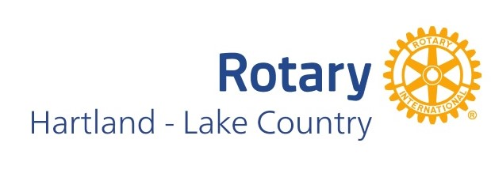

**Proposed 2024-2025 Board of Directors**

**Hartland – Lake Country Rotary Club**

President Victoria Jasiek

Past-President Matt Judson

President-Elect Melissa Spindler

Secretary Bill Otto

Treasurer Pete Balzer

Club Service Chair KC Fracek

Community Service Chair Jeremy Pfaff

Fundraising Chair Matt Winters

Membership Chair Karl Scheife

Membership Co-Chair Hans Halaska

Public Relations Chair Michele Schmidt

Public Relations Co-Chair Scott Peterson

New Generations Chair Amber Dentz

Vocational Service Chair Adam Kurth

Vocational Service Chair Craig Petersen

Sergeant-At-Arms Amy Brown

Sergeant-At-Arms Jeff Zirgibel

Paul Harris Paul Decker

Paul Harris Richard Pittelkow

International Chair TBD

Presented to the General Membership of the Hartland-Lake Country Rotary Club on 3/15/2024