*Sent to all Members*  
  
October 27, 2024  
  
Dear {%FName%},

Rotary Minutes are provided by District 6220 Governor Roger Utnehmer (Oot-name-er) to inform and educate about the value of Rotary engagement. Please share by reading at club meetings and posting in newsletters and on social media.

===========================================================

“Lessons Learned from International Travel”

“Visiting other countries offers us much the same opportunity as visiting other Rotary clubs at home.

There is a distinctly different experience beyond our borders. There is also a distinctly different experience beyond the confines of our own Rotary clubs.

International travel teaches appreciation of difference, respect for history, honoring tradition and patriotism and the imperative to stand against racism, tyranny and oppression in all forms.

Visiting other Rotary clubs, attending district assemblies and conferences, and participating in international Rotary conventions does much the same to enhance the value of membership.

Rotary is an international organization, comprised of more than 1.2 million members from more than 200 countries.  It’s in our name, “Rotary INTERNATIONAL.”

Spending the past week in London, Paris and Normandy reminds me of the important role we play as world citizens. Much the same can be said about belonging to Rotary International.  We all owe it to ourselves to expand experience. Make “travel” a verb. And travel to other Rotary clubs and learn how others build goodwill and better friendship, solve problems, become people of action and change lives.

May we consider our essential role as world citizens as we work to eradicate polio, comfort victims of war, model democracy and promote peace.

It’s what being a Rotarian is all about.

This has been a Rotary Minute.”

ROGER UTNEHMER  
Rotary District 6220  
District Governor 2024-25  
  
President, Nicolet Broadcasting, Inc.  
Founder DoorCountyDailyNews.com  
   
(C) 920 495 9677  
151201 Dragonwing Lane   
Wausau, WI 54401

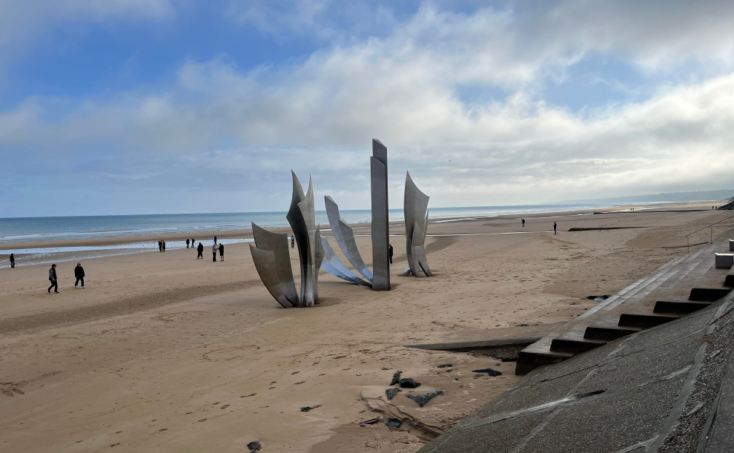

Omaha Beach

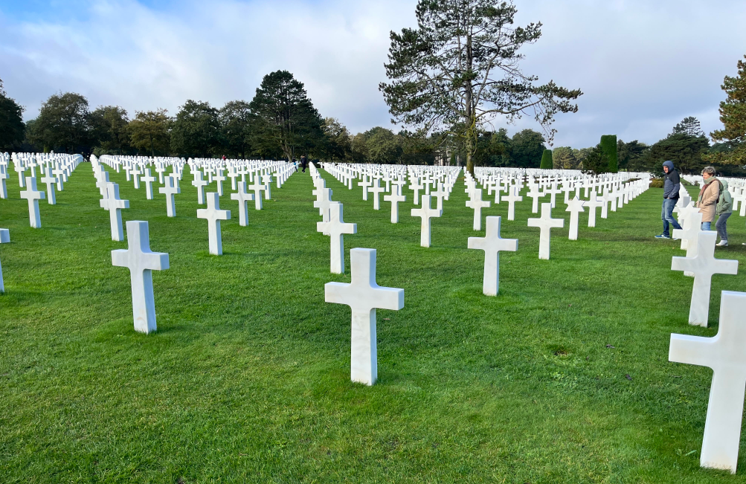

U.S. Cemetery at Omaha Beach