Sent to all Members
October 8, 2023
Dear {%FName%},
Rotary Foundation Minutes are provided by Roger Utnehmer, District 6220 Governor-Elect and Paul Harris Society Coordinator. Please share with your members.
===========================================================
“This is a Rotary Foundation Minute from Palermo, Sicily.

Raising money for the Rotary Foundation can be a great time, generate significant revenue and also expose the positive aspects of Rotary to many others. Wausau Rotarians have developed a fund-raising model that could work for your club also.
For every seven people who join a tour to places like Ireland, Scotland, Italy, the Foundation can earn up to $700. A twenty-four person tour group means a profit of $16,800.
Wausau Rotarians are on their second fund-raising tour this week visiting Sicily, Southern Italy and Rome. Last year they toured Scotland and Ireland.
The groups are comprised of both Rotarians and their friends and relatives.
If your club would like to consider sponsoring a trip to support The Rotary Foundation or to join the Rotarians from Wausau please reach out to me at utnehmer@gmail.com.
This has been a Rotary Foundation Minute.”

Wausau Rotarians pictured enjoying dinner Friday night in Palermo, Italy.
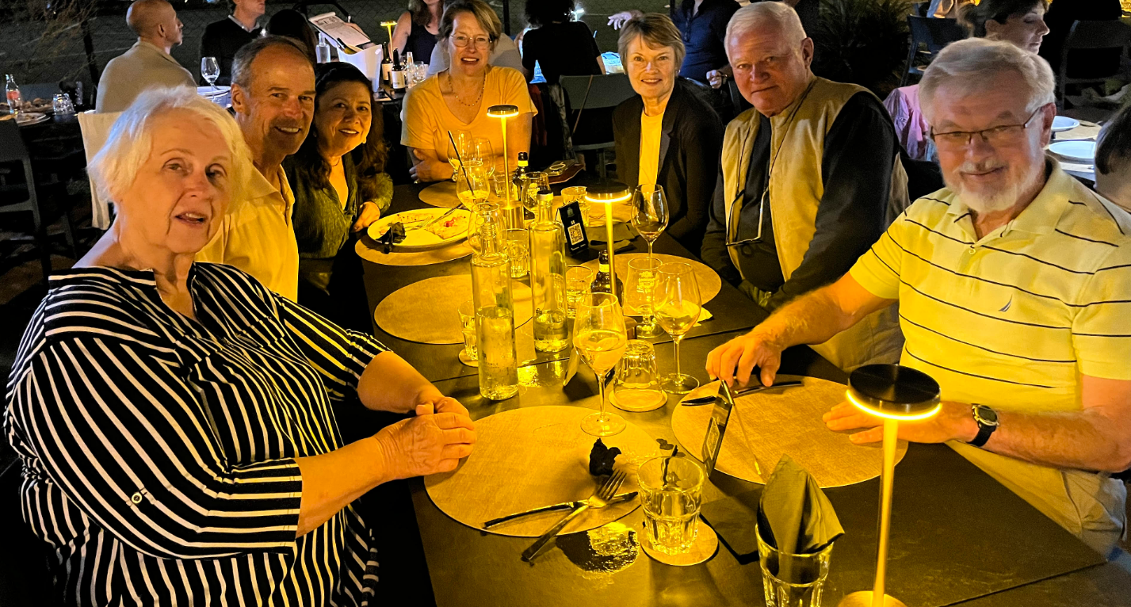

Roger Utnehmer
Rotary District 6220 PHS Coordinator
District Governor 2024-25
(C) 920 495 9677
utnehmer@gmail.com

