Edition 2023

District 6190
Rotary International

Camp RYLA
Camper Guide
And Application
Section 1-General Information and Background
- Purposes and Objectives of Camp RYLA
  - The Rotary Youth Leadership Award (RYLA) provides outstanding student leaders an opportunity to expand and hone their leadership skills at a one-week seminar called Camp RYLA, which is staffed and operated by volunteer Rotarians from District 6190.

  - The Objectives or Camp RYLA are:
    - To provide an atmosphere in which future leaders will experience democratic living that will aid them in developing sound values.
    - To promote an environment that will provide each individual with a basis for insight and understanding for intelligent leadership.
    - To expose the youth leaders to some opportunities and challenges of life in a free democratic society.
    - To promote involvement that encourages the participants to think through and arbitrate conflicts of values.
    - To introduce youth leaders to Rotary principles and Rotary Youth Programs.

- Background
  - District 6190 held its first CAMP RYLA July 23-28, 1995 at Chicot State Park near Ville Platte, LA. The 1996-2003 Camps were held at Emory Wallace Retreat Center in DeRidder, LA. The Camp was relocated to Clara Springs in Pleasant Hill, La in the year 2004 where it continued until 2011. In 2012 the camp was moved to the “OWL”, (Outdoor Wilderness Learning Center) in Dubach, LA., where it remains active today.

  - Rising high school sophomores, male and female, will be eligible to attend.

  - Camp RYLA consists of:
    - Leadership training via:
      - Outstanding speakers from all across District 6190
      - Discussion Groups
      - Rap sessions with fellow campers and Rotarian staff members.
    - Activities to include:
      - Daily competitions among camper groups
      - Team building projects
      - Outdoor activities such as swimming, challenge courses, and team sports
    - Fellowship with students leader peers
    - Campers make friendships that will last a lifetime!

Application
Rotary Youth Leadership Award
For Camp RYLA

June 25th-July 1st 2023, “OWL” (Outdoor Wilderness Learning Center) Dubach, La

Attach
Photo
Sponsoring Rotary Club _________________________________

Club RYLA Chairperson ________________________________

High School __________________________________________

Full Name: |  |  | Age: |  |  | Grade:
Name you wish to be called: |  | High School:
 |  | T-Shirt Size: |  |  | Male |  | Female
Address:
City: | State: | Zip: |  | Birth Date:
Parent’s Email Address:
Parent’s Cell Phone: ( ) -
Parent’s Cell Phone: ( ) - |  | Camper’s Cell Phone: ( ) -
Camper’s Email Address:

Emergency contact name and number:

Allergic reactions and diet restrictions:
Academic Accomplishments: (Honor Roll, Awards, Accelerated/Special Classes)

Other School Activities and Recognitions: (Positions held and responsibilities undertaken)

Sports Participation: (Number of years, levels of competition and any honors)
Outside School Interests, Service Activities, Hobbies, and Recreation:

Work Experience: (Summer/After School)
Essay: Write a short essay on why you think the Rotary Youth Leadership Award Camp would be a good experience for you.
Parent’s Signature: ________________________________________________Date: ___________________
Prohibited Items

In the tradition of all fine, quality camps, we have the following list of prohibited items:

cell phones
MP3 or other music players
radios
laptops
video games or other similar electronic items
tobacco products
alcohol
firearms
knives or other items that may be used as weapons

In order for campers to have an incomparable RYLA experience, CELL PHONES, MP3 or other music players, radios, laptops, video games, and other similar electronic items should not be brought to camp. If these items are brought to camp, they will be taken up and held in a secure location in the camp office. Expensive cameras and watches should be left at home due to the risk of breakage or loss.

Campers in possession of a prohibited item are subject to dismissal from the camp. Any camper who violates a camp policy, is dismissed from camp, or otherwise leaves camp, other than for a medical emergency, will be responsible to the camp for liquidated damages.
Liquidated damages shall be $500.00 and shall be due and payable by the camper's legal guardian(s).

Communication with RYLA Campers
As previously stated campers are not allowed to have cell phones at camp for any reason. In case of an emergency you should contact the Camp Director, Alan Barth 318-547-4319. We encourage family members to email RYLA campers at abarth6190@gmail.com . This email will be checked every morning, the messages will be printed off and given to the campers.
Necessary Items for Camp
Bedding (sheets, pillow, sleeping bag)
Towels and washcloths
Toiletries (soap, shampoo, deodorant, etc.)
Two changes of clothing per day
Swimwear (one piece or tankini, bikinis must remain covered by a t-shirt)
Tennis shoes
Shower shoes
Bug spray
Sunscreen
Sunglasses
Stationary to write home

Statement of Camper's Health

(Developed and Approved by the American Camping Association and American Academy of Pediatrics)

Health History (Yes or No – If yes give approximate dates):

Frequent Colds Kidney Trouble Chicken Pox

Frequent Sore Throat Bed Wetting Measles

Sinusitis Heart Trouble German Measles

Abscessed Ears Athlete's Foot Mumps

Bronchitis Sleep Walking Whooping Cough

Fainting Rheumatic Fever Tuberculosis

Convulsions Constipation Diabetes

Stomach Upsets Poliomyelitis

Serious Ivy, Oak, or Sumac Poisoning

Operations or Serious Injuries

Allergic Reactions to:

Bee Sting Penicillin Other drugs

Any medicine currently being taken?

Any specific activities for which camper's health would be questionable?

General Statement of camper's health

Please attach a copy of camper's health insurance provider card.

Important Notice – If the camper's health changes after the submission of this health statement, or if the camper has been exposed to any communicable disease during the three weeks prior to camp attendance, the RYLA Camp Administrator must be notified prior to attendance.

Liability Release

(To be signed by both parent or guardian and camper applicant. Camper cannot participate without this release)

General Release;

In consideration of being permitted to participate in Camp RYLA and all associated activities.

I/We have read the Camp RYLA Activities statement in the campers' guide, "Camp RYLA: A Student Leadership", distributed to each student with this application. I understand that they carry some risk and that the camper will be expected to participate in those activities. I understand that these activities are a part of what has made the Camp RYLA program so successful in the growth of young people and that my student has my approval to participate in all the activities of the camp.

Camper, for himself or herself, his or her spouse, parents, legal representatives, heirs, and assigns, hereby releases, waives and discharges Camp RYLA, Rotary, its officers and members, all promoters, sponsors, advertisers, owners, and lessees on the premises upon which Camp RYLA is conducted, and each of them, their officers and employees (referred to hereinafter as "Releasees") from all liability to camper, Camper's spouse, parents, legal representatives, heirs, and assigns, for any and all loss or damage, and any claim or damages resulting there from, on account of injury to Camper's person or property, even injury resulting in the death of Camper, whether caused by the negligence of Releasees or otherwise while Camper is participating in Camp RYLA activities.

Camper agrees to indemnify Releasees and each of them from any loss, liability, damage, or cost they may incur due to the presence of Camper in or upon Camp RYLA premises or activities, whether caused by the negligence of Releasees or otherwise.

Camper hereby assumes full responsibility for the risk of bodily injury, death, or property damage, due to the negligence of Releasees or otherwise, while in or upon Camp RYLA premises or activities, and while competing, officiating in, working, or for any purpose participating in Camp RYLA activities.

Camper expressly agrees that this release, waiver, and indemnity agreement is intended to be as broad and inclusive as permitted by the laws of the State of Louisiana; and that if any portion hereof is held invalid, it is agreed that the balance shall, notwithstanding, continue in legal force and effect.

Medical Release:

In the event emergency medical attention is required for a child at Camp RYLA, the providing of the attention will not be construed as an admission of liability on the part of Camp RYLA and for all emergency treatment and care must be borne by the parents or guardians of the involved child. Should Camp RYLA have voluntary insurance coverage to cover such expenses, such coverage will be limited to the excess over any valid and collectible insurance carried by the injured child's parents or guardians.

In case of medical emergency, I understand that every effort will be made to contact parents or guardians of campers. In the event I cannot be reached, I hereby give permission to the physician selected by the camp director to hospitalize, secure proper treatment for, and to order injection, anesthesia or surgery for my child/ward as named herein.

I support my child's/award's application to Camp RYLA and I agree that if he is selected to attend Camp RYLA, he will complete the entire program. I understand that my child/award will be asked not to attend Camp RYLA if illness or an emergency will preclude him from participating fully in all RYLA activities.

IN WITNESS WHEREOF, Camper and Camper's parents or guardians have executed this release at:

In the State of

This day of 2018

Student:

Parent or Guardian:

OUTDOOR WILDERNESS LEARNING CENTER
AGREEMENT TO PARTICIPATE;
ASSUMPTION OF RISK AND RELEASE OF LIABILITY
PLEASE READ BEFORE SIGNING

Whereas, the Undersigned (sometimes referred to as the Applicant/Participant) wishes to be accepted for
participation in an outdoor experience to be organized and conducted by the staff of the OUTDOOR
WILDERNESS LEARNING CENTER (OWL Center); and in consideration of the staff of the OWL
Center allowing the Applicant to participate in such experience:
The undersigned acknowledges that during the said experience the applicant has requested to participate in, that certain risks and dangers may occur. These include, but are not limited to the hazards of traveling uneven terrain, depending on other people, being at various heights (ground to 40.), accident or illness, the forces of nature and travel by automobile, boat, bicycle or other conveyance. The undersigned further recognizes these risks may also include loss or damage to personal property, physical or psychological damage and/or injury including fatality due to accidents which may occur, including accidents resulting from challenge course experience or other outdoor experiences. I further understand that the activities I (my child) am (is) requesting to participate in, I (he / she) will be exposed to the effects of altitude and the elements of nature, including temperature extremes, and inclement weather.
I certify I (my child) am (is) completely healthy (both physically and emotionally) and capable of
participating in this outdoor experience. I have listed on the accompanying Health Statement Form any
medical condition the staff of the OWL Center should be aware of which may hinder my (my child’s)
participation. However, I understand it is solely my responsibility to determine whether there is any medical reason that I (my child) should not participate in this outdoor experience.
In consideration of, and as I have made payment for the privilege to participate in such an experience
arranged for me by the staff of the OWL Center, I have and do hereby assume all the above risks. I have
and do assume any other risk incidental to the nature of the said experience whether or not foreseeable, and
will hold the OWL Center, its staff and its owner, Louisiana United Methodist Children and Family
Services Inc., its employees or representatives, harmless from any and all liability, actions, causes of action,
debts, claims and demands of every kind and nature whatsoever, whether for bodily injury, property
damage or loss or otherwise, which I (my child) now have (has) or which may arise from or in connection
with my (my child’s) participation. In short, I cannot sue the OWL Center, its staff or its owner, Louisiana United Methodist Children and Family Services Inc., its employees or representatives. I also state I am not under, and I (my child) will not be under the influence of any chemical substance including alcohol. I fully understand my (my child’s) physical activity involves risk of injury. I also understand my (my child’s) participation in this outdoor experience is entirely VOLUNTARY. I take full responsibility for my (my child’s) decision to participate or not to participate and I (my child) agree(s) to follow all safety instructions.
I understand that Louisiana United Methodist Children and Family Services, Inc. (MCH) and its affiliates, may take photographs and audio and video recordings of its visitors for promotional, news and other purposes. In consideration of the mutual benefits herein, I hereby give my consent and permission to MCH for (a) the use of my and/or my dependent/child’s likeness, name and voice in any manner that MCH, its employees and authorized agents may deem appropriate, and (b) the unqualified right of MCH to take film or digital photographs of me and/or my dependent/child and to display the resulting pictures on MCH's Intranet and/or Internet website(s) as pictures (digital graphics).

Group Name/Name of Applicant ___________________________________________________

________________________________________________________ Date _________________
Name/Signature of Participant (eighteen years of age and older)

________________________________________________________ Date _________________
Signature of Parent or Guardian (if under eighteen years of age)

________________________________________________________ Date _________________
Signature of Witness

Photography Release for Minor Child or Children
I hereby authorize Rotary Youth Leadership Award Camp, hereafter referred to as “RYLA”, to publish photographs taken during camp of myself and/or the minor child or children listed below, and our names and likenesses, for use in RYLA’s print, online and video-based marketing materials, as well as other RYLA publications.
I hereby release and hold harmless RYLA from any reasonable expectation of privacy or confidentiality for myself and for the minor child and children listed below associated with the images specified above. Further, I attest that I am the parent or legal guardian of the child or children listed below and that I have full authority to consent and authorize RYLA to use their likenesses and names.
I further acknowledge that participation is voluntary and that neither I, the minor child, nor minor children will receive financial compensation of any type associated with the taking or publication of these photographs or participation in RYLA marketing materials or other camp publications. I acknowledge and agree that publication of said photos confers no rights of ownership or royalties whatsoever.
I hereby release RYLA, its contractors, its employees and any third parties involved in the creation or publication of RYLA publications, from liability for any claims by me or any third party in connection with my participation or the participation of the minor children listed below.
Authorization:
Printed Name: _____________________________________________________
Signature: _________________________________________________ Date: ______________
Street Address: _____________________________________________________
City: _______________________________________ State: ____________ Zip: ____________
Relationship to Children: _____________________________________________
Names and Ages of Minor Children:
Name: _______________________________________________Age: _________
Name: _______________________________________________Age: _________
Name: _______________________________________________Age: _________

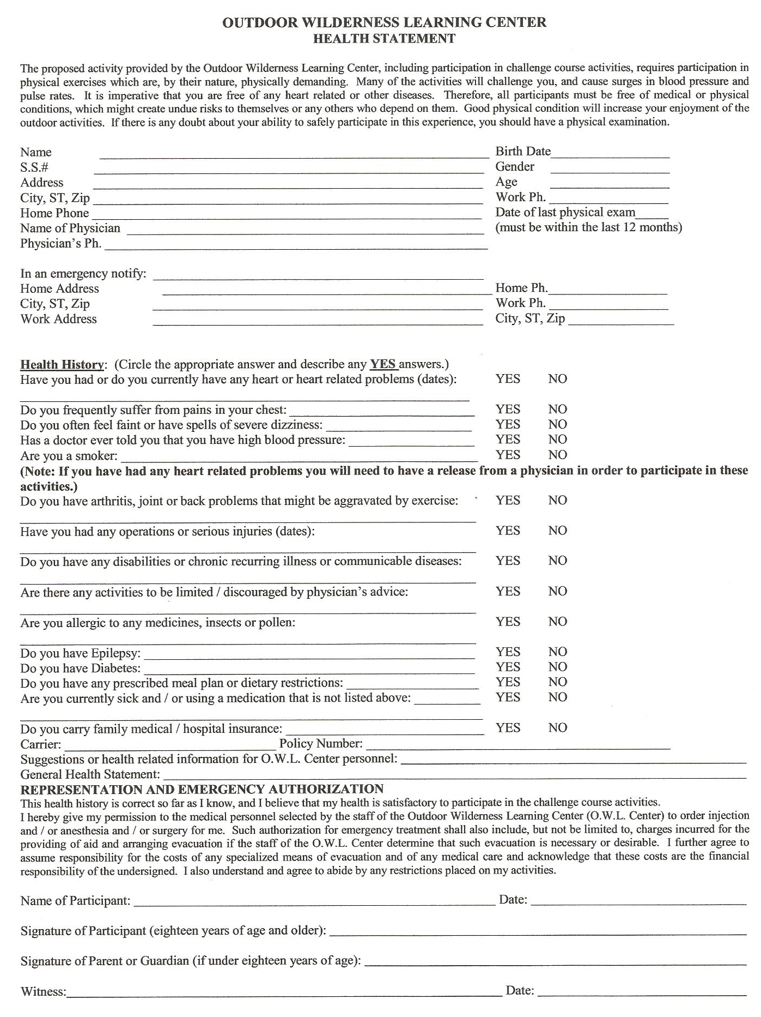
Dear Parent,
A Rotary club has paid the full tuition for your camper. In many cases that Rotary club will arrange transportation to camp. If they do not, you will be responsible for getting your camper to and from camp. Please contact the RYLA chair of that club for more information.

