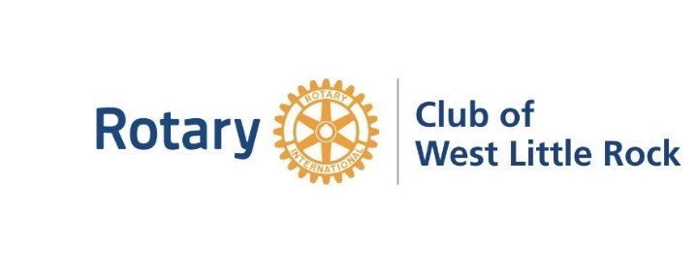

Board Minutes
January 19, 2022
Members in attendance: Gina Newman, Ali Miller, Bob Joiner, Nancy Leonhardt, Roy Smith, Bill Temple, Jerry Wilson, Doug Schackleford, Stacy Robinson, Inez Reeder
Gina called the meeting to order at 11:10 am.
Minutes from the December 15, 2021, Board meetings.
Roy made a motion to approve the minutes. Jerry Seconded the motion. The motion approved unanimously.
- Financial report
Bill reported that the accounts closed bank with $38422, $17818 can to be transferred to charitable account which already has approximately $20,000. This gives approximately $45,000, more than enough funds to cover our current scholarships which will be approximately $5,000 for this year. Bob explained that he feels as long as we can continue to give funds to this account at this amount, we could increase our scholarships. Bob explained that this makes him feel secure about our gifts and commitments for scholarships that are in place.
Net income is about 5,000 more than last year from July – December 2021. Meals revenue is up, and this accounts for this money differential. However, the money for meals goes out to pay CHI St. Vincent. The board discussed whether or not the meal line items should be pulled out separately in the budget. This was left on the table. Nancy explained that RI dues would also be coming out this week.
Bill made a motion to approve, Roy seconded the motion. The motion passed unanimously.
- Old Business

  - Terry Elementary Grant report update on projects
February 28th we are scheduled for Dr. Suess’ Birthday at Terry, however we will wait until about two weeks prior to schedule things for certain due to pandemic concerns.
  - Service project reports
Stacy reported that the service project committee is meeting tomorrow, and she will report at the next meeting.
  - Red Apple Ball, April 21, 2022 (postponed due to recent outbreak of Covid)
Gina reported that she has spoken with the Principal of Terry, and this will also be something that is still planned.
  - Egg My Yard Fundraiser 16, 2022- The Rotary After Hours Club want to join with us for this fundraiser and we will schedule a zoom meeting with the club leadership.
  - Fundraisers for Scholarship funding - The club discussed how the Easter Lily sales will not bring in the revenue that is worthy of the time. Inez brought up how the Egg My Yard was so popular last year, that this could grow big enough to cover this fundraiser.
  - Rotaract status - Ali says she will have this up to go with progress by the end of January.
  - Gina reported the Rotary Convention will be in Houston June 4-8, 2022
  - Minutes of Sept. 15, 2021 Board meeting – Gina reported that she and Ali will be working together to finalize these.

- New Business
Inez and Nancy reported that they have a new membership drive opportunity by charitable giving incentive by gifting $75 to local charities, costing a total of $300 to the club. Inez made a motion to approve this membership drive, Jerry seconded the motion. The motion passed unanimously.

By laws update – The Board discussed that the by laws need to be updated to reflect the appropriate time of the start of meeting.

Adjourn – Bill made a motion to adjourn the meeting at 11:38. Inez seconded the motion. Motion passed, and the meeting adjourned at 11:38.

