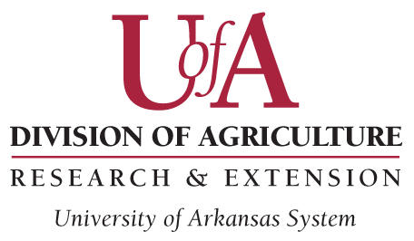

GIFT AGREEMENT

for the establishment of the

Rotary Club of Fayetteville / Dale Killian Memorial 4-H Scholarship

It is the expressed desire of the Fayetteville Rotary Club Foundation (hereinafter “Donor”), on behalf of the Rotary Club of Fayetteville (AR), to provide for the establishment of a scholarship for the benefit of the 4-H Youth Development Program (hereinafter “4-H”), under the Cooperative Extension Service of the University of Arkansas System Division of Agriculture. This gift is made in loving tribute to the memory of Dale Killian who dedicated his life to youth and to service for others, ideals central to both Rotary International and 4-H.

- Name.

The name of the scholarship shall be known as the Rotary Club of Fayetteville / Dale Killian
Memorial 4-H Scholarship.

- Funding.

For the purpose of funding this account, Donor shall contribute the sum of $1,000 to the Division’s Cooperative Extension Service at the following address:

Cooperative Extension Service
4-H Youth Development Program
2301 S. University Avenue
Little Rock, AR 72204

- Purpose.

The purpose of the Rotary Club of Fayetteville / Dale Killian Memorial 4-H Scholarship shall be to annually award a scholarship to an Arkansas 4-H Member who resides in Washington County and is or will be attending the University of Arkansas, Fayetteville.
Rotary Club of Fayetteville / Dale Killian Memorial 4-H Scholarship
Page Two

- Administration.

The selection of the recipient(s) of the Rotary Club of Fayetteville / Dale Killian 4-H Scholarship shall be the responsibility of the selection committee convened by the Arkansas 4-H Program Scholarship Coordinator, University of Arkansas System Division of Agriculture, in accordance with the following criteria:
- the recipient shall be an active member of the Arkansas 4-H youth program in Washington County; and
- the recipient shall submit a current Arkansas 4-H Scholarship application on or before the published deadline date; and
- the recipient shall represent the highest level of accomplishment through participation in 4-H, scholastic excellence, and a commitment to service.

This scholarship shall be awarded at the State 4-H O’Rama. No single scholarship award shall be less than $250. All publicity about this scholarship shall include the full name of the scholarship. The Fayetteville Rotary Club Foundation reserves the right to provide future gifts to supplement this scholarship award. A representative of the Rotary Club of Fayetteville shall be invited to attend the State 4-H O’Rama to present the scholarship(s) on behalf of the Donor and Club and in memory of Dale Killian.

- Stewardship.

The Donor, and/or designated Donor representative, shall receive regular accountability communications from the Arkansas 4-H Program Scholarship Coordinator as to the use of funds, the scholarship recipients, and the times and dates of the State 4-H O’Rama.

- Standard Terms and Conditions.

This Agreement shall be subject to the policies and procedures of the University of Arkansas System Division of Agriculture and the Board of Trustees of the University of Arkansas, which are incorporated herein by reference, and the Arkansas Uniform Prudent Management of Institutional Funds Act (Arkansas Code § 28-69-801 et. seq.).

- Acceptance.

The foregoing terms and conditions shall be effective only upon agreement and proper execution thereof by the Donor representative and the Associate Vice President for Agriculture-Extension/Director of the Cooperative Extension Service.
Rotary Club of Fayetteville / Dale Killian Memorial 4-H Scholarship
Page Three

Agreed to by the Donor:

________________________________ ________________________________
Ray Boudreaux Date
Fayetteville Rotary Club Foundation

Agreed to by the Associate Vice President for Agriculture-Extension and the Director, Cooperative Extension Service, University of Arkansas System Division of Agriculture:

________________________________ ________________________________
Tony E. Windham Date
AVP-E/Director

