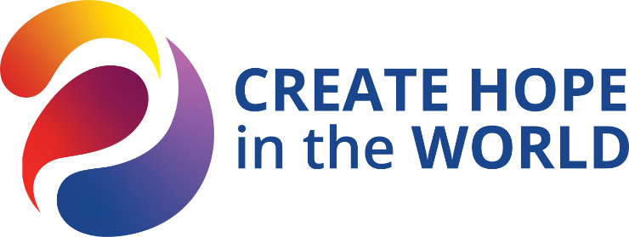
Pam’s Top 5 and How to Progress the Multi-Year Plan
#1 The 3-Legged Stool that is critical to Rotary….Foundation, Public Image/Branding, and Membership Retention and Growth.
- Polio – big push, Annual Fund – every club give
- Brand Image award at Zone level
- Inclusive membership – retaining members (see more below)
Program:
- Human Trafficking - We now have a functioning Human Trafficking – Human Slavery Committee. I hope they might provide us an opportunity for a reverse global grant. (Create Hope, Peace & Conflict Resolution)
- #2 Disaster Recovery/Relief Planning - We need a Disaster Recovery/Relief Planning committee…my goal is that is in place by June 2024. (Create Hope)

Multi-Year Plan
- Update the District Manual of Procedures (MOP) in line with Rotary International and changes in the District. (Increase Our Ability to Adapt)
- #3 Enhancements to Rotaract and Interact….the intent is to grow this area in the district, and for me fits into my interests in youth. I hope we can also add more to empowering girls in this space. (Increase our Impact, Create Hope)
- #4 In the membership area, we will be working on Inclusiveness…helping retain our people and reaching those on the fringes. We will actively seek out people with different lived experiences of all types. How do we accommodate someone with disabilities or a health issue that is making meeting participation hard? To me, this touches on our Mental Health. (Expand our Reach, Create Hope)
- More regional connections…how to effectively use them (Increase our Ability to Adapt)
- #5 A more fun, engaging, family friendly, celebratory District Conference. I will continue the Kids at Conference during my year. We will re-start the 4-Way Test Speech Contest at lunch on Saturday. I believe we need to talk about what our clubs are doing….not all the banners they can receive for different Foundation giving, but doing…. Because of this, I am having a Spring 2024 District Conference, and a late summer 2023 District Training Assembly (DTA). (Expand our Reach, Increase Participant Engagement)

