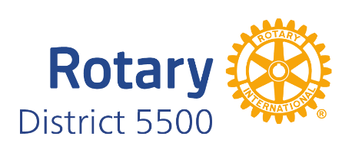

Rotary Photograph and Publicity Release Form

I, , give *Rotary International, Rotary District 5500, and its Rotary Clubs*, permission to use my name, likeness, image, voice, and/or appearance as such may be embodied in any pictures, photos, video recordings, audiotapes, digital images, and the like, taken or made on behalf of *Rotary* activities. I agree that Rotary International, Rotary District 5500 and its Rotary Clubs have complete ownership of such pictures, etc., including the entire copyright, and may use them for any purpose consistent with *Rotary International Public Image guidelines*. These uses include, but are not limited to illustrations, bulletins, exhibitions, videotapes, reprints, reproductions, publications, advertisements, and any promotional or educational materials in any medium now known or later developed, including the Internet. I acknowledge that we will not receive any compensation, etc for the use of such pictures, etc., and hereby release Rotary International, Rotary District 5500, its Rotary Clubs, *and its agents* and assigns from any and all claims which arise out of or are in any way connected with such use.

I have read and understood this consent and release.

***I give my consent*** to Rotary International, Rotary District 5500 and its Rotary Clubs to use my name and likeness to promote Rotary International, Rotary District 5500 and its clubs, and/or their activities.

Signature date

Parent / legal guardian (if age 17 or younger) date

***I do not give my consent*** to Rotary International, Rotary District 5500 and its Rotary Clubs to use my name and likeness to Rotary International, Rotary District 5500 and its Rotary Clubs, and/or their activities.

Signature date

Parent / legal guardian (if age 17) date