Rotary Club of North Las Vegas Teacher Mini-Grants 2019-2020

Dear Principals & Teachers:

Once again the North Las Vegas Rotary Club is taking applications from teachers, who teach in a North Las Vegas elementary school, for our mini-grants. Attached is the application. Please share this with your teachers so those who are interested may complete the application and be considered for the mini-grant.

The North Las Vegas Rotary Club has been awarding mini-grants to teachers in North Las Vegas since 1993. Last year we awarded 20 teachers mini-grant up to $300 to assist in projects, materials, ideas and etc that assisted students in their learning. Over the years we have assisted teachers in obtaining musical instruments, reading material, field trips, white boards and numerous other projects.

We ask each applicant to complete the attached application to describe their proposed project, how this project will benefit the students they teach and a quick budget outlining the use of the grant money.

Applications should be returned by email to Stephen Waldron by December 20, 2019. The email address is swally2@cox.net. Please note that this email is different than prior years. We will be awarding around 20 teachers and will notify the teachers around January 10, 2020. As we have in the past we will also have a presentation evening to present the checks. This presentation event will include all teachers awarded grants as well as a principal or representative of the school. The date for this evening event will be February 7, 2020 and would love those receiving awards to attend. Please mark date on your calendar and plan to attend and be recognized.

If you have any questions, please feel free to call me, Stephen Waldron, at 702-203-0941.
Thank You. 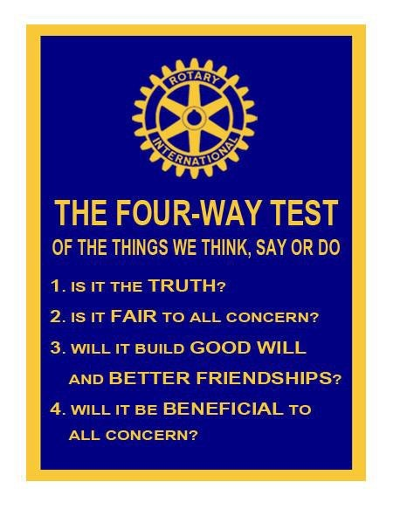

Rotary Club of North Las Vegas
Teacher Mini-Grants Application
Here is the application for Teacher Mini-grants. Copy and print it for your use.
Teacher Mini-Grant Application 2019-20 North Las Vegas Rotary Club
Applicant’s Name: ________________________ School: _______________ Principal: ______________
Home Address: _____________________________________ City: ____________ Zip Code: ________
Phone #’s – Home: ____________________ Cell: __________________ School: ___________________ E-mail: _________________________________________
Grade/Subject: _________________________________ Total number of Students in class)es): ________ Project Title: ___________________________________ Amount requested: _________ (up to $300.00)
Please respond to the following:
- Describe your proposed project.
- How will this project benefit the students that you teach?
- In the space provided create a budget detailing how you will use this grant money.

Item/Description Cost ___________________________________________________________ ______________________________________________________________________________
______________________________________________________________________________
______________________________________________________________________________
______________________________________________________________________________
______________________________________________________________________________ ______________________________________________________________________________

Email your completed application by Friday December 20, 2019 to:
NLV Rotary Mini-Grant Coordinator Stephen Waldron Swally2@cox.net cell #: 702-203-0941
To obtain an electronic copy of the application visit our website at http://www.nlvrotary.org/?s=documents

Award winners will be notified by January 10, 2020 and presented the evening of February 7, 2020.

MINI-GRANT CONDITIONS
- Approval of this proposed project is solely for the purpose of rewarding a mini-grant. The sponsors shall in no way be liable for injuries or damages arising from the performance of this proposed project.
- All mini-grant money is to stay in the Clark County School District. In the event that a grantee leaves the Clark County School District the monies will revert back to the North Las Vegas Rotary Club.
- A relocating teacher may take the mini-grant money to a new school as long as the new school is in the Clark county School District.

FOR OFFICIAL USE ONLY: Rating______________________ Number ___________

