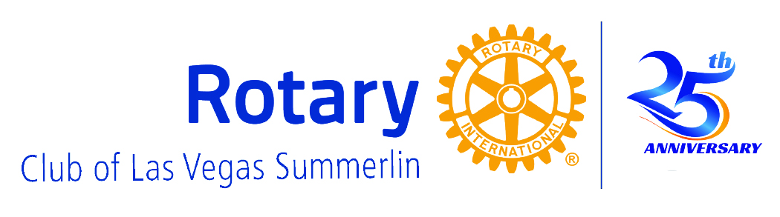

The club follows the guidelines set by the venues and state and local governments. By entering this meeting/event you agree to:
WAIVER AND RELEASE OF LIABILITY FOR COVID RELATED ISSUES
COVID-19. As you know, COVID-19 is a potentially very dangerous coronavirus—particularly for those who are elderly, have preexisting conditions, or have a compromised immune system. As of early October 2020, COVID-19 has claimed the lives of over 210,000 Americans. Common COVID-19 symptoms include coughing, fever, difficulty breathing, fatigue, headache, nausea/vomiting, diarrhea, and loss of taste/smell. For more information, including Clark County testing sites, please see the websites of the:
- Centers for Disease Control and Prevention (“CDC”) (https://www.cdc.gov/coronavirus/2019-ncov/index.html), and
- Southern Nevada Health District (“SNHD”) (https://www.southernnevadahealthdistrict.org/coronavirus).
Because of the COVID-19 pandemic, on March 13, 2020, Governor Sisolak declared a State of Emergency in Nevada.
Rotary Activities. The Summerlin Rotary Club (the “Club”) is providing you with this form because it is hosting a live, in-person event which you have expressed interest in attending. To be clear, there are no current Club activities which are mandatory. Moreover, currently, most if not all Club activities could be attended virtually, by Zoom. Your participation at the live event is therefore 100% voluntary. Your presence at that event is subject to your agreeing to this waiver.
Assumption of Risk. You recognize there are certain inherent risks raised by your appearing at a live Club event, including possible risks to your health, safety, and well-being—including, if you were to contract COVID-19, the death of you or others. You fully understand these risks, and you have had the opportunity to discuss them with us and your advisors. You assume all risks involved in your attending Club in person. That includes risks that may arise from Club’s negligence or carelessness.
Note that we will continue implementing protective safety measures in accordance with Nevada law (e.g., mandatory mask use), and the Club insists that you strictly follow the same. However, if another person were infected, it may be virtually impossible to stop the virus’ transmission to you, even with reasonable precautions on our part. (For example, some people are asymptomatic carriers or are contagious before they experience symptoms.)
Health. Because of the risks, the Club cannot allow anyone who has coronavirus, or may have the virus, to be present at a live event. By coming to a live event, you are certifying to us that to the best of your knowledge:
- you do not have COVID-19, nor any of the symptoms commonly associated with COVID-19 (see above); and
- no medical professional or government employee (e.g., the SNHD) has advised you to stay at home.
Ultimately, you are responsible for your state of health. If at any time (day or night) you begin experiencing COVID-19 symptoms, you agree you will not come to a live event without the Club’s prior, written consent.
Liability Waiver & Release. You agree (for yourself and your assigns, heirs, executors, and family members):
(a) to forever waive, release, and discharge the Club and its directors, officers, employees, contractors, volunteers, and agents (collectively, the “Releasees”) from any and all liabilities (including but not limited to your or another’s personal injury, disability, death, property damage, property theft, and other losses or harms) and claims (of any kind, including in law or equity, in contract or tort, and existing or contingent) relating to or arising out of your appearing at a Club event, including as a result of the negligence of a Releasee, and you covenant not to sue the Releasees with respect to any and all such liabilities or claims;
(b) to indemnify and hold harmless the Releasees from any and all such released liabilities and claims, including reasonable attorneys’ fees and costs (whether or not a legal proceeding is commenced);
(c) the Club is not responsible for the acts, or omissions of third parties, including other Club members; and
(d) the Club is entitled to all of the protections in ¶¶24-29 of SB 4 (2020), and the undersigned waives any argument to the contrary.
You acknowledge that this waiver and release is being relied upon by Releasees in allowing you to attend a live event. This form shall be construed broadly to provide a waiver and release to the maximum extent permissible by law. If any portion of this form is invalid, (i) the court shall modify the other provisions to give maximum effect to this waiver and release, and (ii) all other provisions shall continue in force and effect. This form should not be construed against the drafting party, but interpreted neutrally and by its plain language. This form is governed by Nevada law. All related matters shall be exclusively heard in state courts in Clark County, Nevada.
You, by entering this meeting, confirm that you: (1) have read this notice and fully understand its contents; (2) are aware this notice is a binding, contractual waiver and release of legal rights; (3) are entering this meeting freely, intentionally, knowingly, and voluntarily; and (4) have had the opportunity to consult with legal counsel prior to entering this meeting.

