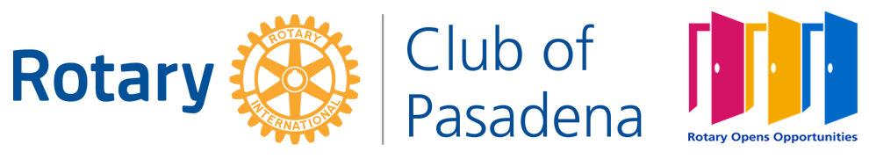

**COMMUNITY GRANT GUIDELINES 2023**

**ELIGIBILITY FOR CONSIDERATION**

Think about your **ORGANIZATION** and please answer the following questions:

1. **Is your organization a qualified 501(c)(3)** **nonprofit or under the fiscal receivership of a qualified 501(c)(3) nonprofit?**
2. **Is your organization directly providing senior programs for residents in the Pasadena area*?**

If you answered “YES” to these questions, the Pasadena Rotary Club Community Grants welcomes your application for 2023 (*see below for further details*). If you answered “NO” either of these two questions, we thank you for your interest, but unfortunately your organization **DOES NOT** fit the Pasadena Rotary Club Community Grants guidelines for this year’s cycle and will not be considered.

*\*Seniors programs are defined as services that enrich the lives of older adults, to address food insecurity, encourage exercise, offer food planning and preparation, educate about health practices, and provide direct services such as flu shots, oral exams, physical exams, blood pressure checks and hearing tests.*

1. Qualifying non-profit organizations must be tax-exempt under IRS 501(c)(3) and must serve residents within the Pasadena area. No grants will be made to grant-making private foundations as defined by the IRS. Funding priorities will be focused on agencies providing direct services to clients, not on pass through grants.
2. A current member of the Rotary Club of Pasadena must endorse the application through a brief, written letter of support.
3. **These year’s grant cycle will be awarded to nonprofits for PROGRAMS** that serve SENIORS in the Pasadena, Altadena, and Sierra Madre communities. Organizational request for capital projects (new computer systems, cars, horses, books, electronic equipment, etc.) will not be considered. We are looking to support individual programs that may be funded with a grant of $2,000 to $6,000.
4. Grants to any one organization will not be made more often than two consecutive years.

**COMMUNITY GRANT GUIDELINES 2023** *(continued)*

1. Full application packets, scanned into an emailable .PDF format must be submitted by Monday, February 13, 2023, at 5:00 pm [pasadenarotarygrants23@gmail.com](mailto:pasadenarotarygrants23@gmail.com) to **PLEASE SEE APPLICATION FOR DELIVERY DETAILS – NO LATE SUBMISSION WILL BE ACCEPTED.**

Full **scanned .PDF application packets** must include:

* Complete Grant Application form *(please note word limit)*
* Letter of Support by current Pasadena Rotarian
* Copy of 501(c)(3) determination letter
* General Operating Budget for the organization
* Current financial statement or audited financial statement

Please follow the submission instruction on the Pasadena Rotary Community Grants application form. Once your application packet is complete, please scan into a single PDF document and rename – for example: ***[YOUR ORGANIZATION_Pasadena Rotary Community Grants Application 2023]***

Thank you for your interest in the Pasadena Rotary Club Community Grants.

IMPORTANT NOTE: **PLEASE READ**

**The Monday, February 13, 2023 at 5:00pm deadline will be strictly enforced. No grant applications will be accepted after this date. No grant applications may be submitted to any 1) Community Grants committee member or 2) Pasadena Rotarian or 3) dropped off at the University Club. Unfortunately, those applications will be immediately disqualified.**