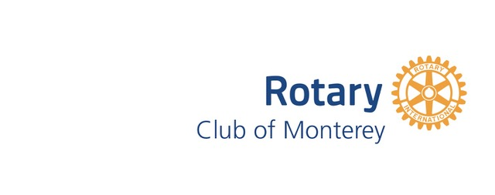

Media Release
September 2019

MONTEREY/NANAO SUMMER YOUTH EXCHANGE

By Dennis McCarthy
In 1992, The Rotary Clubs of Monterey and Nanao, Japan expanded their existing sister city relationship to include our current high school summer student exchange program with the goal of enhancing the mutual understanding of one another’s people and culture. Monterey students and their families first host students from Nanao who experience American life and culture through activities organized and chaperoned by the Monterey Rotary Club. Students from Monterey then travel to Nanao, stay with Japanese families and partake in activities organized by the Nanao Rotary Club that showcase Japanese life and culture.
This year we had three students, Manae, Rina and Nene from Nanao with us from July 22 through July 30. Then our four students, Jordan Willeford (Ed Melvin’s grandson), Thalia Hubbard (Alex Hubbard’s niece), Anders Webb (Natalie Webb’s son) and Gena Leivenberg went to Japan from July 30 returning home on August 8.
All seven exchange students expressed their gratitude for this intercultural opportunity and how it really has changed their lives. Our American students are required to write a brief essay about their experience which Nanao Rotary publishes to their membership. One goal of this exchange is to broaden the world outlook of our students to make them better ambassadors for Monterey and Rotary. To a person, our students’ essays express how they now look at the world differently based on their exposure to another culture. The Monterey Rotary Club’s goal of fostering international friendship and understanding is reflected in the interaction of all seven students as well as in the statements of our Rotary volunteers who helped transport and chaperone our Japanese guests during their Monterey stay. Given the benefits to all involved, students, families and Rotarians, we look forward to continuing this valuable intercultural exchange for years to come.

