Club Database for your Smart Phone
The Rotary Club of Walnut Creek stores all of its important information, including member details, in the “District And Club data base.” (DACdb). This information is now available on your smart phone. In your phone’s internet browser, navigate to the club database at: http://walnut-creek.rotary5160.org/ . You will need to enter your login information on the following screen. Your UserID is your email as shown in the email sending this document to you. Your password should be your Rotary International number. (This can be found in the paper Roster. If the number does not work, try adding a leading zero. If that doesn’t work, contact daswitzer25@msn.com )
Once you have entered your database login information, there are two blue “URLs” in the lower right corner of the white field. These are:
- Go To DACdb Mobile
- Create DACdb Mobile Desktop Icon
These will provide the access that you will need. The first line takes you directly to the database (if login information is accepted.) and this method can be used at any time. Creating the Icon is more complicated an instructions are accessed by clicking the second blue line.
If you have any issues with these instructions, contact Doug Switzer.

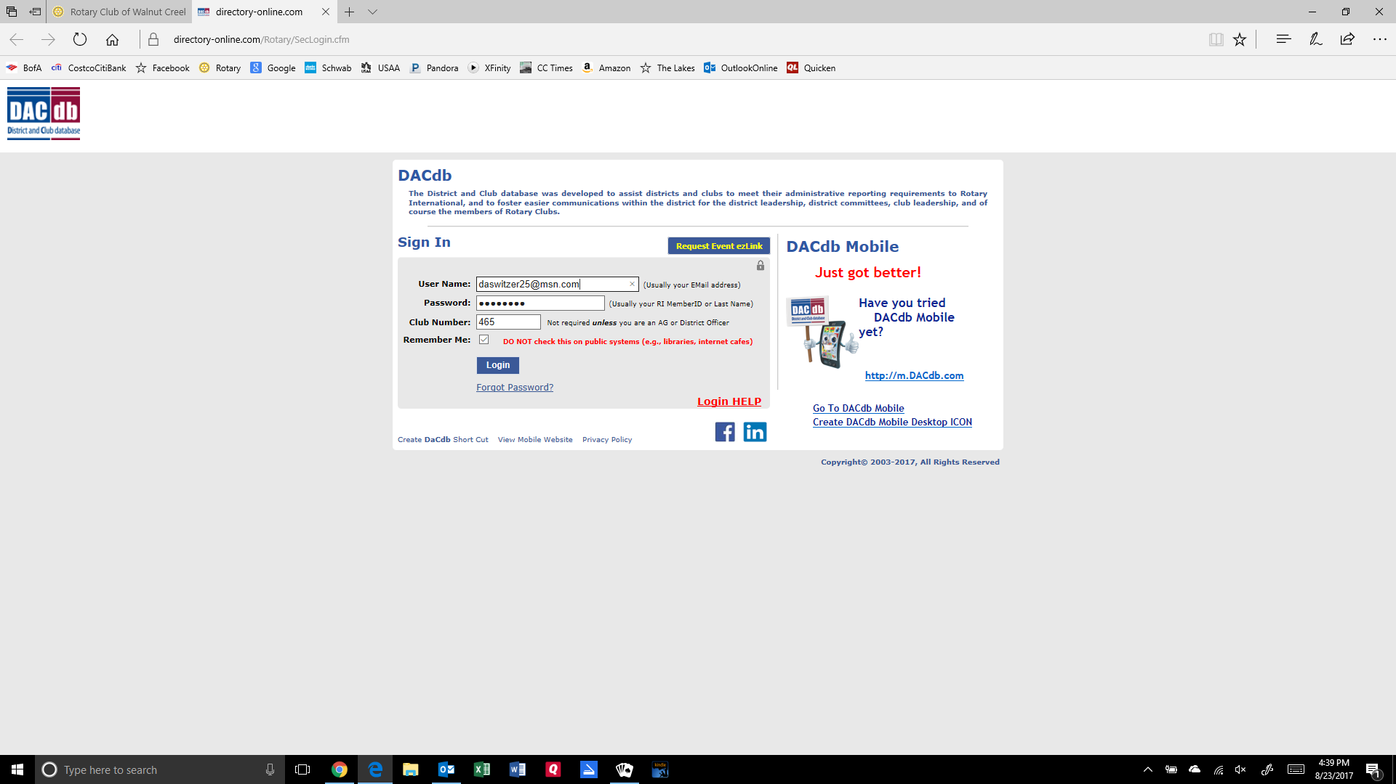

Once you are logged into the database, you will first see a series of blue horizontal “tabs”. If you are looking for a particular member’s contact information, you can click on “Find Member” and do a search. I find it easier to just click on the Members bar and scroll down to the individual member’s picture and name.

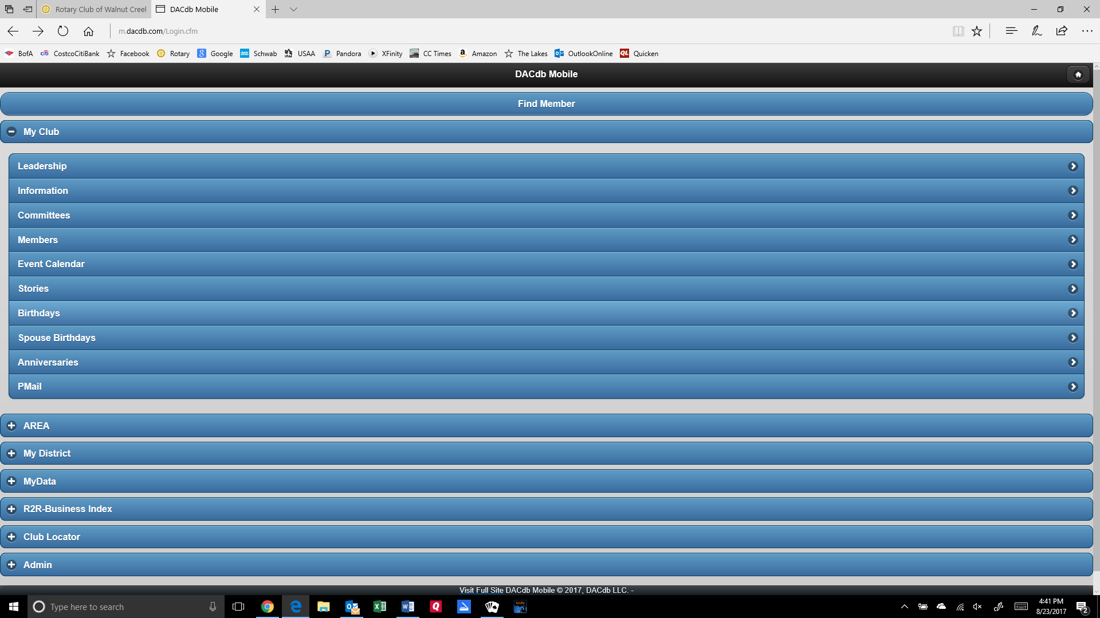

Clicking on Members brings up an alphabetical list of current members preceded by that member’s picture. Click on the white arrow on the far right and you will go to that member’s contact information.

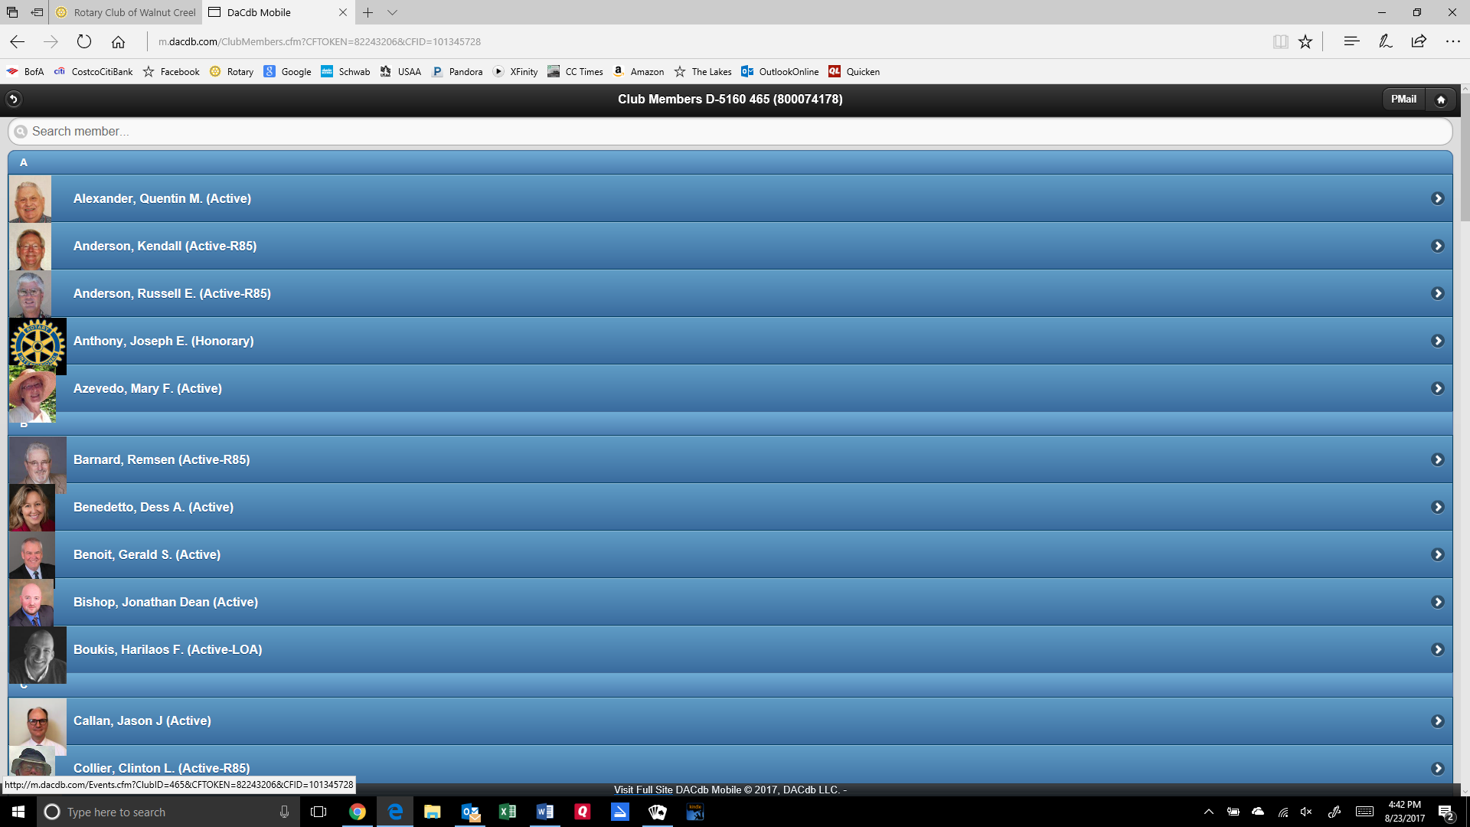

You will note that phone numbers and emails are in blue. This means that if you click on the phone number your phone will initiate a call and if you click on the email address, you will be presented with an option to send an email.

Any questions, please let me know. (Please not calls after 8:00 p.m.)
Doug Switzer
925-360-1058
daswitzer25@msn.com

Please note: If you are trying to extract Birthdates or Anniversary Dates, there is a simple report for this. Just send an email to Doug Switzer. It saves a lot of work.

