Features of the Club Website and Database

This document describes the club’s website. The website’s homepage is located at www.rotarywc.org

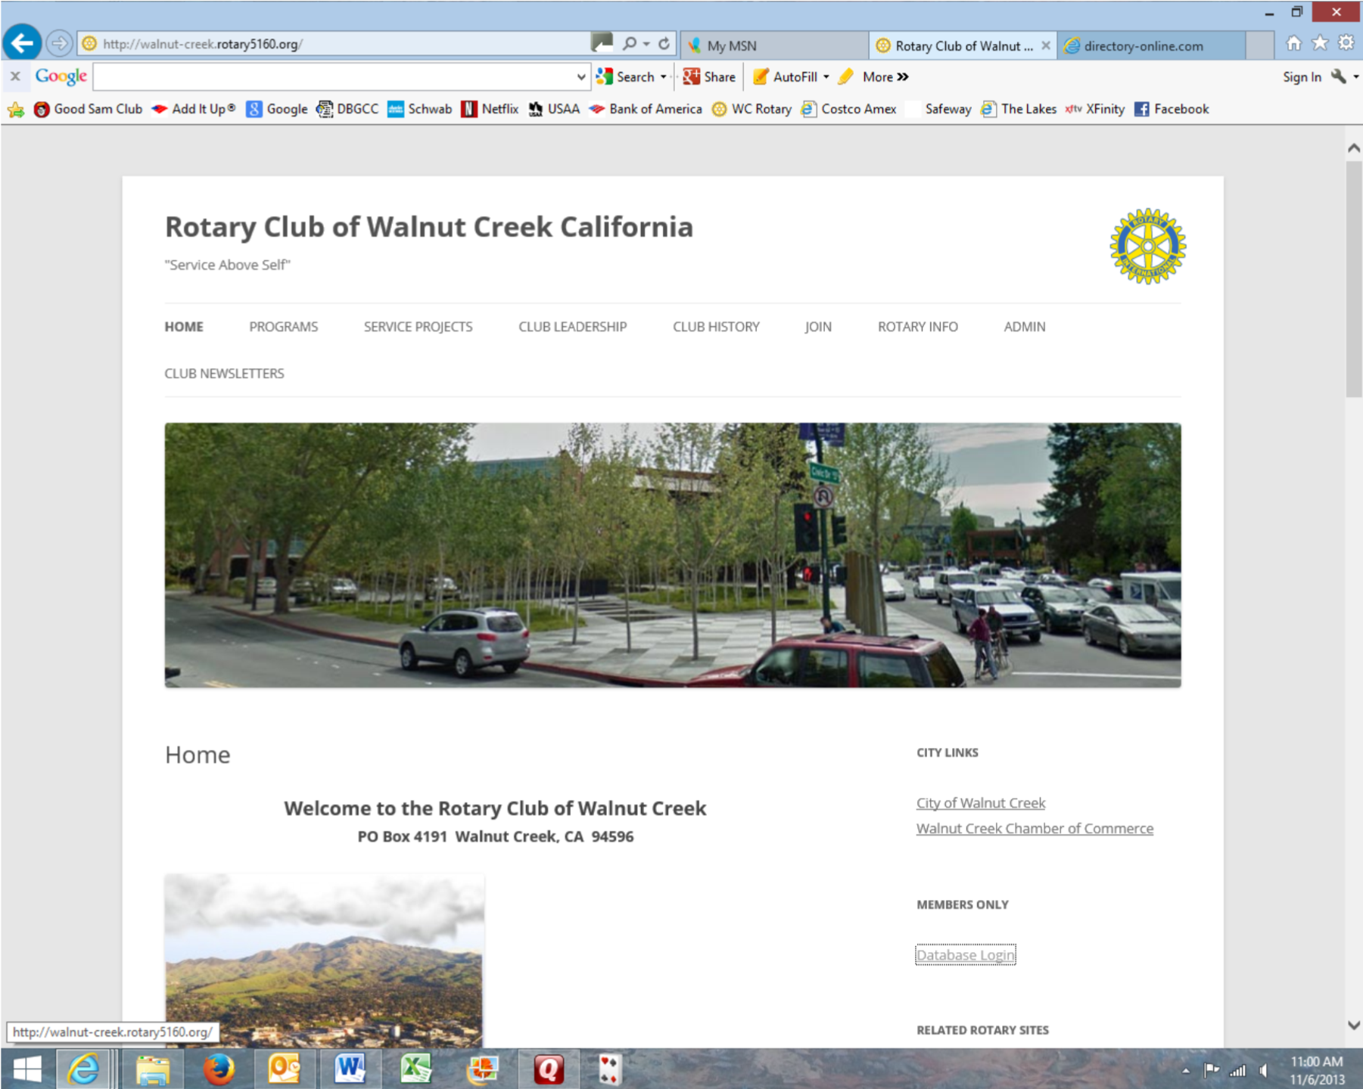
Website

The links along the top of the home page are self-descriptive. Each can be edited by the club secretary. The Admin page contains blank forms for team leaders blank form for monthly team assignments, a copy of the current month’s completed form and a list of committees.

The sub links under About Rotary are “boiler plate” provided by the district. These pages are identical across all club sites in the district.

The links on the right side of the home page include City Links, Members Only, and Related Rotary Sites. City Links and Related Rotary Sites will redirect your browser to external websites.
eClub One Online Makeup is a link to a site that can be used to makeup meetings through an online club.

Members Only will bring you to the database login page.

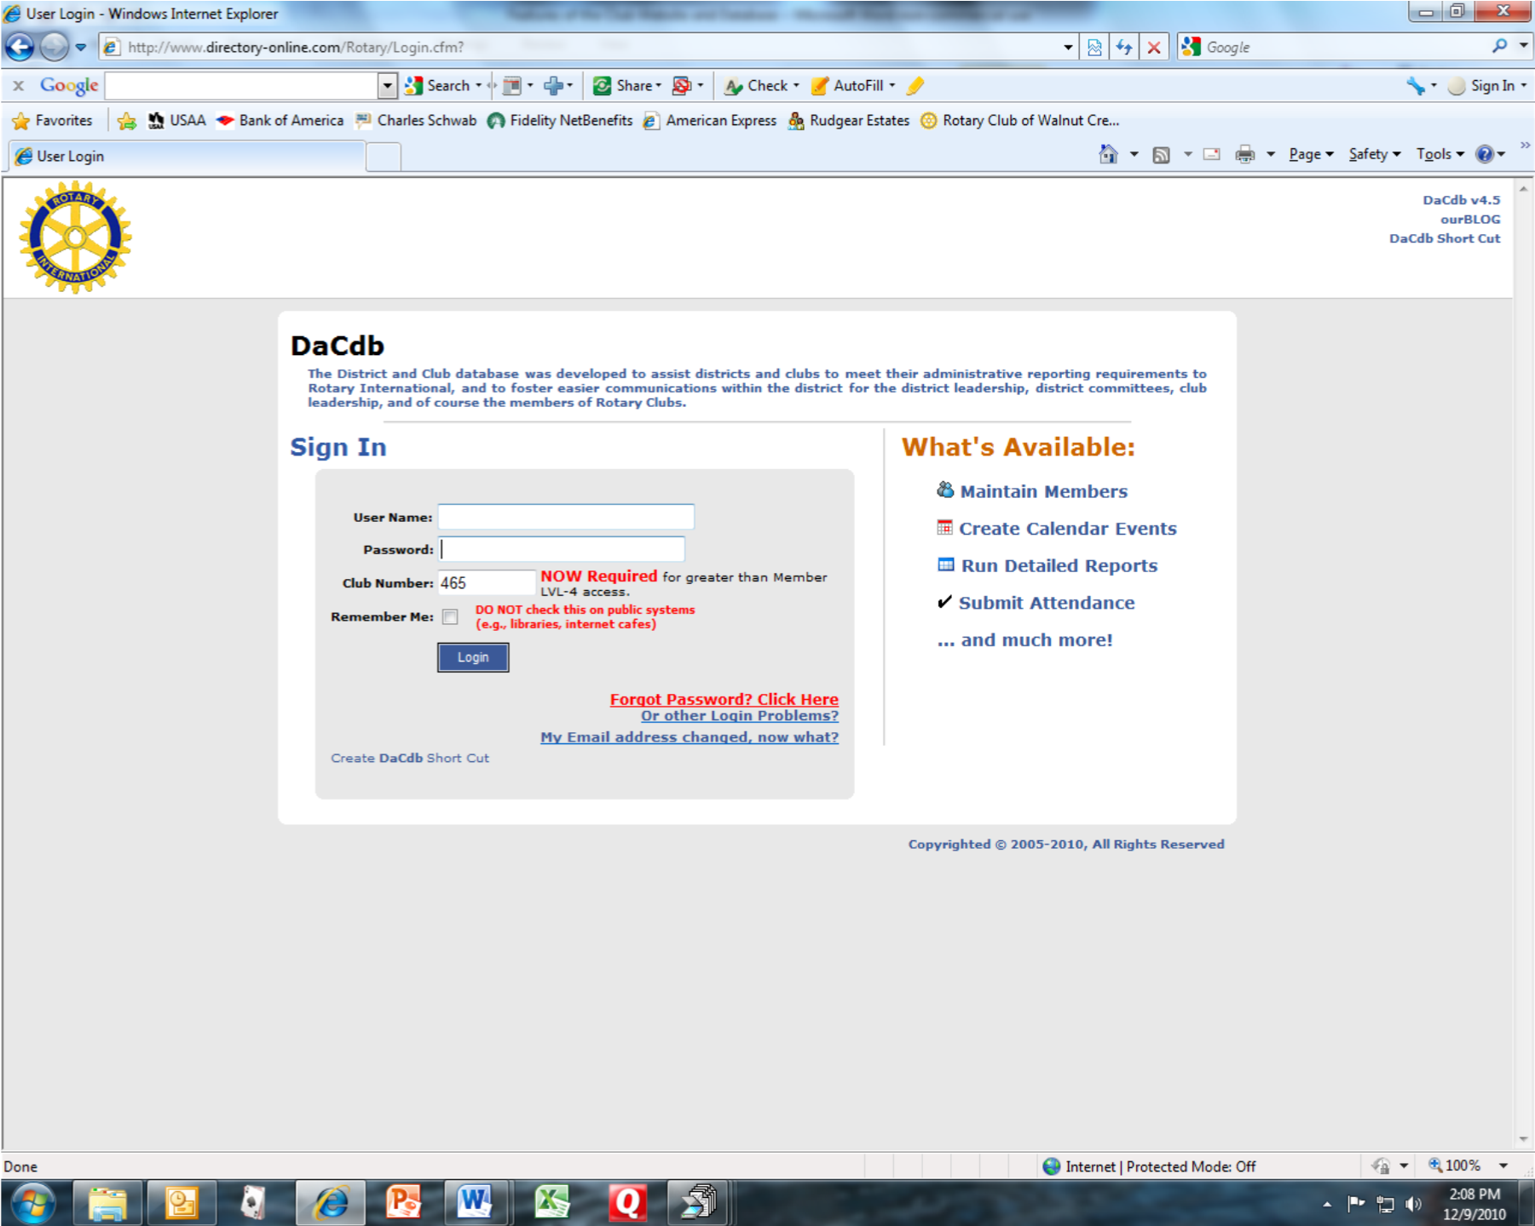

Your user name is your email address as it is entered in the club database. Your password is your Rotary International number (which can be found in the small white directory under your work phone number). You can change your password. Our club number is 465.

Once you are logged in, you will be at the home page of the club database. Your database home page may not contain all of the tabs that appear on the example below. My security level as club secretary gives me full access to everything on the site. Also, some of the tabs are not in use at the present time. Over time, more content will be added to these tabs. The most commonly used tabs are Find and My Club. Find is a very simple query to obtain contact information on a single member. If the name returned is in blue, you can send an email by simply clicking the name.

The My Club tab is a full listing of club leadership and members. (Section 2: Club Committee is not in use at this time.) At the bottom of Section 1, you will find four links highlighted in blue. Club Calendar is not in use at this time. The other three links – District Calendar, Club Calendar, Club Bulletins, and District News letters are all active and current. Our club bulletin is generally available Wednesday morning after the meeting.
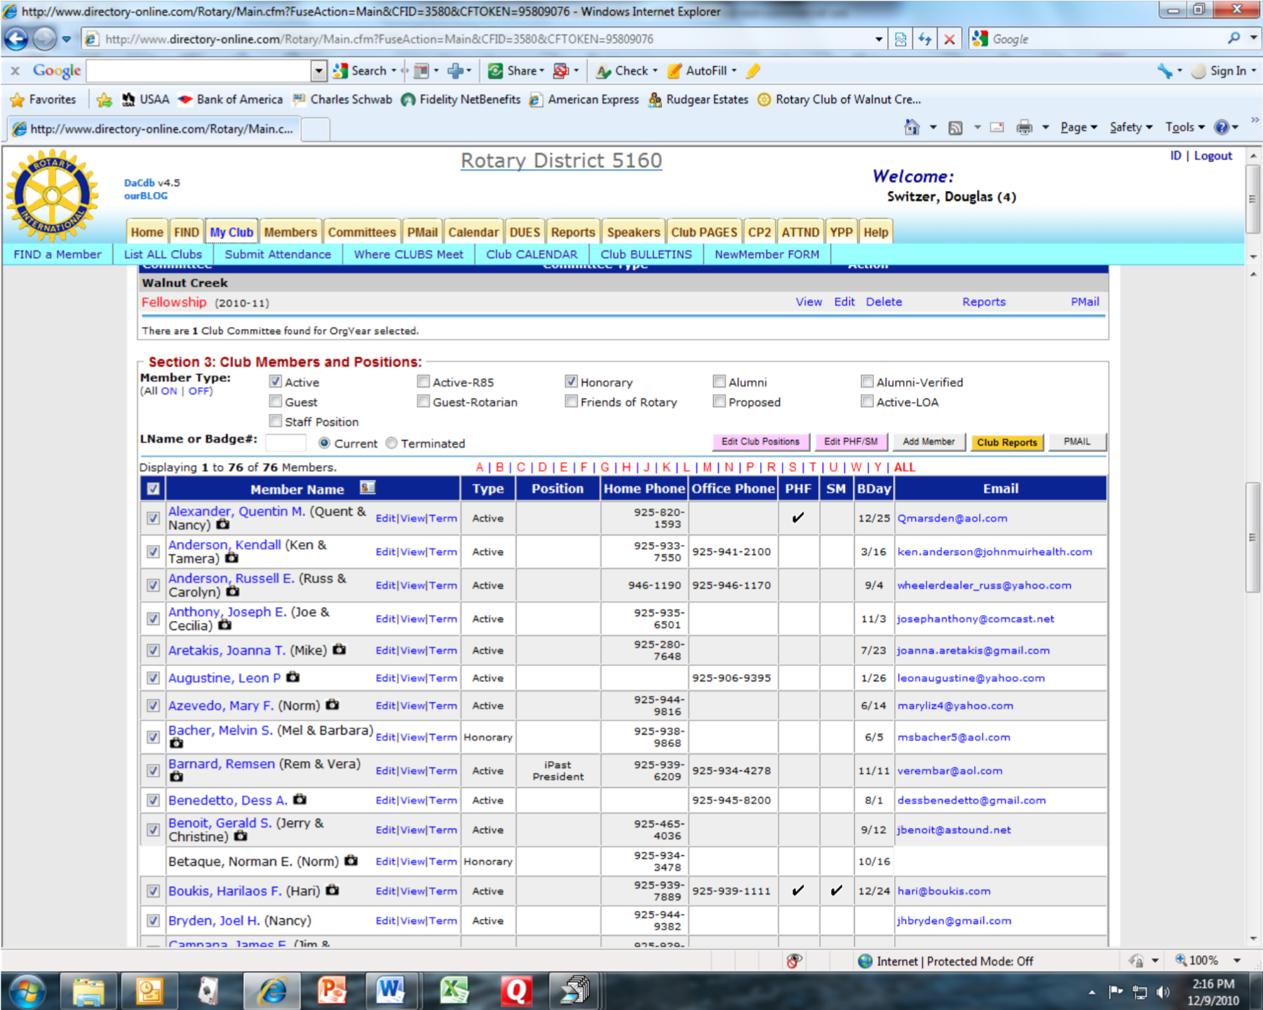

The member listings include a link to an email message as in Find. It also shows home and office phone and other information. If you click on View, you will be directed to the member’s “home page” within the club database.

Club officers and members of the board have the additional ability to send broadcast messages. When Section 3 is first opened, every member’s name (if they have provided an email address) has a check in the box to the left of their name. These check boxes are used to select members who will receive the email. If only a limited number of members are to receive the email, uncheck the box at the top left of the listing. This will uncheck all names. Then, go through and check those who are to receive the communication.
Next, click PMAIL above the blue bar on the right. This brings a list of formats for your email. (I always use the first one.)

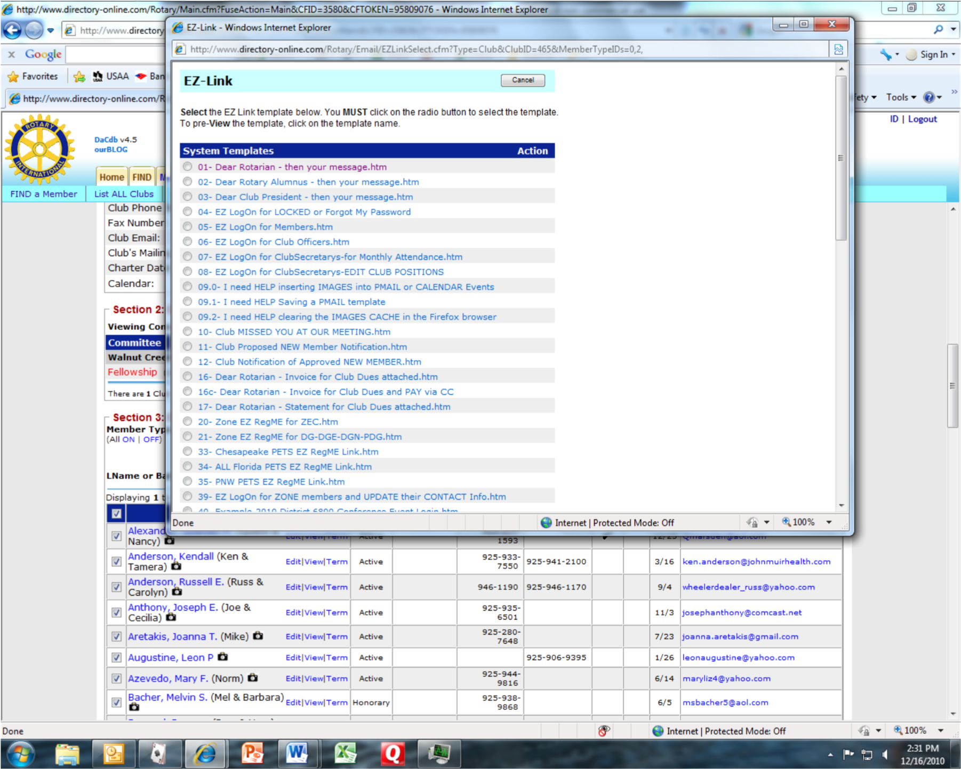

Once the format is selected by clicking on the circle, the next screen will allow entry of the email message. It is generally advisable to create your email in a word processing package and simply cut and paste it into the email formatter.

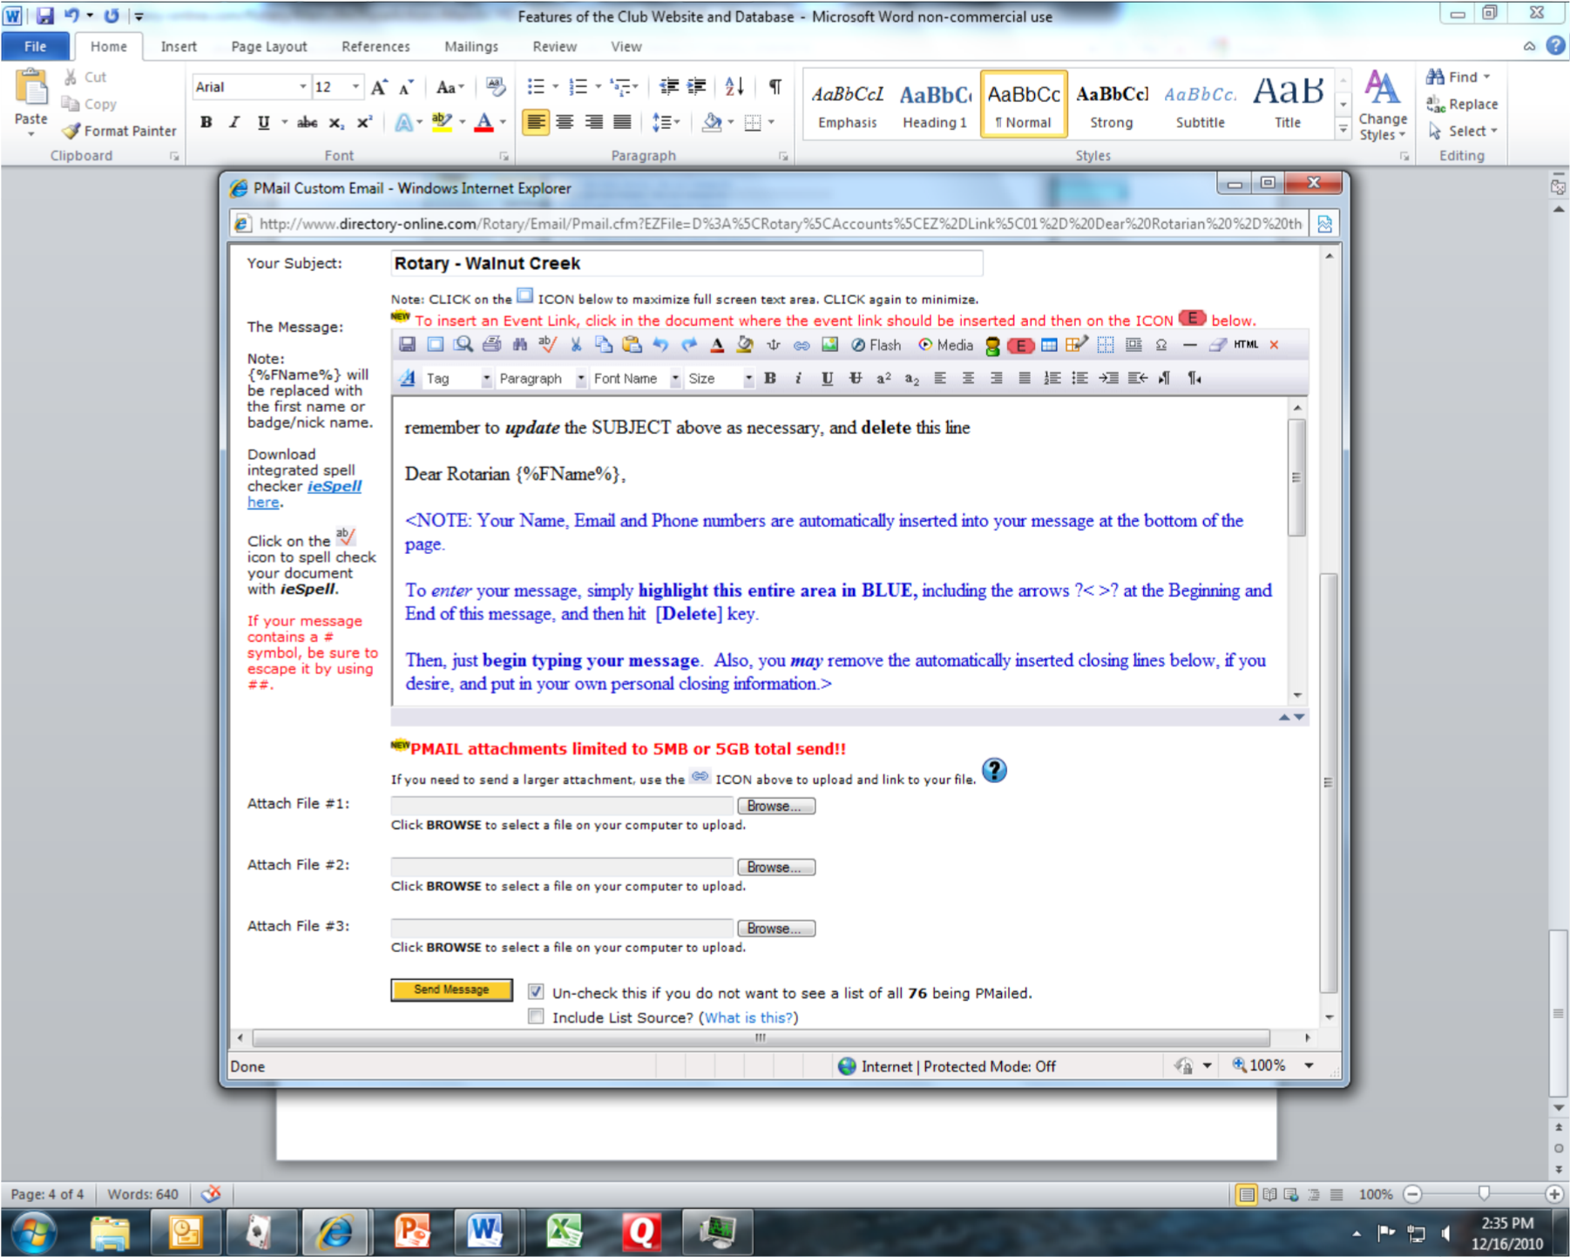

Once email editing is completed, simply click on the yellow Send Message button. You will automatically receive a copy to certify the transmission. (You will also receive a System Administration message if any member’s email service rejects the email.)

If you have any other questions or suggestions on additional content for the website, please give me a call.

Doug Switzer, Secretary
925-289-4981

