The “Work” Book

My thanks to all the folks that wrote all the things that I collected up from old boxes and compiled. Special thanks to Past President Roland Haga. He put together some fantastic templates in his year as president! Luckily I didn’t have to type those.

Contents
Our Entities 7
Club President 9
Good Luck! 9
Club Secretary 11
Recording Duties 11
Reporting Duties 12
Controlling Duties 20
Communication Duties 21
Club Secretary Checklists 21
President Induction 21
Board meetings 21
Member Resignation 21
Member Induction 22
Club Treasurer 23
Changes Afoot 23
Technology 23
Banking 24
Financial Reporting to BOD 24
Adding a New Club Member 25
Setting up Memorized Transactions 27
Processing Quarterly Invoices 29
Processing Make-Up Meal Credits 31
Finemaster Committee Chairperson 33
Finemaster Committee Member 33
Greeter Committee Chairperson 34
Greeter Committee Member 34
Program Committee Chairperson 35
Program Committee Member 36
Program Committee Calendar Keeper 36
Sergeant-at-Arms’ Committee Chairperson 37
Sergeant-at-Arms’ Committee Member 37
Sunshine Committee Chairperson 39
Thought-of-the-Day Committee Chairperson 40
Thought-of-the-Day Committee Member 40
Public Relations Chairperson 42
Webmaster and Technology Coordinator 42
Social Media 43
The Spoke Editor 43
The Spectrum, Daily Journal, the Patch and other papers 43
Redwood City Interservice Club Coordinating Council (ISCCC) Volunteer 43
Redwood City San Mateo County Chamber of Commerce Volunteer 43
The Membership Committee Chairperson 45
Classification Volunteers 45
Mentoring Committee Volunteers 45
New Member Orientation and On-Going Training Volunteers 46
Recognition Volunteers 46
Recruiting Volunteers 46
Retention and Attendance Volunteers 46
Rotary Foundation Committee Chairperson 49
TRF District Raffle Sales Volunteers 49
TRF Donation Processing Volunteer 50
Processing a Single Donation via Check 50
Processing a Single Donation via Credit Card 50
Processing a Multiple Donation via Check 52
Processing a Recognition Point Transfer – Member 53
Processing a Recognition Point Transfer – Club 53
TRF District, Global & Package Grant Volunteers 54
Community Service Committee & Chair 56
Salvation Army Bell Ringing Coordinator 56
Salvation Army Bell Ringing Volunteers 56
Fair Oaks Community Center – Homebound Food Program Volunteers 57
Fair Oaks Community Center – Senior Halloween Party Coordinator 57
Fair Oaks Community Center – Senior Halloween Party Volunteers 57
Community Garden Volunteer 57
Casa de Redwood Pancake and/or Spaghetti Dinner Coordinator 58
Casa de Redwood Pancake and/or Spaghetti Dinner Volunteer 58
Second Harvest Food Bank – Food Drive Coordinator 58
International Service Committee & Chair 59
Wine Raffle Coordinator 59
Wine Auction Coordinator 59
OTHER STUFF????? 59
Vocational Service Committee & Chair 60
JobTrain Tour and Lunch Visit Coordinator 60
OTHER STUFF????? 60
Youth Service Committee & Chair 61
Dictionary Distribution Coordinator 61
Dictionary Distribution Day Volunteers 62
Julgransplundring Auction Coordinator 62
Julgransplundring Auction Volunteers 62
Great American Car Raffle Committee & Chair 64
Ticket Sales Coordinators and Volunteers 64
July 4th Booth Coordinators 64
Our Scholarship Chair 66
KAREN KRUEGER TO HELP WHEN SHE IS PUTTING TOGETHER THE 2014 PACKAGE 66
TEMPLATES, LETTERS AND FORMS 67
TEMPLATE 1: BOARD OF DIRECTOR’S MEETING AGENDA 68
TEMPLATE 2: BOARD OF DIRECTOR’S MINUTES 69
TEMPLATE 3: SAMPLE INDUCTION LETTER 70
TEMPLATE 4: PROSPECTIVE MEMBERSHIP APPROVAL 71
TEMPLATE 5: NOMINATING COMMITTEE SUBMISSION 72
TEMPLATE 6: COMMITTEE ASSIGNMENTS 73
TEMPLATE 7: WEEKLY MEETING AGENDA 74
TEMPLATE 8: COMMUNICATIONS PLAN 75
TEMPLATE 9: OLD SPAGHETTI FACTORY SETUP 77
TEMPLATE 10: ANNUAL DUES STATEMENT 79
TEMPLATE 11: MEMBERSHIP PROCESS 80
TEMPLATE 12: MEMBERSHIP APPLICATION 82
TEMPLATE 13: CHECK REQUEST FORM 84
TEMPLATE 14: OPT-IN COMMUNICATION FORM 85
TEMPLATE 15: LUNCH MENU 86
TEMPLATE 16: LUNCH ACCOUNTING SHEET 87
TEMPLATE 17: INVITATION FOR FUNDING LETTER 88
TEMPLATE 18: GRANT APPLICATION FORM (Version #1) 89
TEMPLATE 19: GRANT APPLICATION FORM (Version #2) 91
TEMPLATE 20: COMMUNITY FUNDING DECLINED LETTER 95
TEMPLATE 21: COMMUNITY FUNDING ACCEPTED LETTER 96
TEMPLATE 22: GRANT PROGRESS OR FINAL REPORT FORM 97
TEMPLATE 23: MEMBER PAST DUE PAYMENT LETTER 99
TEMPLATE 24: MEMBER REMINDER OF ATTENDANCE REQUIREMENT 100
TEMPLATE 25: DONOR CAR RAFFLE ACKNOWLEDGEMENT LETTER 101
TEMPLATE 26: OFFICERS, DIRECTORS AND COMMITTEE INFORMATION 102
TEMPLATE 27: THE YEAR AT A GLANCE 106
MEMBERSHIP INFORMATION GUIDE 108
THE CRYPTIC MEANING BEHIND ‘GUEST’ INTRODUCTIONS 116
ROTARY CODE OF ETHICS FOR BUSINESS PEOPLE 117

Our Entities

Club
Service

Club President
Outline of Responsibilities:
Good Luck! This list was developed by Past President Roland Haga. This is a great overview of the meetings and the training that is provided by Rotary International and District 5150.

Your Rotary Year as President of the Rotary Club of Redwood City!

Things to Plan and Remember!

- June through September: Attend Board Meetings and become familiar with Presidential obligation and how to run Board Meetings, weekly minutes, start talking to members about roles in your year i.e. major chairs, committees, etc.

- September through December: Get commitments for major committees in the club; 1) Service Projects Committee Chairs - Youth, Vocational, Community and International, plus 2) Membership Committee Chair, 3) The Rotary Foundation Committee Chair, 4) Public Relations Committee Chair and the various 5) Club Service positions. Register for Pre-PETS I, Pre-PETS II, PETS and International Convention in June (Club picks up $2,500 towards your air flight and hotel accommodations). Be sure to attend all items that meet requirements for the Club’s MOU with TRF. Meet with your new Board of Directors and the President Elect Nominee.

- January/February attend District 5150 President’s Council Meetings to get accustomed to format etc. Seek information from members for their committee choices.

- March : Attend PETS conference in San Jose, CA

- April: Meet with Secretary and Treasurer to establish proposed budget for your year 2013-2014 and plan out your goals for the year

- May: Present budget to Board for approval prior to June.

- June: Attend the Rotary International Convention in Portugal, as representative from the Rotary Club of Redwood City. Attend Rotary Club of Redwood City Installation/Debunking Dinner.

- July 2, 2013: your first meeting and your goals presentation for the year.

- Throughout your Year as Club President! Recognize and celebrate accomplishments of club members in what they do. Attend all District functions through your year including International Convention, Foundation event, Holiday event, District Assembly and the District Conference.
This was picked up from District 5340’s website. “Job Description” – President

RI Requirements
- Be fully aware of your Rotary Club Constitution and By-Laws.
- Have handy and refer often to your copy of the Manual of Procedure 2013.
- Be certain that RI dues are paid on time (1 July and 1 January)

District Requirements
- Be certain that District dues are paid on time (1 July and 1 January)
- Be certain that the District Directory on www.rotary5150.org is kept completely current for all club officers (especially email addresses).
- Keep your club fully informed of District events
- Participate and actively encourage your club members to participate in District events.

Basic Job Description
- Lead your club – add value – make a difference
- Know your customer – your club members – and meet or exceed their expectations
- Sustain and / or increase the membership base
- Implement successful projects that address the needs of your community and the communities of the world
- Support the Rotary Foundation through both program participation and financial contributions.
- Develop leaders capable of serving Rotary at your club level and beyond
- Support the major emphases of Rotary International President
- Support the goals of the District Governor – attend District events
- Create and implement goals for your club
- Train, develop and lead your board of directors
- Train and prepare your president elect
- Run the weekly club meetings and the monthly board meetings
- ……and have fun

Helpful Information
- You have special access (only you and the club secretary) to the Member Access feature on the Rotary website – www.rotary.org – use it to make your job easier
- Club President’s Manual – (RI publication 222-EN) – packed full of great information – read it and refer to it often
- Manual of Procedure 2013 – (RI publication 035-EN)
- Club Officers’ Kit – (RI publication 225-EN) – get two copies – keep one and divide the other into sections for your board or committee members
- Refer often (at least weekly) to www.rotary5150.org and other calendars for current events and information – keep your club informed

People who can Help
- Your immediate past president
- All the other past presidents in your club
- Your Assistant Governor
- The governor and members of the governor’s team -- see the directory on www.rotary5150.org for contact information

Club Secretary
Outline of Responsibilities:
The Club Secretary is all about the members; whether that is recording information about members or the club, reporting information about members or the club to other entities and to the club itself, keeping the roster information on members, inducting members, controlling the election of members, handling the resignation or transfer of members, and the correspondence of information with members. Throw in knowledge about the Constitution and By-Laws and this club officer is central to club operations.

Recording

- Keeps the minutes for board meetings
- Maintains the By-Laws and changes to the By-Laws
- Changes to member information among the various systems

Recording Duties

- Minutes. The Club Secretary is the keeper of the minutes for club assemblies, special board meeting, regular board meetings and about any occasion where keeping minutes of the event would be helpful. These are uploaded to the Club’s website as part of the ‘board packet’ when it is sent out to the BOD prior to the next Board meeting. (BOARD PACKET ITEM)

The Board of Directors’ Documents section of the website contains other items as well. Following a good naming convention, such as 2013-2014 Board Packet – July 2013 Club, will sort the documents together.

- By-Laws. The most current set of Club By-Laws are uploaded onto the Club’s website and exist under the Bylaws & Constitution Documents section. The header shows the date the current By-Laws were approved and the footer details subsequent revision dates.

Every three years RI updates the recommended Club By-Laws and the required Club Constitution. The Club Secretary should take the time upon the release of these new documents to ensure the club is not in direct conflict with items in the Constitution. Also, there may be recommendations in the new RI By-Laws that should be passed onto the Board as relevant or necessary changes.

- Member Information. Member information is kept in a variety of different places. Slowly that list is getting narrowed down, but some amount of duplication seems inevitable.

District & RI. Rotary International and District 5150 are (sort of) synchronized between Rotary.org and Rotary5150.org. However, NEW members must be entered in BOTH systems. New members won’t sync. Changes MUST be entered at the District ClubRunner site to synchronize properly.

Our Club. This is where the majority of duplication takes place. As of the writing of this document, member information exists in the following four places:

Google Apps account Controlled by secretary@redwoodcityrotary.org
Customers in QuickBooks Setup by treasurer@redwoodcityrotary.org
Club Website CiviCRM Database at www.redwoodcityrotary.org
Google Drive Excel Spreadsheet Generates roster pages & club sign in sheet (Secretary)

Two of these information sources are controlled by the Club Secretary, one by the Club Treasurer and one by the Club Webmaster. It is our hope that the Excel spreadsheet’s duties will be taken over by reports from the website.

Reporting

- Semi-Annual Report (SAR) to RI in July and January
- Monthly Membership to District 5150 & Club by the 10th of the month
- Monthly Attendance to District 5150 & Club by the 10th of the month
- Membership Changes to RI, District 5150 & Club on an ongoing basis
- Club Info Changes to RI & District 5150 on an ongoing basis
- Rotarian Relocation to Rotary Clubs on an ongoing basis
- CDFA Report to the State of CA on a quarterly basis
- Raffle License Application to the Attorney General on a yearly basis
- Raffle Report to the Attorney General on a yearly basis
- Statement of Information to the Secretary of State on a every other year basis
- Tax Returns to the IRS on a yearly basis

Reporting Duties

- Semi-Annual Report (SAR). Every November and May, the Club Secretary and Club President receive an email detailing the cutoff date for SAR data reporting. This email will give website links to www.rotary.org/myrotary for extended information and MOST IMPORTANTLY will give the dates when the member information will be gathered for dues reporting. A clean SAR with data that matches current membership makes for an easier billing situation for the Club Treasurer.

Remember ALL member updates should be performed at the District 5150 website for proper synchronization to occur.

Make sure to do each of these steps as soon as possible after receiving the first email:

- Update your roster. Designate any members who have left the club as terminated, and add any new members who are not yet on the list.
- Check contact details.
- Designate current and future club officers. Make sure to provide or update email and mailing addresses for both, current and future, officers. Always use president@redwoodcityrotary.org, treasurer@redwoodcityrotary.org and secretary@redwoodcityrotary.org to ensure continuity of communications. Do NOT change a member’s email address, rather use these email addresses wherever it makes sense.
- Confirm club contact information. Update or provide a permanent club mailing address and a permanent club email address (secretary@redwoodcityrotary.org).

- Monthly Attendance. Many people believe that attendance and the tracking of attendance is the lifeblood of retention in Rotary. By enlisting the membership committee, or other Rotarians, to follow up on missing Rotarians, people in the club will understand that we do miss them when they are gone and they are an integral part of everyone’s experience in Rotary.

Attendance is tracked by the Club Secretary. An attendance sheet is present at every club meeting at the Sergeant-at-Arms table. The Sergeant-at-Arms tries to ensure that club members sign in and passes that sheet along to the Club Secretary at the end of the meeting. The Club Secretary also makes sure that new sign in sheets are available as members are inducted into the club or as members leave the club.

This information, along with reporting of other activities, goes on the Club Attendance spreadsheet. This is currently kept in the Club Secretary’s Google Drive (secretary@redwoodcityrotary.org ). The Club Secretary adds columns for events within the month and gives credit for the event when more than two Rotarians are present.

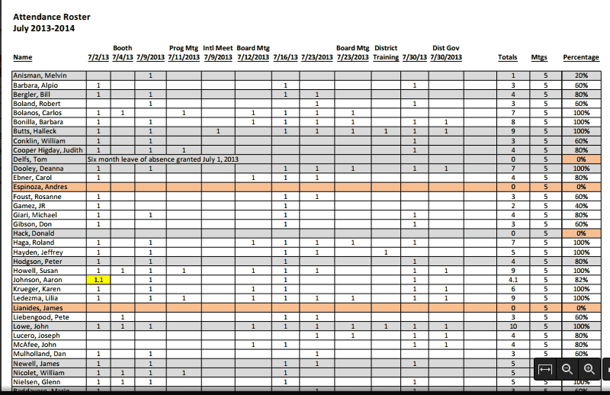

The totals from this spreadsheet are used for the attendance percentage numbers released to the District as part of the Club’s membership reporting. (BOARD PACKET ITEM)

- Monthly Membership. District 5150 Area Membership Coordinators need monthly updates on membership data. An easy format for this, and one that is included in the Board Packet as a screen shot, is available on the District 5150 website (www.rotary5150.org ).

Login to www.rotary5150.org, the landing page for login is shown below. Click on My Club’s Info

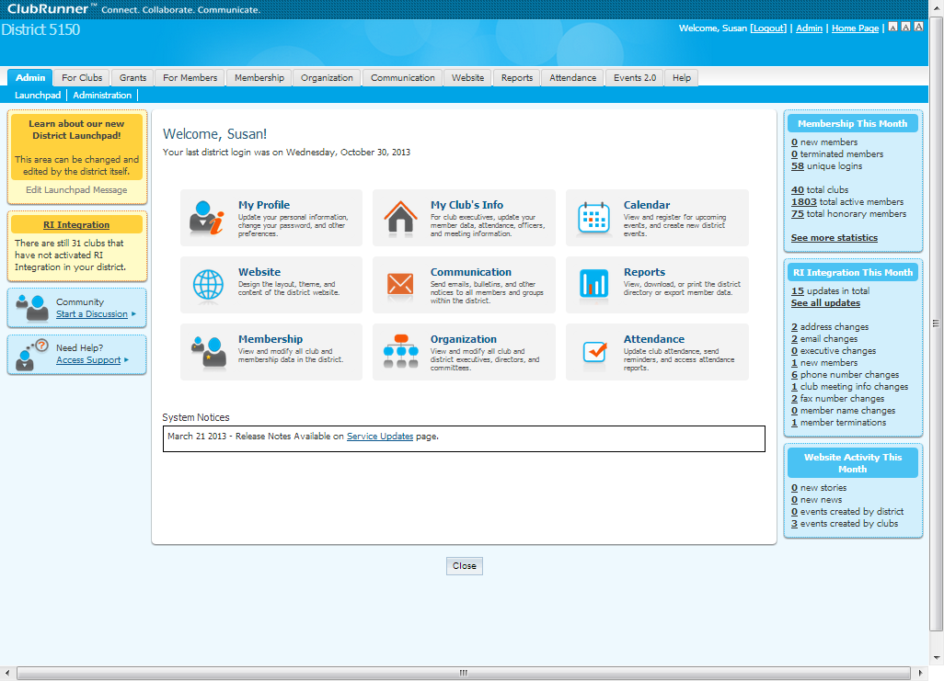

Then find and click on Monthly Club Attendance on the left hand side under Report Updates.

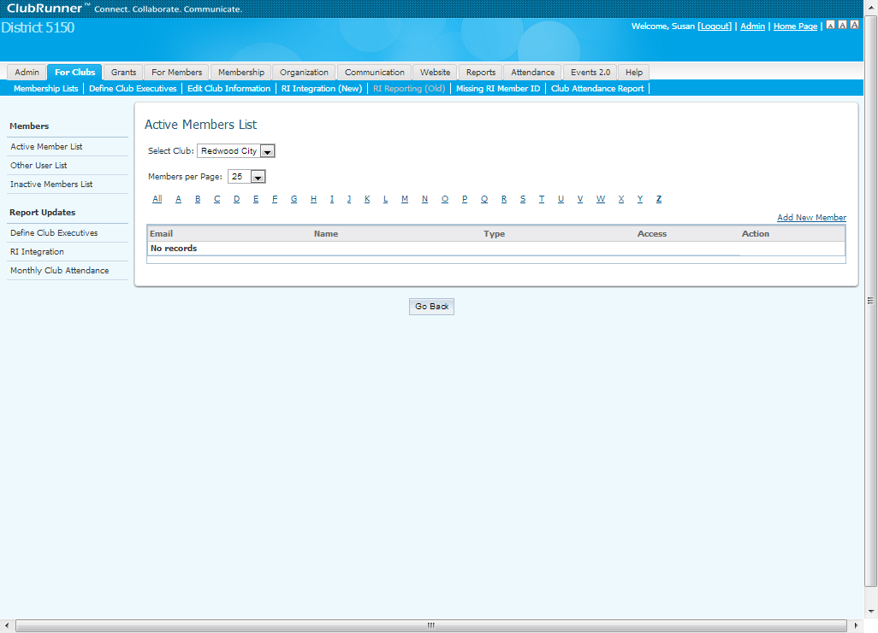

Fill in the numbers for the current month (number of members, new members, terminated members, number of meetings and attendance percentage from the Club Attendance spreadsheet) and then take a ‘screen shot’ of the screen with whatever software you have available. One copy of this page will be inserted into the Board Packet and one copy will be emailed to the District 5150 Area Membership Coordinator by the 10th of the month.
(BOARD PACKET ITEM)

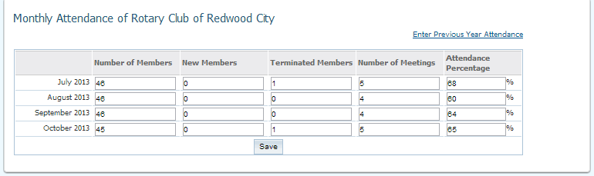
- Membership Changes. Things change. Members come, but hopefully don’t go. Email addresses are swapped out and members move. All of these changes need to be recorded in the proper places in all the applicable systems and in some cases they need to be reported to the people that manage that information. For example, the Club Treasurer needs to know email address changes so that invoices can be sent and received. See Item #3 above under Recording Duties

- Club Info Changes. The Club Secretary is responsible for ensuring that information about the club itself is current at Rotary International. The meeting place, time, day of week, official email address (Secretary@redwoodcityrotary.org), official mailing address (P.O. Box 2605, Redwood City, CA 94064) and other necessary information needs to be kept up-to-date. The Club Secretary should periodically do a search with RI Club Locator App to make sure the club shows correctly.

- Rotarian Relocation. On occasion Rotarians change clubs. The Club Secretary coordinates this process with the Club Secretary of the Rotarian’s current club. In addition, the Club Secretary is called upon to ensure that former Rotarians left their clubs in good standing before being welcomed as a new member.

- CDFA Report. The California Department of Food and Agriculture requires a quarterly report regarding the Certified Farmers’ Market Program. Our market certificate #20-41-12 is still valid as of the writing of this book. Until that certificate is cancelled, the Club Secretary needs to file the report on the following dates to ensure that the report is not late and that penalties will not be assessed. IRS regulations prohibit some tax-exempt entities from paying fines or penalties from their bank accounts. Beware!
  - April 15th
  - July 15th
  - October 15th
  - January 15th

An example of this report is in the Club Secretary’s Google Drive account. Completed and filed reports should be stored in the Documents section of the website under the correct Rotary year.

- Raffle License Application. Every year that the Club has any raffle activity, a Raffle Registration Application must be filed with the California Attorney General’s office. The most current application is shown below with all the information necessary for filing. This report is due by September 1 of each calendar year. Completed and filed reports should be stored in the Documents section of the website under the proper Rotary year.

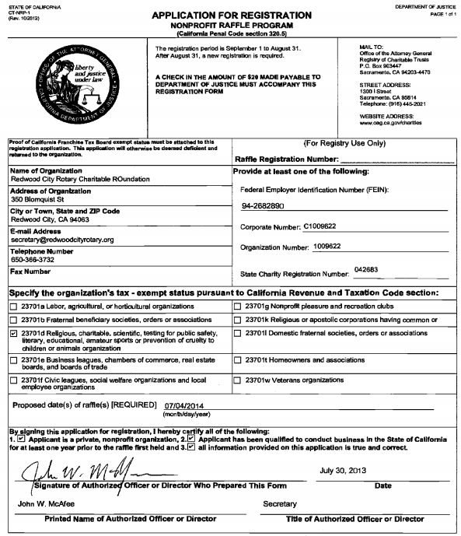

- Raffle Report. The Club Secretary works together with the Club Treasurer to send the latest Non-Profit Raffle Report to the California Attorney General. The Non-Profit Raffle Report is due no later than October 1st of each year. Better to file them at the same time and make sure all the forms are completed! The first page of the latest report is shown below. Completed and filed reports should be stored in the Documents section of the website under the proper Rotary year.

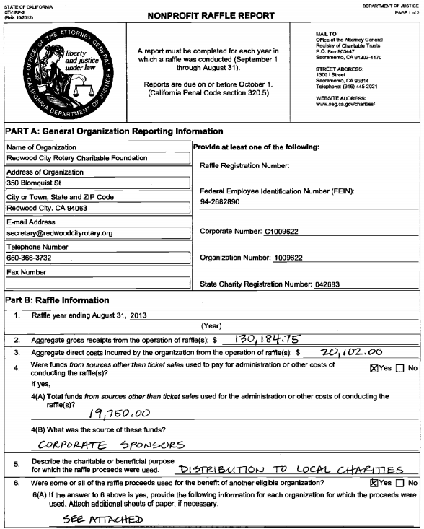

- Statement of Information Report. A Statement of Information Report is required to be filed with the California Secretary of State for each business entity. The report is supposed to be filed upon any change of information with regard to corporate officers and a separate form is required for both our Club and our Foundation. At a minimum, the report MUST be filed every two years (on even years) no later than November 15th. Completed and filed reports should be stored in the Documents section of the website under the proper Rotary year.

This form may be e-filed from the Secretary of State website at https://businessfilings.sos.ca.gov/.
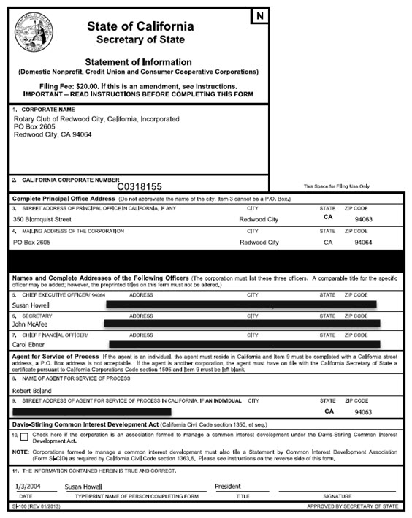
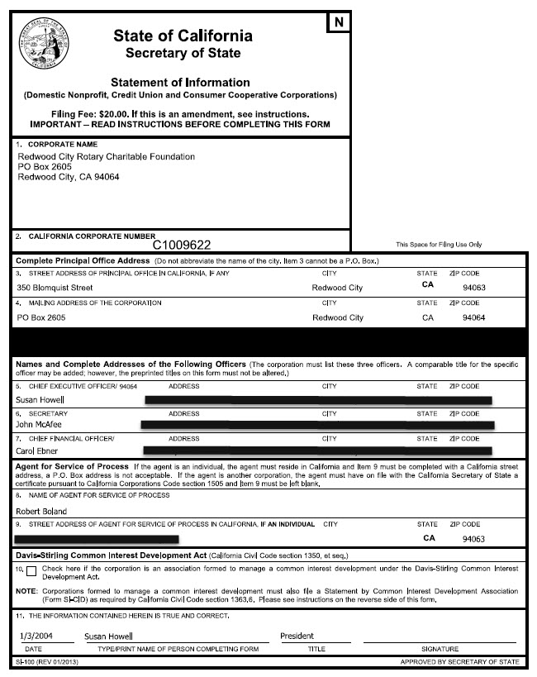

- Tax Returns. Required by the Internal Revenue Service and prepared by our very own Rotarian, Jim Newell, CPA. Three tax returns (Club, Foundation and Trust) are due to the IRS no later than November 15th of every year. The Club Secretary should upload the returns and the financial statements prepared in conjunction with the returns to the Document section of the website under the proper Rotary year.

Controlling

- Elections for the Board of Directors and convening the Presidents’ Council for other officers
- Ordering of supplies, including badges for PHFs, new members and the debunking
- Issuance of insurance certificates
- Additions and subtractions to the master Club Classification Listing
- Board meeting packets for both the Club and our Foundation

Controlling Duties

- Controlling Elections. Elections are held yearly for the Board of Directors. The By-Laws detail the ballot system to be used. The Club’s website calendar lays out the timing of the entire event complete with the announcement to the club members.

At the time of this writing, the By-Laws stipulate that the ballot will be setup at www.surveymonkey.com. Find the directions for how to setup a ballot in Survey Monkey on the Club’s website under the How-to Guides section.

- Ordering of Supplies. The Club Secretary maintains all membership related supplies for the club. That includes the supplies needed for three major induction functions or events: Members, Presidents and Paul Harris Fellows.
  - Member Inductions. The Club Secretary takes over the process once a prospective member turns in an application. Everything from that point forward is controlled by the Club Secretary. The Membership & Induction Process, located in this document as Template 10 gives a more detailed view of the entire process, but suffice to say, the Club Secretary takes a major role in make sure the transition from prospective member to new member is smooth.
  - President Inductions (debunking). The Club Secretary also makes sure all the proper items are on hand for the debunking in June. Supplies may be ordered as early as April to make sure everything is on hand. A partial list is included below but it is always a safer bet to check the order from the previous year just in case things have changed.
  - Paul Harris Fellows Recognition. The Club Secretary orders the badge that gets placed on the Club’s banner during the recognition ceremony.
  - Other supplies. Make-up cards, sign in sheets, and most other supplies used in club business are ordered or maintained by the Club Secretary.

- Issuance of Insurance Certificates. The Club Secretary has access to the Rotary International portion of the website that handles the issuance of insurance certificates with a named insured.

- Club Classification Listing. The current Club Classification Listing is on the website in the Member Materials Document section. The Club Secretary adds and subtracts members from the listing as members are inducted or terminated from the Club.

- Board Meeting Packets. The Club Secretary collects the information from the president and treasurer, then issues the board packets to the Directors on the Tuesday before the Board meeting.

Communication

- Issues emails regarding elections
- Notifies board members of upcoming meetings
- Advises members of special items

Communication Duties

- Emails regarding elections. Notifies the membership regarding all rounds of elections. Notifies the Immediate Past President of the necessity to convene the Presidents Council for the determination of the Treasurer, Secretary and President-Elect Nominee.

- Notifies board members. Sends out the board packets on the Tuesday prior to the Board meeting. Ensures that all board members are given proper notification of special board meetings.

- Special item announcements. As the keeper of the best information regarding members, the Club Secretary may be asked from time to time to notify members of a variety of items. The announcement of prospective members is one example.

NOTE: See APPENDIX FOR A VARIETY OF TEMPLATES

Club Secretary Checklists

President Induction
- Past president pin
- President and Past president badges
- Gavel
- Past president plaque
- Pins for incoming board members
- Check prior orders for debunking supplies
- Ensure that President’s Pin will be at the debunking!

Board meetings
- Check website calendar to make sure the calendar is correct
- Request agenda from president (Club and Foundation)
- Ask treasurer for treasurer’s report (Club and Foundation)
- Put together prior meeting’s minutes
- Gather attendance report
- Complete membership report at www.rotary5150.org and screen print
- Compile items #2 through #6 into the Board Packet and email to BOD

Member Resignation
- Update membership data at www.rotary5150.org
- Notify treasurer@redwoodcityrotary.org to stop invoices in Quickbooks
- Change Club Classification Listing and remove member from classification
- Fix Google Drive Excel Spreadsheet
- Generate corrected attendance sign-in sheet & bring to meeting
- Change attendance spreadsheet to eliminate member
- Adjust email groups in secretary@redwoodcityrotary.org account
(Add to Ex-member, remove from both Rotary Member groups)
- Notify webmaster to eliminate web access and membership groups

Member Induction
- Discover classification of prospective member
- Application gets returned to secretary@redwoodcityrotary.org
- Secretary emails application to board
- Secretary adds vote on membership as agenda item for the board meeting
- If Board approves, then application goes to club for approval
- If Board does not approve, secretary or sponsor notifies prospective member
- Secretary congratulates prospective member when 7 days has passed
  - Sets date for induction
  - Gives treasurer tentative induction date and asks for invoice
  - Secretary emails invoice prospective member
  - Notifies mentor of new mentee and induction date
  - Notifies president of induction date
    - Membership packet put together with the following:
    - Letter signed by president
    - Certificate of Membership
    - Object of Rotary
    - ABC’S of Rotary booklet
    - The Four Way Test
    - Committee Selection form
    - Rotary Pin
    - Rotary Coin
    - Rotary Decal
    - Badge
    - Mentor assigned
- Update membership data at www.rotary5150.org and www.rotary.org
- Notify treasurer@redwoodcityrotary.org to add member into Quickbooks
- Change Club Classification Listing and add member to proper classification
- Fix Google Drive Excel Spreadsheet
- Generate corrected attendance sign-in sheet & bring to meeting
- Change attendance spreadsheet to add member
- Adjust email groups in secretary@redwoodcityrotary.org account
(Add to both Rotary Member groups if a regular member)
- Notify webmaster to setup member for web access and membership groups

Club Treasurer
Outline of Responsibilities:

The Club Treasurer is all about the money. Currently that includes the cash and accounts of both the Rotary Club of Redwood City and the Redwood City Rotary Charitable Foundation. One treasurer is shared across these two separate tax-exempt organizations. In any event, if it is monetary in nature, it is handled by the Club Treasurer.

Changes Afoot

The last two years have been filled with changes and a great deal of flux. The advent of the Rotary Farmer’s Market in the Spring of 2012 led to the need of a more automated means of issuing invoices and some easing of bookkeeping tedium. The Farmer’s Market also brought about the establishment of credit card processing for Our Foundation. The decision was made in February 2012 to use QuickBooks Online to handle the market.

Then in the Spring of 2013, the creation of a TechSoup account and the ability to buy software on a much less expensive basis altered the landscape considerably. Suddenly the online version was substantially more expensive with much less functionality than a three user license of desktop QuickBooks 2012 Premier Professional. The move was made. A chart of accounts was setup for the Club operations and the chart of accounts for the Foundation was expanded to cover all Foundation business. The desktop version allows for the use of “classes” which delineates and assists in reporting items that span different fiscal years, such as the Great American Car Raffle.

The website was changed out in the Summer of 2013 and with a By-Laws change, the Club is now able to take credit cards for Club operations, as well as, Foundation donations. The website allows for payment processing of dues and meals. It is a question at this point, whether invoicing operations for dues and meals should remain in QuickBooks or move to the website. This is particularly true as more members move to paying online. There are substantial benefits to both directions.

Technology

- Quickbooks 2012 Premier Professional installed on Club Treasurer’s computer
- Google Apps for Business Account acquired by Our Foundation
  - Google Drive for secretary@redwoodcityrotary.org holds QuickBooks’ QBW files
    - One file for Redwood City Rotary Charitable Foundation
    - One file for Rotary Club of Redwood City
    - One file for Redwood City Rotary Trust
- Email treasurer@redwoodcityrotary.org forwarded to the Club Treasurer’s personal account
- Quickbooks uses treasurer@redwoodcityrotary.org email address. Program will prompt for password
- Online PayPal accounts, Wells Fargo accounts and others
- Most everything else is handled with Excel or Word

Banking

- Rotary Club of Redwood City
  - Wells Fargo – Main Street Branch – Checking
  - Two signatures required – President, Secretary, Treasurer and President Elect
  - Club Treasurer sets up names with branch
  - Paypal - Payment processor
    - Transfers to Wells’ checking done as required by treasurer

- Redwood City Rotary Charitable Foundation
  - Wells Fargo – Main Street Branch – Checking
  - Two signatures required – President, Secretary, Treasurer and President Elect
  - Club Treasurer sets up names with branch
  - Paypal - Payment processor
    - Transfers to Wells’ checking done as required by treasurer

Financial Reporting to BOD

- Rotary Club of Redwood City
  - Reports financial status to Board of Directors on the Tuesday before the board meeting
  - Compiles aging report on past due accounts on a routine basis
  - Pursues overdue accounts as needed and/or reports to BOD
- Redwood City Rotary Charitable Foundation
  - Reports financial status to Board of Directors on the Tuesday before the board meeting

Adding a New Club Member

- Open Customer Center – Click on the CUSTOMERS icon in the toolbar ribbon across the top of the screen OR click on CUSTOMER then CUSTOMER CENTER in the topmost toolbar

- Click on New Customer & Job in the upper left hand corner of the Customer Center and then click on New Customer.

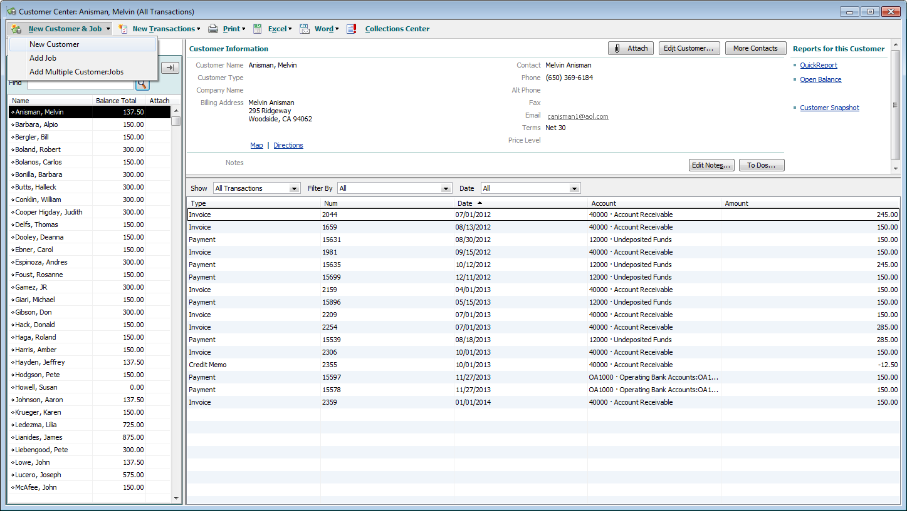

- It is necessary to fill out enough information to get an invoice out of the system. That can be as little as the name and email address or if no email address is present, then the name and the mailing address. In the long run, it is better to complete all the fields that are supplied to the Club Treasurer by the Club Secretary.

New member information will be sent to the Club Treasurer by the Club Secretary when the initial invoice is requested.

- Typical member information entered on the ADDRESS INFO screen is shown below.

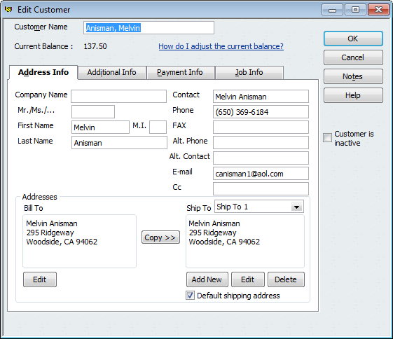

- Two additional pieces of information must be entered on the ADDITIONAL INFO screen.

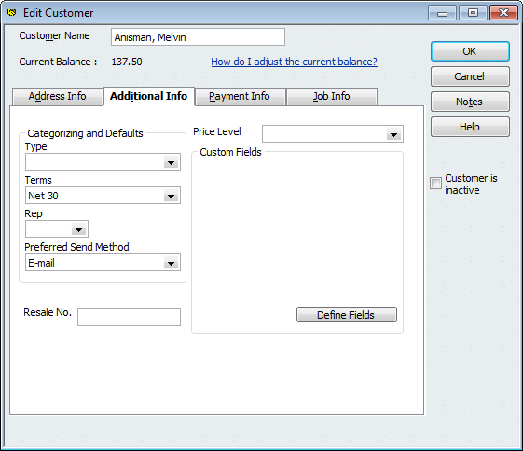

Setting up Memorized Transactions

      - There are always a few ways to do anything in Quickbooks. That is true with the creation of memorized transactions. Find the way that works for you. In the meantime, here is one way.

      - Create the missing quarterly meal invoice for the member. Click on Invoices on the Home Screen, then Create Invoices

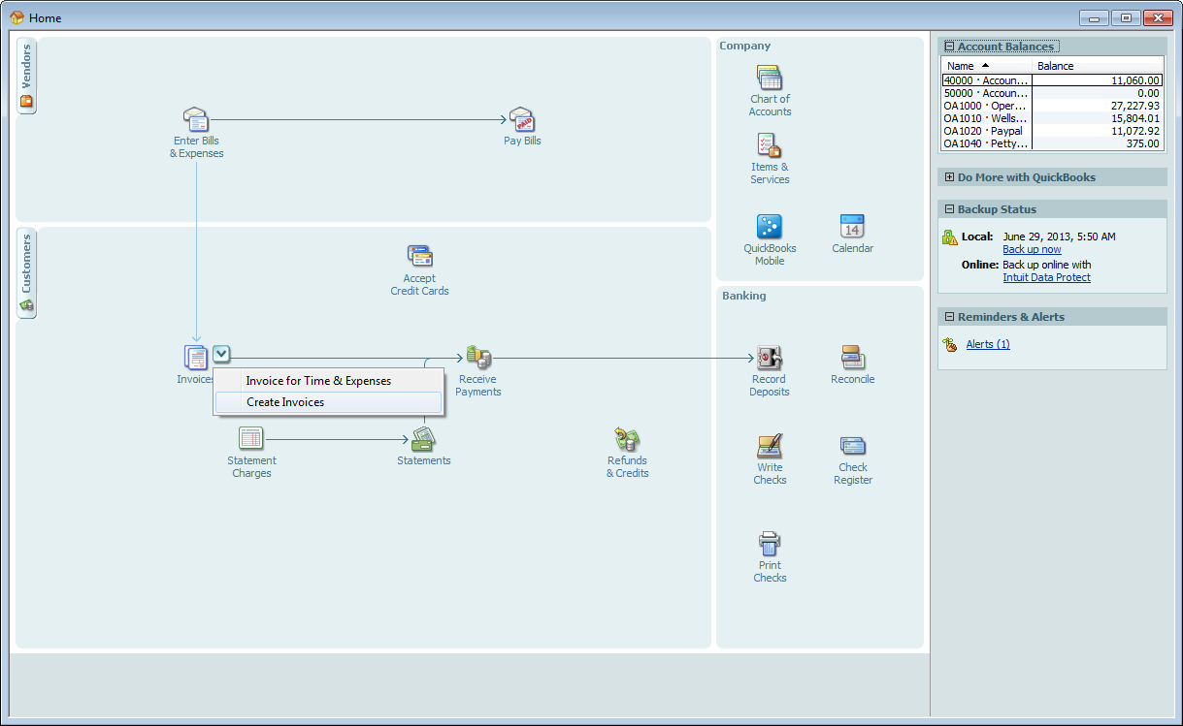

      - Make sure to choose Meals – Quarterly Meal Charge. Also be sure to click EMAIL or PRINT. Then choose CREATE and MEMORIZE TRANSACTION.

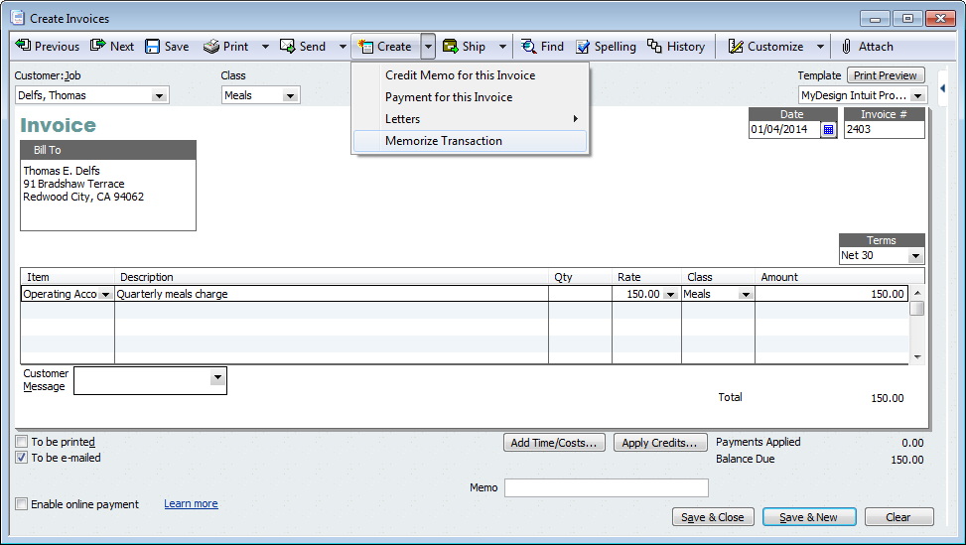
      - CHANGE the information to match the example below. The member’s name should be correct, Automated Transaction Entry radio button, How Often = Quarterly and the NEXT DATE for an invoice. Click OK.

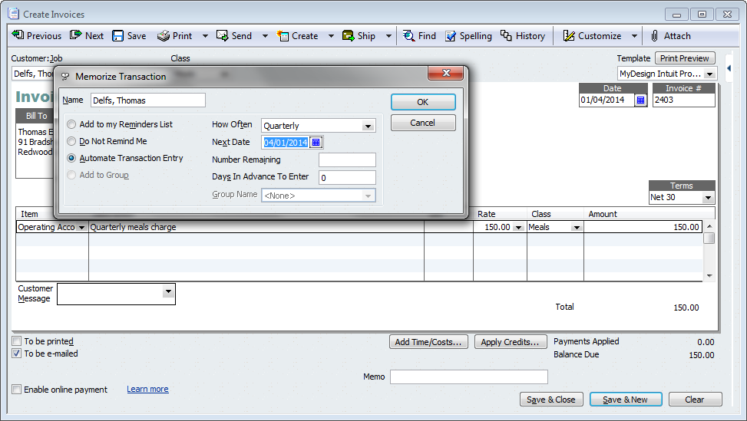

      - A quick check of the CUSTOMER CENTER will now show the invoice entered for Delfs, Thomas.

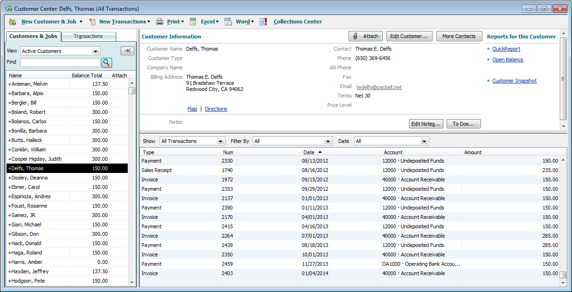

- A check of LISTS, MEMORIZED TRANSACTIONS will also yield the club member with a transaction for the next quarter matching the other club member’s transactions.

Processing Quarterly Invoices

- Open Quickbooks file RWC Club.QBW from Google Drive of treasurer@redwoodcityrotary.org. There should be a Google Drive icon in the bottom right hand service tray in Windows.
- If the invoices have queued up properly, then the screen will look like the screen below

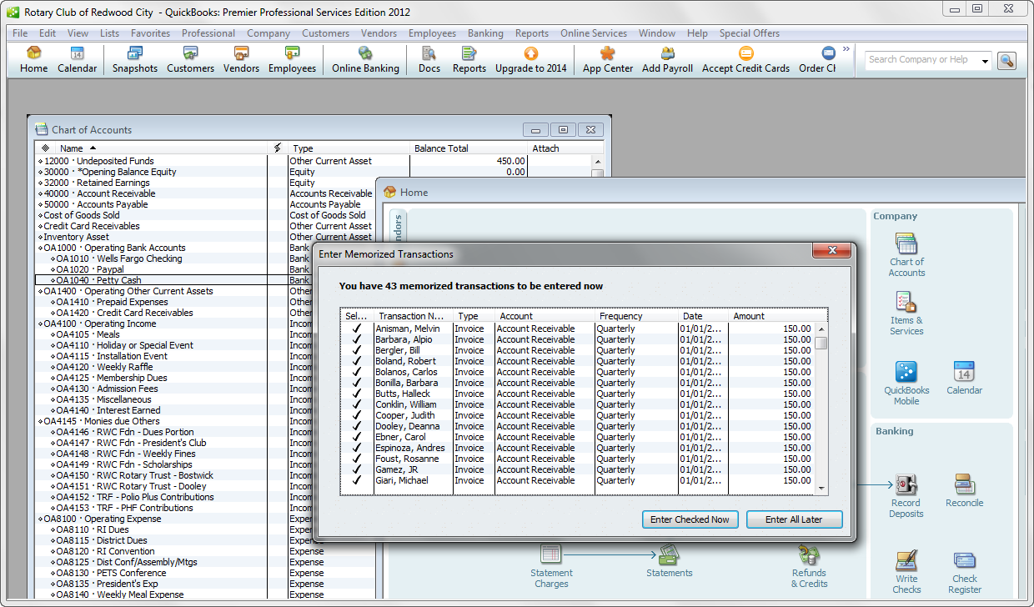

- Click on “Enter Checked Now” box. This will NOT send the invoices but rather will enter the invoices into the system and ready them to be sent. The following box will pop up after the invoices have been entered. It is also possible to scroll down the list and UNCHECK the ones that are not applicable. HOWEVER, this will not permanently stop the invoice from being produced every quarter.

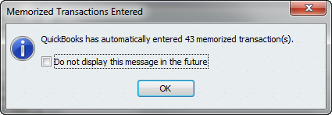

- At this point, the number of invoices created needs to be reconciled To reconcile, click on the CUSTOMERS icon in the toolbar ribbon across the top of the screen OR click on CUSTOMER then CUSTOMER CENTER in the topmost toolbar

- This will produce the screen below. Each ACTIVE member should be in the list on the left. When that member is highlighted, the last line of each member should show the line for the new invoice that will be sent. In this case, that would be 01/04/2014. Scroll through the members and note the missing invoices. Any missing invoice needs two things created 1) a current invoice 2) an automated MEMORIZED TRANSACTION.

It also could be the member is missing altogether if they are new. Write down the missing members and go to the instructions for SETTING UP MEMORIZED TRANSACTIONS.

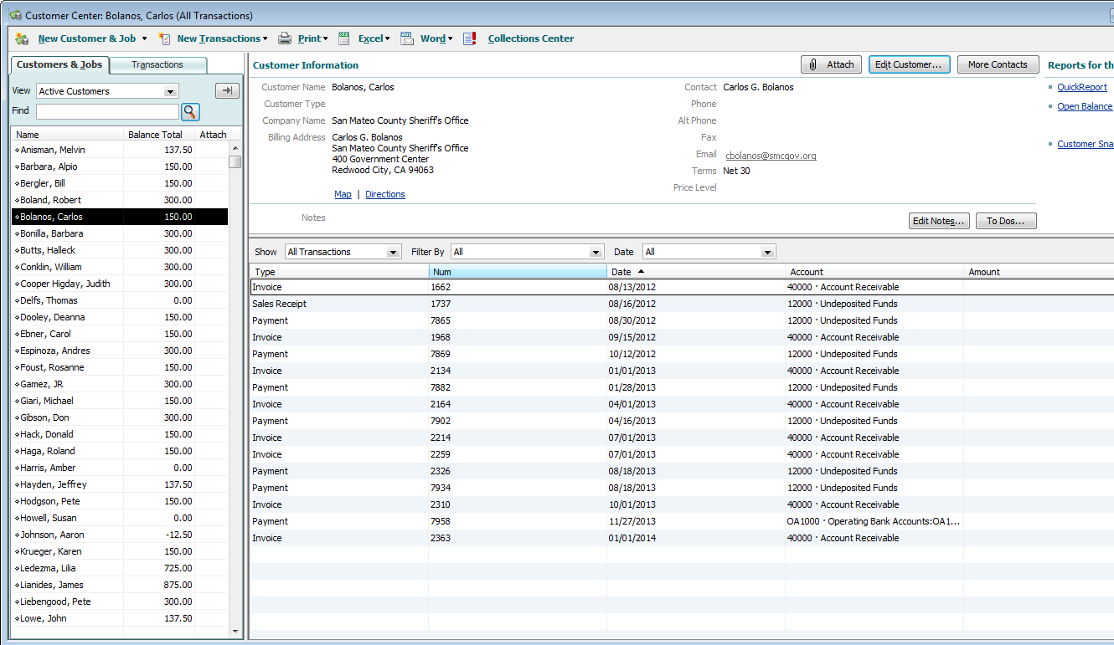

- When all is ready to go, open any invoice or even a blank invoice. Click on SEND, SEND BATCH. If the books are kept clean and items are emailed out as needed, then the only items listed in the box will be current. The system will prompt for the email password. PRINT the invoices for the members without email addresses.

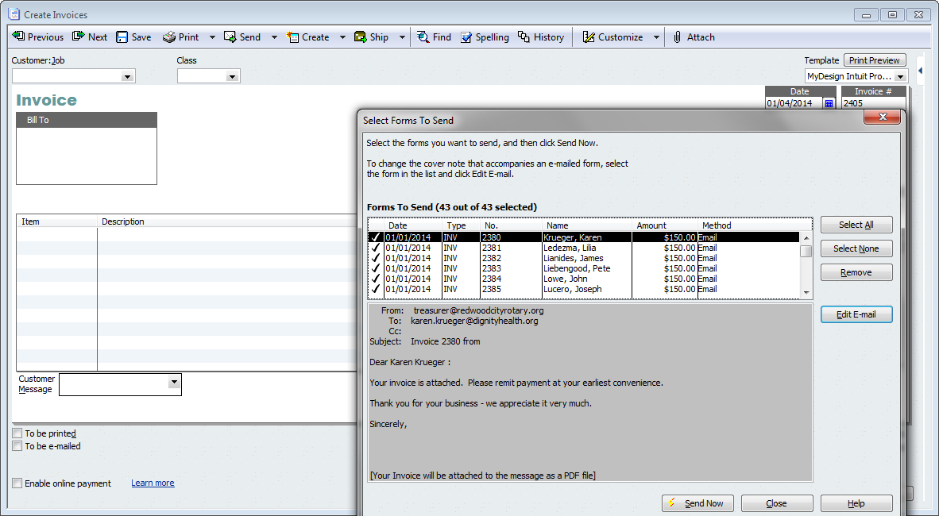

Processing Make-Up Meal Credits

      - An attendance spreadsheet is included with every board packet. This spreadsheet indicated make-ups requiring meal credit with an indicator of 1.1
      - Open Quickbooks. Click on Refunds & Credits on the Home screen. Choose the Club Member, Class, Meal Credit as the invoice item and don’t forget to click on TO BE PRINTED or TO BE E-MAILED.

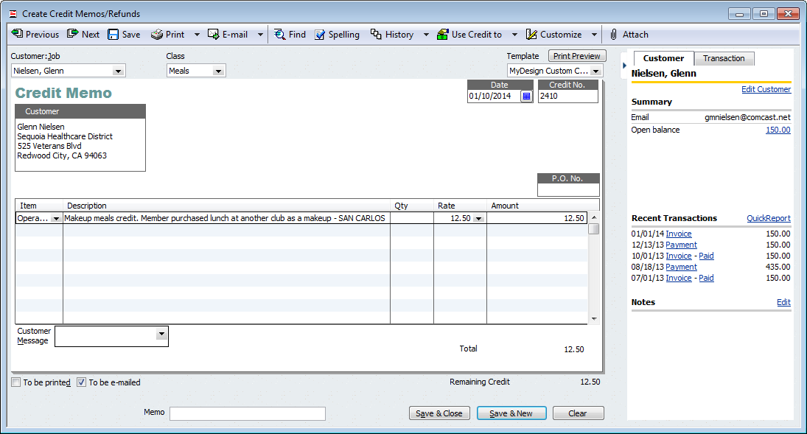

      - The answer to the next box depends upon timing more than anything. If the make-ups were caught and sent right after the quarterly invoices were emailed, then APPLY TO AN INVOICE is more applicable. If the make-ups are kept up-to-date or entered BEFORE the quarterly invoices are sent, then check on RETAIN AS AN AVAILABLE CREDIT. The amount will be applied against the next quarterly invoice. You will be prompted to apply the credit at that time.

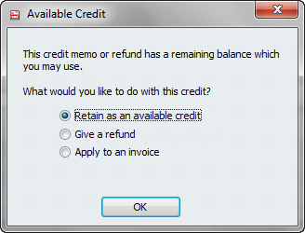

There is so much more to this job! But substantial assistance is needed to do a decent job of writing this description.

Finemaster Committee Chairperson
Outline of Responsibilities:

The chairperson that leads the Finemaster Committee has the latitude to manage the committee in whatever way they see fit to benefit the Club. This book merely attempts to detail the method used to manage the Finemaster Committee in 2013-2014.

- Each President-Elect attempts to ask for and receive committee assignments prior to the beginning of their year.

- The list of members interested in being on the finemaster committee is passed to the finemaster chairperson.

- The chairperson usually contacts prior members of the committee to see if they meant to continue on the committee.

- The Master Finemaster sets up the schedule for the year and contacts committee members with a schedule for the year. The chairperson may need to work with the other chairpersons, e.g. Greeter, Sergeant-at-Arms, Finemaster and Thought-of-the-Day, to ensure the same person isn’t on another schedule for the same day.

The Master Finemaster will work with newer committee members to ensure that new committee members will understand the duties of the position.

Finemaster Committee Member
Outline of Responsibilities:

Sometime before the meeting:

- Decide on a topic for your fining session. These can be fun, they can be informative, they can be questions to members. Almost anything is fair game as long as it is not religious, political or disparaging of a member.
Day of:
- Ask and fine as many members as possible in the time leading up to 12:55 p.m.

- The fine session is Our Club’s opportunity to raise money for our own foundation. More is better!

NOTE: If a finemaster has a conflict or cannot make their date, then it is their responsibility to find a replacement.

Greeter Committee Chairperson
Outline of Responsibilities:

The chairperson that leads the Greeter Committee has the latitude to manage the committee in whatever way they see fit to benefit the Club. This book merely attempts to detail the method used to manage the Greeter Committee in 2013-2014.

- Each President-Elect attempts to ask for and receive committee assignments prior to the beginning of their year.

- The list of members interested in being on the greeter committee is passed to the greeter chairperson.

- The chairperson usually contacts prior members of the committee to see if they meant to continue on the committee.

- The Master Greeter sets up the schedule for the year and contacts committee members with a schedule for the year. The chairperson may need to work with the other chairpersons, e.g. Greeter, Sergeant-at-Arms, Finemaster and Thought-of-the-Day, to ensure the same person isn’t on another schedule for the same day.

The Master Greeter will work with newer committee members to ensure that new committee members will understand the duties of the position.

Greeter Committee Member
Outline of Responsibilities:

- Plan on arriving at the Rotary Meeting at 12:10-12:15 pm. This gives you ample time to put on the GREETER badge and round up the following items:

- Name badges
- Rotary make-up badges
- Guest Book

- Greet members and non-members alike as they come to the meeting.

- Visiting Rotarians should be given a make-up card, asked to sign the Guest Book, directed to pay the Sergeant-at-Arms and introduced to at least one member.

- Visitors should be given a name badge, asked to sign the Guest Book, directed to pay the Sergeant-at-Arms and introduced to at least one member.

- Guests of the Club (meaning they have been brought to the meeting by a member and are interested in membership). They also should be given a name badge, asked to sign the Guest Book and setup with their sponsor or a member of the membership committee. You are done for the day!!!!!

Program Committee Chairperson
Outline of Responsibilities:

The chairperson that leads the Program Committee has the latitude to manage the committee in whatever way they see fit. This book merely attempts to detail the method used to manage the Program Committee in 2013-2014.

            - Each President-Elect attempts to ask for and receive committee assignments prior to the beginning of their year.

            - The list of members interested in being on the program committee is passed to the program chairperson.

            - The chairperson usually contacts prior members of the committee to see if they meant to continue on the committee.

            - Program chairperson contacts the new committee members and advises all members of the timing for the program committee meeting. This meeting is typically the second Thursday of the month.

            - The program chairperson divides the open program weeks by the number of members on the program committee. Then, at the first program committee meeting of the year, the members choose their block of dates.

            - Monthly meetings are held, on the second Thursday of each month, to review the status of the upcoming speakers or programs.

Do 50 meetings mean finding speakers for 50 programs? Well not exactly. Here is a list of some programs that do not require a speaker:

President’s address - First meeting in July
Car Raffle presentation – July
District Governor’s Visit – Announced after July 1st
Breakout Sessions – Six programs, every other month, beginning in July
Icebreakers – Two programs, or perhaps more, if needed
Holiday Party – December
Student Choir – December
Scholarship Awards – May
Debunking – Last Tuesday in June unless conflict with RI International Convention

As this list shows, there are only 35 programs remaining after the ‘usual’ programs are counted.

Program Committee Member
Outline of Responsibilities:

The Program Committee is THE committee that greatly influences the engagement of club members with the meeting. Bad programs will likely leads to lower attendance. Even same old, same old programs can influence the mood of the room and the enthusiasm of the membership. At the same time, it is tough to know what will please a roomful of disparate, diverse individuals. One of the easiest ways to proceed is ask members.

- At the beginning of the Rotary year, each member of the Program Committee will choose a block of dates that work best for them. Program committee members routinely trade dates with other members of the committee.
- Program committee members have a responsibility to attempt to find speakers that elevate the meeting, engage the membership and drive the club towards any long term goals or strategic direction.
- The chairperson usually contacts prior members of the committee to see if they meant to continue on the committee.

- Attend Program Committee meetings.
- Communicate the program information to 1) the chairperson of the program committee 2) the SPOKE editor 3) the webmaster. It is not necessary to send an email to the webmaster at news@redwoodcityrotary.org UNLESS the committee member is unable or unwilling to setup the speaker information on the website’s calendar. Instructions for updating a calendar entry are stored in the Documents How-to section of the website.
What is completely out of bounds? The session should skip subjects of religion or politics, as well as, programs that would embarrass or ‘call out’ a current member of the club.

Program Committee Calendar Keeper
Outline of Responsibilities:

- Keep the website calendar up-to-date as programs and other items are decided upon or announced.

- Instructions on the website in the Documents section.

- It’s easy, quick and painless to do!

Sergeant-at-Arms’ Committee Chairperson
Outline of Responsibilities:

The chairperson that leads the Sergeant-at-Arms Committee has the latitude to manage the committee in whatever way they see fit to benefit the Club. This book merely attempts to detail the method used to manage the Sergeant-at-Arms Committee in 2013-2014.

- Each President-Elect attempts to ask for and receive committee assignments prior to the beginning of their year.

- The list of members interested in being on the sergeant-at-arms committee is passed to the sergeant-at-arms chairperson.

- The Master Sergeant-at-Arms sets up the schedule for the year and contacts committee members with a schedule for the year. The chairperson may need to work with the other chairpersons, e.g. Greeter, Sergeant-at-Arms, Finemaster and Thought-of-the-Day, to ensure the same person isn’t on another schedule for the same day.

- If a Sergeant-at-Arms has a conflict or cannot make their date, then it is their responsibility to find a replacement.
The Master Sergeant-at-Arms will work with newer committee members to ensure that new committee members will understand the duties of the position.

Sergeant-at-Arms’ Committee Member
Outline of Responsibilities:

Day of:

- Plan on arriving at the Rotary Meeting at 11:50 am. This gives you ample time for set up prior to Rotarians arriving at the meeting. Please note that there will be occasions when the meeting will be located off-site. When this occurs, it may be required that Rotary banners and other materials need to be brought to the meeting by the individual Sergeant at Arms for that specific week.

- Table Set-up and Meeting Responsibilities:

- Date roster sheet and set out for recording attendance.
- Date Log sheet, record beginning raffle ticket number for easily reference to tickets sold at end of meeting.
- Log Sheet has place to record number of Guest Lunches ($15), Fellowship ($7) and Raffle Tickets are $1 each. Record checks separately from cash as they come in, this makes balancing cash and checks easier later.
- Set out guest book, Rotary info and miscellaneous fliers included in briefcase

- The Sergeant at Arms is responsible for doing the pledge of allegiance at each meeting. When called upon please be prepared to lead the club with the pledge of allegiance.
- Collect fines during the fine session.

- Finalize Daily Accounting:
- Record the final number of Lunches and Fellowships.
- Record the number for Polio Plus (the amount in the brown wooden box)
- Record the number for Fines.
- Record next Raffle Ticket to subtract form beginning number to establish Raffle count for the day.
- Finalize accounting of checks and cash for lunches and fellowships.

- At the end of the meeting, turn in cash, checks and the accounting sheet to the club’s treasurer. If the Treasurer is not at the meeting, keep the accounting sheet, checks and cash and turn in the following week.

- At the end of the meeting, turn in the daily Roster sheet to the club’s secretary. If the Secretary is not at the meeting, mail the information to them or call them to make other arrangements, if necessary. Please inform the Secretary if any supplies listed in item #9 are low and need replenishment.

- At the end of the meeting, gather up all the Sergeant-at-Arms items and place them back in the green bin. It is not the duty of the facility to have our things ready for storage!

- Contents of the GREEN Sergeant-at-Arm’s bin.

- Rotary Bell
- Polio Box
- Fine basket
- Raffle tin with
  - Raffle marble bag
- Pencil box with
  - Name tags
  - Pens
  - Makeup cards
- Briefcase with
  - Committee listings
  - Lunch accounting sheet
  - Attendance sheet
  - Service per week listings
  - Rotary info / Other fliers
- Easel for the Information board

Sunshine Committee Chairperson
Outline of Responsibilities:

The Sunshine Committee has the latitude to manage the committee in whatever way they see fit to benefit the Club. This is an excerpt from Our Club’s Committee Report for the District Governor from 1984-1985. The following was written by committee chairman William D. Koon and submitted to then President Allen Gruman.

- To help foster the feeling of friendship which is important in the operation of our club’s many functions the Sunshine Committee to offer recognition of those days, namely, birthday and anniversaries, which have special meaning to each member.

- Significant illness of a member or wife will be acknowledged by flowers sent in the club’s name or by a “Get-Well” card if the latter seems more appropriate.

- Bereavement caused by the death of a member or wife does not, in your committee’s judgment, lend itself to a standardized response, Mr. President. Appropriate club reaction should be determined by prompt discussion among the committee, members who are especially close to the family, and yourself.
NOTE: This was written before women were inducted into Rotary.

Thought-of-the-Day Committee Chairperson
Outline of Responsibilities:

The chairperson that leads the Thought-of-the-Day Committee has the latitude to manage the committee in whatever way they see fit to benefit the Club. This book merely attempts to detail the method used to manage the Thought-of-the-Day Committee in 2013-2014.

- Each President-Elect attempts to ask for and receive committee assignments prior to the beginning of their year.

- The list of members interested in being on the Thought-of-the-Day committee is passed to the Thought-of-the-Day chairperson.

- The chairperson usually contacts prior members of the committee to see if they meant to continue on the committee.

- The Master Thought-of-the-Day person sets up the schedule for the year and contacts committee members with a schedule for the year. The chairperson may need to work with the other chairpersons, e.g. Greeter, Sergeant-at-Arms, Finemaster and Thought-of-the-Day, to ensure the same person isn’t on another schedule for the same day.

The Master Thought-of-the-Day will work with newer committee members to ensure that new committee members will understand the duties of the position.

Thought-of-the-Day Committee Member
Outline of Responsibilities:

Sometime before the meeting:

- Decide on your thought-of-the-day. The information below regarding invocations and prayers is from the 2013 Manual of Procedure published by Rotary International.

Invocations and Prayers
Rotary clubs throughout the world include members who have many different religious beliefs and values and yet are united by their service to humanity. Each Rotary club uses its own judgment in conducting its meetings in a manner that reflects Rotary’s principle of tolerance and emphasizes shared Rotarian service ideals and projects. (RCP 7.020.)

Day of:

- Deliver your Thought-of-the-Day after the Pledge of Allegiance

- If a Thought-of-the-Day has a conflict or cannot make their date, then it is their responsibility to find a replacement.

Public
Relations

Public Relations Chairperson
Outline of Responsibilities:
The chairperson that leads the Public Relations Committee has the latitude to manage the committee in whatever way they see fit to benefit the Club. The items on the listing below were the District Governor’s targets for 2013-2014. This list gives a good overview of the items held to be important for the Public Relations Committee.

- Attend district seminars, district assembly and district conference
- Regularly update a club Facebook page
- Link the club Facebook page to the District and RI Facebook pages
- Use Meetup, One Brick or other social promotional tool for Club projects, meetings or events
- Actively use social media to share club stories
- Integrate the Club’s PR campaign with the District’s efforts
- Have PR efforts around all service projects
- Depict our Club’s involvement in the community in a local newspaper or website
- Conduct a PR campaign aimed at business to explain Rotary
- Wear logo gear at public Rotary sponsored events
- Display the Rotary wheel at community projects

Webmaster and Technology Coordinator
Outline of Responsibilities:
- Try to keep content on the website up-to-date, interesting and relevant
- Maintain backend CiviCRM database with member’s information (Club Secretary to provide copy of app)
- Update Drupal (front-end) and CiviCRM (back-end) software as needed
- Help members as needed with uploading, downloading or updating information
- Work with others to get understanding around the technology used by the club
- Change assignments for our Club’s branded Google Apps (Gmail) addresses as needed:
  - Secretary@redwoodcityrotary.org
  - President@redwoodcityrotary.org
  - Treasurer@redwoodcityrotary.org
  - News@redwoodcityrotary.org
  - Membership@redwoodcityrotary.org
- Pay $3.95 per month for the club’s website SSL certificate (be sure to get reimbursed)
- Keep redwoodcityrotary.org domain name current and paid
- Turn in updates to Google, TechSoup and Dreamhost as needed to keep non-profit status for tech needs

Social Media
Outline of Responsibilities:
- Our Club currently has accounts with the following social media companies:
  - Facebook
  - Twitter
  - Meetup
  - Instagram
  - LinkedIn company page
  - Signup Genius
  - Hootsuite – to help cross post and manage
- Account login for each is either news@redwoodcityrotary.org or RWCRotary. Please ask for password.
- Keep the content fresh, interesting, engaging and fun and HAVE FUN along the way!!!!!

The Spoke Editor
Outline of Responsibilities:
- Keep up OUR WEEKLY NEWSLETTER that has been published since 1946
- Put your own spin on it and drive it home!
- Good to have areas
- Birthdays
- Club Anniversaries
- Recognize members – attendance, awards, interesting info
- Roster – interesting to be able to go back over time and see the members
- District info or RI info
- Upcoming events, programs or other calendar items
- What happened last week / What is happening next week
- Service positions needing to be filled
- Word from the BOD

The Spectrum, Daily Journal, the Patch and other papers
Outline of Responsibilities:
- Develop a relationship that might serve to get our Club’s efforts recognized
- Blog (if you are the blogging sort) about whatever you would like related to Rotary
- Update online calendars with upcoming information

Redwood City Interservice Club Coordinating Council (ISCCC) Volunteer
Outline of Responsibilities:
- Attend the ISCCC meetings each month
    - 2nd Monday of the month
    - American Legion Hall, 12:30-1:30 pm, bring your own lunch
- Develop a relationship and bring back reports to the club on other service organization’s activities

Redwood City San Mateo County Chamber of Commerce Volunteer
Outline of Responsibilities:
- Attend as a Rotarian and PROMOTE ROTARY!

Membership
Committee

The Membership Committee Chairperson
Outline of Responsibilities:

The chairperson that leads the Membership Committee has the latitude to manage the committee in whatever way they see fit to benefit the Club. The items on the listing below were the District Governor’s targets for 2013-2014. This list gives a good overview of the items held to be important for the Membership Committee.

- Meet regularly
- Attend district seminars, district assembly and district conference
- Increase the membership of the club
- Induct members under 35
- Induct a former Rotaractor, Interactor, GSE/VTT Team member or Rotary Scholar
- Initiate or update a new-member welcome program
- Assign Rotary Mentors to all new members
- Maintain current members via retention programs
- Strategize to attract, educate, engage and retain members
- Engage all members in Club activities
- Adopt a leadership development process
- Encourage members to join Rotary Fellowships or Rotary Action Groups
- Keep in touch with Club alumni

Classification Volunteers
Outline of Responsibilities:

Help to keep our Classification Listing up-to-date and relevant for our membership efforts. Suggest additions or subtractions from our listing in the Documents section of our website.

Mentoring Committee Volunteers
Outline of Responsibilities:

The duties of the mentoring volunteer encompass bringing a new member from induction through graduation from their ‘red badge’ and beyond. The “Sample Induction Letter Template” in the appendix lists the items that must be accomplished to bring a member from red badge to blue. In addition, sometimes the best mentor is the one that just reaches out. Whether that is to get the new member to the meeting and just helping the new member feel more comfortable. Don’t discount the little things!

New Member Orientation and On-Going Training Volunteers
Outline of Responsibilities:

According to Our Club’s 1962-1963 District Governor’s report, Rotary Information Chairperson Alan Bostwick states that the role of the Rotary Information Volunteer is to “pay close attention to the information which is distributed by Rotary International and which gives detailed suggestions for informing both old and new members about the history, object, scope and activities of Rotary. The committee will endeavor to see that present members know more about Rotary at the end of the year, and that new members receive sufficient information to make them feel at home in the club.”

Our Club currently publishes a Member Information Guide that may be found in the Appendix of this book. This guide is updated routinely and contains some great information. Our www.redwoodcityrotary.org website is a resource for information regarding club programs and history. There are a great, many wonderful information sources on Rotary International’s website.

This goal may be accomplished via ‘fireside’ chats, specific club programs targeting Rotary training or distributed information.

Recognition Volunteers
Outline of Responsibilities:

There are a great many things that our club members do outside of the meeting for which they should receive recognition. These volunteers work hard scouring whatever may need to be scoured to bring this information to light for the rest of the club members. This information could be distributed to the SPOKE editor via an email to news@redwoodcityrotary.org, given as an announcement at a meeting, handed off to the Finemaster to incorporate into the weekly meeting’s fine session or passed along to the Club President for an announcement.

Recruiting Volunteers
Outline of Responsibilities:

We all need to bring potential members to a meeting. New blood keeps us alive, vibrant and moving forward! Grab someone and bring them along. Check out the following documents in the appendix – Membership Process, New Member Guide, the Membership Application for more information or to pass along to a prospective member. Still have questions? Don’t feel comfortable with the process or your knowledge of Rotary? Then enlist the help of another member in your process to bring in a new member.

Retention and Attendance Volunteers
Outline of Responsibilities:

The duties of this position include working with the Club Secretary to get accurate and up-to-date attendance information. Using this information, these volunteers target the missing and attempt to bring them back to the meetings on a regular basis. This could be a phone call, a friendly email, a ride or a swift kick! Whichever you believe will bring Our Rotarian back to regular attendance.

The information in the section below has been provided by PDG Riki Intner and the 2013-2014 District 5150 Membership team. Membership covers the ability to Identify, Introduce, Invite, Induct, Inform, Involve and Educate.

There are five parts, with equal importance, under the master banner of membership. These five areas are:

- Development – the process of attracting member to your club
  - No magic bullet
  - Have a goal plan, plan of action and a leader to encourage Rotarians to participate
  - Get Rotarians to invite someone to attend a meeting
  - Hold a membership interest meeting
  - Make sure everyone understands the process of bringing in a new member
  - Make club meetings interesting and exciting
- Engagement – the process of getting members involved and active
  - Assign members to a committee
  - Red badge to blue
  - Firesides
  - Socials with family and partners
  - Mentorship
- Retention – the process of keeping members involved and active
  - Be a “Vibrant Club” – fun meetings, great programs, projects, socials, family feeling, support business opportunities, networking events (RMB), develop leaders
  - Follow up with missing members
  - Recognition opportunities and awards
- Education – the process of learning about Rotary
  - Club level
    - Financial commitment
    - Attendance quotas and purpose
    - Projects the club is working on
    - Activities
    - Fellowship
    - Importance of wearing the Rotary pin
    - Process for induction is outlined and understood
  - District level
    - Events – District Assembly, TRF Event, District Conference
    - Supportive role through committee trainings, leadership and RMB
  - Rotary International level
    - Annual Convention, TRF, projects, public image, Family of Rotary
    - Travel makeups
    - RI Official Directory
    - www.rotary.org resources
- Extension – the process of creating new Rotary clubs and Rotarians

Membership is a BIG JOB! There are many opportunities for everyone to help the chairperson in a myriad of ways. Just grab onto something and run with it!

The
Rotary
Foundation
Committee

Rotary Foundation Committee Chairperson
Outline of Responsibilities:

The chairperson that leads the TRF Committee has the latitude to manage the committee in whatever way they see fit to benefit the Club. The items on the listing below were the District Governor’s targets for 2013-2014. This list gives a good overview of the items held to be important for the TRF Committee.

- Meet regularly
- Attend district seminars, district assembly and district conference
- Encourage giving to the highest possible per capita level for APF and Polio Plus
- Inspire club members to be 100% EREY
- Work with the Program Committee to have TRF based programs
- Educate members about various recognition levels – PHF, PHS, Benefactor, Bequest, Major Donor

The Club’s TRF chairperson is combination cheerleader and educator for The Rotary Foundation. The chair should also work hard to engage and enlist others to help, as well as understand TRF programs!

Everyone has a reason to give. They may like the person asking. They may want the club to meet their goal. They might want the recognition of another Paul Harris Fellow recognition. They may just like to play the games. However, everyone wants to think their money is making a difference in the world. Therefore, it is very important to make the connection between the money given and the good works. Take the time to work with the president or program committee to get more TRF information interjected into the meeting.

TRF District Raffle Sales Volunteers
Outline of Responsibilities:

- District Raffle (August-October)
  - Every year prior to the District 5150 Foundation Event, the District Foundation Chair organizes a raffle event to raise TRF awareness and attempt to give great incentive to meet the District’s TRF goals
  - The job is to make the raffle tickets available to the members
  - Turn over the proceeds or the list of outstanding donations to the volunteer handling and processing donations
  - Another job is to promote the District Foundation event itself and club member attendance
  - Roughly 60% of our club’s TRF goal is typically met by this raffle

TRF Donation Processing Volunteer
Outline of Responsibilities:

Before a campaign begins, login to Rotary.org and download the latest Club Recognition Summary (CRS). Check the totals of the CRS report. This will make it much easier when the campaign is over to ensure that all donations were credited.

Processing a Single Donation via Check

- Receive check
- Fill out relevant CHECK PORTIONS of donor form 123-EN. (See Figure 1)
- Attach check to form
- Scan form and save in directory with others of the same year

Processing a Single Donation via Credit Card

- Receive promise to pay by credit card – take form to meeting to get information
- Fill out relevant CREDIT CARD PORTIONS of donor form 123-EN. (See Figure 1)
- Scan form and save in directory with others of the same year

Figure 1. FORM 123-EN with relevant portions highlighted

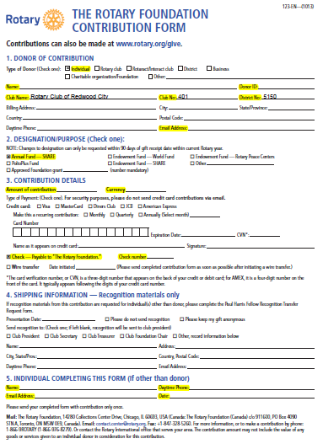

Processing a Multiple Donation via Check

- Receive cash from multiple donors.
- Fill out relevant CHECK PORTIONS of donor form 094-EN. (See Figure 2)
- Scan form and save in directory with others of the same year

Figure 2. FORM 094-EN with relevant portions highlighted
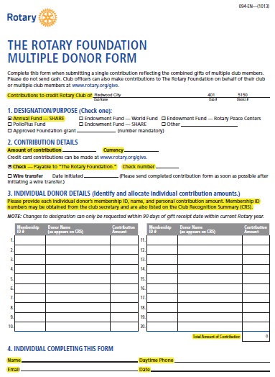

Processing a Recognition Point Transfer – Member

- Receive a request from a Club Member to transfer recognition points
- Fill out the appropriate fields in Form 102-EN (See Figure 3)

Processing a Recognition Point Transfer – Club

- A Club Member wins a sport’s pool and it is necessary to transfer recognition points
- The amount to be transferred must be at least 100
- Fill out the appropriate fields in Form 102-EN (See Figure 3)

Figure 3. FORM 102-EN with relevant portions highlighted

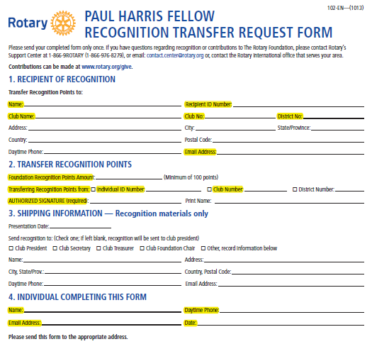
TRF Sport’s Pool Volunteers
Outline of Responsibilities:

- Setup and Sell the Sport’s Pools
  - Create buzz for the game
  - Create the cards for the game
  - Sell the tickets for the game
  - Turn over the proceeds or the list of outstanding donations to the volunteer handling and processing donations
  - The games are:
    - World Series (October)
      - Seven cards – one for each game
      - Ten blank lines on the left hand side for the American League team
      - Ten blank lines on the right hand side for the National League team
      - No numbers to start (numbers are drawn after the card is full or after the game starts)
      - Each line typically sells for $10 each
      - Winner gets 25% of card total in PHF credit (must be at least 100 points)
    - Super Bowl (January)
      - One big card
      - Eleven squares across by eleven squares down
      - No numbers to start
      - Numbers are drawn after the card is full or after the game starts
      - Each square typically sells for $10 each
      - Winner gets 25% of card total in PHF credit (must be at least 100 points)
    - NCAA Final Four (March)
      - Men all sixty four teams / Women thirty two
      - Setup the brackets for each
      - Each line on the bracket is $10
      - Have people draw numbers and assign to bracket in order
    - Soccer or Hockey
      - ???

TRF District, Global & Package Grant Volunteers
Outline of Responsibilities:

- This volunteer keeps track of the grant process at the District and TRF levels
- Attends various training opportunities on grants
- Passes along information on grants and grant opportunities to club members and service project chairs
- Encourages the club to utilize all possible grant situations so that Our Foundation funds can go further
  - Example the use of District Grants to pay for the Dictionary Project rather than using $4k or our foundation funds. We left $4,000 on the table that we could have utilized for other projects.

Service
Project
Committees

Community Service Committee & Chair
Outline of Responsibilities:

The chairperson that leads the Community Service Committee has the latitude to manage the committee in whatever way they see fit to benefit the Club. The items on the listing below were the District Governor’s targets for 2013-2014. This list gives a good overview of the items held to be important by the District Governor for the Community Service Committee.

- Meet regularly
- Attend district seminars, district assembly and district conference
- Involve prospective members in community events
- Include ALL members in projects
- Distribute Rotary Dictionaries (handled by Youth Service in Our Club)
- Dispense scholarships to students
- Schedule a project on “Rotary at Work” day
- Complete District Grant paperwork on time
- Partner with other Rotary Clubs
- Participate with other organizations other than Rotary
- Perform hands-on programs that benefit the community

Here is the what, when, how, when and where of a few things we do in Community Service?

Salvation Army Bell Ringing Coordinator
Outline of Responsibilities:

- The leader of this service commitment will:
  - Coordinate activities with the designated Salvation Army personnel
  - Work out the date, time and place choice for the event.
  - Setup signup sheets and get volunteers – Don’t forget to remind volunteers of their commitment!!
  - Get the event setup on the Club’s Calendar and mentioned in The Spoke
  - Inspire the club members to have a good time, wear Rotary gear and ring the change right into that kettle!

Salvation Army Bell Ringing Volunteers
Outline of Responsibilities:

- The Rotary Club of Redwood City has assisted the Salvation Army with bell ringing for decades. This community service opportunity asks each volunteer to ring the bell for two hours at the named location.

- Dress warm, wear your Rotary gear, ring the bell and HAVE FUN!

- Twelve volunteers needed for a 9 a.m. to 9 p.m. and two doors of the building.

Fair Oaks Community Center – Homebound Food Program Volunteers
Outline of Responsibilities:

- Delivery of Second Harvest Food Bank's groceries to the homebound of the immediate area.

- Each week Rotarians and non-Rotarian volunteers to our program deliver 18 bags of groceries, including fresh vegetables. The program needs two people each week. Each volunteer delivers groceries to nine separate households.

- Roundtrip timeline from beginning to end about 1-1/2 to 2 hours plus food pickup at Fair Oaks Community Center, 2600 Middlefield Rd Redwood City, CA 94063

- A minimum of two volunteers are needed each week.

Fair Oaks Community Center – Senior Halloween Party Coordinator
Outline of Responsibilities:

- The leader of this service commitment will:
  - Coordinate activities with the designated Fair Oaks personnel
  - Work out the time and any requests they may have for the party. We have had music, balloon makers, and other entertainment over the year.
  - Work out what can happen to keep within the budget
  - Shops for all the necessary items – food, plastic cutlery, condiments, etc (or gets a volunteer to do this)
  - Setup signup sheets and get volunteers – Don’t forget to remind volunteers of their commitment!!
  - Keep track of the accounting, submit receipts and a summary to the Club Treasurer to be reimbursed
  - Get the event setup on the Club’s Calendar and mentioned in The Spoke
  - Motivate club members to join in and participate. More volunteers is really not a problem.

Fair Oaks Community Center – Senior Halloween Party Volunteers
Outline of Responsibilities:
- Typically, the party includes food, gift cards, music, costume parade with judging and other requests within the designated budget.
- Be ready to laugh, serve food, be a costume judge
- Four to five volunteers are needed from approximately 10:30 am to 1:00 pm.

Community Garden Volunteer
Outline of Responsibilities:

Casa de Redwood Pancake and/or Spaghetti Dinner Coordinator
Outline of Responsibilities:

- The leader of this service commitment will:
  - Coordinate activities with the designated Casa de Redwood personnel
  - Work out the date, time and food choice for the event.
  - Keep within the budget
  - Shops for all the necessary items – food, plastic cutlery, condiments, etc (or gets a volunteer to do this)
  - Setup signup sheets and get volunteers – Don’t forget to remind volunteers of their commitment!!
  - Keep track of the accounting, submit receipts and a summary to the Club Treasurer to be reimbursed
  - Check if possible to pay nominal amount for cleanup services
  - Get the event setup on the Club’s Calendar and mentioned in The Spoke
  - Drive the events to reality with the help of some cool, committed Rotarians!

Casa de Redwood Pancake and/or Spaghetti Dinner Volunteer
Outline of Responsibilities:
- Show up for the time of your signup OR please make sure to find a replacement for yourself if something interferes with your commitment
- Our club members cook the food, serve food and wait on tables for about 100 seniors. The club provides funds for the food and drinks so that the residents may be charged only a nominal event. The volunteers are needed for setup, cooking, serving and cleanup.
- Twelve to fourteen volunteers are needed. The timing depends upon breakfast or dinner.
- This EVENT IS A BLAST!!!! And the food is usually really good…..

Second Harvest Food Bank – Food Drive Coordinator
Outline of Responsibilities:

- OPTION #1 - The leader of this service commitment will:
  - Announce the dates of the food drive at enough meetings prior to the food drive to get participation
  - Attempt to get the venue where we have our meetings to put a Second Harvest barrel onsite
    - If not, work out the how, where, why of transporting the food members bring to the meeting
  - Get the event setup on the Club’s Calendar and mentioned in The Spoke
  - This job is all about reminding members to bring food
- OPTION #2 – Coordinate a FOOD SORT
  - Setup one specifically for our club or join with another group that is already signed up
    - One Brick Silicon Valley routinely signs up for sorts in San Carlos
    - Rotary Club of San Carlos also sorts food at least every other month
  - Announce the dates, get the event setup on the Club’s Calendar and mentioned in The Spoke

International Service Committee & Chair
Outline of Responsibilities:

The chairperson that leads the International Service Committee has the latitude to manage the committee in whatever way they see fit to benefit the Club. The items on the listing below were the District Governor’s targets for 2013-2014. This list gives a good overview of the items held to be important for the International Service Committee.

- Meet regularly
- Attend district seminars, district assembly and district conference
- Encourage members to travel outside of the USA on international or TRF project
- Write a TRF Global Grant or sponsor a grant application
- Sponsor a Rotary Global Scholar Candidate
- Underwrite a Rotary Peace Fellow Candidate
- Sponsor a candidate for a VTT team
- Perform hands-on programs that benefit the world community

Here is the what, when, how, when and where of a few things we do in International Service?

Wine Raffle Coordinator
Outline of Responsibilities:

- The leader of this service commitment hangs out at various retailers of decent, but hopefully cheap, wine throughout the Bay Area
  - Buys wine & cons members into buying raffle tickets
  - Raffles off the wine every week
  - Tries to get excitement around a weekly event

Wine Auction Coordinator
Outline of Responsibilities:

- On occasions the club has put together a larger event
  - Solicit members for wine
    - Acquiring bottles, cases, jugs, kegs of decent grape for folks to buy
  - PDG Bill Conklin is a FANTASTIC auctioneer and also a wine fanatic
  - Hold a party with a bit of cheese or fruit, some tables, chairs and some socializing
  - Invite people and invite more people
- Spend the money on a project

OTHER STUFF?????
Outline of Responsibilities:

Vocational Service Committee & Chair
Outline of Responsibilities:

The chairperson that leads the Vocational Service Committee has the latitude to manage the committee in whatever way they see fit to benefit the Club. The items on the listing below were the District Governor’s targets for 2013-2014. This list gives a good overview of the items held to be important for the Vocational Service Committee.

- Meet regularly
- Attend district seminars, district assembly and district conference
- Designate two people in your community for Employee-of-the-Month
- Honor at least two students for Student-of-the-Month
- Convince club members to list Rotary Club of Redwood City on LinkedIn profiles
- Participate with Rotary Means Business meetings and seminars
- Provide a featured speaker for Rotary Means Business
- Maintain a Club Vocational Director
- Perform hands-on programs that benefit a variety of vocations or show Rotary’s connection to business

Here is the what, when, how, when and where of some things we do in Vocational Service?

JobTrain Tour and Lunch Visit Coordinator
Outline of Responsibilities:

OTHER STUFF?????
Outline of Responsibilities:

Youth Service Committee & Chair
Outline of Responsibilities:

The chairperson that leads the Youth Service Committee has the latitude to manage the committee in whatever way they see fit to benefit the Club. The items on the listing below were the District Governor’s targets for 2013-2014. This list gives a good overview of the items held to be important for the Youth Service Committee.

- Meet regularly
- Attend district seminars, district assembly and district conference
- Start an Interact or Rotaract Club
- Invite former Interact and/or Rotaract members to a club member
- Sponsor a Youth Exchange Student
- Participate with Rotary Youth Leadership Awards (RYLA)
- Encourage members to participate in Youth Protection training
- Take part in programs that bring the knowledge of Rotary to the youth in the community

Here is the what, when, how, when and where of some things we do in Youth Service?

Dictionary Distribution Coordinator
Outline of Responsibilities:

- The leader of this service commitment works with a variety of different people to get the dictionaries out to the 3rd graders.
  - Contact the Portola Valley/Woodside and the Peninsula Sunrise Rotary Clubs to see if they are participating and the list of schools each club is handling.
  - Work with the schools to determine the number of dictionaries needed. Add five boxes for speaker gifts.
  - Order the dictionaries from the District 5150 dictionary coordinator
  - Arrange to have dictionaries delivered
  - Find facilities for storage
- Arrange with club members to have all the dictionaries labeled
- Setup dates and times with the schools for delivery. These were the schools in 2013-2014
  - Fair Oaks
  - Hoover
  - Ford
  - Clifford
- Get signups from members to take the dictionaries to the schools, work with the kids and HAVE SOME FUN!
- Arrange for some publicity, take pictures, but make sure to have the kids hold the dictionaries OVER their faces. Otherwise it is not ok for us to use the pictures on social media.

Dictionary Distribution Day Volunteers
Outline of Responsibilities:

- Show up at the school at the appointed time – each school takes a bit over an hour of time
- Hand a dictionary to all the kids, work with the teacher and take pictures (note we can’t show kid’s faces)

Julgransplundring Auction Coordinator
Outline of Responsibilities:

- Wow! There is just a lot to do and Esther and Fred Strathdee have the inspiration to pull it off!!!!!!!!!!!!

Julgransplundring Auction Volunteers
Outline of Responsibilities:

Setup – These folks show up on the evening before and help get the room setup properly! A couple of people for not quite a couple of hours.

Elves – A few volunteers bundle the packages into groups for the auction and then deliver them to the winner. This takes at least two folks for the duration of the event.

Announcer – The combination of auctioneer, salesperson and all round jolly Santa sort.

Registration Desk – A couple of people to check in the visitors, take money for dinner, sign in the name and hand out bidding paddles.

Auction Watchers – Keep track of winning bids by bidding paddle. Add up the totals and report to the cashiers. Needs two people.

Cashiers – Take the sheets from the auction watchers, add winning silent auction totals and let the winners know the total amount for their checks. Checks need to be written to the Rotary Club of Redwood City versus the Salvation Army. We transfer the amount into our Foundation and then write the check for 50% of the proceeds.

Kitchen – Serve up the dinner! Works great with three or four people. Dish up the meatballs and salads.

Redwood City
Rotary
Charitable
Foundation
&
Fund
Raising

Great American Car Raffle Committee & Chair
Outline of Responsibilities:

The chairperson that leads the Car Raffle Committee has the latitude to manage the committee in whatever way they see fit to benefit the Foundation and, hence, the Club. The items on the listing are just a few of the tasks that come along with funding our good works!

- Meet when needed with charities, club members, sponsors or others
- Make a deal with a car dealer for a reasonable price
- Send out solicitation letters to past sponsors
- Follow up and secure funding to cover expenses (typically at least $21,000 - $22,000)
- Work with Club Members or others to find new sponsors as needed
- Submit tickets for printing once funding is firmed up
- Inform Club Treasurer to invoice sponsors
- Send list to Club President (They may want to send thank you cards)
- All the things that come up along the way

Ticket Sales Coordinators and Volunteers
Outline of Responsibilities:

- Bundle up tickets for participating charities
- Bundle up tickets for participating sponsors
- Bundle up tickets for Club Members (Please do NOT make the bundles equal to $150.00)
- Organize ways to encourage Club Members to sell or buy tickets – games, competitions, selling at various locations
- Follow up constantly so that tickets don’t descent upon the Club Treasurer ALL at once on July 3rd!

July 4th Booth Coordinators
Outline of Responsibilities:

- Apply for a booth at http://www.parade.org
- Put together all the items to have a booth
  - Tent
  - Tables and chairs
  - Cooler, ice and bottles of water to sell
  - Cash box
  - Banners – new ones as needed!
  - The humongous, ginormous, heavy ticket bin
- Grab a set of volunteers to work the booth, work the streets and sell some tickets
- Find the right celebrity to draw the winning ticket
- Seize any opportunity to walk around and have a good time at the July 4th event

Redwood
City
Rotary
Trust
Scholarships

Our Scholarship Chair
Outline of Responsibilities:

KAREN KRUEGER TO HELP WHEN SHE IS PUTTING TOGETHER THE 2014 PACKAGE

Appendix

TEMPLATES, LETTERS AND FORMS

TEMPLATE 1: BOARD OF DIRECTOR’S MEETING AGENDA

BOARD OF DIRECTOR’S MEETING AGENDA

Date: Start: 8:30AM

Consent Agenda including:
Agenda
Minutes
Treasurer’s Report
Secretary’s Report

COMMITTEE REPORTS:

OLD BUSINESS:

NEW BUSINESS:

TEMPLATE 2: BOARD OF DIRECTOR’S MINUTES

BOARD OF DIRECTOR’S MINUTES

Call to Order: The meeting was called to order by President Susan at a.m on . This is the board meeting for the month of .

Susan Howell John McAfee Carol Ebner
Carlos Bolanos Barbara Bonilla Deanna Dooley
Roland Haga Karen Krueger Lilia Ledezma
Joseph Lucero Steve Wagstaffe John Lowe

Visitors:
There being a quorum, the Board’s consent agenda for were approved.

Old Business:

New Business:

Executive Session:

The next Board meeting will take place .

There being no further business the meeting adjourned at a.m.

Respectfully submitted,

Club Secretary

TEMPLATE 3: SAMPLE INDUCTION LETTER

November 19, 2013
April 23, 2014

Rotary Club of Redwood City
P.O. Box 2605
Redwood City, CA 94064

New Member Name
Mailing Address
City, CA ZIP

Dear Member Name,

The members of the Rotary Club of Redwood City and I welcome you as a member of our Club and to the world of Rotary International.

Your new member packet includes; Certificate of Membership, Object of Rotary, ABC’S of Rotary booklet, The Four Way Test, Committee Selection form, Rotary Pin, Rotary Coin, Rotary Decal, and your member badge with its temporary red “New Member” sticker.

The following items need to be completed in order for you to be a member in good standing:

- Wear your member badge and Rotary pin. Get in the habit!
- Deliver a five (5) minute “Icebreaker” to the club. This can be a personal report about yourself, your family, your work, or even a hobby. The idea is to let the members get to know you better.
- Attend a meeting of the Board of Directors. Consult the online website calendar for the next meeting time and place. These are also usually announced at the Tuesday meeting during the same week.
- Stand and welcome people as our “Greeter” for two (2) meetings. This lets everyone get to know you.
- Attend a meeting at another club. There is a “Club Locator” app that may be downloaded from Google Play, the iTunes Store or Rotary.org.
- Bring a prospective member as a guest to a meeting.
- Join one of the service project committees and two of the other committees

When all the above tasks are completed, please notify your mentor, your sponsor or the Club Secretary.

Yours in Rotary,

Susan Howell
President 2013-2014

TEMPLATE 4: PROSPECTIVE MEMBERSHIP APPROVAL

November 19, 2013

CONFIDENTIAL

Members of the Rotary Club of Redwood City

The following candidate has been approved by the Membership Committee for membership in our Club. In accordance with the By-laws, the Board of Directors has directed that this name be submitted to the membership. If no comments are received by the President (president@redwoodcityrotary.org) or the Secretary (secretary@redwoodcityrotary.org) in seven (7) days, xxxxx x, xxxx, he/she will be offered membership and will be inducted shortly thereafter. Any and all comments received will be submitted to the Board, which will make a decision at its next regular meeting. The decision of the Board will be final.

Club Secretary

NAME:

POSITION:

BUSINESS:

BUSINESS ADDRESS:

TYPE OF BUSINESS:

PROPOSED CLASSIFICATION:

PRIOR ROTARY:

SPONSOR:

TEMPLATE 5: NOMINATING COMMITTEE SUBMISSION

Susan Howell
159 G Street
Redwood City, CA 94063

Dear Susan,

In accordance with the by-laws of the Rotary Club of Redwood City the nominating committee consisting of the current president and the last four available presidents met for the first time between November 1 and November 15, 2013. Per Section I of the by-laws, the nominating committee would like to submit the following names in nomination:

President-Elect 2014-2015 John McAfee
Club Secretary 2014-2015 Jeff Hayden
Club Treasurer 2014-2015 Carol Ebner

All of the above have agreed to serve if elected.

Sincerely,

Lilia Ledezma
Chairperson, Nominating Committee

TEMPLATE 6: COMMITTEE ASSIGNMENTS

Your Name:

Please check at least ONE BOX under EACH COMMITTEE! Everyone should check at least FOUR BOXES!

MAJOR COMMITTEES

Service Projects – PLEASE CHOOSE AT LEAST ONE SERVICE PROJECT COMMITTEE

Community Lilia Ledezma
International Hal Butts
Youth Fred Strathdee
Vocational Jeff Hayden

Membership Chairperson: Joseph Lucero

Recruitment Mentoring
Retention Attendance
On-going Training Classifications
New Member Orientation Recognition

Public Relations Chairperson: Stefanie Boicelli

Facebook The Daily Journal
Spectrum The Patch
Tout or Twitter Charity Pages such as Charity Blossom
District 5150 Rotary Showcase
Our Website Spoke (our newsletter)

Club Administration (President-Elect Nominee): Barbara Bonilla

Sergeant-at-Arms Thought for the Day
Greeters (Red Badges) Fine Masters
Programs Spoke (our newsletter)
Events / Fellowship Fundraising

The Rotary Foundation Chairperson: John Lowe

Sports Pools District Grants
GSE Teams Global Grants
District Raffle Packaged Grants

It would be appreciated if you make your selections and return this form to me as soon as possible. Please make sure your name is on the form.

Thanks!
Susan Howell, President, 2013-2014

TEMPLATE 7: WEEKLY MEETING AGENDA

WEEKLY MEETING AGENDA

DATE:

11:30 – 12:00 Room setup, President arrives, Sergeant-at-Arms arrives, Guests that require A/V setup might arrive and a few stragglers here and there.
12:00 – 12:10 Lunch is set out. Membership starts arriving. Greeter needs to be here.
12:15 – 12:30 Fellowship for members and a bit of time to eat before meeting starts
12:30 – 12:30 Meeting called to order:

Our own PDG Bill Conklin or
Pledge of Allegiance =
Thought for the Day =
Introductions:
Visiting Rotarians =
Guests of the Club =
Rotarians with guests =
Announcements:

12:50 – 12:59 Fine Master =
1:00 – 1:25 Speaker or other program =
Speaker Introduction is by
1:25 – 1:30 Closing items
Next week’s program -
Book signing
Raffle drawings
1:30 Meeting adjourned

TEMPLATE 8: COMMUNICATIONS PLAN

COMMUNICATIONS PLAN

- Major goal is to have a better club communications for 2013-2014.

- Members of the major committees, or the chairperson, will give their reports to the club on scheduled weeks. The chairs will be encouraged to seek guidance from the board on issues or approvals. The chairs of the committees are:

Week 1. John Lowe – TRF Lilia Ledezma – Community
Week 2. Barbara Bonilla – Club Youth – Fred Strathdee
Week 3. Public Relations – Alpio Barbara Vocational – Jeff Hayden
Week 4. Membership – Joseph Lucero International – Hal Butts

- Secretary will manage board meeting announcements, the board meeting agenda and publish minutes. Please consider the sending of minutes as the trigger for the need of agenda items.

- Financials should be published to the Spoke when given to the club by Jim Newell.

- The Board needs to publish actual to budget at least quarterly in the Spoke.

- We need to be more careful about sending emails without an accurate email address list. If there is a question about your list, then please send it to the club secretary. That list will be the most accurate.

- Work with the Program’s committee and be at least ONE week ahead on the website calendar. Fill in known items as far in advance as possible. Try to be able to announce upcoming topics or speakers.

- Have our Facebook page ‘like’ the District 5150 and RI’s Facebook page so that more Rotary news is posted.

- Work to get our members successfully logged into RI Member’s Access, the District website and our website.

- Identify members that have missed three meetings in a row and have different members contact them before they hit meeting #4. Encourage make up meetings. Encourage make up meetings on line.

- Switching to generic, but branded, email addresses for secretary, treasurer, president, membership and the Spoke. Will allow member with questions to hit the likely target quicker.

- Try to setup email ‘ticklers’ from the website to the members that will be handling weekly duties.

- Add three areas to the Spoke:

  - Board Area:
    - Board member’s attendance
    - Club percentage attendance figures
    - Listing of members under 50% attendance (or have missed three meetings in a row)
    - Bank balances for the three entities.
    - The Board will decide each month what else should be released.
  - Member Recognition Area:
    - Birthdays for that particular month – no years or ages (-:
    - Rotary anniversaries – let’s celebrate how long people have been around!
  - Committee Area:
    - Brief synopsis of what a committee has coming up during the upcoming month
    - Report that was given to the club
    - Meeting times or places
    - Let’s get all the activities put back into a committee i.e. Homebound, Car Raffle, Scholarships

TEMPLATE 9: OLD SPAGHETTI FACTORY SETUP

OLD SPAGHETTI FACTORY SETUP

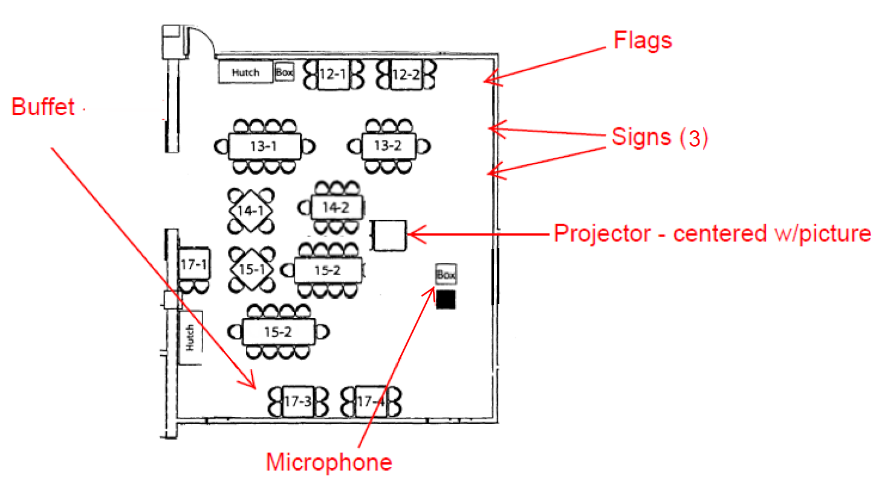

11:30 – 11:50 Room setup, President arrives, Sergeant-at-Arms arrives, presenters that require A/V setup might arrive.
11:50 – 12:05 Lunch is set out and membership starts arriving
12:05 – 12:30 Fellowship for members and a bit of time to eat before meeting starts
12:30 – 1:00 Meeting begins
Singing
Pledge of Allegiance
Thought for the Day
Introductions – visitors, visiting Rotarians, Rotarians with guests
Announcements
Fine session
1:00 – 1:25 Speaker or other program
1:25 – 1:30 Closing items
1:30 Meeting adjourned
ITEMS IN BLUE BOX

- Screen
- Projector in case
- Combination MIC/AUDIO cable (50’)
- Combination VGA/HDMI/USB/MAC (15’)
- Black extension cord
- Long projector cord
- Surge strip
- Floor mats to cover cables

SETUP NEEDED

- Cover picture with screen (careful it is WHITE)
- Set microphone level in office to NUMBER ____
- Set banquet room audio to auxiliary and turn up ALL THE WAY
- Setup room per drawing
- Run combination MIC/RCA cable from jack on wall to lectern – test microphone –

PLEASE RUN CABLING AGAINST WALL!

TEMPLATE 10: ANNUAL DUES STATEMENT

ANNUAL DUES STATEMENT

- Rotary Club of Redwood City - Dues 7/01/13 to 6/30/14 (Not deductible) $ 275.00

- Donation to Redwood City Rotary Charitable Foundation (Deductible) $______

- Donation to a scholarship fund (Deductible)

  - Redwood City Rotary Charitable Foundation - Scholarships $ 10.00
  - Redwood City Rotary Trust - Dooley Scholarship (Optional) $______
  - Redwood City Rotary Trust - Bostwick Scholarship (Optional) $______

- President’s Club – Prepay Weekly Fines (Deductible) $200 $______

- Rotary Int’l Foundation, your Paul Harris (Deductible) $______

Total Enclosed for Rotarian, $______
(Name)

Please make checks payable to Rotary Club of Redwood City and mail to:
Rotary Club of Redwood City, P.O. Box 2605, Redwood City, CA 94064 OR

Login as a member at our club’s website www.redwoodcityrotary.org and click on PAY DUES

- These are your dues for the 2013-2014. They are not tax deductible as a donation.
- This is a tax deductible donation to the Redwood City Rotary Charitable Foundation for funding Club activities through projects with Community, Youth, Vocational and International Avenues of Service.
- a) These funds go to the Redwood City Rotary Charitable Foundation and add to the overall scholarship resources of the Club and increase the scholarships the Club can grant annually. b) Donations to the Robert Dooley Scholarship Fund honor Bob Dooley’s thirty-five years of Rotary service. c) Donations to the Bostwick Scholarship Fund similarly increase the Club’s capacity to grant scholarships. This separate fund was started in 1997 to provide a way for individuals to honor Dr. Alan Bostwick, a member of our Club with more than 50 years of perfect attendance.
- Members may choose to prepay their weekly fines for the Rotary Year. These funds go directly to the Redwood City Rotary Charitable Foundation and are tax deductible. During weekly fine sessions, those who have prepaid simply say “I am a member of the President’s Club” and do not put money in the fine basket.
- Donations to The Rotary Foundation (TRF) are “unrestricted” and provide “matching grant” money to Clubs who sponsor programs that make a real difference in the lives of people around the world. Fifty (50) percent of this unrestricted money comes back to the District three years later. The other 50% is used by TRF as second tier matching grants to complete the funding of approved projects. Upon contributing donations totaling $1,000, a member becomes a Paul Harris Fellow.
- The Rotary Club of Redwood City has the expectation that members will sell or buy their packet of 30 tickets annually to help fund our charitable works. If you choose this option and then opt to not receive the tickets, it’s deductible.

TEMPLATE 11: MEMBERSHIP PROCESS

MEMBERSHIP PROCESS

- A prospective member is found by a sponsor. Sometimes the sponsor pulls the member completely through the membership process. Sometimes the sponsor turns over the contact information to someone on the membership committee. Either way works!

- Lunch #1, sponsor or membership person introduces the prospective member to the table. A few days later the sponsor or membership person should follow up to see if they are interested in coming back to another meeting.

- Lunch #2, sponsor or membership person introduces the prospective member to the table.

- Time for the ASK! Sponsor or membership person calls and speaks with prospective member a day or two after lunch to inquire about pursuing membership.

- If yes, the sponsor invites prospect to a Rotary introductory session. The sponsor should determine the date and time that the prospective member will be able to attend and ask the Membership Chair to arrange the meeting with 4-5 other Rotarians of varying lengths of service to assist.

- Lunch #3, sponsor or membership person introduces the prospective member to the table.

- Introductory Session called to order either before or after the third visit to the club. Purpose of introductory session is to set expectations of membership and discover classification. This is done through the use of the “Membership Information Guide” and the “Club Classification Listing”.

- Secretary takes over process

  - Application gets returned to secretary@redwoodcityrotary.org. Secretary emails application to board. Secretary adds vote on membership as agenda item for the board meeting.

  - If Board approves, then application goes to club for approval. If Board does not approve, secretary or sponsor notifies prospective member.

  - Secretary congratulates prospective member when 7 days has passed

    - Sets date for induction (based on making sure membership packet is complete)
    - Gives treasurer tentative induction date and asks for invoice to be sent to the secretary
    - Secretary emails invoice prospective member
    - Notifies mentor of new mentee and induction date
    - Notifies president of induction date
    - Membership packet put together with the following:
      - Letter signed by president
      - Certificate of Membership
      - Object of Rotary
      - ABC’S of Rotary booklet
      - The Four Way Test
      - Committee Selection form
      - Rotary Pin
      - Rotary Coin
      - Rotary Decal
      - Badge

  - Payment received, badge received and membership packet is ready

  - Member inducted with mentor and sponsor both involved in ceremony

    - Mentor’s job is to get them to meetings for the majority of at least the first eight weeks, get them out of their red badge, get them seated at different tables every week and get them on their committees.

- Training and education – this needs developed!

TEMPLATE 12: MEMBERSHIP APPLICATION

MEMBERSHIP APPLICATION

Organized in 1946, the Rotary Club of Redwood City is an active and well known service organization with deep ties to the Redwood City community. During the past 67 years, members of the Rotary Club of San Jose have volunteered and donated their time, effort, passion and money to improve the lives of those with which we share the world.

Rotary is an organization of more than 1.2 million members, spread across the world in more than 34,000 clubs. Our Club and its members have been dedicated to assisting others and improving our own character as part of our lives as Rotarians. We strive to find a more complete life through fellowship, service, goodwill and humanitarian efforts.

Approval Process – The Rotary Club of Redwood City seeks members of good character with a record of leadership and service to the community. The approval process will take 3-6 weeks after the application has been received.

Information to be completed by applicant – Personal

Name Date of Birth

Home Address

City Zip Code

Home Phone Spouse/Partner

Employment

Employer Years

Type of Organization

Address

City Zip Code Phone

Position/Title Years in Current Position

Communication Preferences

Preferred Mailing Address (circle one) Work Home

Preferred Phone Number (circle one) Work Home Cell

Preferred Email Address (required)
Please list three Community or professional references in addition to the applicant’s sponsors.

Organization Reference Name Reference Email Phone

1

2

3

Financial Requirements as of July 1, 2013 Credit Cards may be used

Due upon approval
Initiation Fee (one time) $100
Plus prorated annual membership (see below)

Annually
Basic Membership (all dues, meetings)………………… $275 (billed July 1st)
Lunches for 50 meetings…………………………………. $600 (billed Quarterly)

Redwood City Rotary Charitable Foundation…………. $125 (Raffle tickets or donation)
The Rotary Foundation donation ………………………. $200 (Set by District 5150 goal)

Event attendance and other Rotary activities are billed separately. A club member that would meet all financial expectations could expect to give $1,300-1,500 annually.

Applicant acknowledgment: I have read the Membership Application and the Membership Information Guide. I understand the financial requirements of membership and the Red Badge requirements.

Date

Information to be completed by the sponsoring Rotarian

Sponsoring Rotarian Phone

Co-Sponsor (not required) Phone

What is the applicant’s proposed Classification?

The applicant has attended two Redwood City Rotary meetings

The applicant has attended the Introductory Session

Previous Rotary Club Years

Comments

Sponsor acknowledgement: I have discussed the service and financial requirements of membership in the Rotary Club of Redwood City with the applicant.
Date
Please scan this application and email to secretary@redwoodcityrotary.org

TEMPLATE 13: CHECK REQUEST FORM

CHECK REQUEST FORM

Date:

Recap of Receipts: (please attach receipts)
Vendor Name Reason Amount

Total Amount Due:

Make Check Payable to:
Address:
City, St & Zip:

(Your Signature) (Print Your Name)

TEMPLATE 14: OPT-IN COMMUNICATION FORM

OPT-IN COMMUNICATION FORM

Member Name: ___________________________________________________ Date: _______________________
By signing this form, you have authorized your membership information that has been or may be shared with other members of the Rotary Club of Redwood City, to be used for commercial purposes by other Rotarians in Our Club. This information will not be retrievable in any way by the Rotary Club of Redwood City and the Club is not responsible in any way for its continued use once it is released.
Signature: ______________________________________________________________________________________

OPT-IN COMMUNICATION FORM

Member Name: ___________________________________________________ Date: _______________________
By signing this form, you have authorized your membership information that has been or may be shared with other members of the Rotary Club of Redwood City, to be used for commercial purposes by other Rotarians, or future non-Rotarians in the firm. This information will not be retrievable in any way by the Rotary Club of Redwood City and the Club is not responsible in any way for its continued use once it is released.
Signature: ______________________________________________________________________________________

OPT-IN COMMUNICATION FORM

Member Name: ___________________________________________________ Date:________________________
By signing this form, you have authorized your membership information that has been or may be shared with other members of the Rotary Club of Redwood City, to be used for commercial purposes by other Rotarians, or future non-Rotarians in the firm. This information will not be retrievable in any way by the Rotary Club of Redwood City and the Club is not responsible in any way for its continued use once it is released.

Signature: ______________________________________________________________________________________

TEMPLATE 15: LUNCH MENU

Welcome

To the

Rotary Club of Redwood City

Lunch (Full) $15.00

Fellowship $ 7.00

Raffle Ticket $ 1.00 ea

Wine Raffle $ 1.00 ea

ROTARY CLUB OF REDWOOD CITY

TEMPLATE 16: LUNCH ACCOUNTING SHEET
 |  |  |  |  |  |  |  | Date:
Checks |  |  |  |  |  |  |  |  |  | Amount
No. of Guest Lunch ________ and Fellowship________ included in Count below
Total No. Lunches ($15) |  |  |  |  |  |  | Total Checks
 |  |  |  |  |  |  | Polio Plus 2013-2014
 |  |  |  |  |  |  | Total Raffle
Total Fellowships ($7) |  |  |  |  |  |  | Total Fines
 |  |  |  |  |  |  | Total Lunch Cash
End Raffle #
Begin Raffle # |  | - |  |  |  |  | Total Revenue
Total Raffle =
100 | X | = |  | 100 | X | =
50 | X | = |  | 50 | X | =
20 | X | = |  | 20 | X | =
10 | X | = |  | 10 | X | =
5 | X | = |  | 5 | X | =
1 | X | = |  | 1 | X | =

TEMPLATE 17: INVITATION FOR FUNDING LETTER

April 23, 2014

Rotary Club of Redwood City
P.O. Box 2605
Redwood City, CA 94064

???
880 Runnymede Road
Woodside, CA 94062
???, Executive Director

Dear Redwood City Non-Profit:

The Rotary Club of Redwood City invites you to submit a funding proposal for our 201x-201x year. We have included a Grant Application Form for your use.

Past grants have been in the range of $500 to $1500. Multiple year funding will not be considered. Funds for operating expenses, Capital Campaigns, and Annual Support Campaigns will also not be considered.

All proposals must be received by Friday, December 30, 2011 for consideration of funding. Submitting organizations will be notified before February 15, 2012 as to who was selected.

The Redwood City Rotary Club would like to thank all our community’s non-profits for all their hard work on behalf of the citizens of Redwood City and look forward to helping as many organizations as we can.

All proposals should be sent certified mail to:

Rotary Club of Redwood City
Attn: Contributions Committee
PO Box 2605
Redwood City, CA 94064

Sincerely,

Rotary Club of Redwood City

TEMPLATE 18: GRANT APPLICATION FORM (Version #1)

GRANT APPLICATION FORM

Send Completed Forms to: Rotary Club of Redwood City
Attn: Contributions Committee
PO Box 2605
Redwood City, CA 94064

Applying Organization Name:

Address:

Contact Name:

Position in Organization:

Email Address and Phone:

Project Name:

Grant Amount Request:

Describe Project (use additional pages if needed)

Who will it serve? How will it benefit them?

Rotary Club of Redwood City Grant Application Page 2

When does it start?

Briefly summarize the organization’s history and purpose.

If this grant will not cover the full cost, what other funding will be secured?

Signature on behalf of organization:

Please enclose a copy of the organization’s IRS tax exempt letter.

TEMPLATE 19: GRANT APPLICATION FORM (Version #2)

GRANT APPLICATION FORM

Send Completed Forms to: Rotary Club of Redwood City
Attn: Contributions Committee
PO Box 2605
Redwood City, CA 94064
I. PROJECT INFORMATION
Project Name:
Sponsor (Club Member):
Project Description:
Project Date: Project Type:
Applying Organization Name:
Organization Address:
Contact Name:
Position: Phone #:
Date:
Grant Request:
“Hands-On” Project
(If both- please check both boxes.)
    - If “Hands-On”, how many volunteers needed? ________________
    - If “Hands-On”, what is the estimated $ cost for materials? _______

- GRANT REQUEST
Please fill out the following if you are requesting funding.
Project Name ____________________________________
Total Project Amount ___________________________________
Grant Amount Request _________________________________
Duration of Project: from_______________ to _____________

Rotary Club of Redwood City Grant Application Page 2
1. Describe Project
- Describe the program for which you seek funding, how the money will be used as part of the project, why you decided to pursue this project, and whether it is a new or ongoing part of your operating budget.
- What population will you serve and estimate how many it will benefit?
- Explain the significance of the project and why your organization is qualified to carry it out.
- How does this program enhance the existing services in the community, if applicable?
- What are the goals, objectives, and activities/strategies involved in this request?
- Outline the strategy/methodology you will use in the development and implementation of the program.
- What is your timeline for this project?
- Describe your plan for evaluating the success of the project. Include the anticipated date you will submit your final outcome report to Rotary.

2. When do you need a response to your request and when are the funds needed?

3. Describe your organization:
- What is your organization’s mission and what community problems, needs, or issues does your organization address?
- Describe the population and geographic area you serve.

Rotary Club of Redwood City Grant Application Page 3

4. Finances:
Please identify other funding sources that you have approached or may be approached for this program/project:
Funding Source Amount Status If pending, please indicate the decision date:

5. Publicity
Please identify how this project will be publicized as being sponsored by the Rotary Club of Redwood City.

Please enclose a copy of the organization’s IRS tax exempt letter.

- COMMITTEE REVIEW
Approved? ________________ Rejected? ______________
- If rejected, why?___________________________

Rotary Club of Redwood City Grant Application Page 4

- PROJECT SUMMARY (to be completed only if project is approved and by sponsoring Rotarian)
Date of Project: ___________________________________________
Project Captain: ___________________________________________
Funds Contributed:_____________________________________________
“Hands-On” Projects:
- · Volunteers: ___________________________________________________
- · No. of volunteer hours worked ____________________________________
- · Funds required to complete project _________________________________
- · Contributions from others: _____________________________________
- · Estimated funds for donated equipment/supplies _______________________
Project Summary :__________________________________________________________
__________________________________________________________________________
Completion Date: ___________________________________________________
Please attach all corresponding photos, notes, letters and receipts to report.

TEMPLATE 20: COMMUNITY FUNDING DECLINED LETTER

April 23, 2014

Rotary Club of Redwood City
P.O. Box 2605
Redwood City, CA 94064

???
880 Runnymede Road
Woodside, CA 94062
???, Executive Director

Dear Mr. ???:

The Redwood City Rotary Club would like to thank you for your ongoing commitment and service on behalf of the citizens of Redwood City. We have received your funding proposal for our 2009-2010 year.

Unfortunately, our funds are limited, and due to the vast number of requests that we received, we will be unable to contribute to your organization this year. However, we do look forward to helping as many organizations as we can in the future.

Sincerely,

xxxxxxxxx
Community Service Committee Chairman
Rotary Club of Redwood City
Phone (650) xxx-xxxx

TEMPLATE 21: COMMUNITY FUNDING ACCEPTED LETTER

April 23, 2014

Rotary Club of Redwood City
P.O. Box 2605
Redwood City, CA 94064

???
880 Runnymede Road
Woodside, CA 94062
???, Executive Director

Dear Mr. ???:

The Redwood City Rotary Club would like to thank you for your ongoing commitment and service on behalf of the citizens of Redwood City. We have received your funding proposal for our 2009-2010 year.

We are very pleased to let you know that we have chosen your organization as a recipient of a grant from the Redwood City Rotary Club this year. Unfortunately, due to the large number of requests that we received, we will be unable to contribute the full amount requested. However, we believe that your organization will be able to utilize the available grant of $____ in a way that will benefit many who are in need, and we look forward to being able to continue helping as many organizations as we can in the future.

Sincerely,

XXXXXXXXXXXXXXX
Community Service Committee Chairman
Rotary Club of Redwood City
Phone (650) xxx-xxxx

TEMPLATE 22: GRANT PROGRESS OR FINAL REPORT FORM

GRANT PROGRESS OR FINAL REPORT FORM

Organization Name:
Contact Name:
Phone:
Project Title:
Progress Report Final Report
Project Description
1. Briefly describe the project. What was done, when and where did project activities take place, and what individuals or organizations benefited?

2. How many Rotarians participated in the project? How many non- Rotarians participated?

3. What did they do? Please give at least two examples.

Rotary Club of Redwood City Grant Report Application Page 2
4. How many non-Rotarians benefited from this project?

5. What are the expected long-term community impacts of the project?

6. If a cooperating organization was involved, what was its role?

Financial Report
How was the financial funding used?

Please attach at least 4 photos of the project, any literature about the project, press release and any publicity from that the project received, i.e. newspaper clippings within 10 days of the completion of the project.

TEMPLATE 23: MEMBER PAST DUE PAYMENT LETTER

April 23, 2014

Rotary Club of Redwood City
P.O. Box 2605
Redwood City, CA 94064

Member Name
Mailing Address
City, CA 94062

Dear xxxx,

Enclosed please find your Quarterly meals invoice for the period to . This invoice also shows a past due balance of $ , bringing your total amount due to $ .

As this amount has been outstanding for a long time, we find there is no option but to suspend your membership in the Rotary Club of Redwood City for failure to fulfill your financial obligations. The club deeply regrets having to take this action, as we value your contribution to our group. Your membership will revert to active status upon receipt of all outstanding amounts due.

Payment should be mailed to the above address or delivered to me at any meeting. If you would like to discuss your situation, please feel free to call me at 650-xxx-xxxx.

Sincerely,

xxxxxxxxx
Club Treasurer

Cc: xxxxxxx, President

TEMPLATE 24: MEMBER REMINDER OF ATTENDANCE REQUIREMENT

April 23, 2014

REMINDER OF ATTENDANCE OBLIGATION OF MEMBERSHIP

Rotary is built upon fellowship and friendship. The strength of Rotary lies in the individual members. Each member brings a unique contribution of vocational and community experience to each meeting. Our Club is stronger because of your attendance and participation. Your attendance at our Club’s meeting is important.

It is understood that among busy people an occasional problem of attendance will arise. When a member misses a meeting, he or she is privileged to “make up” at another Rotary Club. There are Rotary Clubs in almost every community in the Bay Area and over 200 in Northern California. There are “locator” apps available for Android and Apple devices. This will allow you to easily find a nearby club. There are even online meetings that serve as make ups. The first and one of the best known is Rotary EClubOne at http://rotaryeclubone.org .

Needless to say, each make up affords the Rotarian a splendid opportunity to broaden his or her acquaintances, and to bring back to his or her Club, information or ideas that can improve his or her Club’s operations and programs.

If a member misses four (4) consecutive meetings without making up, they are automatically terminated unless given special exemption by the Board of Directors. Each member must have a minimum attendance record of 50% in a six month period. Members that are over the age of 65 AND have twenty years or more in Rotary are exempt. It is also possible to take two (2) separate six month leave of absences as a Rotarian and maintain your membership in good standing. A leave of absence takes a Board of Director vote and the Rotarian must be current with all financial obligations prior to a leave of absence being granted.

We value all our member of the Rotary Club of Redwood City and recognize that the majority of members have a great attendance record. With the effort of everyone, we hope to dramatically increase our attendance effort.

Please remember to submit your make up cards to our Club Secretary, John McAfee.

Sincerely,

Board of Directors
TEMPLATE 25: DONOR CAR RAFFLE ACKNOWLEDGEMENT LETTER

January 14, 2013

Redwood City Rotary Charitable Foundation
P.O. Box 2605
Redwood City, CA 94064

Donor Name
Address
City, State Zip

Attn: Contact Person
Position if known

Thank you for your contribution of $ on December 18, 2012 to the Redwood City Rotary 2013 Car Raffle. Your ongoing support benefits many charities in Redwood City and our immediate vicinity. Charities such as our own Redwood City Rotary Charitable Foundation, St. Anthony’s Padau Dining Room, Casa de Redwood, Sequoia YMCA, Family Connections and the many others on the list are incredibly grateful for the opportunity to sell these tickets and fund their incredible local programs.

This contribution is deductible as a charitable contribution for income tax purposes. The Redwood City Rotary Club Charitable Foundation is a 501c(3) non-profit corporation, E.I.N. 94-2682890. No goods or service were provided for this contribution.

Sincerely,

xxxxxxxxx
Club Treasurer

Cc: xxxxxxx, President

TEMPLATE 26: OFFICERS, DIRECTORS AND COMMITTEE INFORMATION

Officers, Directors and Committee Information
2013-2014

Officers, Directors and Major Committee Chairs …………………………………………………………………………….. Page 2

Service Project Committee Rosters …………………………………………………………………………………………………. Page 3

All other Committee Rosters ……………………………………………………………………………………………………………… Page 4

Susan Howell
President 2013-2014
Rotary Club of Redwood City

May 30, 2013

OFFICERS, DIRECTORS, COMMITTEES – ROTARY CLUB OF REDWOOD CITY 2013-2014
DISTRICT 5150
Contact Information

Officers Phone No Email
President: Susan Howell |  | president@redwoodcityrotary.org
Secretary: John McAfee |  | secretary@redwoodcityrotary.org
Treasurer: Carol Ebner |  | treasurer@redwoodcityrotary.org

Other Board Members Phone No Email
Past President: Lilia Ledezma
President Elect: Barbara Bonilla

Club Directors 6/30/2014 Term Phone No Email
Joseph Lucero
Karen Krueger
Carol Ebner
Roland Haga

Club Directors 6/30/2015 Term Phone No Email
John Lowe
Steve Wagstaffe
Carlos Bolanos
Deanna Dooley

Chairs of Major Committees

Service Projects Phone No Email
Community Service – Lilia Ledezma
International Service – Hal Butts
Youth Service – Fred Strathdee
Vocational Service – Jeff Hayden

Club Administration Phone No Email
President Elect: Barbara Bonilla

Public Relations Phone No Email

Membership Phone No Email
Joseph Lucero

The Rotary Foundation Phone No Email
John Lowe
COMMITTEE MEMBER LISTING
ROTARY CLUB OF REDWOOD CITY 2013-2014
DISTRICT 5150

COMMUNITY SERVICE – LILIA LEDEZMA, CHAIR INTERNATIONAL SERVICE – HAL BUTTS, CHAIR
Aaron Johnson
Barbara Bonilla
Bill Bergler
Bob Boland
Brad Shepherd
Carlos Bolanos
Deanna Dooley
Glenn Nielsen
Jim Newell
Judy Cooper Higday
Linda Schmidt
Mel Anisman
Rosanne Foust
Andres Espinoza
Bill Conklin
Bill Nicolet
Don Gibson
Don Hack
Jill Singleton
JR Gamez
Mike Giari
Rod Toews
Scott Schwartz
Tom Delfs

VOCATIONAL SERVICE – HAL BUTTS, CHAIR YOUTH SERVICE – FRED STRATHDEE, CHAIR
Alpio Barbara
Carol Ebner
Corrin Rankin
John McAfee
Karen Krueger
Roland Haga
Steve Wagstaffe
Barry Taleghani
Dan Mulholland
John Lowe
John Spicer
Joseph Lucero
Pete Liebengood
Steve Webb

SPORTS POOLS – Aaron Johnson, Barry Taleghani & Bob Boland
GSE TEAMS – Mel Anisman, Hal Butts & Don Hack
DISTRICT RAFFLE – Carol Ebner
GRANTS – Barbara Bonilla, Hal Butts, John Lowe, Susan Howell, Karen Krueger & Scott Schwartz
PUBLIC RELATIONS – ALPIO BARBARA, CHAIR THE ROTARY FOUNDATION – JOHN LOWE, CHAIR
FACEBOOK – Corrin Rankin
SPECTRUM –
TWITTER –
DISTRICT 5150 – Carol Ebner & Bill Conklin
OUR WEBSITE – Don Hack & Karen Krueger
THE DAILY JOURNAL – Steve Wagstaffe
THE PATCH – Joseph Lucero
ROTARY SHOWCASE – Hal Butts
SPOKE – Barbara Bonilla
WEBSITE CALENDAR – Jeff Hayden

COMMITTEE MEMBER LISTING
ROTARY CLUB OF REDWOOD CITY 2013-2014
DISTRICT 5150

MEMBERSHIP – JOSEPH LUCERO, CHAIR
Recruitment | Retention | Mentoring | Attendance | Recognition | Ongoing & New Member Training
Carlos Bolanos | Roland Haga | Bob Boland | Don Hack | Pete Liebengood | Deanna Dooley
Aaron Johnson | Karen Krueger | Hal Butts |  | Rod Toews | Glenn Nielsen
 | Carol Ebner |  |  |  | Rosanne Foust
 |  |  |  |  | Alpio Barbara
 |  |  |  |  | Roland Haga

CLUB ADMINISTRATION – BARBARA BONILLA (PRESIDENT-ELECT)
Programs | Finemasters | Thoughts | Greeters | Sergeants | Fellowship
Bill Nicolet | Steve Webb | Rosanne Foust | Glenn Nielsen | Don Hack
Carlos Bolanos | Alpio Barbara | Alpio Barbara | Aaron Johnson | Dan Mulholland | Roland Haga
Fred Strathdee | Barbara Bonilla | Barbara Bonilla | Andres Espinoza | Deanna Dooley | Bill Bergler
Judy Cooper | Barry Taleghani | Barry Taleghani | Bill Nicolet | Jeff Hayden
Lilia Ledezma | Bill Bergler | Bill Conklin | Bob Boland | Joseph Lucero
Linda Schmidt | Bill Conklin | Bill Nicolet | Brad Shepherd | Judy Cooper
Mike Giari | Bob Boland | Bob Boland | Corrin Rankin | Linda Schmidt
Pete Liebengood | Carlos Bolanos | Brad Shepherd | Dan Mulholland | Roland Haga
Rod Toews | Carol Ebner | Carlos Bolanos | Jeff Hayden | Scott Schwartz
Scott Schwartz | Corrin Rankin | Don Gibson | John Spicer
Steve Wagstaffe | Deanna Dooley | Fred Strathdee | Joseph Lucero
 | Don Gibson | Hal Butts | JR Gamez
 | Fred Strathdee | John Lowe | Karen Krueger
 | Glenn Nielsen | John McAfee | Scott Schwartz
 | Hal Butts | Karen Krueger | Steve Wagstaffe
 | John Lowe | Lilia Ledezma | Steve Webb
 | John McAfee | Mel Anisman
 | Joseph Lucero | Mike Giari
 | Judy Cooper | Pete Liebengood
 | Karen Krueger | Rod Toews
 | Lilia Ledezma | Steve Wagstaffe
 | Linda Schmidt
 | Mike Giari
 | Pete Liebengood
 | Roland Haga
 | Rosanne Foust
 | Steve Wagstaffe

FUNDRAISING – BILL NICOLET, CHAIR SCHOLARSHIPS – KAREN KRUEGER, CHAIR

TEMPLATE 27: THE YEAR AT A GLANCE

Weeks | Finemaster | Sergeant-at-Arms | Greeters | Thought of the Day | Programs
 | STEVE WEBB | DON HACK | GLENN NIELSEN | ROSANNE FOUST | BILL NICOLET
2-Jul-13 | Lucero, Joseph | Schmidt, Linda | Nielsen, Glenn | Mulholland, Dan | President's address
9-Jul-13 | Giari, Mike | Cooper, Judy | Butts, Hal | Toews, Rod | America's Cup
16-Jul-13 | Liebengood, Pete | Haga, Roland | Gamez, JR | Butts, Hal | Breakouts
23-Jul-13 | Dooley, Deanna | Schwartz, Scott | Johnson, Aaron | Strathdee, Fred | Raffle Winners
30-Jul-13 | Taleghani, Barry | Hack, Don | Krueger, Karen | Foust, Rosanne | DG Visit & address
6-Aug-13 | Butts, Hal | Mulholland, Dan | Schwartz, Scott | Krueger, Karen | Cooper, Judy
13-Aug-13 | Rankin, Corrin | Hayden, Jeff | Lucero, Joseph | Ledezma, Lilia | Los Altos Rotary CAP
20-Aug-13 | McAfee, John | Lucero, Joseph | Lianides, Jim | Liebengood, Pete | Bolanos, Carlos
27-Aug-13 | Barbara, Alpio | Dooley, Deanna | Wagstaffe, Steve | Singleton, Jill | Ledezma, Lilia
3-Sep-13 | Gibson, Don | Cooper, Judy | Boland, Bob | Strathdee, Fred | Liebengood, Pete
10-Sep-13 | Ledezma, Lilia | Schmidt, Linda | Rankin, Corrin | Taleghani, Barry | Lilia Ledezma
17-Sep-13 | Nielsen, Glenn | Haga, Roland | Spicer, John | Cooper, Judy | Breakouts
24-Sep-13 | Ebner, Carol | Espinoza, Andres | Wagstaffe, Steve | Gibson, Don | Schwartz, Scott
1-Oct-13 | Wagstaffe, Steve | Hack, Don | Webb, Steve | Giari, Mike | Howell, Susan
8-Oct-13 | Foust, Rosanne | Mulholland, Dan | Bolanos, Carlos | Lowe, John | Wagstaffe, Steve
15-Oct-13 | Strathdee, Fred | Hayden, Jeff | Rankin, Corrin | Barbara, Alpio | Howell, Susan
22-Oct-13 | OPEN | Lucero, Joseph | Gamez, JR | Spicer, John | Howell, Susan
29-Oct-13 | Haga, Roland | Dooley, Deanna | Johnson, Aaron | Anisman, Mel | Giari, Mike
5-Nov-13 | Conklin, Bill | Cooper, Judy | OPEN | Boland, Bob | Liebengood, Pete
12-Nov-13 | Bonilla, Barbara | Schmidt, Linda | Espinoza, Andres | Bolanos, Carlos | Toews, Rod
19-Nov-13 | Bolanos, Carlos | Haga, Roland | Lucero, Joseph | Bonilla, Barbara | Breakouts
26-Nov-13 | Foust, Rosanne | Schwartz, Scott | Harris, Amber | Wagstaffe, Steve | Cooper, Judy
3-Dec-13 | Boland, Bob | Hack, Don | Liebengood, Pete | Toews, Rod | IceBreakers
10-Dec-13 | Krueger, Karen | Mulholland, Dan | Shepherd, Brad | McAfee, John | Schmidt, Linda
17-Dec-13 | Webb, Steve | Hayden, Jeff | Rankin, Corrin | Nicolet, Bill | Holiday Party
24-Dec-13 | Dark | Dark | Dark | Dark | Dark
31-Dec-13 | Dark | Dark | Dark | Dark | Dark
7-Jan-14 | Schmidt, Linda | Cooper, Judy | Webb, Steve | Foust, Rosanne | Club Assembly
14-Jan-14 | Ebner, Carol | Schmidt, Linda | Nielsen, Glenn | Krueger, Karen | Ledezma, Lilia
21-Jan-14 | Cooper, Judy | Haga, Roland | Schmidt, Linda | Ledezma, Lilia | Breakouts
28-Jan-14 | Taleghani, Barry | Espinoza, Andres | Gamez, JR | Liebengood, Pete | Schwartz, Scott
4-Feb-14 | Lucero, Joseph | Hack, Don | Johnson, Aaron | OPEN | Bolanos, Carlos
11-Feb-14 | Giari, Mike | Mulholland, Dan | Espinoza, Andres | Toews, Rod | Strathdee, Fred
18-Feb-14 | Dooley, Deanna | Hayden, Jeff | Shepherd, Brad | Taleghani, Barry | Howell, Susan
25-Feb-14 | Liebengood, Pete | Lucero, Joseph | Nielsen, Glenn | Cooper, Judy | Giari, Mike
4-Mar-14 | Lowe, John | Dooley, Deanna | Harris, Amber | Gibson, Don | Toews, Rod
11-Mar-14 | Butts, Hal | Cooper, Judy | Wagstaffe, Steve | Giari, Mike | Wagstaffe, Steve
18-Mar-14 | Rankin, Corrin | Schmidt, Linda | Nicolet, Bill | Lowe, John | Breakouts
25-Mar-14 | McAfee, John | Haga, Roland | Rankin, Corrin | Barbara, Alpio | OPEN
1-Apr-14 | Gibson, Don | Schwartz, Scott | Spicer, John | Boland, Bob | Cooper, Judy
8-Apr-14 | Ledezma, Lilia | Hack, Don | Wagstaffe, Steve | Anisman, Mel | Icebreakers
15-Apr-14 | Nielsen, Glenn | Mulholland, Dan | Webb, Steve | Spicer, John | Strathdee, Fred
22-Apr-14 | Ebner, Carol | Hayden, Jeff | Strathdee, Fred | Bolanos, Carlos | Howell, Susan
29-Apr-14 | Haga, Roland | Lucero, Joseph | Lowe, John | Bonilla, Barbara | Howell, Susan)
6-May-14 | Strathdee, Fred | Dooley, Deanna | Gamez, JR | Toews, Rod | Bolanos, Carlos
13-May-14 | Wagstaffe, Steve | Cooper, Judy | Johnson, Aaron | Shepherd, Brad | Breakouts
20-May-14 | Bolanos, Carlos | Schmidt, Linda | Hayden, Jeff | Anisman, Mel | Scholarships
27-May-14 | Conklin, Bill | Haga, Roland | Espinoza, Andres | Cooper, Judy | Ledezma, Lilia
3-Jun-14 | Bergler, Bill | Schwartz, Scott | Lucero, Joseph | Foust, Rosanne | Liebengood, Pete
10-Jun-14 | Bonilla, Barbara | Hack, Don | Lianides, Jim | Toews, Rod | Giari, Mike
17-Jun-14 | Foust, Rosanne | Mulholland, Dan | Shepherd, Brad | Butts, Hal | Wagstaffe, Steve
24-Jun-14 | Webb, Steve | Hayden, Jeff | Mulholland, Dan | Strathdee, Fred | Debunking

It is possible to cut and paste this template back into Excel. Then take a second to fix the columns so that the template is 1) more friendly 2) more usable 3) more printable.

MEMBERSHIP INFORMATION GUIDE
ROTARY IS LOCAL AND WORLDWIDE

The aim of the Rotary Club of Redwood City is three-fold; fellowship, business networking and helping others. Through these efforts we are living up to our motto, “Service Above Self”. Our efforts to help are geared to our local community, as well as to projects around the World. Each member determines how much time and support can be given to such projects. Five main “Avenues of Service” allow members to channel their efforts according to their particular interests.

The primary content of our weekly meeting is a speaker program. Every effort is made to make these timely, informative and relevant to our area and the world at large.

Membership does imply a commitment to attend the Redwood City weekly meeting or make-up at another club. Another essential part of membership is the undertaking to adhere to high ethical standards as set out in the “Four Way Test”.

Our Club was chartered on April 22nd, 1946 and meets each Tuesday from 12:15 pm to 1:30 pm. We have an up-to-date, online calendar which will let you know where the meeting will be held and what will be the subject of the meeting each week. Check out www.redwoodcityrotary.org/calendar for the latest information.

Each member receives The Rotarian magazine on a monthly basis. This official publication of Rotary International features humanitarian projects that different clubs undertake around the world.

There are approximately 34,000 clubs and 1.2 million members around the World. Members, when traveling, are welcome at local clubs. Be sure to download the “Club Locator” app for your phone or tablet (just go to www.rotary.org). Visiting other Clubs is a great opportunity to meet like-minded individuals from many cultures and is an excellent source of local business contacts.

All Rotary clubs operate on the same fiscal year and a new President is installed annually at each of the 34,000 clubs around the world. This change extends up to the highest levels of Rotary International and reflects the international composition of Rotary. Recent presidents have come from Sweden, Nigeria, Thailand, Italy, Mexico and the United States of America.

A BRIEF HISTORY OF ROTARY

The original Rotary Club was organized in Chicago, Illinois by Paul P. Harris, a lawyer. The first meeting was held on February 23rd, 1905.

The name “Rotary” was chosen because they met in rotation at each member’s place of business.

From that beginning, the Rotary ideals of fellowship, networking and service to others spread to six continents. The second Rotary club that formed is often referred to “Number 2 Club” and it is just right up the road in San Francisco.

Rotary is a service organization of business and professional people united worldwide who conduct humanitarian projects, encourage high ethical standards in all vocations and strive for world understanding and peace.

Rotary now has over 1.2 million service minded men and women belonging to over 34.000 Rotary Clubs in over 200 countries. Rotary exists in almost every geographical location through the world. Also, these individual Rotary Clubs sponsor Interact (ages 12-18) and Rotaract (ages 18-30) clubs for the younger individuals who are interested in the same fellowship and volunteer objectives.

HOW DOES ONE BECOME A MEMBER OF A ROTARY CLUB?

Membership is by invitation. Members are generally chosen to represent their respective businesses or professions. The “Classification Principle” is a flexible guideline intended to insure that our membership includes a qualified representative from many worthy business or profession in our community. In this way, our Club becomes a cross-section of our community. The Club hopes that members will be as diverse as the community in Redwood City.

WHAT ARE THE GUIDING PRINCIPLES OF ROTARY?

These principles have been developed over the years to provide Rotarians with a strong, common purpose and direction. They serve as a foundation for our relationships with each other and the action we take in the world.

THE FOUR-WAY TEST

The Four-Way Test is a nonpartisan and nonsectarian ethical guide for Rotarians to use for their personal and professional relationships. The test has been translated into more than 100 languages, and Rotarians recite it at club meetings:

Of the things we think, say, or do:

- First, is it the TRUTH?
- Second, is it FAIR to all concerned?
- Third, will it build GOOD WILL and BETTER FRIENDSHIPS?
- Fourth, will it be BENEFICIAL to all concerned?

AVENUES OF SERVICE
We channel our commitment to service at home and abroad through five Avenues of Service, which are the foundation of club activity.
- Club Service focuses on making clubs strong. A thriving club is anchored by strong relationships and an active membership development plan.
- Vocational Service calls on every Rotarian to work with integrity and contribute their expertise to the problems and needs of society.
- Community Service encourages every Rotarian to find ways to improve the quality of life for people in their communities and to serve the public interest.
- International Service exemplifies our global reach in promoting peace and understanding. We support this service avenue by sponsoring or volunteering on international projects, seeking partners abroad, and more.
- Youth Service recognizes the importance of empowering youth and young professionals through leadership development programs such as Rotaract, Interact, Rotary Youth Leadership Awards and Rotary Youth Exchange.

THE OBJECT OF ROTARY
The Object of Rotary is to encourage and foster the ideal of service as a basis of worthy enterprise and, in particular, to encourage and foster:
- FIRST: The development of acquaintance as an opportunity for service;
- SECOND: High ethical standards in business and professions; the recognition of the worthiness of all useful occupations; and the dignifying of each Rotarian’s occupation as an opportunity to serve society;
- THIRD: The application of the ideal of service in each Rotarian’s personal, business, and community life;
- FOURTH: The advancement of international understanding, goodwill, and peace through a world fellowship of business and professional persons united in the ideal of service.

THE ROTARIAN AND “SERVICE”

A Rotarian is a person who looks beyond their own needs or wants to connect to the community, the nation and the world. A Rotarian seeks the truth; lets fairness govern relationships; strives to benefit all in every inter-personal and business relationship. In short, he or she lives the Rotary pledge:

“Service Above Self”

The emphasis of Rotary is to create within the individual the SPIRIT OF SERVICE and PARTICIPATION within a humorous and supportive Club. Members are encouraged and supported in their volunteer activities in community, youth and public service areas. It is the sum of individual member’s efforts that determine the success of the Club as a whole.

Our Club undertakes a wide variety of service activities through different Avenues of Service — Community, Youth, Vocational, and World Community Service; to help those less fortunate and for the promotion of goodwill and better understanding throughout the World.

HOW IS ROTARY FUNDED?

Our Club’s operations are funded by annual dues. A separate 501(c)(3): the Redwood City Rotary Charitable Foundation is the conduit for funding many projects. Our Rotary Charitable Foundation is funded by weekly “recognition” fines and the annual major fundraiser: currently a car raffle that is promoted by and directly benefits many local charities as well as the Club’s Foundation.

Various past Club members have made significant donations to establish separate Scholarship Funds in their name and administered by Club Trustees. Each year, the Club’s Scholarship Committee interviews and awards about $12,000-$16,000 to eight local high school graduates intent upon continuing their education with two or four year colleges.

Rotary Headquarters in Evanston, Illinois also operates through two entities: Rotary International (RI) for world-wide operations and The Rotary Foundation (TRF). The latter is a separate charitable foundation funded primarily by the voluntary contributions of Rotarians all over the world. It is from these contributions that the Rotary Foundation provides many other very worthwhile programs worldwide. Donors are recognized as Paul Harris Fellows and further levels of recognition. Our Club also has several sports related “Pools” each year that help generate funds for TRF. You will be contacted by our Club’s TRF Chairperson to explain the importance of giving to the Foundation and becoming a Paul Harris Fellow.

WHAT IS EXPECTED OF A MEMBER?

Rotary is built upon fellowship and friendship. We have found that the strength and effectiveness of Rotary lies in its individual members. Each member brings a unique contribution of experience to each meeting. Our Club will be stronger because of each member’s attendance and participation. Attendance at the Club’s weekly meeting or occasional making-up at another club is important for the vitality of the Club as a whole.

It is understood that among busy people an occasional problem of attendance will arise. When a member misses a meeting, he or she is encouraged to “make-up” at another Rotary Club locally or almost anywhere in the World. There are Rotary Clubs in almost every community in the Bay Area and over 200 in Northern California. When traveling out of the area consult “Club Locator” in the Rotary International web site: www.rotary.org. A make-up that occurs within two weeks of a missed meeting is accepted in lieu.

It is fair to say, each make-up affords the Rotarian a splendid opportunity to broaden his or her acquaintances, and to bring back to our Club information or ideas that can invigorate the Club’s operations and programs.

A 50% or better attendance record overall is necessary to remain a member in good standing.

WHAT ARE THE COMMITTEES IN THE CLUB?

There are five main committees in most Rotary clubs. Each of these committees offer a myriad of rich opportunities for service. We hope that each member chooses to serve on one or more of the main committees: Club Administration, Membership, The Rotary Foundation, Public Relations or Service Projects and get involved!

- Club Administration committees assist in keeping the club functioning at a high level. Whether it is service as a greeter, fine master or club treasurer, club administration offers members the ability to keep the meeting moving along. Volunteering on the program committee can bring your own passions to the members through interesting, compelling speakers.

- Rotarians on the Membership Committee attempt to encourage members to bring in prospective members, initiate programs that will welcome, educate and mentor new members, and all the while, maintaining a high retention rate among current members.

- The Rotary Foundation is the lifeblood of Rotary service. It is through the efforts of The Rotary Foundation that Rotary has come within 0.01 percent of ridding the planet of polio. It is through the efforts of The Rotary Foundation that projects around the world are funded by grants, conflict resolution centers are built, or Group Study Exchange and Vocational Training Teams are funded. One-half of the funds donated by a Rotarian this year come back to their district three years hence to assist that district in projects.

- Public Relations is about building the relationship we have with our community and the world. There is no reason that Rotary should be a best kept secret and yet it is in many communities. It is only by ‘tooting our own horn’ that we attract new members and continue to do good works and grow. Members in the Public Relations realm of club service assist with the website, submit stories to the local press, the district newsletter or perhaps post stories to Rotary Showcase. Service may merely be as easy as taking photos or keeping FaceBook, Twitter or Google+ interesting to others.

- Four service project committees round out the remaining opportunities for service in Our Club. Service project committees comprise four of the five “Avenues of Service” in Rotary. A good overview of the scope of the activities performed at the Rotary Club of Redwood City is available on our website or by looking through our FaceBook feed. The four committees – Community, World Community, Vocational and Youth Service meet at least every eight (8) weeks during the regular weekly meeting time.
WHAT HAPPENS AS A NEW MEMBER?

Rotarians are expected to give of their time and talents to carry out projects or assignments developed by the committees and endorsed by Club officers. If your sponsor is the membership chairperson or has a relatively short amount of time in Rotary, then we will work to assign a mentor to help you to get acclimated to the club. New members sport a ‘red badge’ or sticker until the items listed below are completed.

During the first few months each new member is asked to do the following:
- Wear your member badge and Rotary pin. Get in the habit!
- Deliver a five (5) minute “Icebreaker” to the club. This can be a personal report about yourself, your family, your work, or even a hobby. The idea is to let the members get to know you better.
- Attend a meeting of the Board of Directors. Consult the online website calendar for the next meeting time and place. These are also usually announced at the Tuesday meeting during the same week.
- Stand at the front door and be a “Greeter” for two (2) meetings. This lets everyone get to know you.
- Attend a meeting at another club. There is a “Club Locator” app that may be downloaded from Google Play, the iTunes Store or Rotary.org.
- Bring a prospective member as a guest to a meeting.
- Join one of the service project committees and two of the other committees.

When you have completed these steps, you will be considered a member in good standing and your “New Member” sticker will be removed from your badge. Each new member should look to their mentor or sponsor to guide them through the process of getting to know more about the Club and its activities.

WHAT ARE THE EXPECTATIONS FINANCIALLY?

- Payment of a onetime initiation fee which provides for the Rotary lapel pin and Rotary informational material.

- Annual dues to our club which covers per member dues payable to Rotary International, District 5150, and includes the cost of a subscription to The Rotarian, the monthly Rotary Magazine.

- Participation in our annual fundraiser through the member’s purchase (or sale) of twenty-five (25) car raffle tickets marked to benefit the Redwood City Rotary Charitable Foundation.

- Attendance at the annual debunking festivities in June.

- Attendance at the annual holiday party in December.

- Timely payment of the quarterly lunch invoices when emailed. A make-up credit of $12.50 is given in the following quarter for each time a member pays for lunch at another Rotary Club and submits a “make-up” card.

- Weekly fining sessions are a humorous device employed at meetings to provide members with recognition of their achievements and for contributions of service to the Club. Fines are usually $5.00. Members may prepay their fines by joining the President’s Club at the invoiced amount. This also will serve as proof of their tax deductible donation.

- Meet the club’s goals that have been submitted to District 5150 and Rotary International goals of giving to The Rotary Foundation.

- Become a Paul Harris Fellow within five years of joining.
WHAT ARE SOME OF THE BENEFITS OF MEMBERSHIP?

- Broaden the circle of friends and acquaintances.

- Be “in touch” with the mainstream of community life and the people who make it “tick”. Speakers of interest are a regular part of the weekly program.

- Obtain increased knowledge of other businesses and professions and gain a sympathetic understanding of the problems and successes of others.

- Opportunity to seek advice from others in different fields.

- Develop talents and capacities in leadership roles.

- Gain recognition for their business or profession by participating in an organization dedicated to vocational, community and world community service projects, dedicated to helping others, increased goodwill and international understanding.

- Develop ways to express in a practical way the desire to make significant contribution to society.

- Broaden the social contacts for self and spouse or your significant other.

- Find new outlets for his or her goods and services because of the relationships developed.

- Share hobbies and other interests. There are numerous Rotary Fellowships for skiing, sailing, stamps, flying to name but a few.

- Increase knowledge of world affairs and a keener appreciation of the customs and character of other peoples.

- Expect a friendly contact and warm Rotary welcome in cities, large or small, almost anywhere in the world.

WHAT ARE THE NEXT STEPS?

Those interested in being considered for membership should inform their sponsor and they will be emailed an application. Your completed application should be sent to secretary@redwoodcityrotary.org.

The approval process takes 3-6 weeks after the application has been received.

Thank you,
Membership Chairperson

APPENDIX A: ETIQUETTE and EXPECTATIONS

ATTENDANCE:
You will get out of it what you put into it! Regular attendance at Rotary meetings is expected. Plan to attend meetings and functions to enjoy our fellowship and service opportunities. Make-ups at Board meetings and other clubs count toward your attendance record and enhance your Rotary experience. Participation at Rotary sponsored events also count.

YOUR PIN:
Wearing your pin or a garment with the Rotary logo will identify you as a member and promote Rotary in our community.

FIRST NAME BASIS:
Rotary is a first name organization. Each of us has a “badge name” by which we prefer to be known. When addressing a member who is chairing a meeting, it is appropriate to recognize “President Susan or President John”, rather than “Madam or Mister President”.

HOSPITALITY:
Make an effort to greet fellow members and guests. Our guest speaker usually is seated at table nearest the President’s podium. Please take a seat at that table until all places are filled.

Make an effort to sit at a different table each week. It’s a great opportunity to get acquainted with all club members over time.

UNDER YOUR WING:
Make an effort to get acquainted with new members. Invite them to sit with you during our luncheon and encourage them to work alongside you in our service activities.

FINE MASTER SESSIONS:
It is appropriate for the person called upon during the fining session to stand while addressing the Fine Master for the Day.

MEMBER-TO-MEMBER COMMUNICATIONS:
It is appropriate to use a variety of communications to inform club members about club activities. Promoting one’s business to club members is discouraged. It is appropriate only to include club members who have requested such information. Member contact information should not be shared with non-Rotarians without the member’s permission.

THE CRYPTIC MEANING BEHIND ‘GUEST’ INTRODUCTIONS

During the introduction phase of the meeting, the president will ask about visitors in a specific way.

Are there any Visiting Rotarians? These are Rotarians visiting us from other clubs. They may introduce themselves in the ‘standard’ Rotary format or another club member may introduce them. When visiting Rotarians are introduced, they are welcomed with a collective “Hi, (first name) such as “Hi Bill” or “Hi Alice”.

Are there any Guests of the Club? These are the code words that say this person is interested in being a member. They are a guest and it is not appropriate to identify a guest as a “prospective member”. Guests are welcomed by applause.

Are there any Rotarians with Guests? This category allows for the introduction of anyone that has not previously been introduced. Generally this is partners, children, friends, or others that are not interested in Rotary membership. This may also cover those individuals that have come to our meeting merely to give an announcement.

Guest Introduction Etiquette and Policy

Our Rotary Club often hosts many guests and visitors at our luncheons. In the interests of time, and protecting our members from being captive to extensive marketing or campaigning by our guests, it is important to follow the guest introduction process below.

Guest Introduction Process
- Please state the Guest’s Name and Business
- Please state any community organizations or affiliations the guest has
- If they are a candidate for office you may mention that.
- A candidate for office may not address the Rotary Club in any form, including Rotarymercials
- Do not give the microphone to the guest at any time. If a guest wishes to address the club they should seek the approval of the sergeant-at-arms in advance for the Rotarymercial segment. We will not be a captive audience to promotions of any kind, and the sergeant shall be the gatekeeper and decision maker for these types of announcements.
- Do not mention the number of times a guest has visited or that they are in process of becoming a Rotarian. You may say that they are “visiting again”. A person may not always be approved for membership and this could be potentially embarrassing for them. If a person has been approved and is being inducted at that meeting, you may mention that
Guests
Except for business meetings, which are usually held on the first Thursday in each month, or club assemblies or club forums, guests of members and visiting Rotarians are always welcome at club meetings.
Rotarians seated with the guest at table are expected to introduce themselves to the guest and make the guest feel welcome. A Rotarian at the table should be ready to introduce anyone that is visiting the club and seated at their table.

ROTARY CODE OF ETHICS FOR BUSINESS PEOPLE
My business standards shall have in them a note of sympathy for our common humanity. My business dealings, ambitions and relations, shall always cause me to take into consideration my highest duties as a member of society. In every position in business life, in every responsibility that comes before me, my chief thought shall be to fill that responsibility and discharge that duty so when I have ended each of them, I shall have lifted the level of human ideals and achievements a little higher than I found them. In view of them, it is my duty as a Rotarian,
FIRST: To consider my vocation worthy, and as affording me distinct opportunity to serve society.
SECOND: To improve myself, increase my efficiency and enlarge my service, and by so doing attest my faith in the fundamental principle of Rotary, that he profits most who serves best.
THIRD: To realize that I am a businessperson and ambitious to succeed; but that I am first an ethical person, and wish no success that is not founded on the highest justice and morality.
FOURTH: To hold that the exchange of my goods, my service, and my ideas for profit is legitimate and ethical, provided that all parties in the exchange are benefited thereby.
FIFTH: To use my best endeavors to elevate the standards of the vocation in which I am engaged, and so to conduct my affairs that others in my vocation may find it wise, profitable, and conducive to happiness to emulate my example.
SIXTH: To conduct my business in such a manner that I may give a perfect service equal to or even better than my competitor, and when in doubt to give added service beyond the strict measure of debt or obligation.
SEVENTH: To understand that one of the greatest assets of a professional or of a businessman is his friend and that any advantage gained by reason of friendship is eminently ethical and proper.
EIGHTH: To hold that true friends demand nothing of one another and that any abuse of the confidences of friendship for profit is foreign to the spirit of Rotary, and in violation of its Code of Ethics.
NINTH: To consider no personal success legitimate or ethical which is secured by taking unfair advantage of certain opportunities in the social order that are absolutely denied others, nor will I take advantage of opportunities to achieve material success that others will not take because of the questionable morality involved.
TENTH: To be not more obligated to a Brother Rotarian than I am to every other man in human society; because the genius of Rotary is not in its completion, but in its cooperation; for provincialism can never have a place in an institution like Rotary, and Rotarians assert that Human Rights are not confined to Rotary Clubs, but are as deep and as broad as the race itself; and for these high purpose does Rotary exist to educate all men and all institutions.
ELEVENTH: Finally, believing in the universality of the Golden Rule, all things whatsoever ye would that men should do unto you, do ye even so unto them, we contend that Society best holds together when equal opportunity is accorded all men in the natural resources of this planet.
NOTE: Adopted by the Sixth Annual Convention of the International Association of Rotary Clubs in San Francisco, July 19-23, 1915.

