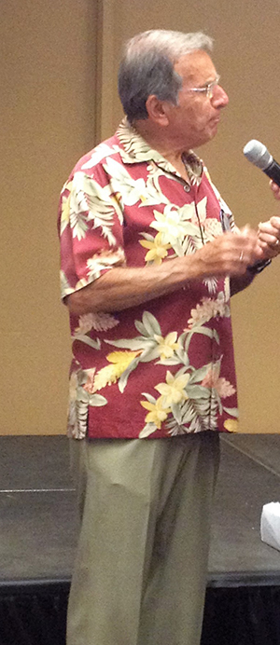

The Rotary Club of Rancho Cotati invites you to join us in President Len Geraldi's debunking. Dinner is at Sally Tomatoes with a No Host Bar. The Cost is $45, which includes one drink ticket. You have a choice for your dinner entree´, Chicken Cacciatore or Eggplant Parmesan. Cocktails and appetizers at 5:30 p.m. and dinner at 6:30 p.m.

