Delta Rotary and ShelterBox USA
2019 Good Earth Home Show

Training Guide for New Volunteers

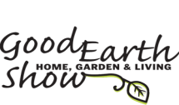

January 2019

This document contains confidential and personal contact information and is the property of Eugene Delta Rotary.
The contents are intended to be used only by Eugene Delta Rotary Board members or their assigned agents. Distribution of the contents requires prior Board approval.

Table of Contents
Page
Purpose of this Document 3
Acknowledgements 3
Rotary International and ShelterBox Partnership 3
ShelterBox USA 3
What’s in the “Box” 4
In-country Partnering 5
Accreditations 7
Financial Performance Metrics 7
Nobel Prize Nomination 8
Local Advertising Strategy to be based off the 2018 Experience 8
Interacting with the Public 8
Business Sponsor 9
Home Show Donations 2015 to 2018 9
Delta Rotary Volunteers 9
Accepting Donations 10

Appendix
2019 Delta Rotary ShelterBox Team 11
Questions and Answers 12
Talking Points 13
Case Studies 14
Home Show Sign Up Form 15

Purpose of the Document
This training guide is designed to equip Delta Rotary members who volunteer for the first time at the Eugene Oregon “Good Earth Home Show.
Acknowledgements
A special thanks goes to ShelterBox USA staff for the assistance provided in developing this document. Specifically, special recognition goes to Sharee Sheets, Volunteer and Partnerships Manager, and Bill Woodward, who is a ShelterBox USA Board Member.

Rotary International and ShelterBox Partnership
In 2012 ShelterBox became Rotary International’s first global project partner and remains its only disaster relief charity. This agreement allows both organizations to collaborate in offering a tailored response to a variety of serious global disasters.

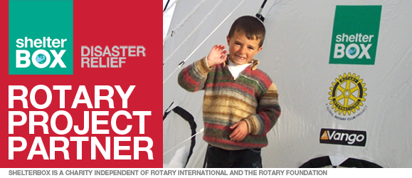

In 2012, Eugene Delta Rotary Club committed to support Rotary International’s relationship with ShelterBox USA by establishing an annual fund raiser to reach the greater Eugene, Oregon community. Over $105,000 has been collected over for ShelterBox USA in the last five years.

The Delta Rotary Board continues to view the best approach to solicit donations from the community is through the annual Good Earth Home held annually at the centrally located Lane County Fair Grounds. This show draws approximately 20,000 to 25,000 people over a three-day weekend period in mid-January.

ShelterBox USA
What ShelterBox Believes: “Shelter is a human right.” Making it available in the after math of chaos of disaster and conflict is vital to basic human existence. When people are plunged into crisis, normality is suspended. But good, quality shelter can cut through the chaos. This is why ShelterBox provides the tools which enable people to rebuild homes and their lives.

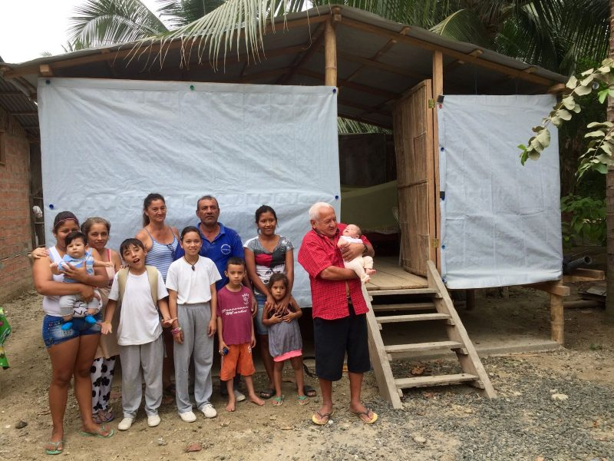
Meeting Unique Needs: The operational teams know from experience that one-size does not fit all crises. The in-country teams work hard to understand the short and long-term impact of each emergency and the need this creates within individual communities.

A Brief History: ShelterBox was founded in 2000 through the efforts of a Rotary Club in Cornwall, England who made ShelterBox their millennial project. This kicked off an outpouring of interest and support from Rotary clubs in many countries. Today, ShelterBox staff and volunteers have assisted more than 1.3 million people in nearly 100 countries. Little did the founders know that today ShelterBox has become the largest Rotary Club project in the world.

Ambassadors: These volunteers are the face of ShelterBox in their local communities. They meet with service clubs, religious, professional, and youth groups, and introduce audiences to ShelterBox. Ambassadors make 12 local presentations annually and frequently join response rescue teams at disaster sites. Greg Vic and Kieran Walsh are Delta Rotary members and ShelterBox Ambassadors. Bill Woodard is a Delta Rotary honorary member, an Ambassador, and a ShelterBox USA governing Board member.

What’s in the Box?
Many aid workers, the press, and local political leaders recognize the large green “ShelterBox” as a life-building resource. The sturdy green ShelterBoxes contain family-sized tents specifically designed to withstand the elements and provide people with temporary shelter until they are able to start the process of rebuilding a home. The types and quantities of supplies packed in a ShelterBox depend on the level of disaster, climate, partner participation and other variables.
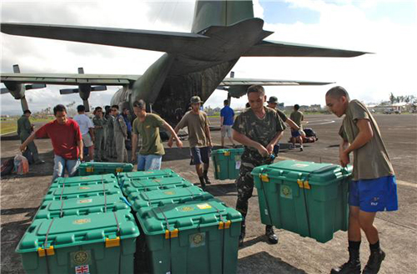
Fully packed, a box generally weighs around 110 lbs. Each box contains the following:
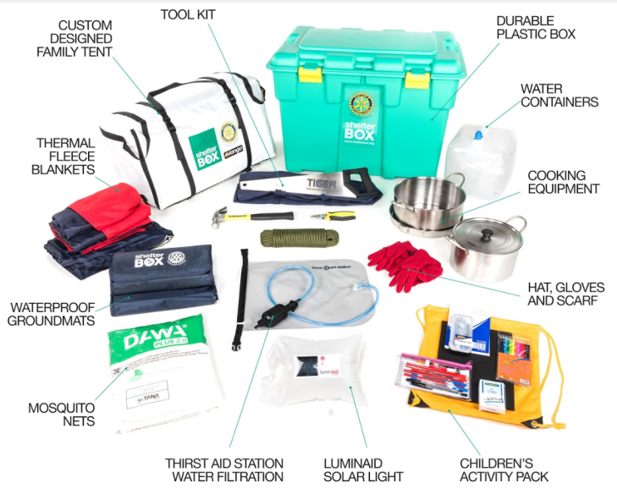

ShelterKits contain many of the essential tools people need to begin repairing and
rebuilding their homes. The ShelterKits are custom packed with vital hardware including toolkits, ropes, fasteners and heavy-duty tarps that can be used to build a shelter, repair damaged buildings, and begin to rebuild a home.
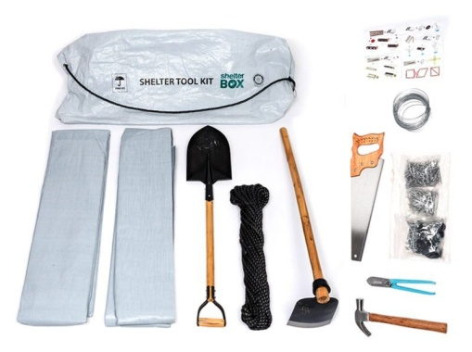

When natural disasters destroy buildings and families flee conflict, children’s education often stops. To off-set this need, ShelterBox can provide “SchoolBoxes” which contains the basic supplies a teacher needs to deliver lessons, in whatever space is set aside for children to learn.
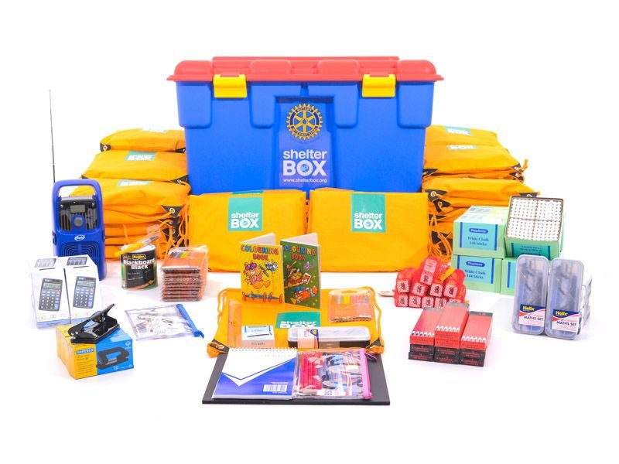
In-country Partnering
ShelterBox Response Teams frequently go to the most remote communities. This is made possible though the help of a dedicated network of local or in-country volunteers. Highly trained ShelterBox Response Teams (SRT) ensure aid is delivered quickly and efficiently using the best means available including high or low-tech methods.
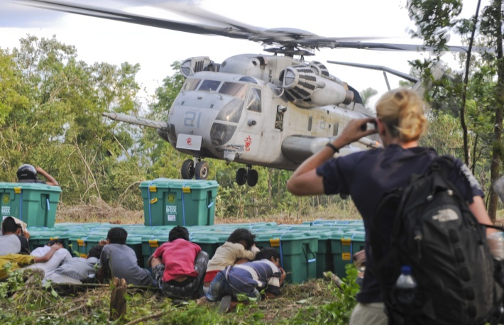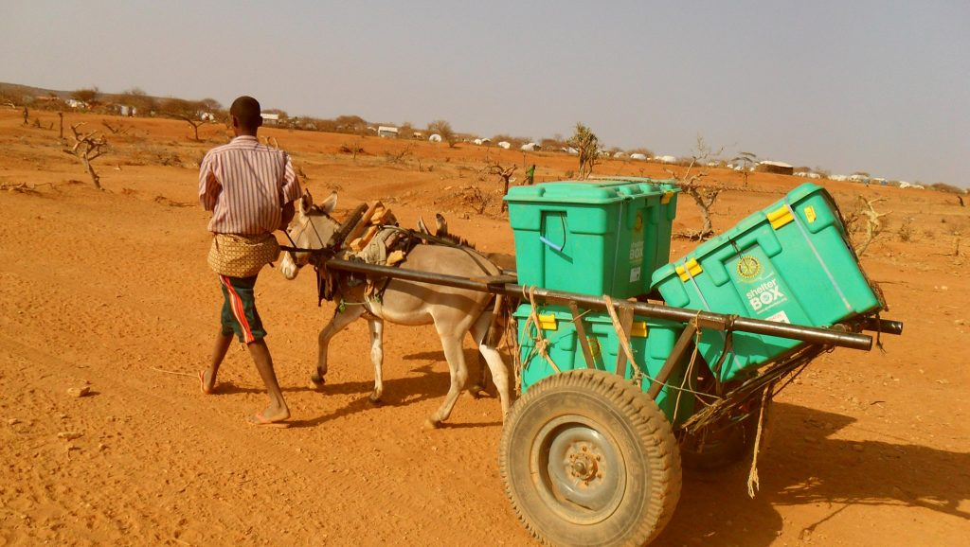

ShelterBox typically partners with other support entities like Rotary International, Habitat for Humanity, International Red Cross, and local country governments to provide a best-fit response. Other examples of 2018 ShelterBox Partnerships include:

Rotary (world-wide)  Action Aid (Somaliland)  ACTED (Nigeria & Iraq)  Plan International Niger (Niger)  IEDA Relief (Cameroon)  ICAHD (Chad) | Hand in Hand (Syria)  Bahar (Syria)  ReliefAid (Syria)  BRHA (Iraq)  LuminAID (Corporate partner)  Vango (Corporate partner)

ShelterBox pre-positions ShelterBoxes and ShelterKits in locations across the globe to enable-life saving resources to be deployed quickly. ShelterBox currently has 11 main pre-positioned warehouses around the globe:
- Cornwall, UK is used as a box packing warehouse.
- Supplier warehouses in Belgium and Dubai.
- UNHRD - Dubai, Las Palmas, Panama, Subang, Accra and Brindisi.
- IFRC Panama.
*UNHRD = United Nations Humanitarian Response Depot
*IFRC = International Federation of Red Cross

Creativity abounds within the ShelterBox network. For example, through the interest of Queen Elizabeth, ShelterBox International works with the British Navy to use available space on selected ships to store a substantial quantity of ShelterBoxes. This approach significantly shortens the response time in disaster areas where the British Navy patrols.

Who is selected to receive aid? ShelterBox evaluation teams consider the type of disaster, level of damage, needs of the community, and their ability to recover before selecting the level of support.

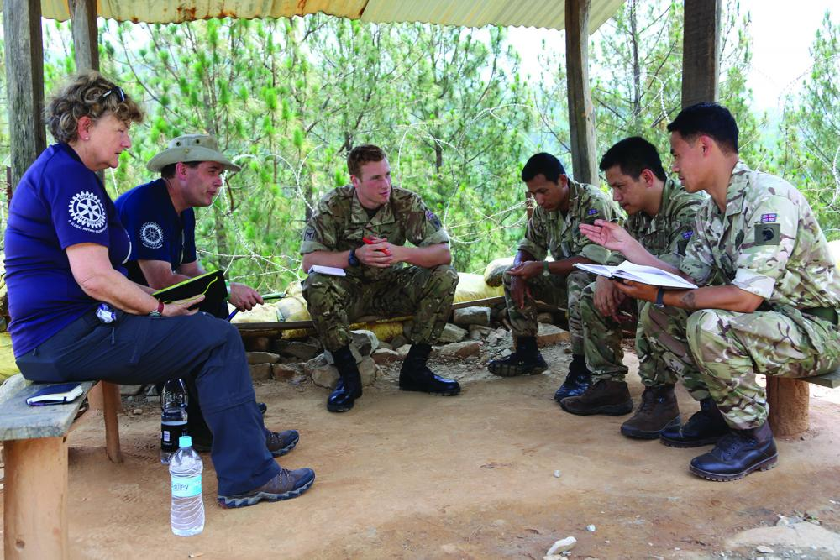
The British Army's elite Royal Gurkha Rifles with Rotary volunteers dealing with earthquake victims in Nepal.

Accreditations

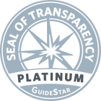

- For the second year in a row, ShelterBox USA earned a 4-star rating from Charity Navigator for demonstrating strong financial health and commitment to accountability and transparency.
- ShelterBox has been awarded the 2018 “Platinum Seal of Transparency” by Guide Star Exchange, an independent non-profit that reviews all aspects of the operations and performances of service organizations.
- ShelterBox is the only official Project Partner of Rotary International in Disaster Relief, whose 1.2 million members raise funds for ShelterBox and often provide local support on the ground during a disaster.
Financial Performance Metrics
As reported in the ShelterBox USA 2017 Annual Report
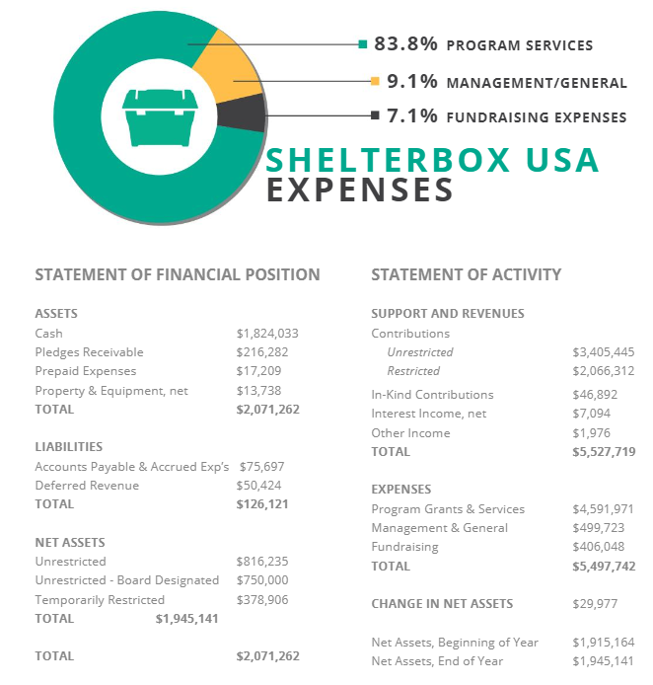

ShelterBox is funded by public donations and receives no direct government funding. The 2018 budget for ShelterBox USA is $6,065,476.

Nobel Peace Prize Nomination Update
ShelterBox was nominated along with several hundred other organizations and individuals for the 2018 Nobel Peace Prize. The winner, Nadia Murad, was announced October 5th, 2018.

While the prize wasn’t awarded to ShelterBox, the organization did play a significant role in the helping to bring a degree of normalcy to Nadia Murad’s homeland in Iraq.

When the Islamic State in 2014 took over in Northern Iraq, Nadia was one of many Yazidi women and girls who were abducted and subjected to repeated rape. After escaping, Murad committed herself to a life of activism, protesting the cruelties inflicted on her people.

In 2014, ShelterBox worked extensively in Kurdistan, particularly around the Dohuk region, which had the largest concentration of displaced people. More than 1,700 tents were distributed in Kurdistan and other parts of Iraq in 2014.

ShelterBox through local partners continues to work there today, supporting people fleeing from conflict both in Iraq and across the border in Syria. ShelterBox is honored to have been nominated alongside incredible people like Nadia.

Local Advertising Strategy to be based off the 2018 Experience
The promotional efforts by Karen Ramus, Sandi Black (McKenzie River Broadcasting and Delta Rotary member) and Dan O’Brien (KEZI and Delta Rotary member) when combined creates substantial public awareness for the ShelterBox brand and the Good Earth Home Show.

Dan O’Brien is planning weekly press releases to a variety of local media outlets, reporters, and journalists in early January. Target markets included Eugene, Springfield, Cottage Grove, Creswell, Oak Ridge, Salem and Florence.

Interacting with the Public
Volunteers, who interact with the public at all fund-raising events and other Rotary activities, must keep in mind we live in a politically polarized society and Eugene Oregon is no exception.

Delta Rotary members need to maintain a respectful position with all segments of the community including political and social issues advocated by either left or right-leaning people, local groups or national organizations.

Bottom line is each Rotary member by default represents Delta Rotary, our Rotary District and Rotary International in public and private settings. Thus, staying neutral and avoidance of controversial topics should be a guiding principle.

Business Sponsor
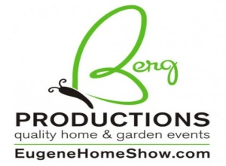
The Good Earth Home, Garden and Living Show is managed by Karen Ramus, President of Berg Productions of Eugene, Oregon. This privately held company also manages two additional home shows at the Lane County Fair Grounds annually.

Karen Ramus has been recognized by Delta Rotary as an honorary member and personally by Kerri Murray, President ShelterBox USA. Berg Productions has annually provided without charge a large booth, hotel accommodations for visiting ShelterBox staff and a $10,000 donation match challenge.

Home Show Donations 2015 to 2018
Five years ago, the Eugene Delta Rotary Club committed to support Rotary International’s relationship with ShelterBox USA by establishing an annual fund-raiser to reach the greater Eugene/Springfield, Oregon community. Since 2013, Delta Rotary has collected over $105,000 for ShelterBox USA.
Total year over year donations increased by 26% last year:
2017 = $18,875
2018 = $23,725
2019 = $25,000 (Goal)
The sources of contributions provided in 2018 included:
Cash - Booth Donation Box $3,635
Checks - all sources $3,050
Credit Cards - Club home page $5,190
Credit Cards - SB home page $ 450
Credit Cards - Members prior to event $1,250
Credit Cards - AMEX $ 150
Berg Productions - Donation Match $10,000
$23,725
Delta Rotary Volunteers
Thirty-six booth greeters are needed to meet the general public over the three day Home Show event. Volunteers should be prepared to answer questions the public may have regarding ShelterBox and encourage them to make a cash/check or credit card donations.

Greeter Responsibilities include:
- Commit to a 2 ½ hour time slot for a time and day of your choice.
- Sign up at the Friday luncheon or contact Harold Foutz.
- Review the “New Volunteer Training Guide” and contact Jim Mettler with any questions.
- Plan on wearing a “ShelterBox’ T shirt.
Four volunteers are needed for each 2 ½ hour segment. Booth greeters may sign up in November or December 2018 at the Club luncheon or email Harold Foutz at haroldf@wildish.com .

Show dates and hours:
Friday January 18, 2019 5:00 PM to 9:00 PM
Saturday January 19, 2019 10:00 AM to 8:00 PM
Sunday January 20, 2019 10:00 AM to 5:00 PM

Accepting Donations
There are several methods that allow donors to send funds to ShelterBox USA:

1) Credit/debit card donations can be made online at https://www.shelterboxusa.org/donate/. Tax deductible receipts will automatically be sent to donors via email.

2) Donors may call Shelter Box at
941 907-6036 and donate by credit/debit card.

3) Credit card donations made at the Shelter Box Booth
Shelter Box will make available two credit card slider readers that plug into tablets or iPads. The electronic devices will use the network available at the show to reach the Shelter Box home page. Instructions to open a connection/ the app and process the donation will be located at the welcome table in the booth.

The two tablets and the credit card readers can be retrieved at Karen Ramus office and should be returned to the same location each night. A team leader will be assigned to answer questions related to donations. Please check the team roster for the names of the Delta Rotary volunteers who will be acting as team leaders for each of the time segments.

Appendix

2019 Delta Rotary ShelterBox Team

Task/Team Leaders Team Objective
Delta Rotary Team Chair Validate the strategy, identify & manage the team leaders and
Cherie Curzon interface SB USA.
951 201-5054 cheriecurzon@aol.com

ShelterBox USA Interface Provide general guidance, training and logistical support.
Bill Woodard 503 799-6482 wr_woodard@msn.com

Facility Management Direct the use of the Lane Cty Fairgrounds
Karen Ramus Banners/Signage Design & procurement.
541 484-9247 karen@eugenehomeshow.com

Floor Plan Build on the 2016 event results with Karen Ramus.
Rex Starr 916 203-3203 rexstarr@yahoo.com

Construction Manage booth setup & tear down.
GregVik 541 501-5007 gvik@vikconstructionconpany.com

Communication/PR Develop the messages & interface local media.
Dan O’Brien 541 515-2717 danobrien@kezi.com

“Interact” Participation Oversee the kid’s participation & their security.
Kim Meyers 541 914-8442 klmcpa.meyers@gmail.com

Club Volunteers Manage the booth signup process.
Harold Foutz 541 343-3625 haroldf@wildish.com

Financial Donations Manage cash donations, volunteer training & tax receipts.
Kim Meyers 541 914-8442 klmcpa.meyers@gmail.com

Training Volunteers are fully prepared to interact with the public.
Jim Mettler 541 653-8006 jimmettler63@gmail.com

Come Join the Delta Rotary ShelterBox Team
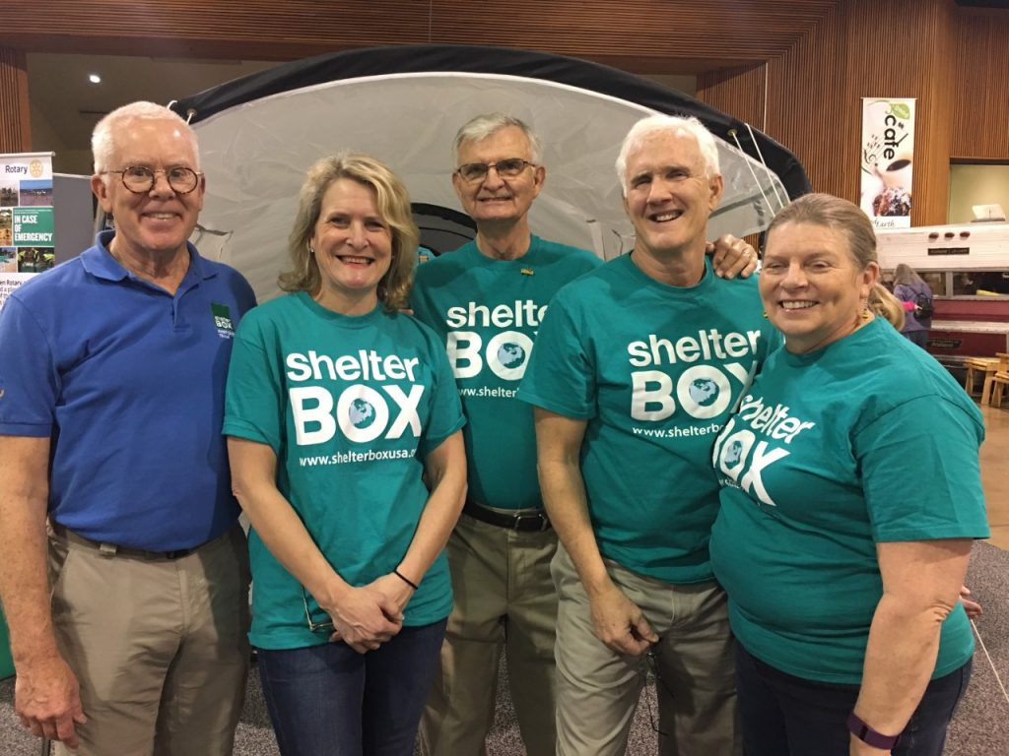
Pictured left to right: Bill Woodard, Beth Sheehan, Jim McCarthy, Greg Vik and Kim Meyers

Questions and Answers

Are all the ShelterBoxes the same?
ShelterBoxes and ShelterKits are frequently packaged with different items based on weather conditions and needs of the people in need. Every deployment looks different; and, we seek to supply the specific aid items needed in the wake of a disaster.
How long will the items last recipients of a ShelterBox?
The basic items contained in a ShelterBox have various shelf lives. Tents will last years as will cook tinsels shovels, saws, etc. Water purification and lighting devices have a shorter useful life.

What is the cost of each ShelterBox?
The actual cost of the contents and shipping are dependent on the geographic location of the disaster and the specific needs of the people being assisted. ShelterBox does place a value of $1000 for each delivered ShelterBox.

Are people in all countries eligible to receive a ShelterBox and what is the basis for deciding who will receive a ShelterBox?
Decisions as to where and the type of box contents are determined by ShelterBox Operations in collaboration with other rescue agencies, country and local government aid agencies.
Are donations made to ShelterBox USA tax deductible?
Yes. ShelterBox USA is 501c3 charitable organizations. Receipts for checks or credit card use can be made directly with ShelterBox USA through their web site or by phone.

What is the relationship between ShelterBox USA and ShelterBox International (UK based)?
Both are legally separate organizations that maintain separate boards and administrative staff. The two collaborate closely regarding how and where support services are dispatched globally.

Is it possible to purchase a ShelterBox, ShelterKit or ShelterBox Tent for personal use?
ShelterBox currently does not produce tents or other equipment for commercial sale.

Is there any follow-up with those who receive a ShelterBox?
ShelterBox Operations sends a Monitoring & Evaluation team in-country following a deployment. The team, when the environment is deemed to be safe, meets with beneficiaries and asks several operational questions including: how the aid impacted their family? What worked? What didn’t? How can we do better?
What is not included in a ShelterBox or ShelterKit?
Perishable items as food and First Aid kits typically have an expiration date and are not included. ShelterBox does support medical needs as our tents will be used as temporary hospitals and recovery units when medical facilities are not available.

Will the rechargeable Shelter Box lights be made available for purchase by the public this year?
Yes. Delta Rotary has ordered 75 lights for this year’s home show. The smaller light will be sold for $20 and the larger light with the capability to recharge cell phones will be available for $40.
Prices may change to manage excess inventory at the Sunday show.

2019 Talking Points

- The need for emergency shelter is urgent. Currently 85 million people globally have been displaced by natural disaster and conflict – more than any other time since World War II.
- ShelterBox crosses geographic boundaries and cuts through governmental red tape to link people who need support and those who provide it.
- In 2017 ShelterBox responded to both natural and man-made disasters in 21 countries by providing shelter aid to 160,000 people.
- The world wide headquarters is located since the year 2000 in the UK. The US affiliate, a 501(c) (3) non profit is based in Sarasota, FL.
- Rotary International, a global community of 1.2 million member partners with ShelterBox in delivering needed aid to disaster areas. Since 2012 ShelterBox became Rotary International’s first Project Partner and remains its only disaster relief charity.
- Other partners include: United Nations Human Refugee Council (UNHRC); International Red Cross (IFRC); International Organization for Migration; Handicap International; PLAN; and Habitat for Humanity.
- The type of disaster aid includes: ShelterBoxes; ShelterBox Standard Relief Tents; United Nations Tents; ShelterKits; and Tarps
- Currently over 1000 volunteers and 120 paid professional staff are trained and ready for deployment. Due to the high level of volunteer support, 83 cents out of each dollar donated goes to the beneficiaries.
- Fundraising efforts focus on individual, club/group and corporate giving. No donations from governments occur.
- Integrity and impartiality are key operational principles that are maintained no matter how challenging the mission. The organization is frequently engaged by the United Nations Human Refugee Counsel to provide aid in the most difficult countries around the world; examples include North Korea, Syria.
- A key goal is to grow the global impact by a factor of 10 to reach 1,000,000 people by 2025.

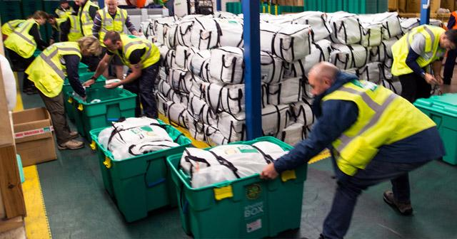

Case Studies
Since 2009, Boko Haram has been waging an insurgency in Northern Nigeria. The violence has since spread to the neighboring regions of Niger, Chad and Cameroon. Around 10.7 million people in the Lake Chad region are in need of relief assistance. Currently 2.4 million people are estimated to have been displaced and perpetual insecurity continues to drive displacement.

Chad
In Chad, ShelterBox is partnering with the local aid agency ICAHD to support vulnerable families who have been affected by conflict. So far, we’ve distributed vital aid to nearly 4,000 families. The aid includes blankets, buckets, solar lights, mosquito nets and ground sheets. Distributions are now complete for this project. The final phase provided nearly 2,000 families with tarpaulins, blankets, water carriers, kitchen sets and solar lamps.

Niger
Recent Boko Haram attacks in Kablewa have led to massive population displacement in Niger. Many families have been forced to find shelter in host communities, spontaneous sites in the bush or in displacement camps. ShelterBox is working with Plan International Niger to provide emergency aid to these families. We have provided ShelterKits, mosquito nets, water carriers, ground mats, and kitchen sets to 1,189 families.

Nigeria
The conflict in Nigeria is now entering its ninth year and the devastating consequences continue to impact structures and the lives of 8.5 million vulnerable people. ShelterBox continues to partner with ACTED and distributed 765 ShelterKits and other aid items in two camps in North-Eastern Nigeria. We are also planning to provide aid to a further 1,130 families in the near future.

Indonesia tsunami and earthquake

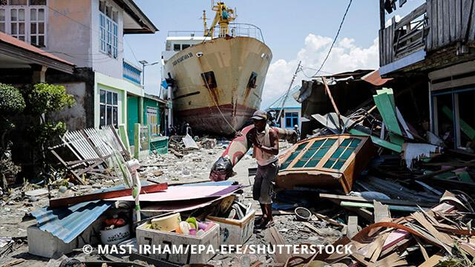

On September 28, a 7.5 magnitude earthquake and a deadly tsunami caused 2,100 people to have lost their lives and hundreds more are still reported missing on Sulawesi Island. Many thousands are in need of emergency shelter and other essential aid items.

Good Earth Home, Garden and Living Show
Eugene Fairgrounds - January 18-20, 2019
Shelter Box Booth
Eugene Delta Rotary Club
Delta Rotary has the incredible opportunity to help raise $10,000 for ShelterBox. This
will provide 10 Shelter Boxes for needy people throughout the world! The home show
organizers will donate $10,000 if Delta Rotary promotes donations to ShelterBox at a
booth at the home show. This $10,000 is on top of any amounts that people donate
to ShelterBox at the booth. What an impactful way to help those in need!
Feel free to invite your spouse / significant other to work a shift with you!
Friday, January 18, 2019 |  | Name ♦ |  | Name ♦
5:00PM - 7:00PM
7:00PM - 9:00PM
Saturday, January 19, 2019
10:00AM - 12:30PM
12:30PM - 3:00PM
3:00PM - 5:30PM
5:30PM - 8:00PM
Sunday, January 20, 2019
10AM - Noon
Noon - 2:30PM
2:30PM - 5:00PM
* Indicates shift leader; also able and willing to collect money using the PayPal Swipe on the I-Pad.
♦ If you are volunteering, and you don't have a ShelterBox Shirt, please include your shirt size (in Men’s sizes)
by your name. This will allow us to provide an official ShelterBox shirt to you to wear while volunteering.

