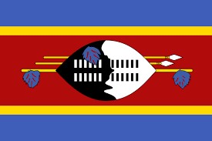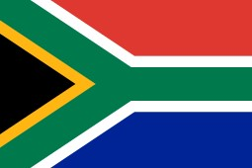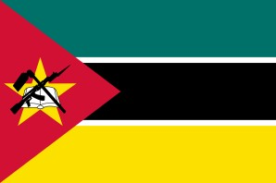

Botswana Eswatini Mozambique South Africa
COME GET A TASTE OF AFRICA!
District 9400 covers the following countries, Botswana, Eswatini,
Mozambique and the following provinces in South Africa – Gauteng, Limpopo, North West and Mpumalanga.
Breathtaking experiences and captivating activities await you!
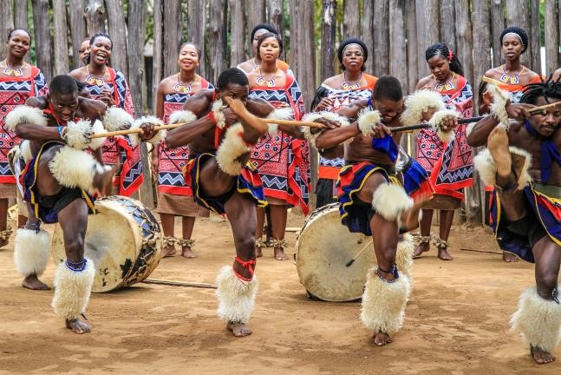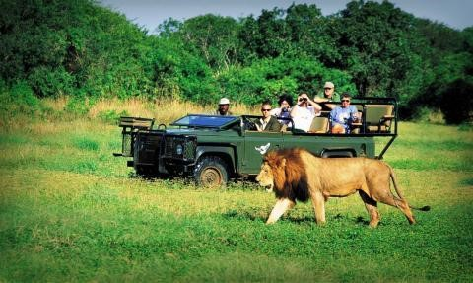
Great Safari Opportunities Fantastic Cultural Experiences
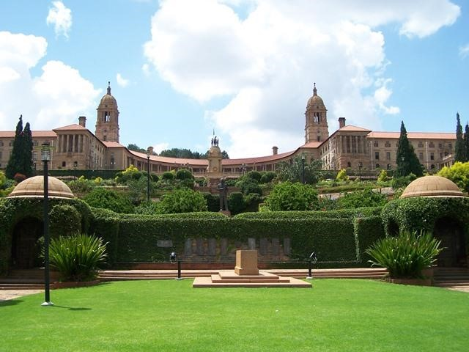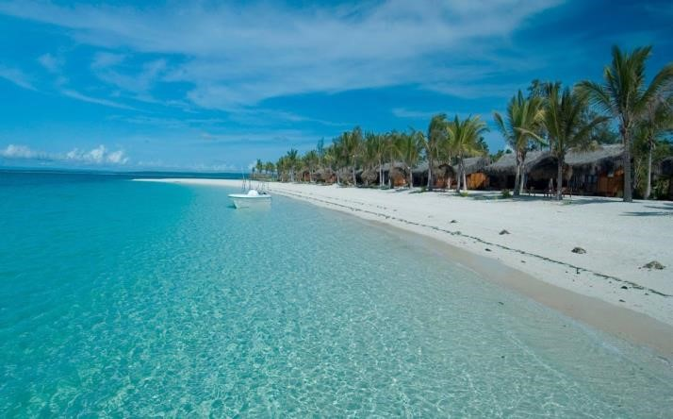
Beautiful Scenery Inspiring Political History
- Rotary District 9400 District 9400 is a multi-country district namely:
Botswana:
- Botswana is a landlocked country in Southern Africa which became independent in September 1966. The local population refer to themselves as Batswana and they speak Setswana and English. Botswana is named after the main tribe of the country, the Tswana people. “Bo-” Tswana refers to the people, “Se-” Tswana refers to the language. A single person ID a “Mo-“Tswana and the people are “Ba-“Tswana.
- The country is fairly flat and is mostly covered by the Kalahari dessert. The surrounding countries are South Africa, Namibia, Zimbabwe and a small section of Zambia. With a population of just over 2 million people, Botswana is a very sparsely populated country.
The currency is the Pula and the country is divided into 9 Districts.
Eswatini:
- Eswatini is also a landlocked country in Southern Africa, surrounded by South Africa and Mozambique to the East. Officially known as the Kingdom of Eswatini, it is a very small country. The current ruler is King Mswati III and the capital is Mbabane. The population is primarily ethnic Swazis who speak siSwazi.
- Eswatini is well known for its culture with two very well-known festivals in December and August. December is normally the time for incwala “the main ritual of Kingship” with the King as the most important person there. Umhlanga “the Reed Dance ceremony” takes place in August when thousands of unmarried and childless girls participate in this eight-day event.
Mozambique:
- The Republic of Mozambique is a coastal country in South East Africa with (from North to South) Malawi, Zambia, Zimbabwe, Eswatini and South Africa surrounding it. The currency is the Mozambican metical and the official language is Portuguese. Some of the other languages spoken is; Swahili, Sena and Makhuwa. The country has a population of about 25 million people and have rich and extensive natural resources
- The Coastal trade of Mozambique was first dominated by Arabs and Persians, and later the Portuguese from around the 1500’s. The country is divided into 10 Provinces (Provincias) and about 130 districts and again further into Administrative posts and lastly Localities (the lowest geographical level)
South Africa
- The Republic of South Africa covers the southern tip of Africa and has about 2,800km of coastline. South Africa is bordered by Namibia, Botswana, Zimbabwe and
Mozambique. Within the country is Lesotho, an enclave surrounded by South African territory. South Africa is a multi-ethnic society with eleven official languages.
- South Africa contains some of the oldest archaeological sites in the world including human fossils. One of the eight Unesco World Heritage sites in South Africa is “The Cradle of Humankind” situated in the Gauteng province. The country is divided into nine provinces which in turn are divided into districts, metropolitans and district municipalities.

About Group Cultural Exchange
District 5110 is proud to announce a Group Cultural Exchange (formerly Group Study Exchange) with District 9400 in Africa. A team of 3-4 team members plus a team leader will travel to District 9400 in April 2021, in time to celebrate their district’s 100th Anniversary. Both teams will return to Oregon together and attend our District Conference. Each team will spend 3-4 weeks abroad. Each team member, excepting the team leader, will be expected to pay $700 to help defray training and materials expenses – the team will meet approximately five (5) times prior to departure.
The program focuses on two main elements:

Vocational (50%+)
- Opportunity for team members to observe vocations as practiced in another country
- Ability to ask questions, share ideas, and develop professionally
- Exchange of potential project opportunities

Cultural
- Participants study another country, its people, language, and institutions through experiences in an organized and safe program
- Develop appreciation for diversity worldwide
- Meet and communicate with host families, and live with each other in the spirit of friendship and goodwill

Team MEMBER Requirements
- Be currently employed for at least two years in any recognized business or profession on a full-time basis
- Be 25 to 45 years of age
- Must work or live in Rotary District 5110
- Must be a citizen of the US
- Language training recommended, but not required
- Can be either Rotarian or non-Rotarian

Team LEADER Requirements
- Active Rotarian in one of District’s 5110’s amazing clubs
- Good physical health
- International travel experience
- Well organized and ability to be flexible if changes arise
- No age requirement
- Desire to work with fabulous young adults
- Can NOT have been a prior team leader

Costs
District 5110 does an amazing job of providing for our GSE program. This is a priceless experience for the GSE Teams. For each team member, District 5110 provides the most economical round-trip ticket between the home and host country, while generous local Rotarians in the host area provide meals, lodging, entrance fees, and group travel in their district. Team members are responsible for all personal and incidental expenses incurred before (including gas to team meetings, purchase of host family gifts), during (souvenirs), and after the study tour. A $700 participation fee is required.
Applications for both team member and team leader are available now via the link below, and are DUE OCTOBER 15, 2020

For questions regarding GCE, contact GCE Chair Rae LaMarche
5110GSE@gmail.com
*Covid-19 caveat: Although we will continue to plan for this adventure, should travel not be possible due to the Covid 19 pandemic, the trip will be postponed one year. We request your patience and understanding.

