Friends of Rotary – Newsletter

September 2023
Welcome to our Friends of Rotary Newsletter. Our objective of this newsletter remains to raise the awareness of what our Battle Ground Rotary Club’s (BGRC) programs are each week and what dates and activities our club is organizing.
By providing a forward-looking newsletter, we are hoping to:
- Raise community awareness of what the Battle Ground Rotary Club is focused on.
- Encourage our readers to come to a meeting, meet us and take advantage of the information being provided.
- Encourage our readers to participate in our Community Service projects.
Words from the editor
What a summer. Often, I think just how blessed I am. Here I am writing to a group of likeminded, service minded friends and it’s not censored. Sometimes it may feel like our freedoms are being challenged. Then I travel and run into the reality that what a great time it is to be alive.
So many choices, so many ways to make a difference. All too often I see the need and feel like I just can’t solve all of the needs. Thankfully we’re not in this alone! As a Rotarian and friend of Rotary we team locally and with our resources locally and internationally to focus our talents and resources to specific humanitarian needs. We also team with other nonprofits to help fund their services.
For Battle Ground Rotary, I’ve been highlighting our club’s specific focus areas in the past 6 months of this newsletter. I’m doing this so that you know you are making a difference. Thank you!
We have accomplished our objectives of giving and serving, yet there is so much more to do. As the new school year starts, we’ll ramp up our Reading Buddies program. We’ll leverage our personal gardens to help feed the needy. We’ll do one last Old Town Main Street Clean up. We’ll ramp up for our annual fundraiser, Festival of Wreaths and Wine scheduled for December 2nd.
Our world needs doers, people with resources and time to impact those less fortunate. I thank all of you for choosing to be that kind of person.
I know many of you are time challenged and that your support is situational. I can’t thank you enough for trusting Rotary and our club to put your valuable resources to use to impact our community, country, and world.

September is Rotary Basic Education and Literacy Month
Wired for success. To Close the digital divide, start with the teachers.
The Rotary Club of Panamá Norte loaded the packs with essential supplies and distributed them to grade schools throughout the country, a classic Rotary service project repeated in communities around the world. In this case, though, it led to something extraordinary — momentous changes in Panama’s education system.
The spark that ignited it came from what the Rotary members witnessed while delivering those backpacks about 10 years ago. “One of the things that we saw was the disaster in terms of technology and in terms of the possibility of kids being able to learn with technology,” says club member Enedelsy Escobar-King. “Most of the time what we found was that all of the computers were destroyed, or they were to be discarded, or that teachers didn’t know how to use them.”
Over the next few years, club members continued to deliver backpacks but also laid the groundwork for a larger project to address the high-tech disaster they had encountered. Specifically, they turned their attention to two grade schools in Veracruz, a corregimiento (or township) about 10 miles southwest of Panama City, where the club is based.
Link to full article
September – Shine the light – Reading Buddies
Over the past 4 years our Club has collaborated with Daybreak Elementary by reading with 1st, 2nd and 3rd graders. Reading can be very challenging for students who are coming from a home where English is their second language. It’s also challenging for students who have not learned to read before entering first grade.
Not having reading skills affects their ability and that impacts their self-esteem.
Our club members volunteer that focused time with the students to help them develop their reading skills. That helps improve their learning experience, making a positive learning experience, improving their self-esteem and their desire to participate and learn. This is an activity where we can see the tangible impact of our effort.
If this is something you have a heart for, please contact Terry Reddish who is our focal for this effort.
Terry can be contacted at; 360-903-7416

Our September meetings and topics are posted on our website and on Facebook, typically 2-3 days prior to the meeting.
Hold the Dates.
September 6th Club Social at 5:30-6:30
September 13th
September 20th
September 27th
October 11th Next FOWW meeting (after the club meeting)
November 26th Wreath Building at Hanenkrat’s
December 2nd Festival of Wreaths and Wine at Battle Ground Community Center

BGRC Club Member Anniversaries
None in September
Club Member Birthdays
Jeff Quade September 14th
Bethene Denman September 25th
Shiela Galeotti September 26th
Our Tradition is to end each meeting by reciting Rotary’s 4 Way Test, so I will end each newsletter with this…
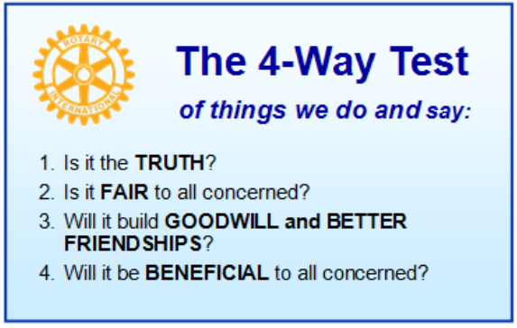
These are tests that we challenge ourselves to live by as Rotarians. But above that we commit to “Service Above Self”, which is Rotary’s motto. This is who we are. We invite you to check us out by participating in one of our projects or attending a meeting.
See you soon hopefully!

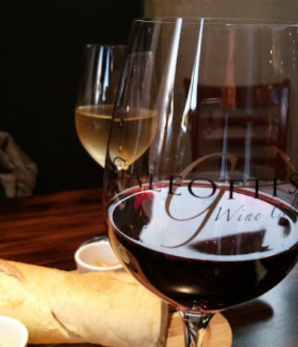
We meet at:
Galeotti’s Wine Cellar
715 East Main Street
Battle Ground, WA 98604

When: Wednesdays from 5:00 to 6:30 PM
Social from 5:00 to 5:30 PM
Meeting starts at 5:30 PM
BGRC Facebook Link
BGRC Webpage Link
For more information or to be removed from this mailing list, please call:
Dan Hanenkrat 360-907-4491

