Friends of Rotary – Newsletter

October 2023
Welcome to our Friends of Rotary Newsletter. Our objective of this newsletter remains to raise the awareness of what our Battle Ground Rotary Club’s (BGRC) programs are each week and what dates and activities our club is organizing.
By providing a forward-looking newsletter, we are hoping to:
- Raise community awareness of what the Battle Ground Rotary Club is focused on.
- Encourage our readers to come to a meeting, meet us and take advantage of the information being provided.
- Encourage our readers to participate in our Community Service projects.
Words from the editor
Hi friends! Becky and I just got back from the a wonderful experience. We spent almost a month traveling France and Italy and Iceland with my brother-in-law and his wife. That is my excuse for this late newsletter.
As we traveled and visited capitals and buildings that are significantly older than our country, it made me realize just how lucky we are but also how ‘new’ we are as a country. The countries we visited have deep cultures shaped by a history of religion, wars, and leadership that is hard to fathom for us. Their history became the cradle of our beliefs, laws and systems that have evolved to become our unique land of opportunity, the United States. While visiting Europe and seeing the history was great, I am still thankful that I live in this day, time and place.
I’m bringing this to light due to as our western cultures evolve, I want us to remember that we live in a time where we can make a difference and it isn’t just about us.
As a Rotarian, I belong to an amazing international organization of leaders who work hard to promote peace, address disasters, educate, end poverty and build community all across the globe, in face of cultural differences. May we team with our local and international communities and friends to live our lives driven by a primary purpose: the desire to help our fellow man. Let this purpose be guided by respecting our differences and talents for the betterment of all.
I hope this newsletter is a reminder that you can and are making a difference.

October is Rotary Economic and Community Development Month
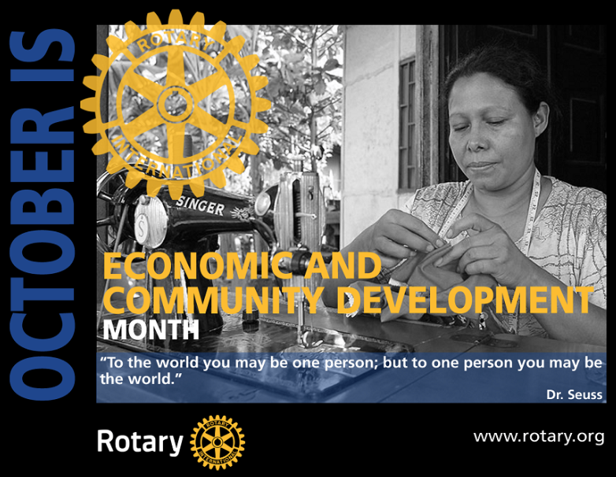
This month is dedicated to promoting economic growth and development in communities around the world. The United Nations’ Sustainable Development Goals encourage us to focus on ending poverty, promoting gender equality, creating decent work and economic growth for all, and creating sustainable cities and communities.
Rotary International supports investments in people to create measurable and enduring economic improvement in their lives and communities. The Rotary Foundation enables Rotarians to invest in people by creating sustainable, measurable, and long-term economic improvements in their communities and livelihoods by:
- Building the capacity of entrepreneurs, community leaders, local organizations, and community networks to support economic development in impoverished communities.
- Developing opportunities for productive work.
- Reducing poverty in under-served communities.
- Supporting studies for career-minded professionals related to economic and community development
October – Shine the light – Scholarships in Guatemala
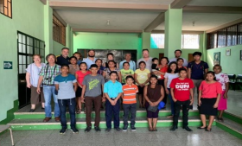
Battle Ground Rotary has teamed with our Rotary District to provide scholarships for children in families that cannot afford to send their children to school in Coatepeque Guatemala.
We do this by providing secondary education students with books and backpacks, and other school supplies. It all started in 1996, when three Rotarians, one each from RC Canby, RC Lake Oswego, and RC Portland first visited a village called San Rafael Pacaya Uno 4.2 miles outside of the southwestern town of Coatepeque, Guatemala.
It took over an hour to traverse a rutted road to meet with villagers and their local Mayor (whose office was in a one room jail). Villagers wanted to talk about their need for clean water. With that request came the first project in Guatemala for the three District 5100 clubs. On that visitation day, the three Rotarians visited the local elementary school where village children were attending first through sixth grade. Besides clean water, village parents wanted to know if Rotarians could help with educating their youth beyond sixth grade. As a result of that request, the school called San Rafael Pacaya Uno now houses elementary children in the morning and secondary education students (7th, 8th, and 9th grades) in the afternoon.
Since those early days, our District 5100 clubs along with the RC Coatepeque Rotarians, have provided the village with clean water through a water tower and the municipality provides a water distribution system to village adobe homes. The school now has had fresh paint several times, a principal’s office with teacher storage units, a play area with a basketball court, and latrines (now in the process of being greatly upgraded). The original Rotarians and clubs insisted on scholarships going to both boys and girls (50-50). In the first year, there were 6 boys and 4 girls. Since then, half of the scholarship students have been girls. A female graduate of the first class is now a teacher at the school as are 5 other former students.
As a result of these efforts, many girls no longer get pregnant as young teenagers, having to stay home to care for their child and siblings so that their mother can work. Many boys are not just working in rubber plantations or as street vendors with their fathers at a young age. This successful education project has changed lives for the surrounding small communities by creating opportunities for poor families, building a better future for students, their families, and their community.

For more information or if you would like to help support this effort please contact,
John McGuire at 208-891-3198, or johnjmcg@q.com

Our October meetings and topics are posted on our website and on Facebook, typically 2-3 days prior to the meeting.
Hold the Dates.
October 4th Club Social at 5:30-6:30
October 11th
October 18 t^{h}
October 18th Next FOWW meeting (after the club meeting)
October 25th
November 8th FOWW meeting (after the club meeting)
November 22th FOWW meeting (after the club meeting)
November 26th Wreath Building at Hanenkrat’s

SAVE THE DATE:
November 29th Festival of Wreaths and Wine On-Line Auction Starts November 29th. Live Event is Dec 2nd at the BG Community Center!
Tickets will go on sale Nov 1

BGRC Club Member Anniversaries
Candice Jackson October 6th

Club Member Birthdays
Ron Berst October 15th

Our Tradition is to end each meeting by reciting Rotary’s 4 Way Test, so I will end each newsletter with this…
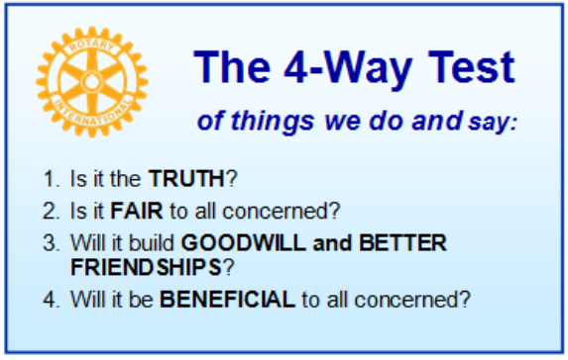
These are tests that we challenge ourselves to live by as Rotarians. But above that we commit to “Service Above Self”, which is Rotary’s motto. This is who we are. We invite you to check us out by participating in one of our projects or attending a meeting.
See you soon hopefully!

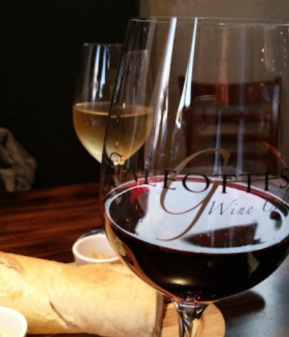
We meet at:
Galeotti’s Wine Cellar
715 East Main Street
Battle Ground, WA 98604

When: Wednesdays from 5:00 to 6:30 PM
Social from 5:00 to 5:30 PM
Meeting starts at 5:30 PM
BGRC Facebook Link
BGRC Webpage Link
For more information or to be removed from this mailing list, please call:
Dan Hanenkrat 360-907-4491

