Friends of Rotary – Newsletter

November 2023
Welcome to our Friends of Rotary Newsletter. Our objective of this newsletter remains to raise the awareness of what our Battle Ground Rotary Club’s (BGRC) programs are each week and what dates and activities our club is organizing.
By providing a forward-looking newsletter, we are hoping to:
- Raise community awareness of what the Battle Ground Rotary Club is focused on.
- Encourage our readers to come to a meeting, meet us and take advantage of the information being provided.
- Encourage our readers to participate in our Community Service projects.
Words from the editor
It’s time to gather with Friends and family to celebrate our blessings!
The harvest is in, so we pause and give thanks for our family, friends and our freedoms. We give thanks for the ones we have loved and are now gone. It is all to easy to get caught up in this crazy news cycle and let it drive our emotions.
This is a season where we can chill a bit. Thanksgiving, Christmas, and New Years will be upon us and gone in a flash. My family has half a dozen birthdays, and our Club has its annual fundraiser on December 2nd. I have so much to celebrate and be thankful for!
My Rotary Family and my Friends of Rotary form an amazing blessing in my life. I won’t be writing a December newsletter due to the need to focus solely on our fundraiser.
I wish you all a Happy Thanksgiving, a Merry Christmas/Happy Holidays, and an Amazing New Year!
Thank you for your ongoing friendship and support!

Dan

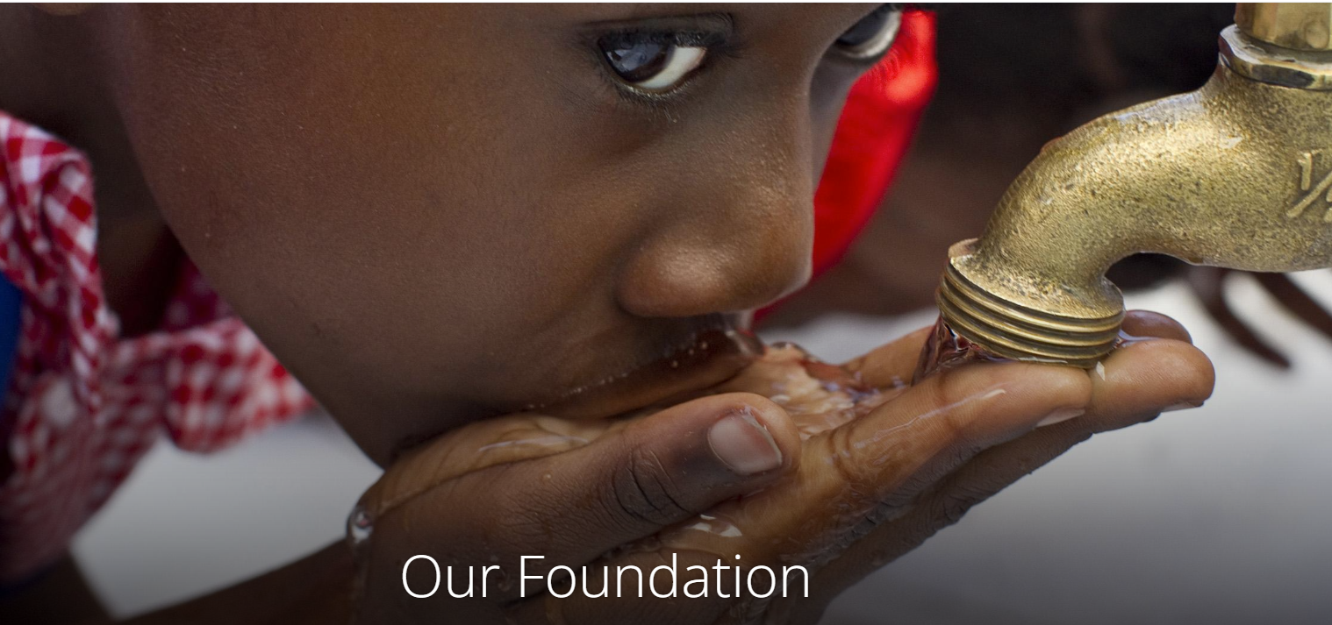
November is Rotary Foundation Month
Since it was founded more than 100 years ago, the Rotary Foundation has spent more than $4 billion on life-changing, sustainable projects. The Rotary Foundation (TRF) is funded by the 46,000 Rotary Clubs consisting of 1.2 million members worldwide and by donations from non-members. It’s often confused with Club Foundations, like our own local Battle Ground Rotary Foundation. Each Club like BGRC has its own foundation and foundation fundraiser to raise funds to spend in the local community or on specific international projects. Battle Ground Rotary Club’s Foundation Fundraiser is Festival of Wreaths and Wine coming up November 29-Dec 2nd. (see article below and go to www.battlegroundrotary.org for more info and registration).
At The Rotary International Foundation level, funds are collected from club members and others, and are managed and grow for three years minimum. After three years, funds are then distributed back to the Rotary Districts worldwide. Local Rotary Clubs then request these funds in the form of matching grants to help with needs in local communities or internationally. BGRC has used those matching grants/funds to purchase medical equipment for Battle Ground Healthcare, and to pay for school desks/books in Africa, for instance.
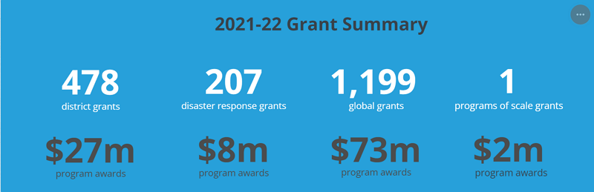
The RI Foundation mission is to help Rotary members to advance world understanding, goodwill, and peace by improving health, providing quality education, improving the environment, and alleviating poverty.
Rotary Foundation received the highest rating from Charity Navigator for 15th consecutive year. For the 15th consecutive year, The Rotary Foundation has received the highest rating – four stars – from Charity Navigator, an independent evaluator of charities in the U.S.
The graphic below gives you an idea of the current list of priorities and last years grants.
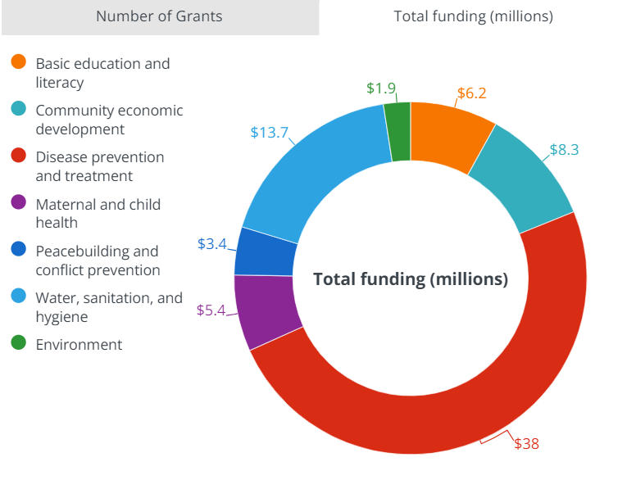
The Rotary Foundation transforms your gifts into service projects that change lives both close to home and around the world.
Since it was founded more than 100 years ago, the Foundation has spent more than $4 billion on life-changing, sustainable projects.
With your help, we can make lives better in your community and around the world.

What impact can one donation have?
- For as little as 60 cents, a child can be protected from polio.
- $50 can provide clean water to help fight waterborne illness.
- $500 can launch an antibullying campaign and create a safe environment for children.
Link to Rotary International Foundation

November – Battle Ground Rotary Club Festival of Wreaths and Wine Fundraiser
We’re on the home stretch in preparing for this year’s Festival of Wreaths and Wine (FOWW).
As our primary fundraiser we have been working with our community, sponsors, donors, and Club members to make this our best FOWW yet.
First, a SHOUT OUT to our two primary sponsors: Event Sponsor RV Inn Style Resorts and Platinum Sponsor, Renners Real Estate. We could not do it without community support!
As we have in the past, we have both an online auction starting November 29th at noon, culminating with a FUN Live event the evening of December 2nd. Registration for both the online auction and the live event tickets is available now. Evening event tickets are $35 per person and this is a 21 and over event. Go to www.battlegroundrotary.org to register for the online auction and purchase tickets for the live event on December 2nd.
As in the past we’ll be auctioning custom handmade wreaths that are truly amazing.
Also, on the online auction we’ll auction:
- Merchandise, Artwork, Hand Made quilts, Pearl Earrings…
- Services, Rotary Club Yard Project and Handyman services
- Experiences, Date Nights, Ridgefield Raptors game night package, …..
- Gift Baskets
The evening event will be a lot of fun and a great way to kick off Christmas!!! On December 2nd, at the BG Community Center, there will be an evening of live music by Ricky Lee Jackson, a spaghetti dinner, wine tasting with local wineries, a silent auction and raffles! Wineries represented are Emanar, 14 Acres, Lane Cellars and one more! At the silent auction, there will be 15+ wine baskets featuring wines and wine styles from SW Washington Winery Association, Walla Walla, Columbia Gorge, Napa, and the Willamette Valley. There will be a 50/50 raffle, a Wine Ring Toss (everybody’s favorite!), and Heads or Tails. Come enjoy the music, fun, laughter and donate/give to a local organization that serves the Battle Ground Community!
As a reminder: this year’s tickets to the live event are only being sold online. To buy yours or to register to be an online bidder (free), go to the following link. Battle Ground Rotary 2023 FOWW

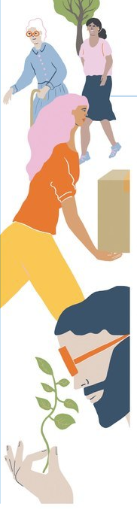
November Rotary Magazine Article -Be an Ally
The following article is part of Rotary’s focus to raise awareness of the significance of mental health.
I’m adding this article in this month’s newsletter because we need to not only manage our own mental health, we need to be an ally to those who need help.
Raising awareness helps us recognize mental health issues sooner and to understand that we’re not in this alone.
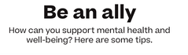

Link to Article
Find out more in the Prioritizing Mental Health brochure which has information about Rotary International President Gorden Mcinally’s mental health initiative and ideas for how as Rotarians we can get involved. Download the brochure at rotary.org/initiatives23-24

Our November meetings and topics are posted on our website and on Facebook, typically 2-3 days prior to the meeting.
Hold the Dates.
November 1st^{h} Club Social at 5:30-6:30 @ Lumos Hearth and Fireplace
November 8th Club Meeting
November 8th Next FOWW meeting (after the club meeting)
November 15th Club Meeting
November 22nd Club Meeting
November 22th FOWW meeting (after the club meeting) Community Center Status
November 26th Wreath Building at Hanenkrat’s
SAVE THE DATE:
November 29th Festival of Wreaths and Wine On-Line Auction Starts November 29th. Live Event is Dec 2nd at the BG Community Center!
Tickets to the Community Center event are available NOW.

BGRC Club Member Anniversaries
Mark Sabo

Our Tradition is to end each meeting by reciting Rotary’s 4 Way Test, so I will end each newsletter with this…
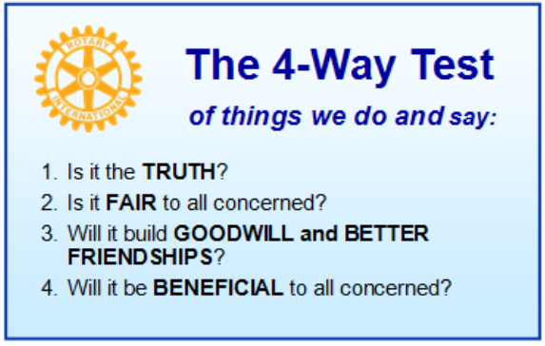
These are tests that we challenge ourselves to live by as Rotarians. But above that we commit to “Service Above Self”, which is Rotary’s motto. This is who we are. We invite you to check us out by participating in one of our projects or attending a meeting.
See you soon hopefully!

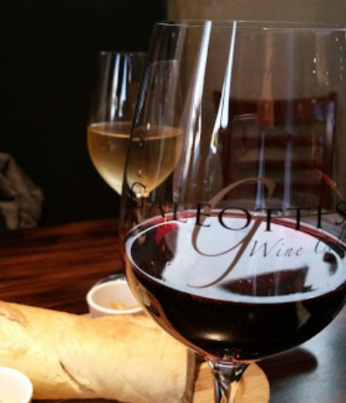
We meet at:
Galeotti’s Wine Cellar
715 East Main Street
Battle Ground, WA 98604

When: Wednesdays from 5:00 to 6:30 PM
Social from 5:00 to 5:30 PM
Meeting starts at 5:30 PM
BGRC Facebook Link
BGRC Webpage Link
For more information or to be removed from this mailing list, please call:
Dan Hanenkrat 360-907-4491

