Friends of Rotary – Newsletter

August 2023
Welcome to our Friends of Rotary Newsletter. Our objective of this newsletter remains to raise the awareness of what our Battle Ground Rotary Club’s (BGRC) programs are each week and what dates and activities our club is organizing.
By providing a forward-looking newsletter, we are hoping to:
- Raise community awareness of what the Battle Ground Rotary Club is focused on.
- Encourage our readers to come to a meeting, meet us and take advantage of the information being provided.
- Encourage our readers to participate in our Community Service projects.
Words from the editor
I’m running a little late on this edition, my apologies. Summers in the NW for us mean more travel and that means I miss connecting with our local friends and family. I sure miss being in the mix and yet love connecting and travel.
I’m pretty sure I’m not alone on this. My point here is that as the days get shorter and the fall weather creeps in, I’m looking forward to more time at home and spending time with Rotary related service.
Speaking of that, we’re gearing up for this year’s Festival of Wreaths and Wine. This year’s fundraiser will be at the Battle Ground Community Center on December 2nd.
We’ve started reaching out to our past donors and sponsors in an effort to establish them earlier this year which will facilitate recognition of their support and promotion of our fundraiser.
We are working on locking in our Event Sponsorship and have yet to gain that commitment. If this is something that you would like to be or know of someone who could be that, please contact me.
I’m attaching our Donor and Sponsorship brochure which details all of the levels and benefits other than the Event Sponsor. We are seeking only one Event sponsor for top recognition.
Our objective is to lock in our donors and sponsors by 9/1 which will allow us to publish our Save the Date cards and start promoting the Fundraiser via social media.
Festival of Wreaths and Wine Sponsorship Brochure

Friends, be safe and thank you for helping us help others!

August is Rotary Membership and Extension Month

Rotary International, membership is open to everyone. Rotary is grouped into three age groups. For high schoolers, the Rotary clubs for High school-age is called Interact. BGRC sponsors an Interact group at CAM here in Battle Ground. There are clubs for young adults in their 20’s called “Rotaract” and then the adult organization “Rotary.”

“Rotary” club membership consists of local business owners, sales and service professionals and retirees from those professions.

There are two Clubs in Battle Ground, seven total in Clark County.
Our Club – Battle Ground Rotary meets at Galeotti’s on Wednesday’s evenings at 5:30. BGRC Webpage Link
The Lewis River Rotary meets on Tuesdays and alternates between morning and evening. Lewis River Rotary Webpage Link

Rotary’s motto is “service above self” and as you can imagine, being in a group of people who value serving others lends itself to building deep friendships. As we serve together, we build friendships and communities that can be more and do more than we can individually.

One of the aspects of Rotary membership is that we can pause our membership with a leave of absence and yet remain a member. COVID taught us some lessons and the key one is that of flexibility.

My point here is that membership is not difficult or onerous. Meetings are fun, members are welcoming. The level of participation is really up to you.
Attached is some data from this month’s Rotary Magazine as to what matters to Rotary members.
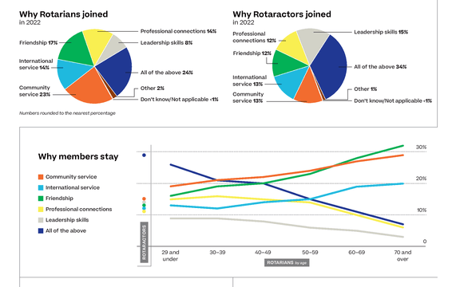
Article link Membership Makeover
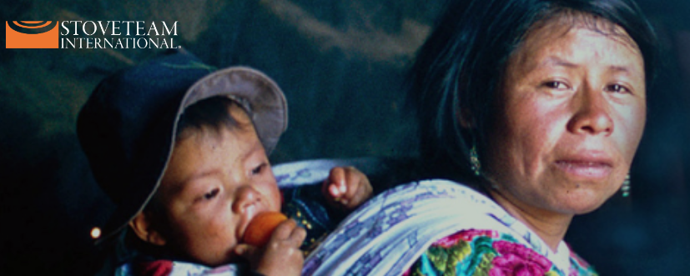

August – Shine the light – StoveTeam International
Over 4 billion people in developing countries cook with wood. Meaning they spend a great deal of their lives collecting wood, burning that wood to cook their meals with stoves that are not efficient and produce unhealthy conditions.
StoveTeam International is tackling this by engaging engineers and local business in Central America to build and deploy locally manufactured stoves that are more efficient and vent the smoke out of their homes.
Battle Ground Rotary donates 10 stoves a year to this effort. That’s 10 families directly impacted to improve their quality of life.
For more information on StoveTeam International and how you can help, go to the following link StoveTeam International

Our August meetings and topics are posted on our website and on Facebook, typically 2-3 days prior to the meeting.
Hold the Dates.
August 2nd Rotary District Governor Renee Brouse Club Visit
August 9th Club Social at Detroit Pizza 5:30-6:30
August 12th Fundraiser BBQ purchased at last year’s Friends of Wreaths and Wine
August 16th Club Meeting
August 23rd Club Meeting
August 30th Club Meeting & FOWW Meeting (post Club meeting)

BGRC Club Member Anniversaries
Shawna Quade 5th Year
David Welch 4th year
Club Member Birthdays
Heather Renner August 6th
Katherine Ahlberg August 7th

Our Tradition is to end each meeting by reciting Rotary’s 4 Way Test, so I will end each newsletter with this…
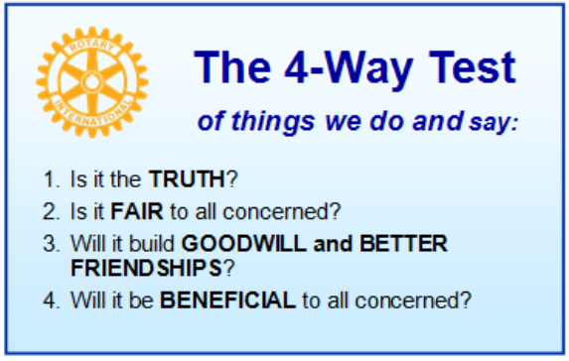
These are tests that we challenge ourselves to live by as Rotarians. But above that we commit to “Service Above Self”, which is Rotary’s motto. This is who we are. We invite you to check us out by participating in one of our projects or attending a meeting.
See you soon hopefully!

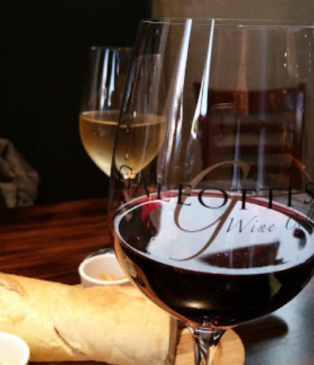
We meet at:
Galeotti’s Wine Cellar
715 East Main Street
Battle Ground, WA 98604

When: Wednesdays from 5:00 to 6:30 PM
Social from 5:00 to 5:30 PM
Meeting starts at 5:30 PM
BGRC Facebook Link
BGRC Webpage Link
For more information or to be removed from this mailing list, please call:
Dan Hanenkrat 360-907-4491

