Friends of Rotary – Newsletter

September 2022
Welcome to our Friends of Rotary Newsletter. Our objective of this newsletter remains to raise the awareness of what our Battle Ground Rotary Club’s (BGRC) programs are each week and what dates and activities our club is organizing.
By providing a forward-looking newsletter, we are hoping to:
- Raise community awareness of what the Battle Ground Rotary Club is focused on.
- Encourage our readers to come to a meeting, meet us and take advantage of the information being provided.
- Encourage our readers to participate in our Community Service projects.
Words from the editor
It’s hard to believe that it’s September already.
It’s been a couple months since I’ve sent a newsletter. Over the summer, our club had a leadership transition in July. Jeff Quade, our 2021-22 President passed the baton to Mike Simpson for the 2022-23 Rotary year. David Welch is now the President-Elect, Kandida Sabo is our new Rotary Club Secretary, and Jeanine Jackson stays on for another year as Treasurer.
As with changes in leadership, we’ll see a change is personal leadership styles. This is Mike’s second time to be our President. He’s established his team and has hit the ground running.

As a club, we stayed busy this summer. Battle Ground Rotary Club was a vendor at this year’s Harvest Festival Cruise In on Friday night, selling hot dogs, chips and water. It was our first year doing this, and we had a great time being part of our community’s premier summer event. It was a warm evening, and we had a great view of the cars as they cruised by! We also raised some money that went into our Foundation to fund our avenues of service.
- Community
- Youth
- International
- Vocational

In case you don’t get down that way, we added a second set of cross walk flags in Old Town just past Galeotti’s and took over watering the flower baskets on the sidewalks in Old Town. With the summer’s heat, that has been an every other day event!

We also formed a team and washed Battle Ground Healthcare’s windows and the sidewalk at their new location. Sue Neal was so pleased with the sparkle and shine!!

As we come out of the summer, our daylight gets shorter and we shift gears as a Club. We will be out promoting our annual fundraiser, Festival of Wreaths, and Wine. We’ll be doing the hybrid event again this year which includes both an online auction and an event with music and food. Ricky Lee Jackson and his band have agreed to be our music again this year! If you have heard them, you have to love them, so come and listen and join the fun! The online auction starts November 28th and will conclude at the end of the live event at the Battle Ground Community Center, December 3rd. We’ll be sending out a “Save the Date card” soon and watch our FB page for updates! If you are interested in being a sponsor or have donations for the auction (wine, gift baskets, gift certificates, art), please contact Dan Hanenkrat at dphanenkrat@gmail.com.

We look forward to seeing everybody!

September is Rotary Basic Education and Literacy Month

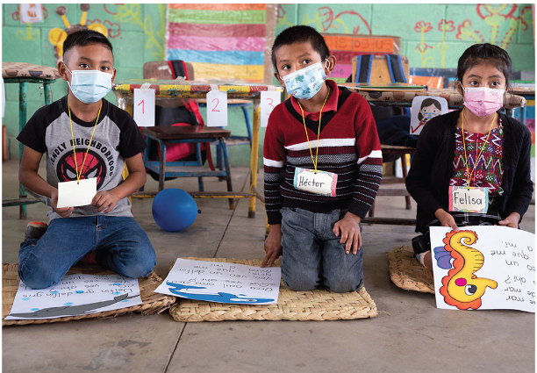
This area of focus hits close to home for me and I know that the remote learning thru the COVID area did not make it easy to learn or retain. Reading is at the core of being able to learn and the ability to learn is at the core of self-esteem. Our Club has worked in the past with Daybreak Elementary teachers in support of helping first graders in a one-on-one tutorship. We have such a diverse community, and our schools reflect that. I’ve observed firsthand the transformation of children struggling and reclusive to excited and engaging.
September’s Rotarian Article is, The gift of reading. Its focus is on children in Guatemala. As Rotarians, we can make a difference in our own community as well.
Link to article
Our September Meetings are as follows:
We meet at Galeotti’s on Main Street, Social time starting at 5:15, Meeting: 5:30-6:30. For information about the program of the week, be sure to look at our Facebook Page on the Tuesday before the meeting: https://www.facebook.com/BattleGroundRotaryClub. It is also usually posted on our BGRC website: www.battlegroundrotary.org

September 7th Social at Rockies Pizza – Join us there at 5:30!!! It is open to everyone!
September 14th
September 21st District Governor, Steve Williams, will be visiting our club
September 28th
Hold the Dates: FOWW IS COMING!!
September 14th FOWW Planning Meeting after Club Meeting
November 27th Build Wreaths for FOWW
November 29^{th:} FOWW On-line Auction Starts
December 3^{rd:} FOWW at Community Center and Auction Ends

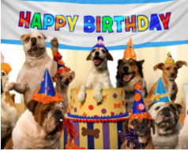
Club Member Rotary Anniversaries
NA
Club Member Birthdays
Jeff Quade, September 14th
Sheila Galeotti, September 24th

Our Tradition is to end each meeting by reciting Rotary’s 4 Way Test, so I will end each newsletter with this…
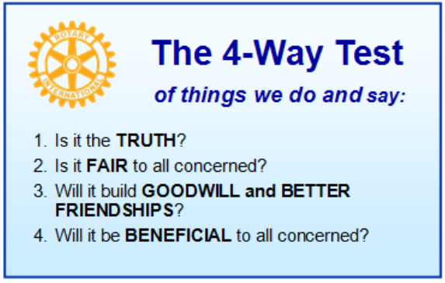
These are tests that we challenge ourselves to live by as Rotarians. But above that we commit to “Service Above Self”, which is Rotary’s motto. This is who we are. We invite you to check us out by participating in one of our projects or attending a meeting.
See you soon hopefully!
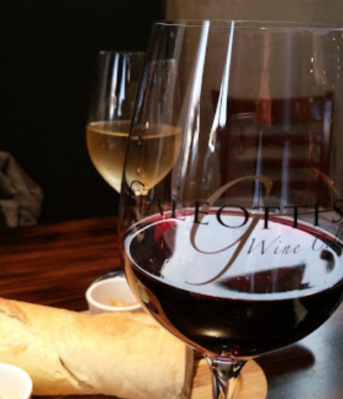
We meet at:
Galeotti’s Wine Cellar
715 East Main Street
Battle Ground, WA 98604

When: Wednesdays from 5:15 to 6:30 PM
Social from 5:15 to 5:30 PM
Meeting starts at 5:30 PM
BGRC Facebook Link
BGRC Webpage Link
For more information or to be removed from this mailing list, please call: Dan Hanenkrat 360-907-4491

