Friends of Rotary – Newsletter

October 2022
Welcome to our Friends of Rotary Newsletter. Our objective of this newsletter remains to raise the awareness of what our Battle Ground Rotary Club’s (BGRC) programs are each week and what dates and activities our club is organizing.
By providing a forward-looking newsletter, we are hoping to:
- Raise community awareness of what the Battle Ground Rotary Club is focused on.
- Encourage our readers to come to a meeting, meet us and take advantage of the information being provided.
- Encourage our readers to participate in our Community Service projects.
Words from the editor
Greetings Friends

Take a deep breath and enjoy the cooler air and shorter days.
I love this time of the year, it may be my favorite. I get to look back at very full summer with friends and family, as well as the results of the projects my wife and I accomplished, including enjoying all of the fresh produce grown.
Hopefully this letter finds you in good spirits and health!

As for the upcoming months, there is much to do. Fall for our Club kicks off our preparation for our annual fundraiser, Festival of Wreaths and Wine. We’ll be reaching out to many of you again, seeking your continued support. Thank you in advance for your support.

We’ll be sending out our Save the Date cards this week.

Our Club is growing, and we are seeking new members. We meet weekly, however, meetings are not mandatory like some clubs. Our membership is open to ages 18 and up. If you have questions about why Rotary and what’s involved in being a member, Darren Davidson is our Membership Chair and can be contacted at: dtdavidson@ft.newyorklife.com

October is Rotary Economic and Community Development Month
Economic and community development is one of Rotary’s six areas of focus. Unemployment, underemployment, lack of economic opportunity, lack of appropriate training, and the absence of social safety nets lie at the core of poverty. For the poor, labor is often the only asset available to improve well-being.
Creating productive employment opportunities is essential for reducing poverty and achieving sustainable economic and social development, and for providing income security and empowerment especially for women, people with disabilities, youth, and the extremely poor. Like education and health strategies, generating income and creating opportunities for a productive workforce and entrepreneurship are essential for reducing poverty.
Consider these facts:
- Every 1% increase in agricultural income per capita reduces the number of people living in extreme poverty by between 0.6% and 1.8%
- Studies find strong evidence that access to microcredit leads to reduced vulnerability, in the sense of a lower threat of fluctuations in income or consumption.
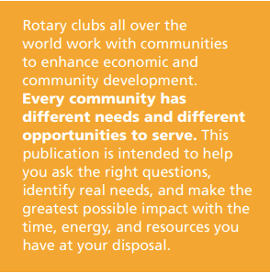
- In Nigeria, studies show that a mere 1% investment in human resources such as education and training will lead to a more than 66% decrease in poverty.
- Women in low value-added sectors lack skills to access other higher value-added sectors. As shown in countries such as Singapore, Taiwan, and Malaysia, an increase in vocational training is a precondition for countries to make the transition from low to high value-added production.
- Tremendous progress has been made to reduce global poverty. According to the World Bank, 1.92 million people lived on less than $1.25 a day in 1990 compared to only 1 million in 2011. In 2015, several Millennium Development Goal targets were met. While substantial progress was made in many areas, pressing global needs still remain. With the adoption of the Sustainable Development Goals, an updated development agenda outlines remaining concern:
- Almost 202 million people were unemployed in 2013, 74.5 million of whom were young people, ages 15-24.
- Agriculture is the main source of income and employment for the 70% of the world’s poor who live in rural areas.
- The gender gap in employment persists, with a 24.8 percentage point difference between men and women in the employment-to-population ratio in 2012.

Featured Rotarian article: Rethinking what we think we know
By Rev. Dr. Celelia Harris
Trust and reconciliation require us to get beyond the surface events that ignite emotions
This is a short testimonial to our readers about how deep seated beliefs are powerful for shaping cultural realities, both good and bad. As such we need to challenge what we think we know.
Link to article

Our October Meetings are as follows:
We meet at Galeotti’s on Main Street, Social time starting at 5:15, Meeting: 5:30-6:30. For information about the program of the week, be sure to look at our Facebook Page on the Tuesday before the meeting: https://www.facebook.com/BattleGroundRotaryClub. It is also usually posted on our BGRC website: www.battlegroundrotary.org

October 5th Social at Cloverlane Event Center at 5:30 pm located at 16391 NE 182nd Ave
October 12th
October 19th
October 26th
Hold the Dates: FOWW IS COMING!!
October 19th FOWW Planning Meeting after Club Meeting
November 2nd, 16^{th &} 23rd FOWW Planning Meeting after Club Meeting
November 27th Build Wreaths for FOWW
November 29^{th:} FOWW On-line Auction Starts
December 3^{rd:} FOWW at Community Center and Auction Ends
December, Club Christmas Party – TBD

Club Member Rotary Anniversaries
NA
Club Member Birthdays
NA
Our Tradition is to end each meeting by reciting Rotary’s 4 Way Test, so I will end each newsletter with this…
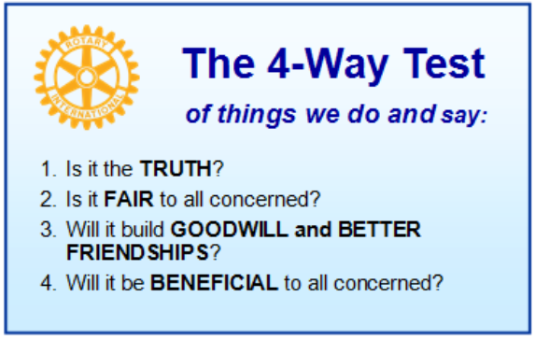
These are tests that we challenge ourselves to live by as Rotarians. But above that we commit to “Service Above Self”, which is Rotary’s motto. This is who we are. We invite you to check us out by participating in one of our projects or attending a meeting.
See you soon hopefully!
We meet at:
Galeotti’s Wine Cellar
715 East Main Street
Battle Ground, WA 98604

When: Wednesdays from 5:15 to 6:30 PM
Social from 5:15 to 5:30 PM
Meeting starts at 5:30 PM
BGRC Facebook Link
BGRC Webpage Link
For more information or to be removed from this mailing list, please call: Dan Hanenkrat 360-907-4491

