Friends of Rotary – Newsletter

July 2022
Welcome to our Friends of Rotary Newsletter. Our objective of this newsletter remains to raise the awareness of what our Battle Ground Rotary Club’s (BGRC) programs are each week and what dates and activities our club is organizing.
By providing a forward-looking newsletter, we are hoping to:
- Raise community awareness of what the Battle Ground Rotary Club is focused on.
- Encourage our readers to come to a meeting, meet us and take advantage of the information being provided.
- Encourage our readers to participate in our Community Service projects.
Words from the editor

It’s hard to believe that it’s July already.

July is the month that Rotary changes out our Management. Jeff becomes our Past President and Mike Simpson becomes our President for 2022-23.

As with changes in leadership, we’ll see a change is personal leadership styles. This Mike’s second time to be our President. He’s established his team and has hit the ground running.

We’d like to thank you for support and your continued support!

We were at this years Harvest Festival Cruise In, selling hot dogs, chips and water. It was our first year doing this, and while it was not as successful as we had hoped, we know that it takes time to ‘build a brand’! The funds we raised, like our Festival of Wreaths and Wine, go into our Foundation to fund our avenues of service.

- Community
- Youth
- International
- Vocational

July is Rotary Transition Month

As I mentioned in my Editors notes, July is a transtion month for Rotary. At the Global level we have a new President of Rotary International, Jennifer Jones.

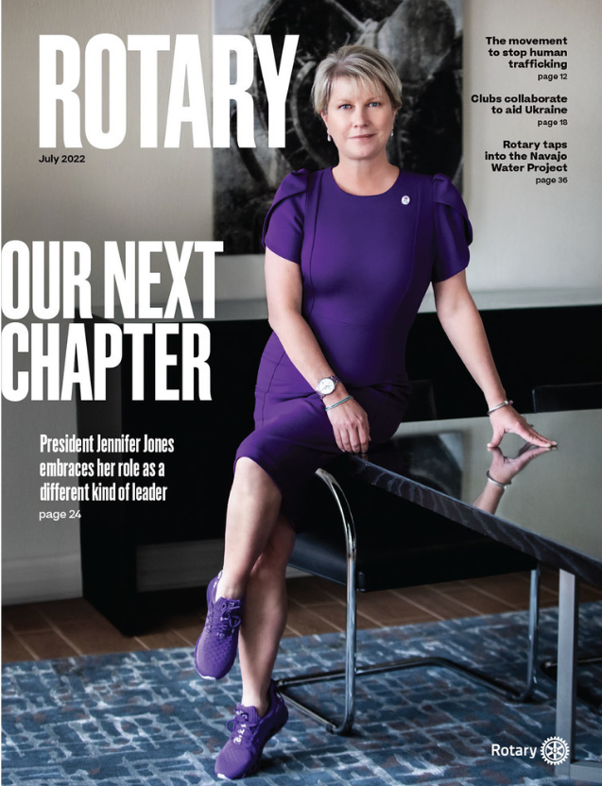
Jennifer is forward looking and looks forward to leading Rotary into “our Next Chapter”.
For the full story read;

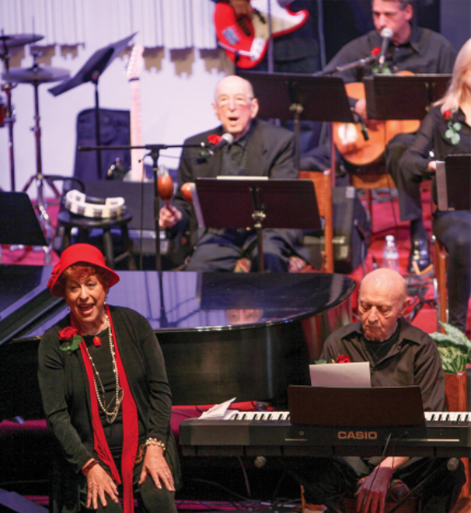
Link to Entire Article

July Rotarian Article: Water is Life

Alongside Rotary and the nonprofit DigDeep, the Navajo are bringing a vital commodity to their ancestral homeland….
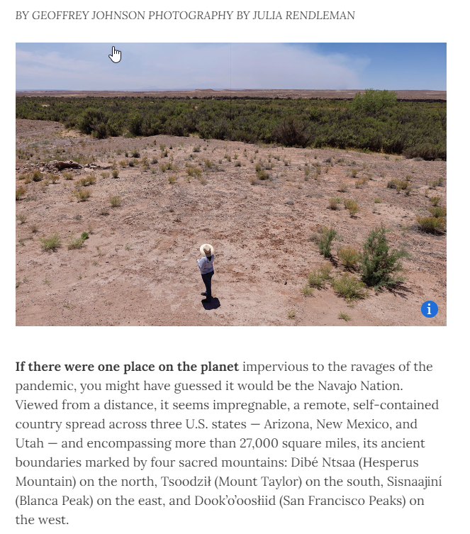
https://magazine.rotary.org/rotary/february_2022/MobilePagedArticle.action?articleId=1764025 - articleId1764025 Link to Entire Article
Our July Meetings are as follows:
We meet at Galeotti’s on Main Street, Social time starting at 5:00, Meeting: 5:30-6:30. For information about the program of the week, be sure to look at our Facebook Page on the Tuesday before the meeting: https://www.facebook.com/BattleGroundRotaryClub. It is also usually posted on our BGRC website: www.battlegroundrotary.org

July 6th Dark
July 13th Center for Fellowship and Peace, four of the visiting Cypriot youth gave a heartfelt talk about what they feel about being Cypriot, and what they want to do to make changes in their own country, and there was scarcely a dry eye in the crowd!
July 20th
July 27th
Hold the Dates.
July 20 ^{th:} FOWW Planning Meeting after Club Meeting
July 23rd Roraty at Your Service, Yard work at Hanenkrat’s 8:30 to Noon
November 27^{th:} Build Wreaths for FOWW
November 29^{th:} FOWW On-line Auction Starts
December 3^{rd:} FOWW at Community Center and Auction Ends

Club Member Rotary Anniversaries
Tony Domine: July 17th. 9th as a Rotarian
Club Member Birthdays
Anthony Andrews, July 3rd
Darren Davidson, July 11th
Mark Sabo, July 13th
Shawna Quade, July 20th

Our Tradition is to end each meeting by reciting Rotary’s 4 Way Test, so I will end each newsletter with this…
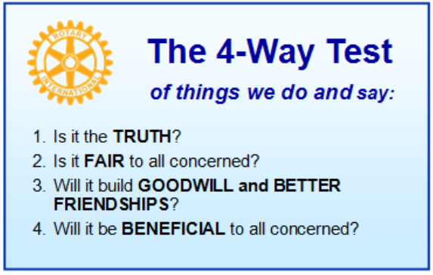
These are tests that we challenge ourselves to live by as Rotarians. But above that we commit to “Service Above Self”, which is Rotary’s motto. This is who we are. We invite you to check us out by participating in one of our projects or attending a meeting.
See you soon hopefully!

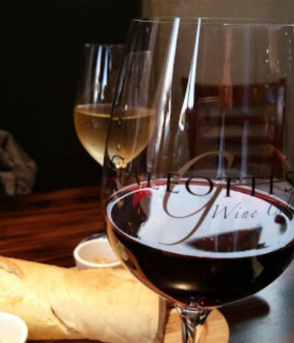
We meet at:
Galeotti’s Wine Cellar
715 East Main Street
Battle Ground, WA 98604

When: Wednesdays from 5:00 to 6:30 PM
Social from 5:00 to 5:30 PM
Meeting starts at 5:30 PM
BGRC Facebook Link
BGRC Webpage Link
For more information or to be removed from this mailing list, please call:
Dan Hanenkrat 360-907-4491

