Friends of Rotary – Newsletter

February 2023
Welcome to our Friends of Rotary Newsletter. Our objective of this newsletter remains to raise the awareness of what our Battle Ground Rotary Club’s (BGRC) programs are each week and what dates and activities our club is organizing.
By providing a forward-looking newsletter, we are hoping to:
- Raise community awareness of what the Battle Ground Rotary Club is focused on.
- Encourage our readers to come to a meeting, meet us and take advantage of the information being provided.
- Encourage our readers to participate in our Community Service projects.
Words from the editor

Welcome friends, We’ve cleared January and it was a time of working out our plans for 2023 and laying the ground work for the upcoming months. We’re excited about having new members join Rotary! It’s great to see the quality of those joining us in service and I look forward to spending time with them while we serve and socialize.

Rotary for me is so much more than our local meetings. As Becky and I travel we often check to see where the local Rotary Club is. Typically there are Rotary wheel signs and Club meeting times posted in City Centers or at important cross roads.

As you look around in each city you will typically find community service projects that those Clubs have committed their time and resources to impact their community.

For our Club we take care of Old Town Battle Ground by cleaning the side walks and weeding twice a year. You will also see wooden benches on both sides of the street that we take care of. Last year we added a couple cross walk flag stations on the East end of Main Street.

Our Sister Club, Lewis River Rotary has taken on the maintenance of Central Park in Old Town. If you’ve not been by there it’s just West of Music World in Old Town.

My point here is that Rotarians care about the livability of their community and those less fortunate in our communities. 32000 Clubs worldwide, 3.2 Million members working together to make a difference one day at a time.

We are blessed to have so many committed to serving!

February is Rotary Peace and Conflict Prevention/Resolution Month
Vocational Services is one of Rotary’s Avenue of Services. As such it implies the significance of having a meaningful vocation. Having a meaningful vocation in tern provides the opportunity to contribute and serve others. Rotarians adhere to the creed of “Service Above Self”. Our members are selected based on their ability and willingness to contribute via time and resources to helping those in need. Our vocations and our willingness to serve are at the center of how we are able to make a to those in need and deepens our relationships.
There is so much more to why Vocational Services is important to being a Rotarian. Introduction to Vocational Services

February Rotarian Articles: Rotary partnership delivers ambulances to Ukraine
Over the past year I’ve been asked “ what can Rotary do to help the Ukrainian?
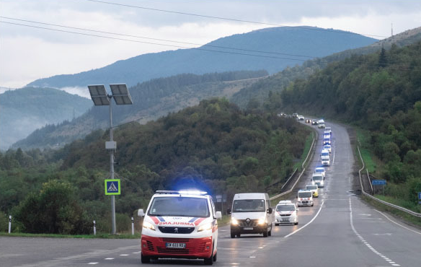
In late September, a convoy of 40 ambulances wound its way from Slovakia, around mountains and through roadblocks, military checkpoints, and torrential rain, to the Ukrainian capital of Kyiv, where the critically needed vehicles were delivered to government officials.
The $600,000 initiative is the first joint project between Rotary and the U.S.-based nonprofit Ukraine Friends, which agreed in July to collaborate to provide resources, organize logistics, and distribute funds for high-impact projects that help Ukrainians affected by the war with Russia. Each organization donated $300,000 to buy the ambulances, and Rotary districts in Ukraine and neighboring Slovakia coordinated the delivery. Link to article

Rotary and Gates Foundation renew partnership
Rotary and the Bill & Melinda Gates Foundation have renewed their longstanding partnership to end polio. The renewal agreement includes a joint commitment of up to $450 million to support the Global Polio Eradication Initiative. Link to article
Our January Meetings are as follows:
We meet at Galeotti’s on Main Street.

January 4nd Social at Prairie Tavern/Bar & Grill starting at 5:30 pm.
January 11th TBD
January 18th TBD
January 25th TBD
Hold the Dates.
March 22rd Festival of Wreaths and Wine 2023 Kickoff meeting, after our normally schedule meeting
Club Member Rotary Anniversaries
Marilyn Moeser 1/26/2022
Club Member Birthdays
Mike Simpson 1/13
Amy Price 1/31
Our Tradition is to end each meeting by reciting Rotary’s 4 Way Test, so I will end each newsletter with this…
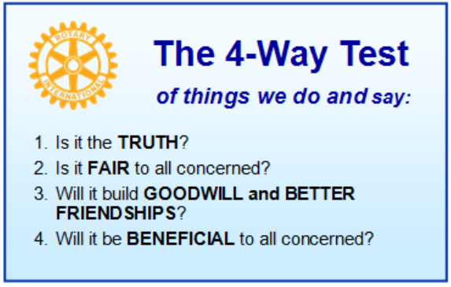
These are tests that we challenge ourselves to live by as Rotarians. But above that we commit to “Service Above Self”, which is Rotary’s motto. This is who we are. We invite you to check us out by participating in one of our projects or attending a meeting.
See you soon hopefully!

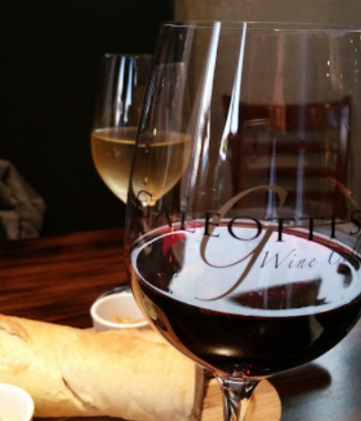
We meet at:
Galeotti’s Wine Cellar
715 East Main Street
Battle Ground, WA 98604

When: Wednesdays from 5:00 to 6:30 PM
Social from 5:00 to 5:30 PM
Meeting starts at 5:30 PM
BGRC Facebook Link
BGRC Webpage Link
For more information or to be removed from this mailing list, please call:
Dan Hanenkrat 360-907-4491

