Friends of Rotary – Newsletter

May 2022

Welcome to our Friends of Rotary Newsletter. Our objective of this newsletter remains to raise the awareness of what our Battle Ground Rotary Club’s (BGRC) programs are each week and what dates and activities our club is organizing.

By providing a forward-looking newsletter, we are hoping to:

* Raise community awareness of what the Battle Ground Rotary Club is focused on.
* Encourage our readers to come to a meeting, meet us and take advantage of the information being provided.
* Encourage our readers to participate in our Community Service projects.

***Words from the editor***

April showers bring us May flowers, Amen

Friends we are living in a crazy world at a crazy time. I’m pretty sure each generation says that, and it’s true. As a retired Navy Reservist, retired IBM services manager and now fully retired, I’ve traveled enough to know that what is taking place around the world is not new.

We are so blessed to live in a nation established on the principles our founders fought and died for. There are millions risking everything to get here and billions who if they could, they would. It troubles me to watch the news and read about how many feel differently.

Rotary for me is an international community of leaders. Normal people, connecting at the local level, organized, networked at regional levels to accomplish change and provide hope. We live by our creed of the Four Way Test and our motto of “Service Above Self”. I’m rehashing this based on it is all too easy to focus on the negative and forget about the good in our human nature.

Let’s be encouragers and actively participate in the good. That is what we have control of.

On that note, our Battle Ground Rotary Club completed several Community Service projects around Battle Ground by picking up trash on Main Street in Old Town between Grace and Parkway and the trash cleanup on the section of SR-503 between Eaton and Onsdorff. The weather cooperated, mostly. Our funding for the therapy table for Battle Ground Healthcare has been approved and the order should be placed next week. Huzzah!!!

We’ve kicked off our planning for this years’ annual fund raiser, Festival of Wreaths and Wine. A big part of what we have to auction is our wine baskets. Last year we auctioned 30 theme baskets and it’s time for us to start collecting baskets for the next auction. If you have a basket that you would like to donate to help us in preparing for the next auction, please contact me.

If you are interested in knowing more, contact me.

Dan Hanenkrat 360-907-4491

##### ***May is Rotary Youth Service Month***

## Rotary’s programs are developing the next generation of leaders, providing funding to make the world a better place, and making peace a priority. And our programs are not just for club members. Learn how you can make a difference in your community through Rotary.

Rotary International Youth Programs

* [Interact, Rotary for high school students](https://www.rotary.org/en/get-involved/interact-clubs)
* [Rotary Youth Leadership Awards (RYLA)](https://www.rotary.org/en/our-programs/rotary-youth-leadership-awards) - Leadership Training for young adults
* [Rotaract, Rotary for College -age adults](https://www.rotary.org/en/get-involved/rotaract-clubs/details)
* [Youth Exchange - Student exchange program](https://www.rotary.org/en/our-programs/youth-exchanges)
* [Grants for skills development](https://www.rotary.org/en/our-programs/grants)
* [Rotary Peace Fellowship](https://www.rotary.org/en/our-programs/peace-fellowships)
* [New Generations Service Exchange](https://www.rotary.org/en/our-programs/new-generations-service-exchange)

*[Link to Entire Article](https://www.rotary.org/en/our-programs)*

***May Rotarian Article: Melodies and Memories***

The good things music does for aging brains

This article provides us some insight to how potent music is in our lifes. How incorporating activity with it, playing, singing provides us the opportunity to interact with others. Stimulating and enhancing our brains activity. Check out the “5 ways to make the most of music”

[*Link to Entire Article*](https://magazine.rotary.org/rotary/may_2022/MobilePagedArticle.action?articleId=1789051&utm_source=newsletter&utm_medium=email&utm_campaign=TXTHE6220505002&utm_content=gtxcel#articleId1789051)

*More from Rotary: People of Action around the globe*

I’m so proud to report that so many good deeds can be done when the common good is the vision.

Our Rotary Magazine does a great job of capturing this. Each month we receive an update on how individuals, Clubs, District and Rotary International are putting Service Above Self to action. These are great examples of what we can do when we say yes.

[*Link to the Entire Article:*](https://magazine.rotary.org/rotary/may_2022/MobilePagedArticle.action?articleId=1789047&utm_source=newsletter&utm_medium=email&utm_campaign=TXTHE6220505002&utm_content=gtxcel#articleId1789047)

***Our May Meetings are as follows:***

We meet at Galeotti’s on Main Street, Social time starting at 5:00, Meeting: 5:30-6:30. For information about the program of the week, be sure to look at our Facebook Page on the Tuesday before the meeting: <https://www.facebook.com/BattleGroundRotaryClub>. It is also usually posted on our BGRC website: [www.battlegroundrotary.org](http://www.battlegroundrotary.org)

May 4th  Fireside Meeting at Galeotti’s

May 11th

May 18th

May 25th TBD

***Hold the Dates.***

May 11th Festival of Wreaths and Wine Planning meeting, after the Club Meeting

May 14th:  Rotary at Your Service – Project, Yard work at Katlin Smith’s

May 19-22nd:  Rotary District 5100 Meeting at Seaside

June 26th: Club Charter BBQ/Picnic and Change of Command @ The Quade’s

July: Center for Peace kids are here from Cyprus, Israel and Palestine

November 27th:  Build Wreaths for FOWW

November 29th:  FOWW On-line Auction Starts

December 3rd:  FOWW at Community Center and Auction Ends

***Club Member Rotary Anniversaries***

Ron Scheurer: May 14th. 8 as a Rotarian

***Club Member Birthdays***

Kayla Tiano, May 18th

***Our Tradition is to end each meeting by reciting Rotary’s 4 Way Test, so I will end each newsletter with this…***

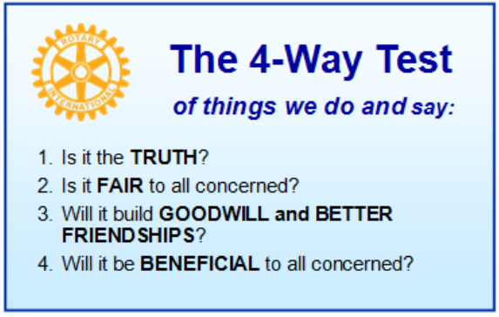

These are tests that we challenge ourselves to live by as Rotarians. But above that we commit to “Service Above Self”, which is Rotary’s motto. This is who we are. We invite you to check us out by participating in one of our projects or attending a meeting.

See you soon hopefully!

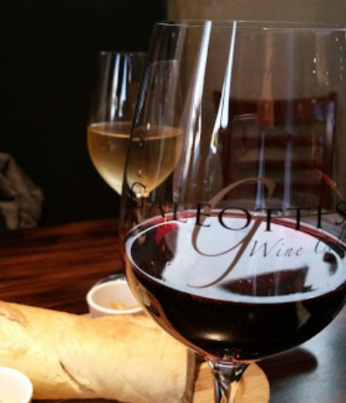**We meet at:**

Galeotti’s Wine Cellar

715 East Main Street

Battle Ground, WA 98604

When: Wednesdays from 5:00 to 6:30 PM

Social from 5:00 to 5:30 PM

Meeting starts at 5:30 PM

*BGRC Facebook* [*Link*](https://www.facebook.com/BattleGroundRotaryClub/)

*BGRC Webpage* [*Link*](http://battlegroundrotary.org/)

*For more information or to be removed from this mailing list, please call:*

*Dan Hanenkrat 360-907-4491*