Friends of Rotary – Newsletter

March 2022

Welcome to our Friends of Rotary Newsletter. Our objective of this newsletter remains to raise the awareness of what our Battle Ground Rotary Club’s (BGRC) programs are each week and what dates and activities our club is organizing.

By providing a forward-looking newsletter, we are hoping to:

* Raise community awareness of what the Battle Ground Rotary Club is focused on.
* Encourage our readers to come to a meeting, meet us and take advantage of the information being provided.
* Encourage our readers to participate in our Community Service projects.

***Words from the editor***

We’re turning the corner on winter and COVID. In a week or so, we’ll be able to see each other’s smiling faces and spring will arrive! The last couple of years for us has been historic. It’s not just been COVID and loss of friends and family. It’s been a time of social and political unrest.

We’ve seen the best in people and the worst as we navigate the times.

For me, I am thankful for my faith, family, friends, community, and my trust that negativity will not rule the day.

As a Rotarian, I’m connected with an amazing group of individuals, each unique and special. These are people who have chosen to engage in our community to make it a place we can call home. A place where we are able to hear the concerns and needs of others and do something about it. A place where we can be part of the solution. A community where we can establish connections and grow friendships as a side benefit.

We’ve weathered the last 18 months and have deepened our commitment to “Service Above Self”.

I’ll close with the statement that Rotary as an international organization is actively working to address the humanitarian crisis taking place in the Ukraine. There are opportunities to help. One of those is to donate. The attached link provides that opportunity. [Disaster-Response-Fund](https://my.rotary.org/en/disaster-response-fund)

If you are interested in knowing more, contact me.

Dan Hanenkrat 360-907-4491

##### ***March is Rotary Water and Sanitation Month***

# ***March Rotarian Article:* Parents, Unite**

When families get the support they need, everyone benefits. So let’s all fight for it as a ‘parent nation’

*by Dana Suskind*

**Excerpts from the article:**

Early in my practice as a pediatric cochlear implant surgeon, I noticed stark differences in my patients’ progress after surgery. Some children excelled developmentally; others did not. Some learned to talk; others did not. The ability to hear, it turned out, wasn’t enough to unlock their full capacity to learn and thrive. I could neither accept nor ignore the disturbing disparities I saw, but I didn’t understand them. So, I journeyed outside the operating room and into the world of social science.

What I found surprised me: The vast majority of brain growth — close to 90 percent — happens within the first five years of a child’s life and is highly dependent on their early language environment. I set out to share that science more broadly, both with my first book, Thirty Million Words: Building a Child’s Brain, and at the TMW Center for Early Learning + Public Health, which I co-direct at the University of Chicago. (I even shared it with Rotary via this magazine in December 2018.) I was thrilled when people eagerly read the book and participated in our programs. But the more deeply I engaged with families, the more troubled I became. The strategies and science took parents only so far before problems too often intruded: multiple jobs, no paid leave, a patchwork quilt of child care, poverty, homelessness, and structural racism. And too many parents, rather than demanding more support, felt ashamed that they couldn’t bear the enormous responsibility of child-rearing alone and remained silent.

… That’s why I want us to build what I call a "parent nation" — in the United States and around the globe. A parent nation, as I see it, is a society that cherishes and supports the nurturing, raising, and educating of future generations. And when I say "parent," I mean any caring adult. Just as Rotary’s polio eradication efforts have lengthened and improved millions of young lives around the world, so can a concerted effort to help children reach their full promise.

…Conclusion: Progress for children and their caregivers will require policy changes. Some solutions, such as paid family leave and subsidized child care, are obvious. Others, like portable benefits and fair workweek laws, are less so. I am not a policymaker or expert. But I can confidently say this: If brain science is the roadmap, it is parents who should do the steering. And the time to build a parent nation, to set our nation and world on a path to equality and prosperity, is now.

With Rotary’s long and rich history of service above self, together we can build a parent nation.

[*Link to Entire Article*](https://magazine.rotary.org/rotary/march_2022/MobilePagedArticle.action?articleId=1770760&utm_source=newsletter&utm_medium=email&utm_campaign=TXTHE6220302002&utm_content=gtxcel%23articleId1770760)

*More from Rotary:* How to Bounce Back – Build resilience in yourself and others

# *I’m adding this article even though it was in last months’ Rotary Magazine.*

# Learn practical tips to strengthen your resilience, and how to instill resilience in others

by **Louis Greenstein**

Why do some people spring back from hardship while others struggle? Experts agree that resilience is a function of several elements, including genetics, trauma, and personal development, not necessarily in that order. Each of us is genetically hardwired to recover after a failure — some more quickly than others. And, to an extent, our resilience is informed by our experiences. A young person who is abused, neglected, or abandoned is less likely to develop the resilience of one who was nurtured and supported. But most important, whatever degree of resilience we possess, we can always work to increase it. Resilience gets projects accomplished and polio eradicated. It beats the odds, turning losses into wins. Which leads to the question: What, exactly, *is* resilience?

Link to the entire article to learn more about how to develop the art of bouncing back and what are the 7 C’s of Resilience

[Link to the Entire Article:](https://www.rotary.org/en/how-bounce-back-build-resilience-yourself-and-others)

***Our March Meetings are as follows:***

We meet at Galeotti’s on Main Street, Social time starting at 5:00, Meeting: 5:30-6:30. For information about the program of the week, be sure to look at our Facebook Page on the Tuesday before the meeting: <https://www.facebook.com/BattleGroundRotaryClub>. It is also usually posted on our BGRC website: [www.battlegroundrotary.org](http://www.battlegroundrotary.org)

March 2nd  Social at Hanenkrat’s

March 9th  TBD

March 16th TBD

March 23rd TBD

March 30th TBD

***Hold the Dates.***

March 23rd Festival of Wreaths and Wine 2022 Kickoff meeting, after our Club meeting

March 27th Club Fireside/Social at the Hanenkrat’s

March 30th Board Meeting after Club Meeting

April 20th Main Street Beautification

April 27th Board Meeting after Club Meeting

April 30th Highway 503 Clean Up

May 14th Rotary at Your Service – Project, Yard work at Katlin Smith’s

May 19-22nd Rotary District 5100 Meeting at Seaside

June 26th Club Charter BBQ/Picnic and Change of Command

November 27th Build Wreaths for FOWW

November 29th FOWW On-line Auction Starts

December 3rd FOWW at Community Center and Auction Ends

***2022 Festival of Wreaths and Wine,***

We’re starting to gather baskets and items for this year’s fundraiser. If you have baskets that we can use or re-use we’d like to start collecting them.

Additionally, we’ll start establishing sponsors for the baskets and wreaths.

We’ll be hosting an on-line auction and community center event again this year. We welcome your feedback and suggestion on how we can make this successful for you and us.

You can call or email Dan Hanenkrat, 360-907-4491 or dphanenkrat@gmail.com

***Club Member Rotary Anniversaries***

Becky Hanenkrat: March 26th. 8 with BGRC, 24 as a Rotarian

Dan Hanenkrat: March 11th, 7 with BGRC, 13 as a Rotarian

***Club Member Birthdays***

Kandida Sabo, March 6th

***Our Tradition is to end each meeting by reciting Rotary’s 4 Way Test, so I will end each newsletter with this…***

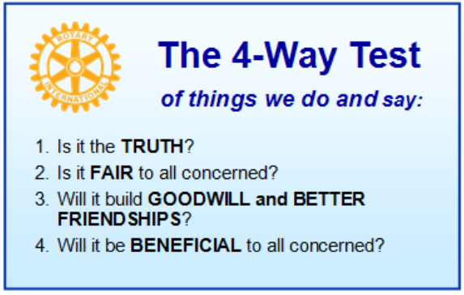

These are tests that we challenge ourselves to live by as Rotarians. But above that we commit to “Service Above Self”, which is Rotary’s motto. This is who we are. We invite you to check us out by participating in one of our projects or attending a meeting.

See you soon hopefully!

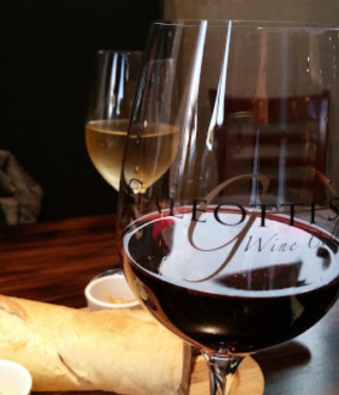**We meet at:**

Galeotti’s Wine Cellar

715 East Main Street

Battle Ground, WA 98604

When: Wednesdays from 5:00 to 6:30 PM

Social from 5:00 to 5:30 PM

Meeting starts at 5:30 PM

*BGRC Facebook* [*Link*](https://www.facebook.com/BattleGroundRotaryClub/)

*BGRC Webpage* [*Link*](http://battlegroundrotary.org/)

*For more information or to be removed from this mailing list, please call:*

*Dan Hanenkrat 360-907-4491*