Friends of Rotary – Monthly Newsletter

July 2021

Welcome to our Friends of Rotary Newsletter, June 2021. Our objective of this newsletter remains to raise the awareness of what our Battle Ground Rotary Club’s (BGRC) programs are each week and what dates and activities our club is organizing.

By providing a forward-looking newsletter, we are hoping to:

* Raise community awareness of what the Battle Ground Rotary Club is focused on.
* Encourage our readers to come to a meeting, meet us and take advantage of the information being provided.
* Encourage our readers to participate in our Community Service projects.

***Words from the editor***

Most of you know that our Rotary year is from July 1 to June 30th and that means, I am finishing my year as Club President. I am passing the baton to Jeff Quade who was our President Elect for the last year.

I would like to thank our Club Members and our Friends of Rotary for the amazing support you have provided me. We as a Club weathered not meeting in person and ZOOMing for most of my term. During that time, we still lived our motto, “Service Above Self”.

We also completed a couple of fund raisers in spite of being in social isolation.

We donated a physical therapy table to Battle Ground Health care. We sent money to Kenya to feed the four students we sponsor. Due to schools being closed, they had been sent back to their villages and their families did not have enough food. We did two Main Street Battle Ground Beautification events. Masked up, we weeded and picked up trash in the Old Town section of Main Street. We responded to the needs of the survivors of the Santiam wildfires with basic needs for those who lost their homes. We refurbished the park benches on Main Street, bringing them back to useable condition.

We did our best to not let COVIDs impact our making a difference. Thank You

***June Programs Recap***

**June 2nd:** Our Social was to be a Main Street Clean up event. As it turned out it was 90 + degrees, so we went to plan B and everyone went to Emanar Cellars, in the Village.



They have awesome Spanish wines, patio seating and tasty food.

Emanar sponsored a Spanish Wine basket at last years Festival of Wreaths and Wine!

We rescheduled our clean up to June 26th, 9 AM 😊.

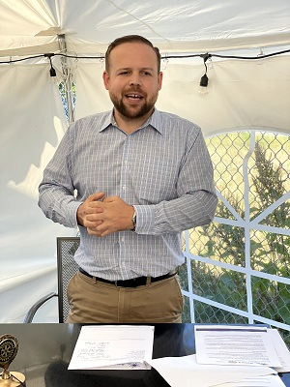**June 9th**  NW Assoc. of Blind Athletes, Billy Henry

As a freshman in high school, Billy Henry and some buddies from his power lifting team were hanging out and came up with an idea that has been a life-changing opportunity, not only for Billy, but for thousands of vision-impaired in the Northwest.  
In 2007, the Northwest Association of Blind Athletes was founded with the mission to provide confidence, self-esteem, a higher quality of life and the belief for vision impaired individuals that they can do anything they want to do.   
Billy shared the history of the NWABA with Battle Ground Rotary club.  NWABA currently runs 6 different programs and services for the visually impaired.     
SPORTS OUTREACH:  Providing on-going programs, Paralympic Experiences, clinics, and camps.  
SPORTS TEAMS: Supporting teams that compete in local, regional, and national competitions.  
SPORTS ADAPTATIONS: Offering access to adaptive sports equipment through our Equipment Lending Library.  
INCREASING VISIBILITY: Spreading awareness about visually impaired individuals and their athletic capabilities.  
SCHOLARSHIPS: Providing small scholarships for participants to continue to reach their greatest potential.  
CAMP SPARK: Coaching kids during a week-long comprehensive sports camp.

[Read More](javascript:void(0))

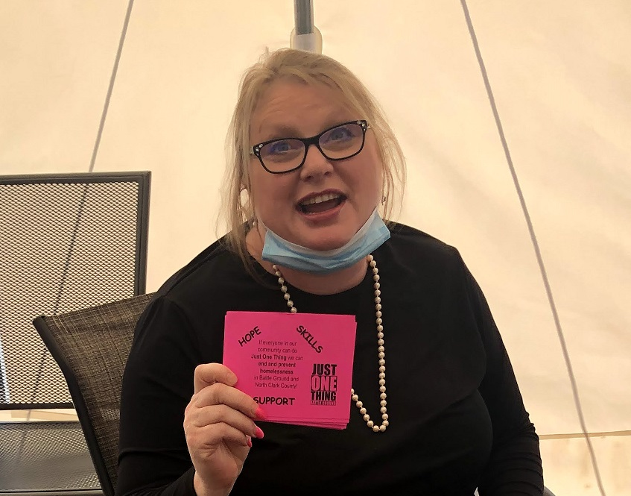

**June 16th Battle** Ground Rotary Club hosted Lydia Sanders from the BGSD Family-Community Resource Center (FCRC)

for the third time. It NEVER gets old!  Lydia has been the homeless liaison since 2005.   As usual, it was a wonderful presentation and a lot of discussion around some big challenges that the BGSD and the Battle Ground community face with homelessness, with a particular focus on teens.

For those of you unfamiliar with the work of FCRC, Battle Ground Public Schools’ Family and Community Resource Center (FCRC) helps meet the needs of families faced with housing instability and similar economic challenges.  The center’s staff of 6 full time, along with 20+ tutors and mentors, fields request for a variety of resources to help those in need.  Those requests typically include items such as school supplies, backpacks, winter clothes and personal items that enable students to stay focused on their studies.  While a main goal of the FCRC is to assist families experiencing housing instability, it can also help connect families with many other types of resources and is intended to respond to the changing needs of the community.

Lydia started off sharing some really positive news:   the number of homeless in the BGSD has been going down for the last couple of years.  Homeless does not mean shelter-less like sleeping in tents – it means not living at home – which could mean living with someone else, doubling up, or couch-surfing.  Last year, there were 272, and this year, there are 223.  This is a huge difference in BGSD from 5 years ago, when the number reached 361.  The major improvement is unique to BGSD, as they are the only school district whose homeless numbers are declining.  Until last month, there were no youth sleeping outside during the school year.  The good news is that even with COVID-19, only three unaccompanied youth were sleeping in their cars, and there are no families with small children outside.  Lydia shared that this is due to some key intentional actions taken by the FCRC.

During the pandemic crisis, Lydia noticed that many of FCRCs familiar families were struggling, but they seem to be making things work.  With the relief, the ‘no evictions’, and the emergency food options, they seem to be getting by.  What will be telling is when the no eviction order is lifted.   The FCRC is expecting the needs in the community to increase significantly over the next school year.

[Read More](javascript:void(0))

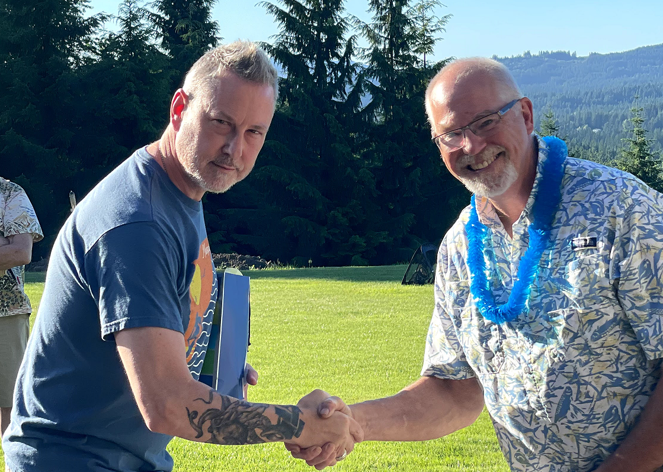

**June 23rd** Annual Club Change of Leadership Picnic

 Club President Dan Hanenkrat turns the reins over to President-Elect Jeff Quade for the new Rotary year.   
Battle Ground Rotary had a Hawaiian-themed Charter Picnic Wednesday 6/23 to recognize the Board members that have served all year and induct the new Board for the 21-22 Rotary Year.

President Dan Hanenkrat recognized all the 2020-21 board members with BGRC wine glasses as a gift and received a President Plaque for his service throughout one of the most challenging years a Rotary Club President could face.

More than that, it was just great fun, with great food, and great weather!!! We love getting together, and it was so fantastic to be able to finally really do it!

Go to our website, www.battlegroundrotary.org and the Photo Gallery to see how great the day was!

**June 30th**  Darren Davidson Classification Talk

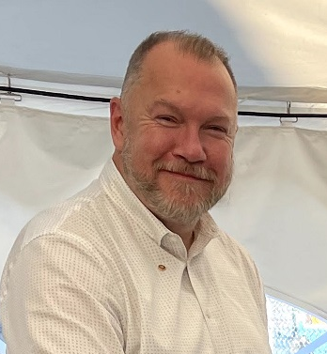On June 30th, at the BG Rotary Club meeting, one of our newest members, Darren Davidson gave a “classification talk”. In Rotary-speak, that means they introduce themselves to the club, talk about their past, how they got to where they are in life, both from a career perspective, as well as from a personal perspective, if they so choose.

Darren shared an interesting background. Today, Darren works for NY Life as a Financial Advisor, but his path to arrive in this career is not typical.

As a high school youth, Rotary stole a special place in his heart. A neighbor in his town kept asking him to a local Rotary Club meeting, and Darren was so impressed by the good works and the leadership that he worked with them on their projects, even as a high schooler. Then the Rotary Club sent him to the Freedom of Leadership conference in Valley Forge, PA, his first time on an airplane. After graduation, he received a Rotary Scholarship, helping him get through college.

[Read More about Darren here](http://www.battlegroundrotary.org/)

***July is Rotary Foundation Month***

We will take time during each meeting to highlight Rotary International Foundation.

# ***July Rotarian Article: Our vision for a better world***

As most of you know The Rotary Foundation plays a major role in our local clubs being able to do the larger, more impactful services. In this month’s Rotarian Foundation Trustee Chairman John Germ shares his thoughts on how Rotary and the Foundation are evolving and adding the focus are of environmental sustainability.

Rotary believes in improving the human condition throughout the world, for all.

This article highlights Our basic beliefs and values that allow Rotarians to stay focused on the common good of making the world a better place for all.

[For the complete article](https://magazine.rotary.org/rotary/july_2021/MobilePagedArticle.action?articleId=1703083&utm_source=newsletter&utm_medium=email&utm_campaign=TXTHE6210625002&utm_content=gtxcel%23articleId1703083)

***Our July Meetings are as follows:***

BGRC has started to meet in person again. We meet at Galeotti’s on Main Street.

July 7th: Club Social at – Ridgefield Raptors Baseball Game

July 14 th

July 21st North County Community Food Bank, Liz Cerveny

July 28th

***Hold the Dates.***

August XXth Festival of Wreaths and Wine Planning Meeting

August 25th **District Governor** Visit and Board Meeting

November 28th Build Wreaths and Wine Baskets

November 30th – December 4th Wreath and Basket Online Auction

December 4th Festival of Wreaths and Wine at Battle Ground Community Center

***Club Member Rotary Anniversaries***

None this month

***Club Member Birthdays***

Shawna Quade July 20th

***New stuff: BGRC Online Garage Sale for fundraising***

Our Club has opened an online garage sale to help us raise funds to support our club operations. Each month we will open an online auction for donated items and services. This is new for us yet provides us a means to help fund us during these unusual times.

If you have something you want to donate for us to sell, please email Dan_Hanenkrat@msn.com

The link to this month Garage sale is [Garage Sale](https://event.auctria.com/d8ee9a75-2a0c-4652-8a26-0ae62864bda7/aa6cd270-8751-11e9-a741-3fcfcb35cbb0)

There is a cash donation option at this site.

***Festival of Wreaths and Wine (FOWW) Save the Date***

This year’s FOWW will be a hybrid event. The online auction worked so well last year that we will keep it. We will combine the online auction with an event at the Battle Ground Community Center. At the Community Center we will have live music, wines from local wineries available for purchase, catered food. Attendees will be able to review the auction items and track their bid status via the online auction.

Last year we grossed $8,900, netting about $8,000. Our Goal this year will be to net $10,000. This auction is how we fund helping those in need, locally and internationally.

We are seeking sponsors for Wreaths and the Wine Baskets. You can sponsor a wreath for $100. The baskets are typically based on donated wines, merchandise, or services.

Our Event Sponsor last year was Your Insurance Gal Agency, Owner Stacey Johnson donated $1,000 and took home the wreath that she created. Photo attached. Thank You!

Please contact Dan Hanenkrat if you are interested in being a sponsor or donor this year. 360-907-4491

***Our Tradition is to end each meeting by reciting Rotary’s 4 Way Test, so I will end each newsletter with this…***

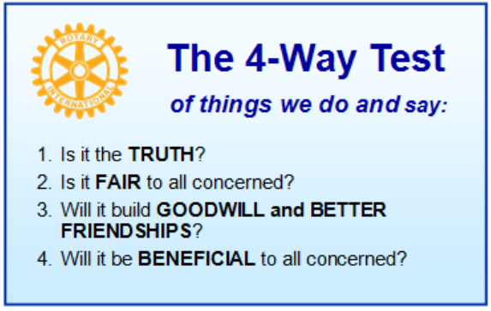

These are tests that we challenge ourselves to live by as Rotarians. But above that we commit to “Service Above Self”, which is Rotary’s motto. This is who we are. We invite you to check us out by participating in one of our projects or attending a meeting.

See you soon hopefully!

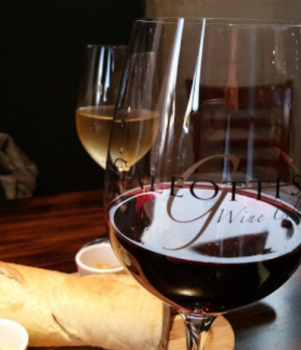

**We meet at:**

Galeotti’s Wine Cellar

715 East Main Street

Battle Ground, WA 98604

When: Wednesdays from 5:00 to 6:30 PM

Social from 5:00 to 5:30 PM

Meeting starts at 5:30 PM

*BGRC Facebook* [*Link*](https://www.facebook.com/BattleGroundRotaryClub/)

*BGRC Webpage* [*Link*](http://battlegroundrotary.org/)

*For more information or to be removed from this mailing list, please call:*

*Dan Hanenkrat 360-907-4491*