Friends of Rotary – Newsletter

February 2022

Welcome to our Friends of Rotary Newsletter. Our objective of this newsletter remains to raise the awareness of what our Battle Ground Rotary Club’s (BGRC) programs are each week and what dates and activities our club is organizing.

By providing a forward-looking newsletter, we are hoping to:

* Raise community awareness of what the Battle Ground Rotary Club is focused on.
* Encourage our readers to come to a meeting, meet us and take advantage of the information being provided.
* Encourage our readers to participate in our Community Service projects.

***Words from the editor***

Hi friends, it’s been a while since I’ve sent a newsletter. A lot has taken place since the last one.

As most of you know we were heads down in November and December focused on our annual fundraiser, Festival of Wreaths and Wine. As an Online Auction and live event at the Battle Ground Community Center it was a great success. We netted our objective of $15,000. Thank you!

Thank you to the sponsors, donors, bidders, and those who attended and to those in our Club that put in the hours to help us raise the funds that fuel our giving.

January is the month at Rotary focuses on establishing/votes on our Clubs leadership for President in 2023-24 and our Clubs Secretary for the next two years.

Darren Davidson was elected to be Club President in 2023-24. This means he’ll be our Membership Chair in 2022-23 and President Elect in 2023-24 and assuming the President position in July of 2024.

Kandida Sabo will take over from Amy Price as our Club Secretary in July of 2022.

We are blessed that they are so committed to serving our Club and our community.

##### ***February is Rotary*** Peacebuilding and Conflict Prevention Month

***February Rotarian Article: The Seven Centers of Peace***

Learn more about how Rotary creates leaders fostering peace throughout the world. This article drills down into how each of these Seven Centers are dedicated to graduating difference makers. Situated in difference parts of the world, the Rotary Peace Centers offer tailor-made curricula to train individuals devoted to peacebuilding and conflict resolution – no matter where they land.

[*Link to article*](https://magazine.rotary.org/rotary/february_2022/MobilePagedArticle.action?articleId=1764025#articleId1764025)

***February Rotary Projects Around the Globe:***

Franklin, TN. USA: Rotarians clean up the old City Cemetery

Canada: Redesign and rejuvenation of a duck pond in a heavily used park in Manitoba

England: Dragon Boat races raise over $30,000 for charity

India: 250 students participate in a “Freedom from Polio” Art contest

Phillipines: Planting and restoration of mangrove trees

[*Link to article:*](https://www.rotary.org/en/rotary-projects-around-globe-february-2022)

***Our February Meetings are as follows:***

We meet at Galeotti’s on Main Street.

February 2nd  Social at Galeotti’s

February 9th C-Tran, Eric Florip

Mass Transit Magazine names C-TRAN's Eric Florip to "40 Under 40" list

C-TRAN is the regional public transportation provider for portions of Clark County. It offers Local bus service within its Clark County service area, Regional bus service to the nearest MAX light rail station, and Express commuter service to downtown Portland. It also provides Connector service within the city limits of Camas, La Center, and Ridgefield.

February 16th TBD

February 23rd  TBD

***Hold the Dates.***

March 23rd Festival of Wreaths and Wine 2022 Kickoff meeting, After our normally schedule meeting

March 27th Club Fireside/Social

April 20th Main Street Beautification

May 19-22nd Rotary District 5100 Meeting at Seaside

June 25th Club Charter BBQ/Picnic and Change of Command

November 27th Build Wreaths for FOWW

November 29th FOWW On-line Auction Starts

December 3rd FOWW at Community Center and Auction Ends



***Club Member Rotary Anniversaries***

None

***Club Member Birthdays***

None

***Our Tradition is to end each meeting by reciting Rotary’s 4 Way Test, so I will end each newsletter with this…***

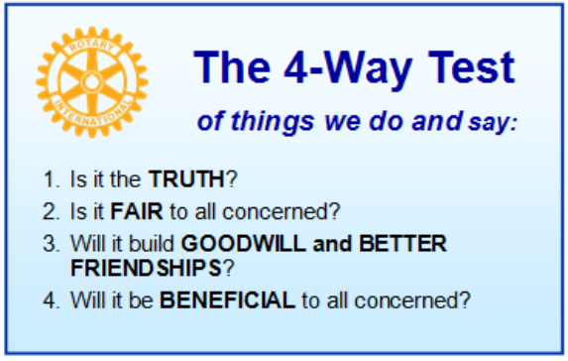

These are tests that we challenge ourselves to live by as Rotarians. But above that we commit to “Service Above Self”, which is Rotary’s motto. This is who we are. We invite you to check us out by participating in one of our projects or attending a meeting.

See you soon hopefully!

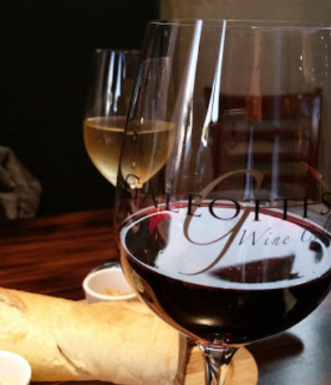**We meet at:**

Galeotti’s Wine Cellar

715 East Main Street

Battle Ground, WA 98604

When: Wednesdays from 5:00 to 6:30 PM

Social from 5:00 to 5:30 PM

Meeting starts at 5:30 PM

*BGRC Facebook* [*Link*](https://www.facebook.com/BattleGroundRotaryClub/)

*BGRC Webpage* [*Link*](http://battlegroundrotary.org/)

*For more information or to be removed from this mailing list, please call:*

*Dan Hanenkrat 360-907-4491*