Friends of Rotary – Newsletter

April 2022

Welcome to our Friends of Rotary Newsletter. Our objective of this newsletter remains to raise the awareness of what our Battle Ground Rotary Club’s (BGRC) programs are each week and what dates and activities our club is organizing.

By providing a forward-looking newsletter, we are hoping to:

* Raise community awareness of what the Battle Ground Rotary Club is focused on.
* Encourage our readers to come to a meeting, meet us and take advantage of the information being provided.
* Encourage our readers to participate in our Community Service projects.

***Words from the editor***

April marks our families push to get our yards and gardens back in shape. It also opens up our march to this summers’ activities. This summer will be like no other in a long time.

As a family, we’ll focus on rebuilding the bridges of separation and time away from each other. In a way, we’ve been blessed with technology that allows us to stay connected. Zoom, Facebook, and so many other technologies have their pro’s and con’s, but during the last two years, the ability to connect while isolated has made a huge difference in so many lives.

This spring BGRC will be once again working with the City of Battle Ground, and volunteering our time to maintain/beautifyi Main Street in Old Town between Grace and Parkway. You may see us out there weeding, picking up trash, planting some flowers and making it look as attractive as possible to visitors. We will also resume the trash cleanup on the section of SR-503 between Eaton and Onsdorff which we do in conjunction with WA-DOT.

For those of you who contributed to our annual Fundraiser, The Festival of Wreaths and Wine last December, we are so grateful. The monies raised have enabled us to fund our commitments for the four youth in the Kenya Rise to Shine Educational Program (<https://www.rtsef.org/>) for their tuition and board for school. We are also in the process of buying our second physical therapy table for Battle Ground Healthcare (<https://battlegroundhealthcare.org/>) . We’ve already funded our annual Shelter Box ([www.shelterboxusa.org](http://www.shelterboxusa.org)) and are about to send enough money to “purchase” 10 Justa stoves as part of commitment to Stove Team International (<https://www.stoveteam.org/>) which transforms lives in Central America.

Friends, YOU make that possible! Thank you

This month we will be forming a working party to clean up Main Street Old Town on the 20th of April.

Then on the 30th we will meet at the Safeway in Battle Ground at 9am to walk SR-503 and clean up the trash along the highway.

If you are interested in knowing more, contact me.

Dan Hanenkrat 360-907-4491

##### ***April is Rotary Maternal and Child Health Month***

***April Rotarian Article:* Strength in times of crisis**

**Past and current conflicts have had a significant impact on Rotary in Ukraine — which has only made members there more resolute**

**U**kraine is an agricultural powerhouse and a country of significant technological and strategic importance, but it has had a turbulent history. The buildup to the Russia- Ukraine war that began in February preoccupied many members of Rotary around the world, who worried about the future of Rotary within Europe’s second-largest country.

[*Link to Entire Article*](https://magazine.rotary.org/rotary/april_2022/MobilePagedArticle.action?articleId=1779765#articleId1779765)

## *More from Rotary: Setting the stage*

**For better collaberation, create the right conditions**

Think about the last time you worked with other people. Maybe it was a project at your job, or service in your community. How did it go? Did everyone do their share? Would they want to work together again?

As you ask yourself these questions, you may be thinking about each team member’s strengths and capabilities. Not a bad thing to consider. But what if there were another way to think about working together? What if in addition to "Have we assembled the right people?" we were to ask, "Have we set the right conditions for a successful collaboration?"

[Link to the Entire Article:](https://magazine.rotary.org/rotary/april_2022/MobilePagedArticle.action?articleId=1779760#articleId1779760)

***Our April Meetings are as follows:***

We meet at Galeotti’s on Main Street, Social time starting at 5:00, Meeting: 5:30-6:30. For information about the program of the week, be sure to look at our Facebook Page on the Tuesday before the meeting: <https://www.facebook.com/BattleGroundRotaryClub>. It is also usually posted on our BGRC website: [www.battlegroundrotary.org](http://www.battlegroundrotary.org)

April 6th  Social at Main Street Floral

April 13th  Classification Table, Andrew

April 20th Main Street Beautification work Party

April 30th TBD

***Hold the Dates.***

April 20th:  Main Street Beautification – Meet at Galeotti’s

April 27th: Board Meeting after Club Meeting

April 30th:  Highway 503 Clean Up

May 4th:  Club Fireside meeting

May 14th:  Rotary at Your Service – Project, Yard work at Katlin Smith’s

May 19-22nd:  Rotary District 5100 Meeting at Seaside

June 26th: Club Charter BBQ/Picnic and Change of Command

July: Center for Peace kids are here from Cypress, Israel and Palestine

November 27th:  Build Wreaths for FOWW

November 29th:  FOWW On-line Auction Starts

December 3rd:  FOWW at Community Center and Auction Ends

***2022 Festival of Wreaths and Wine***

We’re starting to gather baskets and items for this year’s (2022) fundraiser. If you have baskets that we can use or re-use we’d like to start collecting them.

Additionally, we’ll start establishing sponsors for the baskets and wreaths.

We’ll be hosting an on-line auction and community center event again this year. We welcome your feedback and suggestion on how we can make this even more successful for you and us.

You can call or email Dan Hanenkrat, 360-907-4491 or dphanenkrat@gmail.com

***Club Member Rotary Anniversaries***

Terry Reddish: April 16th. 8 as a Rotarian

Kandida Sabo: April 12th. 5 as a Rotarian

***Club Member Birthdays***

David Welch, April 24th

***Our Tradition is to end each meeting by reciting Rotary’s 4 Way Test, so I will end each newsletter with this…***

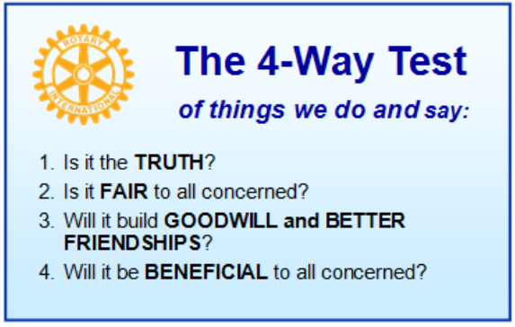

These are tests that we challenge ourselves to live by as Rotarians. But above that we commit to “Service Above Self”, which is Rotary’s motto. This is who we are. We invite you to check us out by participating in one of our projects or attending a meeting.

See you soon hopefully!

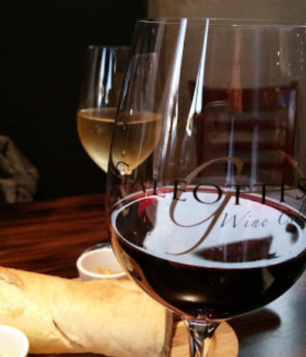**We meet at:**

Galeotti’s Wine Cellar

715 East Main Street

Battle Ground, WA 98604

When: Wednesdays from 5:00 to 6:30 PM

Social from 5:00 to 5:30 PM

Meeting starts at 5:30 PM

*BGRC Facebook* [*Link*](https://www.facebook.com/BattleGroundRotaryClub/)

*BGRC Webpage* [*Link*](http://battlegroundrotary.org/)

*For more information or to be removed from this mailing list, please call:*

*Dan Hanenkrat 360-907-4491*