Friends of Rotary – Monthly Newsletter

May 2021
Welcome to our Friends of Rotary Newsletter, May 2021. Our objective of this newsletter remains to raise the awareness of what our Battle Ground Rotary Club’s (BGRC) programs are each week and what dates and activities our club is organizing.
By providing a forward-looking newsletter, we are hoping to:
- Raise community awareness of what the Battle Ground Rotary Club is focused on.
- Encourage our readers to come to a meeting, meet us and take advantage of the information being provided.
- Encourage our readers to participate in our Community Service projects.
Words from the editor

Hopefully this newsletter finds you in good health and spirits.

I’ve been writing this newsletter now for over a year in hopes our Friends of Rotary are interested in keeping track of what we’re up to. The secondary purpose is to promote and encourage participation.

To say that COVID restrictions impacted our membership and our ability to volunteer as we had in the past, understates the impact.

In last month’s newsletter I recapped what we were able to accomplish. With your help!

We are now meeting in person again and it is time for me extend an invitation for you to come and check us out. For those who left due to not being a fan of ZOOM meetings, that’s behind us hopefully.

May’s Social is 5/5 at 5:30 at the La Uva Fortuna Farm (Rusty Grape). We’d love to see you there.

As a Club we are striving to make a difference in our community and internationally. If you would like to know more about us. Please call me.

Dan Hanenkrat 360-907-4491

Aprils Programs Recap

April 7th: Our Social was at Community Travel. Sherrie Wilson, the owner.

BGRC is so grateful to Sherrie at Community Travel in Battle Ground http://www.community-travel.com/ for hosting a Rotary Social last Wednesday night. We had the opportunity to learn about her business, ask questions about traveling now with the pandemic still going, and enjoy some great food and wine! Sherrie even had some gift items to raffle off!
Congratulation to Kandida Sabo for being the highest bidder on an amazing basket that Sherrie provided!

April 14th Reflector New Ownership, Coralee Taylor
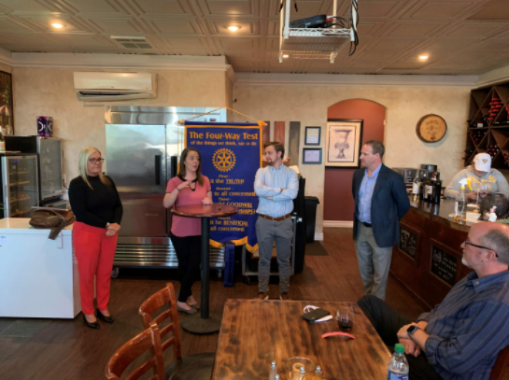
BGRC was delighted to host the new owners of the Reflector, BG's own community newspaper.
In the picture from left to right: Coralee Taylor - CEO, Justina Tomtas - regional editor, Franklin Taylor- Vice President, and Chad Taylor - Publisher
CT Enterprises owns three papers including the Reflector. The team spoke to us about the history of their business, our paper the Reflector. We were privileged to hear the direction they want to move and the value they place on journalism. They shared insights to the industry which some believe to be dead but is a valuable community tool to create connection and closeness.
About The Reflector
The Reflector Has Provided Community News Since 1909
Regular weekly features include agriculture, sports, vital statistics, people, home and family, and editorials. Lively letters to the editor are "first reading" for many people each week. Monthly features include pets, horse corral, and home improvement sections. The weekly Calendar of Events and Happenings sections keep local citizens up-to-date on what's happening in the area.

April 21th Grief Recovery, Jeanine Jackson

Jeanine Jackson of Ashbrook Aesthetics spoke to us about the Wild Branch Counseling Center's newly certified counselors, Jeanine Jackson, Mike Galeotti, and Michael Galeotti. Her presentation featured descriptions of grief and it's devastating impact on people, physically, mentally, and relationally. From the loss of a loved one, a business, a pet, a marriage, we all are going to be affected by grief throughout our lives. The Grief Recovery Method is an action-based program that has proven results. Jeanine is currently running her pilot program and is seeing wonderful results.

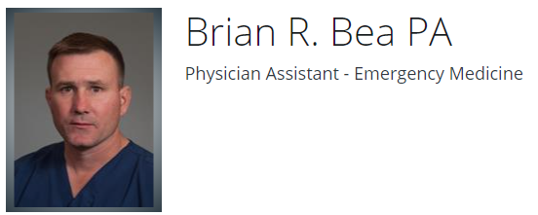

April 28th Provider perspective of COVID,

On Wednesday, April 28, BGRC was privileged to have Colonel Brian Bea, PA-C come and speak to us about his family and career as a medical professional, and engage in a discussion about his recent experiences working with COVID patients in the area.
When asked about COVID vaccinations, he was very clear – he served our country so that every individual could have the choice to be able to vaccinate or not. As a PA, he believes it’s important, but also recognizes that every individual’s health is different, and the vaccine has not been tested against every auto-immune issue. He recommended that those who have health issues be sure to discuss with their doctor whether the vaccine is right for them.
He shared some tragic stories about COVID in the ER that he witnessed. Young people gone in hours, older patients in the hospital for weeks. He also emphasized that COVID and the flu are clearly different. The viruses react differently to treatment, but the measures being taken to control the spread of COVID have made a huge difference in our normal flu season outbreak. Wearing masks, washing hands and social distancing have done more against the flu than at any time in history.
For the longer article, go to www.battlegroundrotary.org
May is Rotary Youth Service Month
We will take time during each meeting to highlight Rotary Youth Service initiatives

May Rotarian Article: Rotary’s Hidden Influence
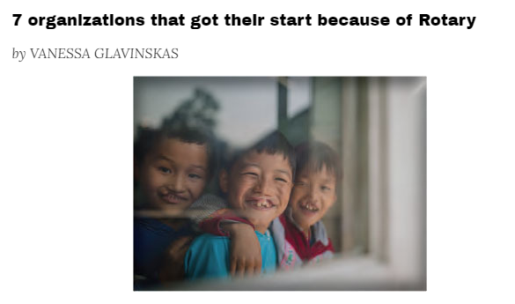
Rotary’s positive influence on the world extends far beyond its members and its clubs. From medical missions to disaster relief to combating climate change, Rotary plays a role in a vast array of initiatives that help humanity. The reach and impact of Rotary’s work are a testament to Rotary members’ leadership, passion, and drive to help others.
Below, we look at some organizations that have grown out of a Rotary project or an individual member’s incredible commitment to a cause. These entities are well known — but their roots in Rotary might not be.

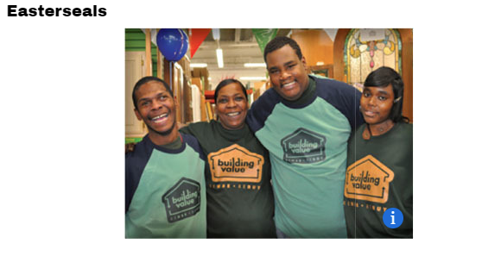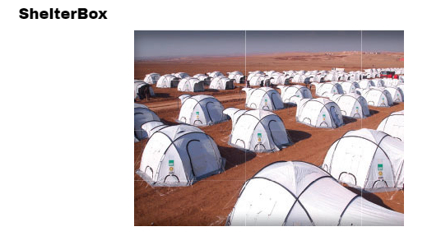

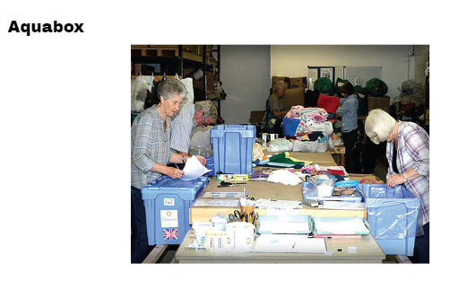

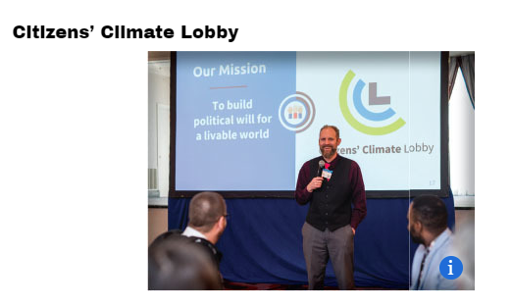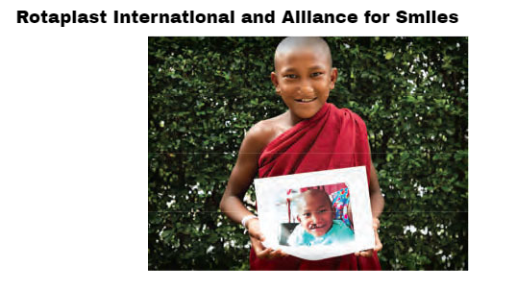

As Rotarians and Friends of Rotary we help fund these and many less know local and international initiatives that improve the human condition
For the full article, click here

Our May Club Meetings are as follows:
BGRC has started to meet in person again. We meet at Galeotti’s.

May 5th: Club Social at La Uva Fortuna Farm (Rusty Grape)
May 12th: Classification Talk
May 19th Red Sweater Project, Ashley Holmer
May 26th: YWCA & Board Meeting, Nikolas Tidwell
Hold the Dates.
May 12th: FOWW Meeting.
June 16th Main Street Beautification, Clean Up
June 23rd Club Charter Picnic, Past members are invited, at Hanenkrat’s

Club Member Rotary Anniversaries Club Member Birthdays
Kayla Tiano 5/18 Ron Scheurer 5/21
Thank You for Your Service

New stuff: BGRC Online Garage Sale for fundraising
Our Club has opened an online garage sale to help us raise funds to support our club operations. Each month we will open an online auction for donated items and services. This is new for us yet provides us a means to help fund us during these unusual times.
If you have something you want to donate for us to sell, please email Dan_Hanenkrat@msn.com
The link to this month Garage sale is Garage Sale

Our Tradition is to end each meeting by reciting Rotary’s 4 Way Test, so I will end each newsletter with this…
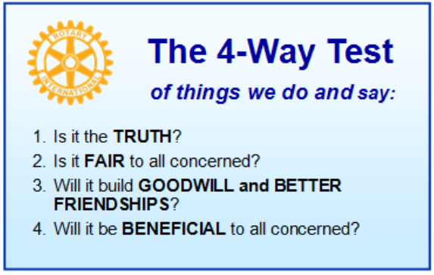
These are tests that we challenge ourselves to live by as Rotarians. But above that we commit to “Service Above Self”, which is Rotary’s motto. This is who we are. We invite you to check us out by participating in one of our projects or attending a meeting.
See you soon hopefully!

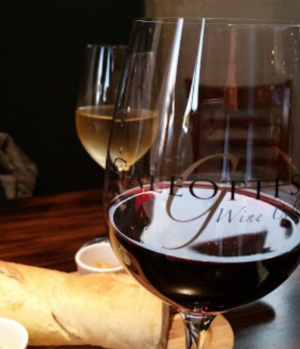
When not on Zoom, we meet at:
Where:
Galeotti’s Wine Cellar
715 East Main Street
Battle Ground, WA 98604

When: Wednesdays from 5:00 to 6:30 PM
Social from 5:00 to 5:30 PM
Meeting starts at 5:30 PM
BGRC Facebook Link
BGRC Webpage Link
For more information or to be removed from this mailing list, please call:
Dan Hanenkrat 360-907-4491

