Friends of Rotary – Monthly Newsletter

March 2021
Welcome to our Friends of Rotary Newsletter, March 2021. Our objective of this newsletter remains to raise the awareness of what our Battle Ground Rotary Club’s (BGRC) programs are each week and what dates and activities our club is organizing.
By providing a forward-looking newsletter, we are hoping to:
- Raise community awareness of what the Battle Ground Rotary Club is focused on.
- Encourage our readers to come to a meeting, meet us and take advantage of the information being provided.
- Encourage our readers to participate in our Community Service projects.
Words from the editor

As we roll into March, we see a light at the end of the COVID social distancing tunnel. Yahoo!!

We have been relying on ZOOM as our primary way of meeting. We should count our blessings. If this would have happened to us 5 years ago, we would be using conference calls. 15 years ago, it could have been emails. 40 years ago, it would have been using the mail.

So, on the bright side our ability to function as a club has been challenging, but possible. Possible due to members who have chosen to endure monthly meetings that cannot satisfy the relational aspect of meeting in person. Club leadership that must not only adjust to a work life that could not have been envisioned but carry the weight of our club continuing our commitment to our community and the programs we support internationally. If anything, those needs became greater.

Thank you!

Thank you to the businesses that sacrificed to support Rotary! Our fundraiser in December was successful enough to fund our annual giving budget. Money for fire victims, scholarships for high potential high school students in Kenya, food for the less fortunate in our community.

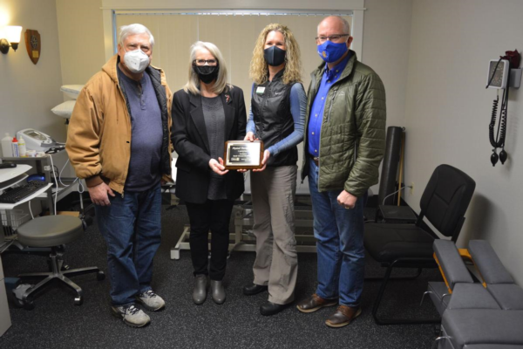
We also delivered a therapy table to Battle Ground Healthcare.

You may have seen the articles in the Reflector, demonstrating that your support and faith in our ability to make a difference is at work. Reflector Story

Thank you!

As a Club we are striving to make a difference in our community and internationally. If you would like to know more about us. Please call me.

Dan Hanenkrat 360-907-4491

February Programs Recap

February 3rd^{h}: We met at Galeotti’s Wine Bar in their new big tent. It was so nice to meet in person. The tent was large enough to social distance. Unfortunately, the snow storm that hit us also destroyed the tent. We have been told that it is being replaced and should be back up and running in a couple weeks.

February 10th Aaron Marvin from Food+Water+Shelter speaks to BGRC
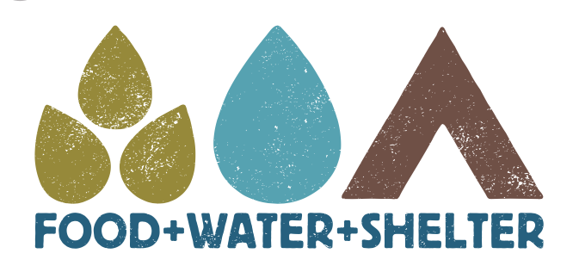
Aaron Marvin, the President of Food+Water+Shelter (https://www.food-water-shelter.com/) spoke to our Battle Ground Rotary Club on Wednesday, February 10th. Food+Water+Shelter (FWS) is a non-profit that he started to provide basics to people of the Republic of Congo in Africa but has a vision for helping others where there are needs anywhere in the world.
It all started when he and his wife adopted a Malawian child, Campbell and then later, a second child, Tikondane (Tiko) when their own son, Carson, was 2 years old. This started a relationship with the Malawians that has led to his passion to help people there help themselves, raising their standard of living.
Aaron started FWS as a way to engage the Malawians (and others) in helping themselves. The goal of FWS is threefold: provide financial resources, provide education that focuses on self-sustainability, and advocate for those whose voices cannot be heard. FWS is a grant writing organization, helping communities, like the village Tiko was born, in invest in themselves.
Read More

February 17th Rotary Peace Fellowship, Mike Caruso

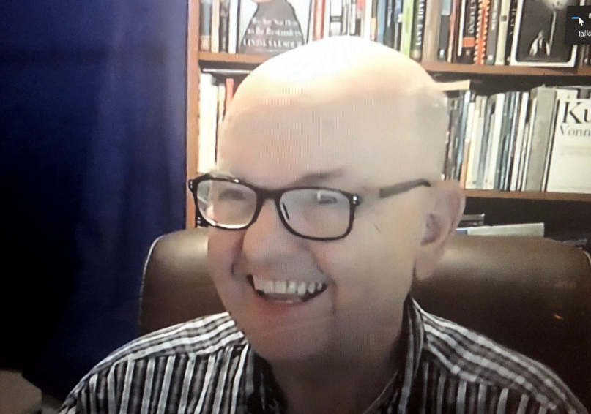
Peace and Conflict Resolution has been a part of Rotary International since its inception. The Rotary’s Vision statement is “Together we see a world where people unite and take action to create lasting change across the globe in our communities and in ourselves”. Rotarians have been a part of peace initiatives including the formation of the United Nations and brokering peace as an independent actor throughout the world.
In 2002, Rotary created Rotary Peace Centers for International Studies in Peace and Conflict Resolution, where we fund fellowships for deserving students and future leaders to earn master’s Degrees in Peace and Conflict resolution. There are currently 5 Peace centers at 6 universities. In addition, Rotary Peace Centers offer a Professional Development Certificate at two universities for up to 20 Fellows annually can pursue a 12-month certificate. Since its inception in 2002, the Rotary Peace Centers have awarded more than 1400 Rotary Peace Fellowships.
In addition to providing and sponsoring education, Rotary International, its Districts, and now the local Rotary Clubs (like Battle Ground Rotary Club and Lewis River Rotary Club) can achieve a “Peacebuilder” designation. Our local District 5100, which covers northern Oregon and SW Washington, has received the Peacebuilder achievement, and has committed $25,000 annually to peace initiatives. The newest Peacebuilder designation is at the Rotary Club Level, which only began recently in 2011, and Clubs can achieve this designation through sponsoring a Peace Fellow and promoting/executing Peace Events within the community.
Battle Ground Rotary Club and the Lewis River Club (Battle Ground) both were among the very first clubs in the world to receive our Peace Builder designation, as the center of the inception was here. Now, there are over 300 Peacebuilder clubs in the world.
Read More

February 24th State of the City Mike Fort, Chief of Police
Mike did a mini town hall for us. As you can imagine this past year threw a curve to our pubic leaders. Mike joined the Battle Ground Police Department in February 2020 after a career in the Porland Police Deparment.

As the Captian of the Battle Ground Police Mike provided us with a great insight into how publc safety has changed due to COVID and how as a small city Battle Ground has fewer challenges than Portland.
As the Portland Vancouver area grows our bound to see the good and the bad.

Mike spent a good deal of time helping us understand how Battle Ground Police’s role in providing public safety. One of key points he made was that police our police are screened and go through extensive training before they are entrusted with our safety. This training takes time and open positions within our plice force take time to process and fill.

Currently there are open positions that he is working the process on filling.
In summary, I was impressed and reasured that we have experienced leaders at the helm in Battle Ground. Mike Fort is focused on our safety.
March is Rotary Water & Sanitation Month
We will take time during each meeting to highlight the Rotary Water and Sanitation initiatives

March Rotarian Article: “What it’s Like”

March’s Rotarian featured article highlights that Rotarians are a diverse lot. Ordinary Rotarians can find themselves in extraordinary circumstances.
This is the fifth annual appearance of What It’s Like, a proven favorite with readers inside and outside Rotary.
https://www.rotary.org/en/what-its-like-to
Our March Club Meetings are as follows:
BGRC will be doing ZOOM meetings on Wednesdays until the social distancing and capacity mandates are removed (with an occasional exceptional outside gathering.

March 3^{rd:} Club Social at Northwoods Brewery/Battle Ground
March 10^{th:} Creating Friendships for Peace – Tammy Haas
March 17^{th:} The Gratitude Guy, ZOOM
March 24^{th:} Recycling
March 31st Bloodworks NW

Hold the Dates.
March 15th Festival of Wreaths 2021 Planning
March 31st: Board Meeting follows the regular meeting.

May 1: Rotary In Service – Spring yard work, sold as a fundraiser item as part of Festival of Wreaths and Wine . Pizza included Contact Dan
Club Member Rotary Anniversaries
- Becky Hanenkrat 3/26
Club Member Birthdays
- Kandida Sabo 3/6
New stuff: BGRC Online Garage Sale for fundraising
Our Club has opened an online garage sale to help us raise funds to support our club operations. Each month we will open an online auction for donated items and services.
This is new for us yet provides us a means to help fund us during these unusual times.
If you have something you want to donate for us to sell, please email Dan_Hanenkrat@msn.com
The link to this month Garage sale is Garage Sale
Our Tradition is to end each meeting by reciting Rotary’s 4 Way Test, so I will end each newsletter with this…
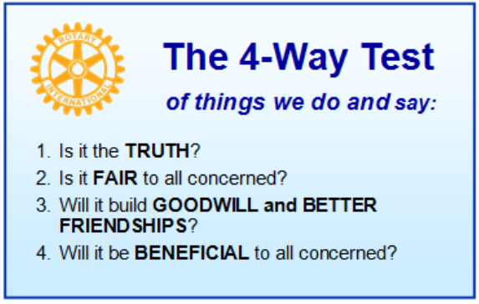
These are tests that we challenge ourselves to live by as Rotarians. But above that we commit to “Service Above Self”, which is Rotary’s motto. This is who we are. We invite you to check us out by participating in one of our projects or attending a meeting.
See you soon hopefully!

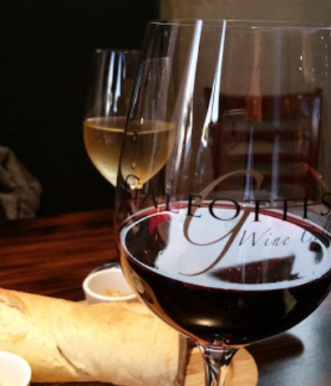
When not on Zoom, we meet at:
Where:
Galeotti’s Wine Cellar
715 East Main Street
Battle Ground, WA 98604

When: Wednesdays from 5:00 to 6:30 PM
Social from 5:00 to 5:30 PM
Meeting starts at 5:30 PM
BGRC Facebook Link
BGRC Webpage Link
For more information or to be removed from this mailing list, please call:
Dan Hanenkrat 360-907-4491

