Friends of Rotary – Monthly Newsletter

June 2021
Welcome to our Friends of Rotary Newsletter, June 2021. Our objective of this newsletter remains to raise the awareness of what our Battle Ground Rotary Club’s (BGRC) programs are each week and what dates and activities our club is organizing.
By providing a forward-looking newsletter, we are hoping to:
- Raise community awareness of what the Battle Ground Rotary Club is focused on.
- Encourage our readers to come to a meeting, meet us and take advantage of the information being provided.
- Encourage our readers to participate in our Community Service projects.
Words from the editor

As I sit here in the safety of my office on Memorial Day, I think of my fellow sailors, airmen and women, marines, and first responders who dedicated and gave their lives based on the belief that their service was required - required to maintain the freedoms and security we still enjoy.

I am proud to have served and to be counted amongst those who believe that the concepts of individual freedom of choice and justice for all are not a political argument. These come with the responsibility of being applied with a blind eye to social status, color of your skin or what you believe or do not believe.

That is the freedom of choice and the responsibility for the consequences of that choice. That is justice meaning equal treatment or equal consequences.

Those who serve and risk their lives and those who served and gave their lives based on the belief that America, our freedom, families, communities, and our values are worth protecting.

I ask that as we celebrate Memorial Day, Independence Day, Veterans Days, and Thanksgiving, that we truly take time to contemplate how blessed we are and at what great cost those blessings are/were secured and maintained.

As a Club we are striving to make a difference in our community and internationally. If you would like to know more about us. Please call me.

Dan Hanenkrat 360-907-4491
Mays Programs Recap

May 5th: Our Social was at

On May 5th, BGRC was hosted by La Uva Fortuna/ The Rusty Grape Vineyard According to those who attended, it was an absolutely wonderful time! The weather was perfect, some Friends of Rotary showed up like Heather Renner! Thanks to Jeremy Brown and his team for showing their best at the BGRC Social. 16712 NE 219th St, Battle Ground

May 12th Classification Talk, Amy Price

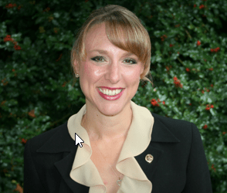
One of our own, Amy Price, The local Riverview Community Bank manager presented to the BGRC on May 12th. Amy is the VP/Branch Manager Riverview Community here in Battle Ground and a graduate of Prairie High School, Clark College and Portland State. Amy’s path to running the largest Riverview Community Bank branch was achieved by working her way up. She started part time at the First Independent Bank in Stevenson as a teller, then moved to Riverview, and has been the Branch Manager since 2011.
Having faced many challenges including bank robbers, Amy works tirelessly in the community as part of the Chamber of Commerce, and her bank helps many small business owners in the area. COVID has presented the most recent challenge of hiring - it seems that due to unemployment, government assistance, and rising wages, Riverview, like many other businesses is having difficulty finding individuals who want to work.

Amy was our Club President in 2018-19 and is currently providing past president advice and is our Club Secretary. Amy also is on the Board of Directors for Camp Hope SW Washington.

We are truly blessed to have such a professional and energetic leader in our community.

May 19th Red Sweater Project, Ashley Holmer
https://www.redsweaterproject.org/
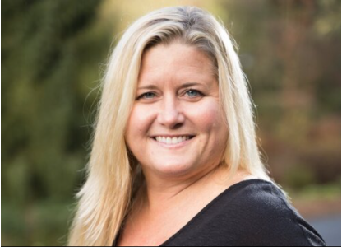
Ashley talked about her incredible journey to establishing the Red Sweater Project.
In 2005, while teaching and coaching soccer in Tanzania, Ashley Holmer saw the poverty, the lack of education, poor teachers, and chose to change the trajectory of her own life. She chose to begin the work to change the lives of many young women and men in rural Tanzania for the better. Dire poverty meant that the 18% of parents who could afford to send their children to school, prioritized to the boys. This was translating to young girls being left out of education, with a graduation rate of less than 1%. For girls this means marriage at 12, pregnancy by 13, and has a huge ripple effect on the community and the future. Studies show that the greatest economic rate of return for investment in education is to educate the girls, as it has impact on the future generations and a long lasting effect.
Ashley helped get funds to build a secondary school in 2008, and realized that more were needed and high school was out of reach for many, because of the $500 needed for tuition. Ashley felt another high school option was needed and Ashley founded a not-for- profit in 2011 called The Red Sweater Project and RSP has opened a high school, called the Mungere school, that funds pay for most of the tuition of the class.
The first class of 100 graduates was in 2016 – and none of those would have completed high school without the Red Sweater Project.
Attending these schools often costs USD $500 per student per year, making them unaffordable for most families living in poverty. That is why Mungere High School is so important to the community. Mungere School is the first high school available to kids in the rural community of Mungere, Tanzania. Every year more than 200 families apply for one of the 30-40 available spots in the incoming class. When completed, Mungere School will serve over 300 students each year.
A high school education from Mungere School is unique in three distinct ways.
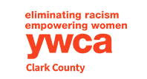
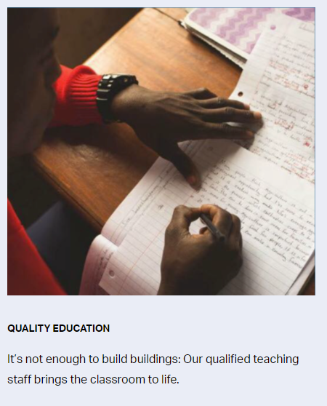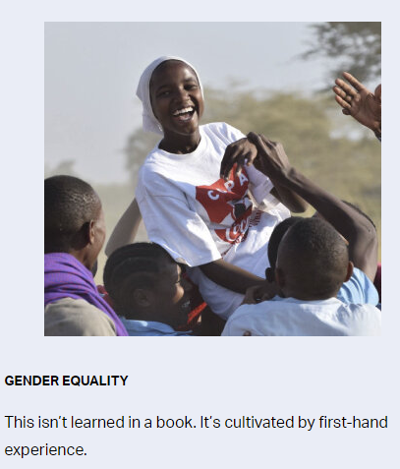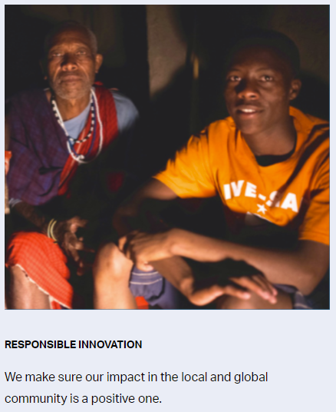
Now, in order to create a sustainable source of funds for the Red Sweater Project, Ashley has started a new venture, call Red Rhino Tours https://www.redsweaterproject.org/tours because Tanzania has some of the best wild life viewing ever. Red Rhino Tours is a subsidiary of the Red Sweater Project and 100% of the proceeds go back into RSP.
We wish Ashley luck and good fortune!

May 26th Laurie Schacht, Director, Clark County YWCA

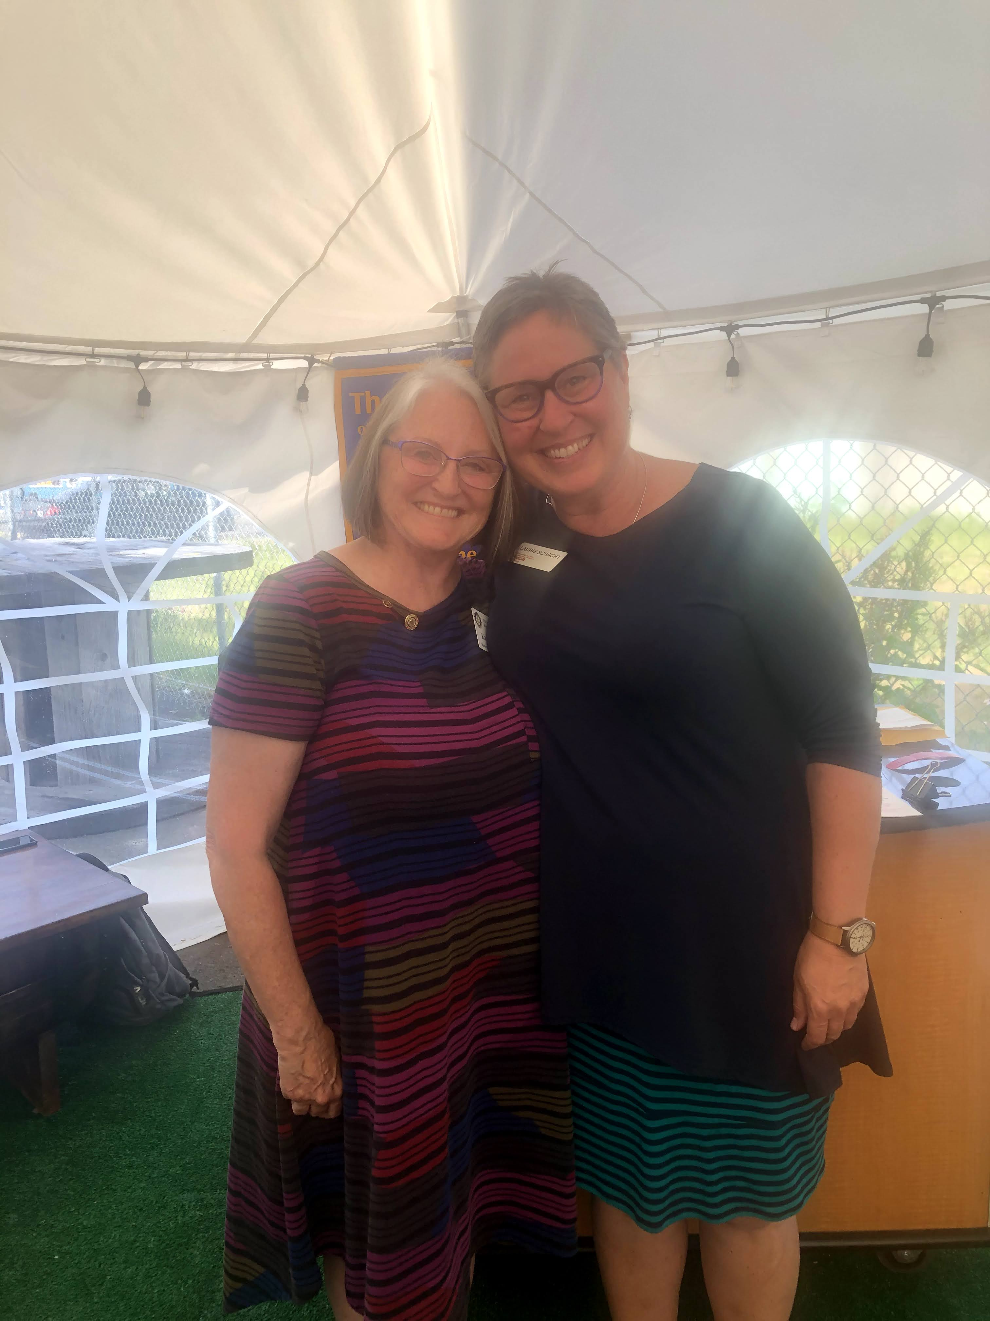
Laurie shared her background and how she joined the YWCA – having moved from Alaska after homesteading up there, reintegration into a busy city like Vancouver was challenging, so she took a job as the “stats” person, to be behind the scenes and not out in front of people. Over time she felt drawn into her work the people, and into the program for sexual assault – and found her passion for making it okay to discuss and creating safe places for sexual assault survivors to share.
Laurie’s passion about the work the YWCA does on behalf of women and children showed through her entire presentation. The YWCA runs 6 key programs:
- The CASA (Court Appointed Special Advocate) Program is based on the belief that every child has a right to a safe, permanent, loving home.
- The Independent Living Skills (ILS) Program helps foster youth age 15-21 successfully transition from state-supported care to independent living.
- The SafeChoice Program advocates for, educates, and supports those affected by domestic violence.
- The Sexual Assault Program provides 24-hour legal, medical, and emotional support to victims of sexual assault and their families.
- Y's Care Children's Program provides high-quality preschool education to children and families from homeless, transitioning, or low-income circumstances.
- Women's Leadership Center (WLC) focuses on empowering women over 50 through empowering workshops.

Laurie shared some of the impacts that the pandemic has had on the Y’s services and work. As an example, the sexual assaults reported dropped markedly at the start, but that was due primarily to the lack of hospital space. Domestic violence dropped, but that was due to lack of mandatory reporters like teachers and doctors/nurses. The reported cases in each category were more extreme however. On the positive side, Zoom is now being used for court appearances, which means the abused does not get put next to/in the same room as the abuser, which means that there may be an increase in reporting.

In 2016, Clark County YWCA celebrated the 100th Anniversary of YWCA. Since that time, they have continued to adapt and respond to a growing community. They expanded their reach by offering domestic violence and sexual assault advocacy services, early childhood education, youth empowerment, family support and outreach programs. The YWCA has achieved so much and impacted hundreds of thousands of people throughout their history.

The YWCA is more than a social services organization. They are a community of like-minded citizens coming together to create a more peaceful and just society for all–and they need our help. Help YWCA Clark County build a fearless future where all people can live free of harm and oppression.
June is Rotary Fellowship Month
We will take time during each meeting to highlight Rotary opportunities for fellowship with fellow Rotarians.
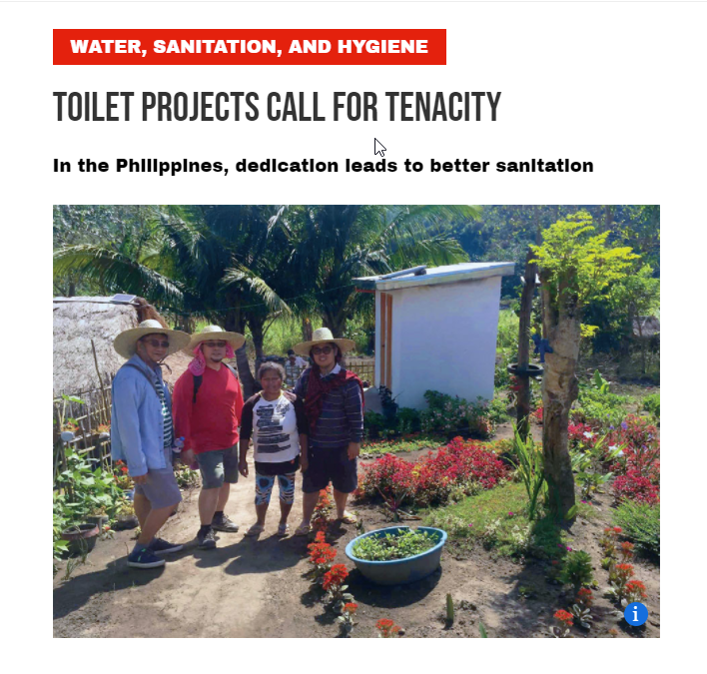
June Rotarian Article:
Most of take for granite the basics most of the world still struggle with and the impact on their daily life’s.
Rotary believes in improving the human condition throughout the world, for all.
This article highlights people of action, Rotarians making a difference.
Water, Sanitation and Hygiene

Our June Club Meetings are as follows:
BGRC has started to meet in person again. We meet at Galeotti’s.

June 2^{nd:} Club Social at – Main Street Beautification Service Project
June 9^{th:} NW Assoc. of Blind Athletes, Billy Henry
June 16th Family and Community Resource Center, Lydia Sanders
June 23rd; Club Picnic at Hanenkrat’s
June 30th; Classification talk, Darren Davidson
Hold the Dates.
June 16th FOW Meeting
June 23rd Club Charter Picnic, Past members are invited, at Hanenkrat’s.
June 30th Board Meeting
Club Member Rotary Anniversaries
Mike and Sheila Galeotti 6/17/10
Jeanine Jackson 6/17/10
Stacey Johnson 6/17/10
Amy Price 6/17/10
Jeff Quade 6/17/10
Mike Simpson 6/17/10
Kayla Tiano 6/17/10
Thank You for Your Service
Club Member Birthdays
Ron Scheurer 6/10
Terry Reddish 6/13
Stacey Johnson 6/22
New stuff: BGRC Online Garage Sale for fundraising
Our Club has opened an online garage sale to help us raise funds to support our club operations. Each month we will open an online auction for donated items and services. This is new for us yet provides us a means to help fund us during these unusual times.
If you have something you want to donate for us to sell, please email Dan_Hanenkrat@msn.com
The link to this month Garage sale is Garage Sale

Our Tradition is to end each meeting by reciting Rotary’s 4 Way Test, so I will end each newsletter with this…
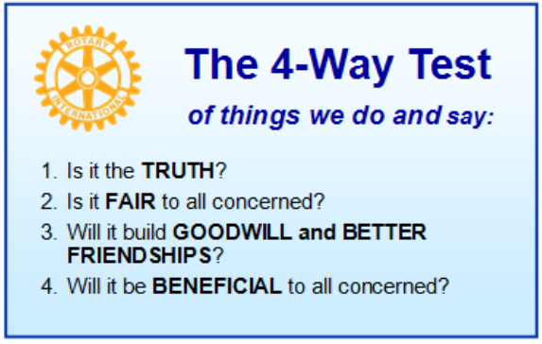
These are tests that we challenge ourselves to live by as Rotarians. But above that we commit to “Service Above Self”, which is Rotary’s motto. This is who we are. We invite you to check us out by participating in one of our projects or attending a meeting.
See you soon hopefully!
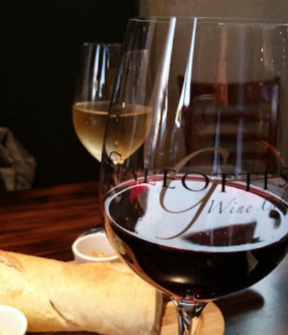
When not on Zoom, we meet at:
Where:
Galeotti’s Wine Cellar
715 East Main Street
Battle Ground, WA 98604

When: Wednesdays from 5:00 to 6:30 PM
Social from 5:00 to 5:30 PM
Meeting starts at 5:30 PM
BGRC Facebook Link
BGRC Webpage Link
For more information or to be removed from this mailing list, please call:
Dan Hanenkrat 360-907-4491

