Friends of Rotary – Monthly Newsletter

January 2021
Welcome to our Friends of Rotary Newsletter, January 2021. Our objective of this newsletter remains to raise the awareness of what our Battle Ground Rotary Club’s (BGRC) programs are each week and what dates and activities our club is organizing.
By providing a forward-looking newsletter, we are hoping to:
- Raise community awareness of what the Battle Ground Rotary Club is focused on.
- Encourage our readers to come to a meeting, meet us and take advantage of the information being provided.
- Encourage our readers to participate in our Community Service projects.
Words from the editor

As I look back on 2020, I find myself amazed at the journey we have had. I could have never imagined how this year could and would unfold. It has changed who we are and who we trust. 2020 will shape our near future and possibly the expectations of what we expect of others.

For me, I am optimistic about 2021. I have seen the bad on the news and the good in our community. I’ve seen local officials, school superintendent, business owners, students, family, friends and fellow Rotarians all impacted, and all demonstrated great character and compassion.

We will leave 2020 behind, time marches on and so does our journey.

Thank you for your support, your kind words and may God Bless your 2021.

December Programs Recap

December 2nd we were dark. Our Festival of Wreaths and Wine Online Auction kicked off on December 2nd and ran through the 5th. We built 25 wreaths and 27 Gift baskets over the weekend in preparation for the auction, so we took a break and kicked off the auction.
The auction was a success and grossed over $9,000
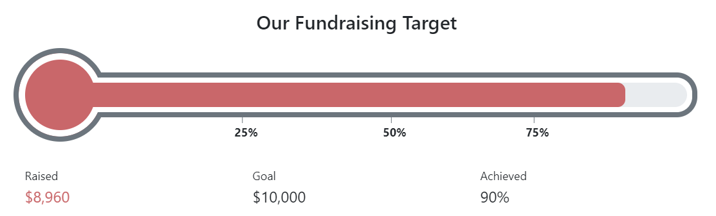

We owe a big thank you to our Event Sponsor, Your Insurance Gal Agency – Stacey Johnson and all of the businesses and individuals who sponsored wreaths and baskets! You can view them on our Battle Ground Rotary web page.

These funds are the fuel that allow us to address local and international humanitarian needs.

Thank you!

On December 9th , our meeting was an auction recap and started our club leadership election process for 2021-22.
Our Rotary year runs from July 1 to June 30th. As such, our Rotary District 5100 hosts training in the spring for the incoming leaders. BGRC’s 2021-22 Club President will be Jeff Quade.

On December 16th, Miki Berber join us to present her experience as a Rotary Exchange student in Denmark from 2016-17. Miki was sponsored by the Lewis River Club and presented to them in November. She did such a great job during their meeting, we asked her to present to our Club. Miki’s presentation included her journey as an exchange student. Traveling, meeting new friends and the emersion into the Danish language. Our Club aspires to sponsor an exchange student. Miki’s sharing her experience hopefully rekindled that fire. You can read more about her experience on www.battlegroundrotary.org

December 23rd, we didn’t hold a meeting as it was Christmas week.
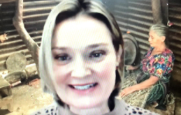
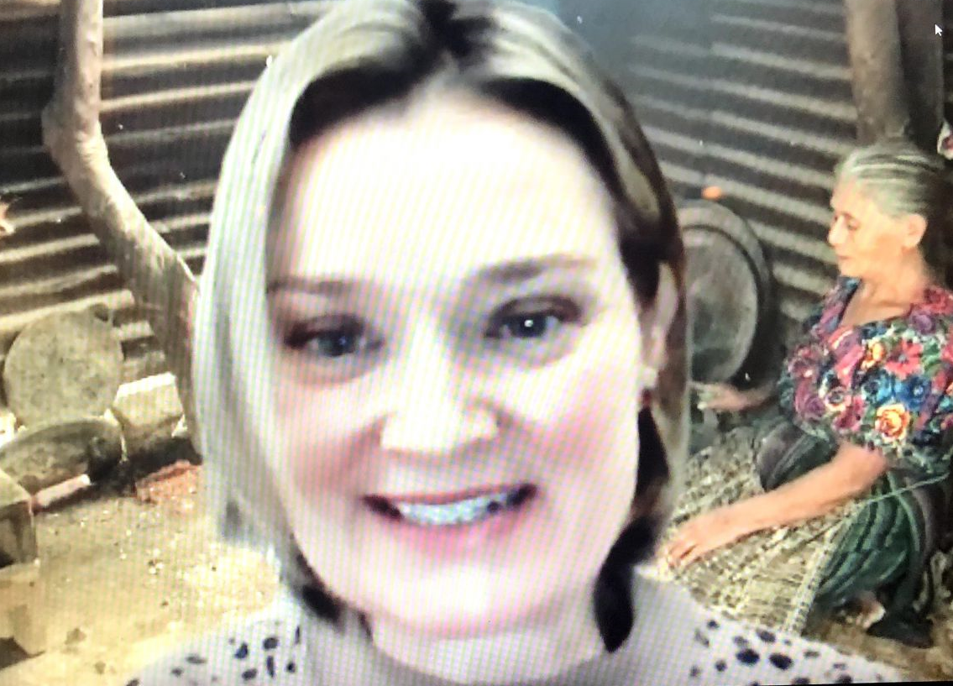
December 30th, our speaker was Shelby Kardas, the Executive Director of Stove Team International (www.stoveteam.org) Stove Team International is an organization that got started in Eugene by Rotarian Nancy Hughes who saw a need and chose to find a way to address it.
The backstory is very interesting – in the early 2000’s, Nancy went to Guatemala to volunteer as part of a medical team, and became, over a period of three trips, the ‘chief cook’ for the trip. While there, she was approached by a young woman who had had her hands burned shut as a child when cooking over an open fire. Nancy was impressed by the need for fire safety, learning that almost all families in these impoverished areas cooked over open fires in their small homes. Ultimately, Nancy learned that fire safety was only the tip of the iceberg... and that was the genesis for Stove Team International.

After sharing Nancy’s story (which is available as a video on the StoveTeam International website) Shelby shared that more black carbon and CO2 comes from open cooking fires around the world than all of the cars and trucks in the world combined! Women and children in particular spend huge amounts of time breathing in the smoke from these cooking fires all day long, as the smoke fills their small homes. The fires start at 4am, and go all day long, and the smoke inhaled equals the equivalent of 3 cigarette packs per day per person. This damages lungs, eyes, hearts and is carcinogenic. Women/children are breathing in the heavy smoke on a daily basis, which is a leading cause of death for children under the age of 5 - killing more than 4 million each year.

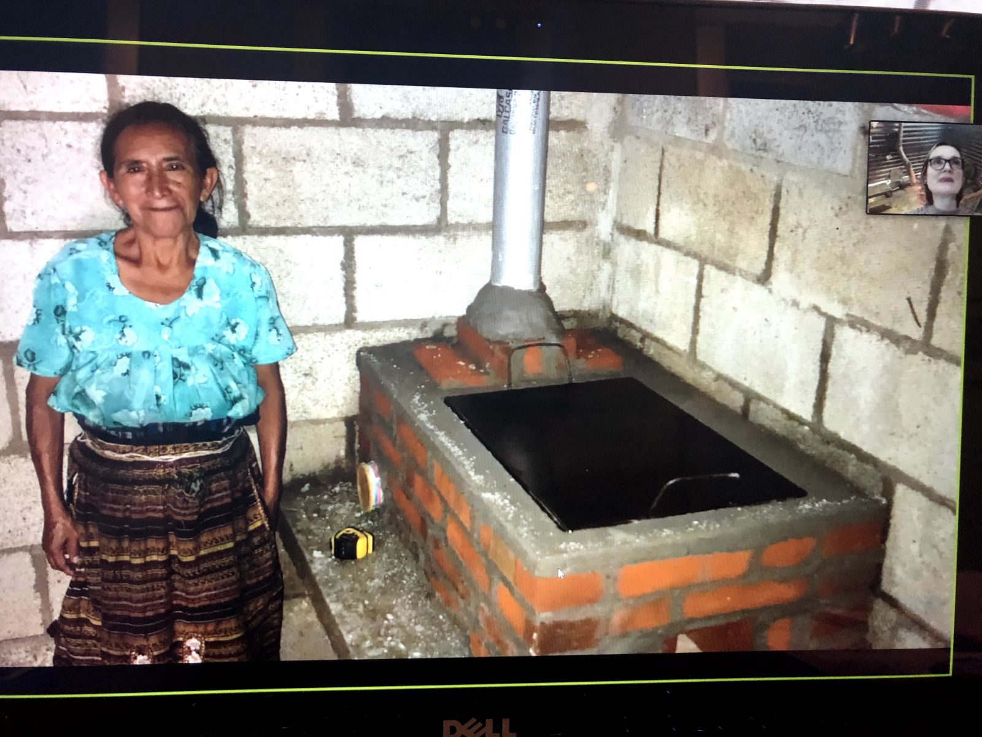
In addition, families spend 20+ hours per week collecting wood to cook over these fires. This is causing huge areas of deforestation, and families are having to venture farther and farther to collect the wood. The damage is estimated at $2-4 trillion per year. This is time that these families could spend doing something more productive. In addition, the collection of the wood is typically done by either the children or the women. Shelby shared a story about Flavia (Pictured with her NEW stove!), who is 72 years old, who has been carrying wood (on her head and shoulders) her entire life, and has severe neck/back problems, along with smoke-damaged eyes.

Having a clean burning hot cookstove in the home is key. Nancy sought the assistance of her local Rotary club and the expertise of leaders like Rocket Stoves in the clean cookstove industry and designed a clean, safe, affordable stove for Latin America. StoveTeam International was formed in 2007 with a mission to assist entrepreneurs in Latin America to build and distribute cookstoves in their own communities.

STOVETEAM COOKSTOVES IMPROVE HEALTH, LOCAL ECONOMIES AND IMPROVE THE ENVIRONMENT
Indoor smoke is nearly eliminated, while overall smoke is reduced by 86%.
Kids are no longer in danger of burns, respiratory illness, eye and skin problems.
Wood use is reduced by over 50%, saving time for families, and especially children.
Projects create jobs in the areas where they’re needed most, employing locals to help with stove distribution, bookkeeping and sales.
Built from all local materials such as concrete, pumice and tile. Projects stimulate economic growth by purchasing all stove materials from local sources.
Stove owners often boost their standard of living by starting local businesses using their cookstove.
Each stove saves up to 15 tons of CO2, helping to ensure sustainable communities for generations to come.
Wood use is reduced by over 50%, saving forests from over-harvesting.

A donation of $75 purchases a stove for a family. Learn more at www.stoveteam.org

January is Vocational Service Month
We’ll take time during each meeting to highlight the vocational expertise we have within our membership and to help identify gaps that we need to fill.
January Rotarian Article: The Future

In 1915, writing in this magazine, Paul Harris remarked: "What Rotary will be 100 years hence, none living can imagine."

More than a century later, there’s no need to imagine: Rotary has thrived, as has the Rotarian magazine. Ten years ago, on the occasion of our 100th year in print, the editors looked back at the magazine’s achievements in an anniversary issue that brought together a prestigious roster of contributors from our archives that ranged from Jane Addams to Kurt Vonnegut — and also included Winston Churchill, Albert Einstein, Mohandas K. Gandhi, Ernest Hemingway, Sinclair Lewis, George Bernard Shaw, and Amy Vanderbilt, to name only a few.
Now, on our 110th anniversary, we’re looking in the other direction: toward the future. As we stand at the threshold of the third decade of the 21st century, we are imagining where we’re headed — and what to expect when we get there.
Within this article are articles addressing:
- PHILANTHROPY
- PEACE
- WATER
- READING
- TRAVEL
- LANGUAGE
- ENVIRONMENTALISM
- LEADERSHIP
- ENTREPRENEURSHIP
- MIGRATION
- THE PAST
link to the article
Our December Club Meetings are as follow:
BGRC will be doing ZOOM meetings on Wednesdays until the Social Distancing mandate is removed.
January 6th Vocational and Committee Updates
January 13th Visioning
January 20th Battle Ground School Levy Update
January 27th Shared Hope, Kelly McCaughey
Hold the Dates.
January 27th Board Meeting follows the regular meeting
Our Tradition is to end each meeting by reciting Rotary’s 4 Way Test, so I will end each newsletter with this…
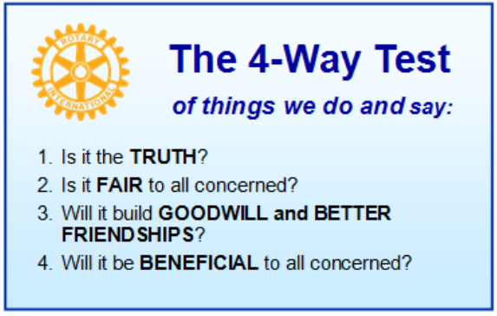
These are tests that we challenge ourselves to live by as Rotarians. But above that we commit to “Service Above Self”, which is Rotary’s motto. This is who we are. We invite you to check us out by participating in one of our projects or attending a meeting.
See you soon hopefully!

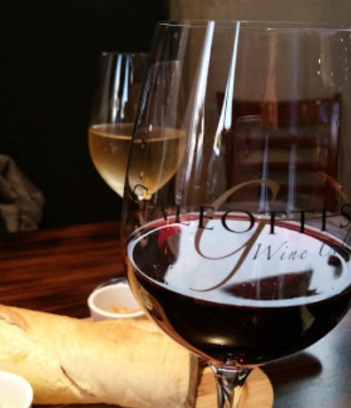
When not on Zoom, we meet at:
Where:
Galeotti’s Wine Cellar
715 East Main Street
Battle Ground, WA 98604

When: Wednesdays from 5:00 to 6:30 PM
Social from 5:00 to 5:30 PM
Meeting starts at 5:30 PM
BGRC Facebook Link
BGRC Webpage Link
For more information or to be removed from this mailing list, please call:
Dan Hanenkrat 360-907-4491

