Friends of Rotary – Monthly Newsletter

February 2021
Welcome to our Friends of Rotary Newsletter, February 2021. Our objective of this newsletter remains to raise the awareness of what our Battle Ground Rotary Club’s (BGRC) programs are each week and what dates and activities our club is organizing.
By providing a forward-looking newsletter, we are hoping to:
- Raise community awareness of what the Battle Ground Rotary Club is focused on.
- Encourage our readers to come to a meeting, meet us and take advantage of the information being provided.
- Encourage our readers to participate in our Community Service projects.
Words from the editor

What a January. Hopefully, this newsletter finds you in good health, while we all wait for relief from COVID-19. Vaccinations on their way, with hopes of a return to our ability to unmask and being more social. Spring is just around the corner and like many of you, I am having visions of being outside and working in the yard and garden.

I would like to take a moment to let you know what our Club was up to in January.
We:
- Wrapped up our Grant from the Santiam Fire which sent goods and money to the victims of the wildlife fires.
- Closed out our Grant for the medical equipment (Physical Therapy Table) donated to Battle Ground Health Care. – (To be Dedicated to BGHC on February 9th!)
- Completed our Club Officer Election process. We elected David Welch to be our Club Vice President for 2021-22, President Elect in 2022-23 and our Club President in 2023-24.
  - Additionally, we elected Jeanine Jackson to be our Club Treasurer for 2021-23
- Wrapped up our Festival of Wreaths and Wine fund raiser by recognizing our sponsors in the Reflector and on our Facebook Page.
- Completed the refurbishing Main Street park bench number 10 of 13 located in front of Berkshire Hathaway at the corner of NE 2nd and E Main Street

As a Club we are striving to make a difference in our community and internationally. If you would like to know more about us. Please call me.

Dan Hanenkrat 360-907-4491

January Programs Recap

January 6th: Vocational Talk, Kandida Sabo, BGRC Vocational Committee Chair

Kandida shared with us how Vocational Services interlock with our Rotary mission.
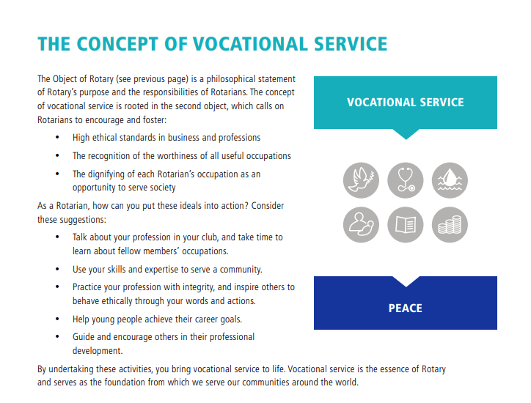

January 13^{th:} Club Visioning , Dan Hanenkrat

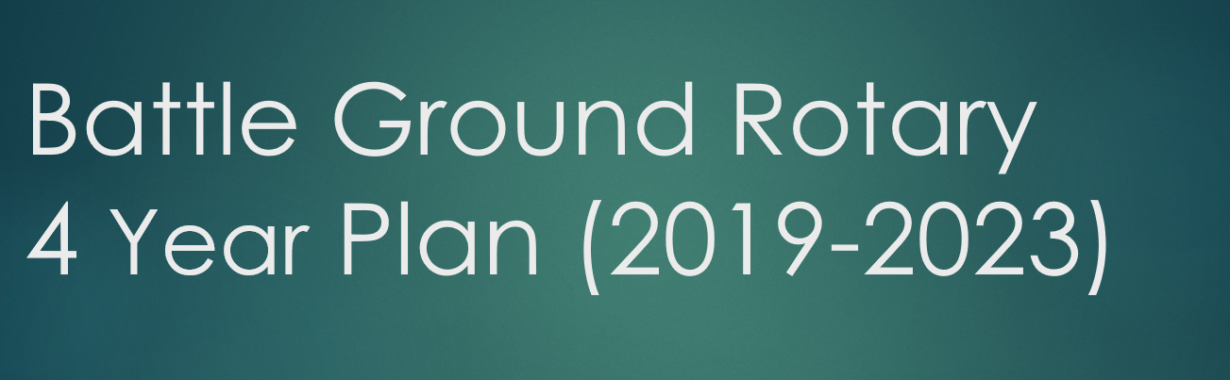
Visioning is our Club’s statement on what our mission is, what our goals are and how we plan to accomplish those goals. We established our Visioning Plan 4 years ago and have updated it each year to account for the change in leadership. Our Plan focuses on establishing the messaging to our club that plan and to enlist members feedback and ideas.

January 20^{th:} Battle Ground School Levy, Denny Waters
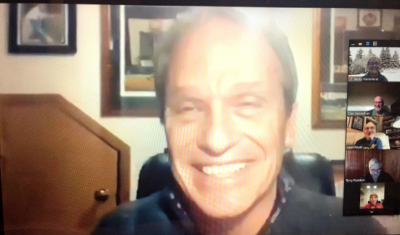
On January 20th, Denny Waters, the Deputy Superintendent for BGSD spoke to the BGRC about the upcoming vote for the 2022-2025 Replacement levy for the school district. The vote will take place on February 9th, and ballots should be arriving within the next several days.
As both a long time BG resident himself, and the next Superintendent for the district, Denny presented the facts about the Levy and shared a short video that lays out the information clearly.
For those who don’t know, the way our school districts are funded was put in place by the WA State legislature back in 1970’s. Many of the current needs in school districts are not being met by that funding – things like school nurses, psychologists, counselors, and of course, school security. Levies like this one have been in place to make up the difference between what the state provides for K-12 basic education and what it actually costs to provide much-needed services and additional options that prepare students for the future. So the main purpose of the levy is really to replace the existing levy that expires in 2022.
Read More

January 27th: Shared Hope International, Kelly McCaughey
“Ending Sex Trafficking One Life at a time”, Kelly shared with us how Shared Hope International proactively focuses on not only helping the victims, but works to establish laws that deters trafficing and protect the victims.
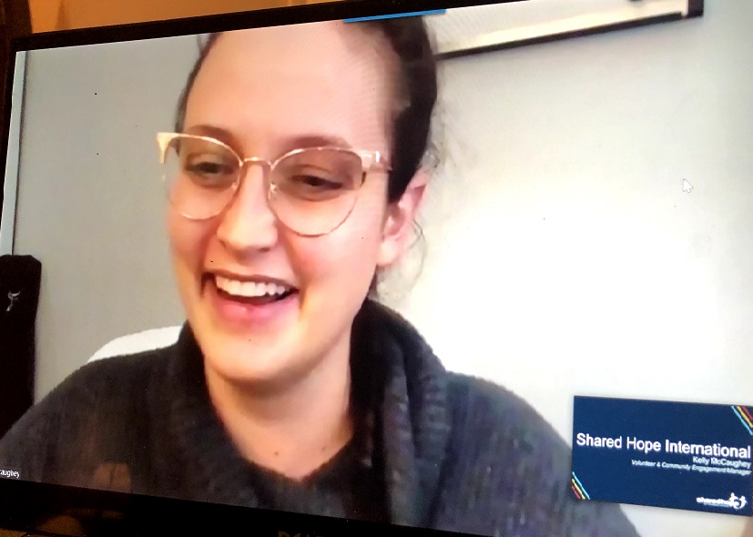
Kelly started off by making sure there was a clear definition as to what sex trafficking is and what it’s not.

Shared Hope International is dedicated to bringing an end to sex trafficking through our three-pronged approach – prevent, restore, and bring justice.
Sex trafficking is often thought to be about prostitution and focused on adults. The fact is that the average age of the victim is between 14-16 years old and the person trafficing them is someone they trust.
I was impressed with the robustness of the programs and the reach. Addressing sex trafficking starts with prevention. Prevention is all about training, awareness and collaboration.
Restoration is based on programs, partners and stories of restoration/ that address the victims hope.
Bringing justice to the victims is about impacting state laws, campaigns and providing access to services to the victims.

This left us with a greater awareness of not only the magnitude of the problem, it also provided us greater insight to resources already in place to help us recognize how we can help.

https://sharedhope.org/what-we-do/prevent/
February is Rotary Peace Month
We will take time during each meeting to highlight the Rotary Peace initiatives

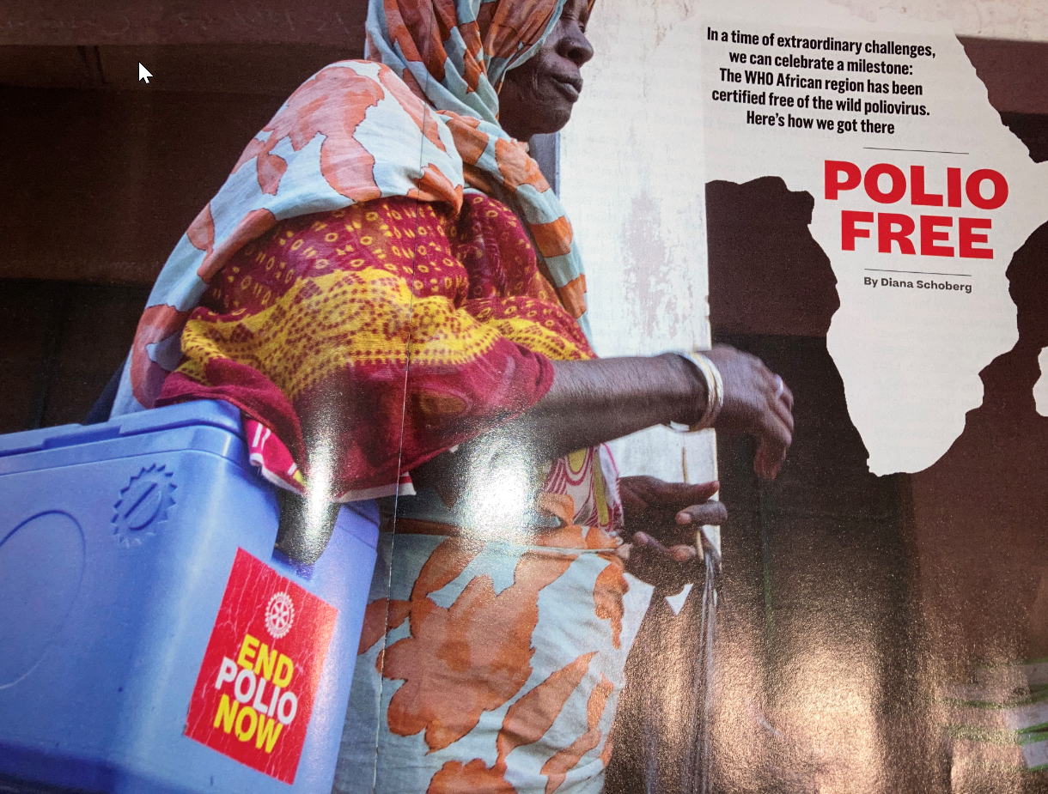
February Rotarian Article: “How We Did It” Rotary’s success in eradicating wild polio from Africa
This month’s Rotarian magazine highlights Rotary International’s commitment to eradicating Polio in Africa, which is not a country, but rather, it is a continent. It is easy for become solely focused on our own issues and forget that Rotary’s (our) commitment of our time and money makes a difference one person at a time. One family, community, city, state, country, continent at a time.
As Rotarians, from those who have been members for 50 years to our new members, we are all part of the solution. This month, the Rotarian magazine is highlighting polio as a demonstration of how when there is a will to fight an infectious disease, we can all band together and defeat it. As a publication, The Rotarian helps us realize that the difference we make is not limited to polio. Our focus on improving the human condition in our communities and globally is the why we are Rotarians.
Our February Club Meetings are as follows:
BGRC will be doing ZOOM meetings on Wednesdays until the social distancing and capacity mandates are removed (with an occasional exceptional outside gathering.
February 3^{rd:} Club Social (outside)lat Galeotti’s
February 10^{th:} Food+Water+Shelter, Aaron Martin (ZOOM)
February 17^{th:} Rotary Peace Fellowship Program, Michael Caruso (ZOOM)
February 24^{th:} State of the City, Mike Fort Police Chief @ Galeotti’s
Hold the Dates.
February 24th: Board Meeting follows the regular meeting.
Club Member Rotary Anniversaries
- None
Club Member Birthdays
- None
Our Tradition is to end each meeting by reciting Rotary’s 4 Way Test, so I will end each newsletter with this…
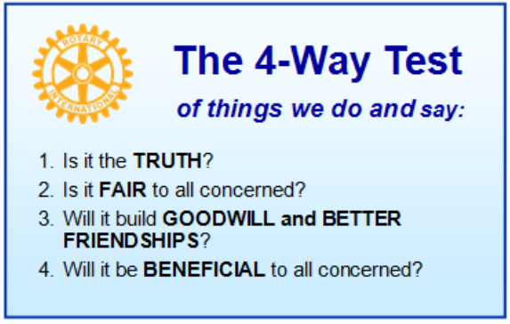
These are tests that we challenge ourselves to live by as Rotarians. But above that we commit to “Service Above Self”, which is Rotary’s motto. This is who we are. We invite you to check us out by participating in one of our projects or attending a meeting.
See you soon hopefully!

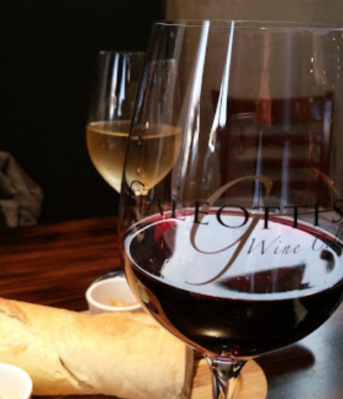
When not on Zoom, we meet at:
Where:
Galeotti’s Wine Cellar
715 East Main Street
Battle Ground, WA 98604

When: Wednesdays from 5:00 to 6:30 PM
Social from 5:00 to 5:30 PM
Meeting starts at 5:30 PM
BGRC Facebook Link
BGRC Webpage Link
For more information or to be removed from this mailing list, please call:
Dan Hanenkrat 360-907-4491

