Friends of Rotary – Monthly Newsletter

April 2021
Welcome to our Friends of Rotary Newsletter, April 2021. Our objective of this newsletter remains to raise the awareness of what our Battle Ground Rotary Club’s (BGRC) programs are each week and what dates and activities our club is organizing.
By providing a forward-looking newsletter, we are hoping to:
- Raise community awareness of what the Battle Ground Rotary Club is focused on.
- Encourage our readers to come to a meeting, meet us and take advantage of the information being provided.
- Encourage our readers to participate in our Community Service projects.
Words from the editor

Spring is here and it’s time to shift our activities to take advantage of the longer days and warmer weather.

For me, it brings back the energy that is zapped by the winter months. Sunshine just puts me in a better state of mind. It also helps to know that vaccinations are being administered to the high risk in our communities.

April is a time for us to get out and start getting our garden and flower beds back into shape.
It’s a month where we can celebrate our blessings and reconnect with those we have been thinking about. As with all the other months, it’s full of opportunities and twists.

For our Club, we just finished our review of our donations budget based on our fiscal year ending June 30th. Our Festival of Wreaths and Wine fundraiser was successful this year and we have some funds yet to be donated.

We’ll be sending a donation of $1000 to North County Community Food Bank and a donation of $500 to Meals on Wheels this month. We say a sincere thank you to our event Sponsors, our donors and the auction winners!

As a Club we are striving to make a difference in our community and internationally. If you would like to know more about us. Please call me.

Dan Hanenkrat 360-907-4491
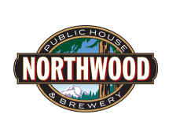
March Programs Recap

March 3rd^{h}: We met at Northwoods Brewery in the Battle Ground Village. Eric Star, the owner, was our host.
Last year Eric approached us about re-finishing his restaurants tables while he was closed dues to COVID. We took it on as a fundraiser and generated $1,750 for our Club. The tables are beautiful.

March 10th Creating Friendships for Peace, Tammy and Vern Haas, spoke to BGRC
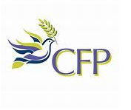
Creating Friendships for Peace, Inc. , (previously known as the Cyprus Friendship Program) is a volunteer grassroots organization whose mission is to promote and strengthen friendships between teens from divided communities and extend those friendships to their families and friends. The friendships are developed through home stays with American families. Each family hosts two teens – one from each side of a conflict. The teen pair shares a bedroom and learns about each other, understanding their different perspectives and realizing that friendships can develop despite significant political and cultural differences. With friendship, an atmosphere is created that allows for mutual respect and understanding – a key ingredient for peace.
Creating Friendships for Peace started as a two-year peacebuilding and leadership training program for Cypriot teens. Working with Greek-speaking and Turkish-speaking Cypriot CFP Coordinators, CFP offers a camp in Cyprus for the first year, where the teens begin the process of reconciliation and learn conflict management techniques and team building. In the second year, teens are selected for the U.S. program, which begins with all teens attending a U.S. camp, followed by home stays with American families.
The program has expanded to include Israeli/Palistinian youth, called the Jerusalem Friendship Program and is piloting an American teen program in 2021.
The curriculum includes advanced conflict resolution training, instruction in effective communication and other skills. Opportunities for participation in community service and environmental awareness projects expose the teens to the benefits of working together to solve problems that affect both sides of a conflict. Since the program began in 2009, CFP has graduated almost 1,000 teens and is responsible for thousands of friendships among the teens, their families, and their friends.
Our Club hosted two of the 18 teens who visited the Portland area in 2019. We have seen firsthand how broken cultural relationships can be repaired.
Creating Friendships for Peace

March 17th David George Brooke - That Gratitude Guy
David has been a speaker, coach, and bestselling author for over 25 years.
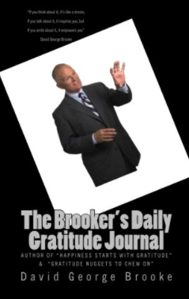
He is a former Nordstrom store manager and has managed in the corporate world for over 30 years.
His published works include “That Gratitude Guy’s Daily Gratitude Journal”, “Monday Morning Minutes: 100 Messages of Gratitude”, “Six-Word Lessons to Embrace Gratitude” and a number of other books on gratitude.
As a result of his passion for gratitude he has presented over 750 speeches & workshops in the past 8 years. He travels nationally and internationally to deliver this important message.
He has over 1300 gratitude videos on YouTube, and over 1500 subscribers. Thousands have seen his message, and he is now considered a leading authority on how living a life of gratitude can enhance and improve your life.
He resides in Seattle, Washington.
“Navigating the New Normal Through Gratitude”
Are you tired & overwhelmed from sheltering at home? Has it been difficult to maintain a positive attitude? Do you need some gratitude reinforcement to get you motivated again? Then this presentation will help you to overcome those issues and more to ensure you conquer your pandemic anxiety.
This presentation is an entertaining, enlightening, and empowering virtual ZOOM talk that provides you with the tools and techniques to blunt some of the effects of this worldwide pandemic.
This is NOT your typical robotic presentation with tons of Power Point slides, instead, this is a very interactive, humorous, and fun, talk that includes high energy, exercises, and numerous takeaways to use in dealing with this crisis.
By embracing the incredible power of gratitude, and by using simple exercises to break old habits and beliefs, you are able to re-form and re-focus your life with a much higher trajectory.
When utilizing gratitude principles, and developing an "attitude of gratitude," attendees are able to successfully fend off the negative forces that work against us all & create a very positive set of coping skills.
Learning Objectives
- Learning how gratitude can overcome any life-changing event.
- Exercises to keep you moving forward with positive expectations.
- The benefits of using a daily gratitude journal
- Increased happiness, a better attitude, and higher self-esteem.
Be prepared to look at your life differently……
“Gratitude turns what you have into enough”
Our Club found this to be one of our best programs. It’s so easy for us to focus on the negatives and discount the positives. What we focus on impacts our attitude and our attitude impacts our relationships and actions. This is not news to us, it’s just a truth that we need to remember and prioritize.

That Gratitude Guy
March 24th Recycling, Meg Johnson
Meg Johnson, waste reduction educator and recycling events coordinator for Waste Connections of Washington explains, “There are no national recycling rules and so every small part of the country has to come up with their own rules, find recyclers to make the materials collected into something new and make the system work for their local area.” To encourage vital earth-friendly practices locally, Waste Connections, the City of Vancouver and Clark County Green Neighbors have implemented some new programs in recent years to improve recycling and composting practices in Clark County and maintain a clean and green way of life in our region for generations to come.
City of Vancouver – Recycling Right made Easy!
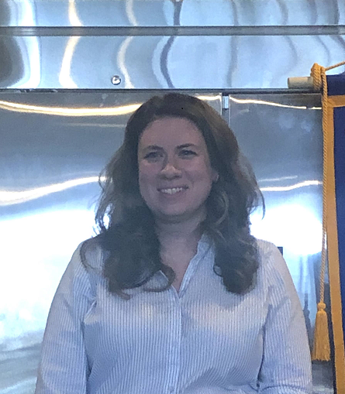
March 31th Lauren Reagan, Bloodworks NW, presents to BGRC
Lauren Reagan, Corporate Relations, of Bloodworks Northwest shared how she got the job.. Her young son was diagnosed with an illness that required 76 transfusions that extended his life for several years. Through that process, Lauren got to know a lot about the local bloodbank, Bloodworks NW, an independent, non-profit organization harnessing donor gifts to provide a safe, lifesaving blood supply to 95% of hospitals in the pacific northwest. When she was furloughed by COVID, she went to work for them, and is a great testimonial for the work that they do.
At Bloodworks NW, their physicians are specialists in transfusion medicine, and provide care for patients with bleeding disorders and other conditions. Their labs offer diverse testing services to support organ and tissue transplantation as well as patient care. Their research institute makes scientific breakthroughs to help people live longer and healthier lives – locally, and around the world. Backed by more than 70 years of history (and previously known as Puget Sound Blood Center), they are a cornerstone of healthcare in the Northwest.
With the help of 230,000 registered donors and volunteers in the region, Bloodworks collects about 900 units of blood each day. All blood receives immediate, comprehensive testing so that it can be available to more than 90 regional hospitals – usually in less than 24 hours after donation. We operate 12 donor centers and our mobile units travel to hundreds of blood drives every month at work sites, schools, places of worship, and other community locations throughout the Pacific Northwest. You can learn more about Bloodworks NW here: https://www.bloodworksnw.org/about
Their mission says it all: Saving lives through research, innovation, education and excellence in blood, medical and laboratory services in partnership with our community.

April is Rotary Maternal & Child Health Month
We will take time during each meeting to highlight Rotary Maternal & Child Health initiatives

April Rotarian Article: A History of Vaccination
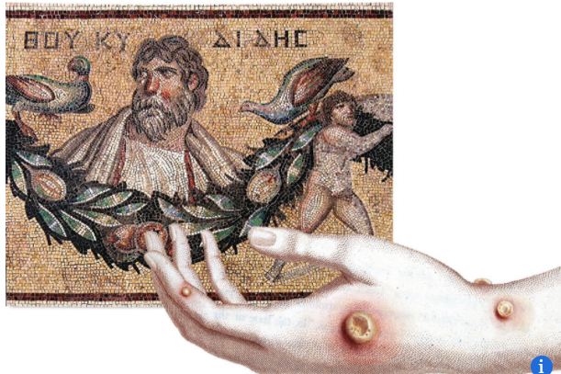
2,000 years of innovation gives the world a shot in the arm

Vaccines have prevented about 10 million deaths from disease since 1963, researchers estimate. Rotary members know the power of vaccination well: The oral polio vaccine has helped bring cases of wild polio down 99.9 percent since 1988, with the virus remaining endemic in only two countries today. And now, as COVID-19 vaccines are being distributed around the world, the experience and knowledge that Rotary and its partners in the Global Polio Eradication Initiative have gained are helping protect communities from the pandemic.
Rotary - April 2021 - A History of Vaccination
Our April Club Meetings are as follows:
BGRC has started to meet in person again. We meet at Galeotti’s.

April 7^{rd:} Club Social at Community Travel, Battle Ground
April 14^{th:} Reflector- New Owners – Coralee Taylor
April 21st Classification Talk, Lois Keller, Thirty One Designs
April 28^{th:} Provider perspective of COVID, Brian Bea PA-C
Hold the Dates.
April 10th District Training -ZOOM
April 17th District Training - ZOOM
April 28th Board Meeting
May 1st: Rotary In Service – Spring yard work, sold as a fundraiser item as part of Festival of Wreaths and Wine . Pizza included Contact Dan
May 12th: FOWW Meeting.
June 23rd Club Charter Picnic

Club Member Rotary Anniversaries
- Terry Reddish 4/16
Club Member Birthdays
- David Welsh 4/24
New stuff: BGRC Online Garage Sale for fundraising
Our Club has opened an online garage sale to help us raise funds to support our club operations. Each month we will open an online auction for donated items and services.
This is new for us yet provides us a means to help fund us during these unusual times.
If you have something you want to donate for us to sell, please email Dan_Hanenkrat@msn.com
The link to this month Garage sale is Garage Sale
Our Tradition is to end each meeting by reciting Rotary’s 4 Way Test, so I will end each newsletter with this…
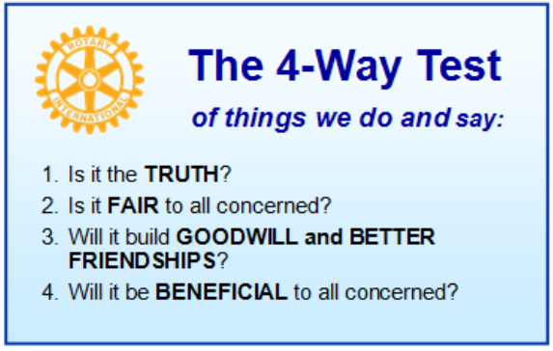
These are tests that we challenge ourselves to live by as Rotarians. But above that we commit to “Service Above Self”, which is Rotary’s motto. This is who we are. We invite you to check us out by participating in one of our projects or attending a meeting.
See you soon hopefully!

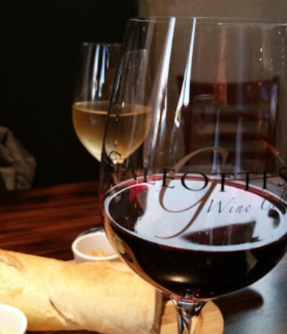
When not on Zoom, we meet at:
Where:
Galeotti’s Wine Cellar
715 East Main Street
Battle Ground, WA 98604

When: Wednesdays from 5:00 to 6:30 PM
Social from 5:00 to 5:30 PM
Meeting starts at 5:30 PM
BGRC Facebook Link
BGRC Webpage Link
For more information or to be removed from this mailing list, please call:
Dan Hanenkrat 360-907-4491

