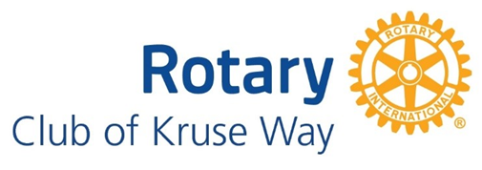
Potential Member Interview Questions/Discussion Topics

- Interviewer to discuss financial obligations (see handout)
- Interviewer to outline information about Rotary in general & Kruse Way Rotary in particular (include relevant handouts)
  - Rotary is a volunteer-based, community service organization and networking should be done on a fellowship level only
  - Members should refrain from professional promotion and business solicitation
  - Rotary is non-religious and non-political
  - Kruse Way Rotary focuses on youth-oriented service (providing scholarships, collaborating with Candlelighters, etc.) and, as per Rotary International policy, takes youth protection very seriously. (Mention Code of Conduct, potential barriers to membership, etc.)

- POSSIBLE QUESTIONS (Ask as many as you feel is warranted to get a feel for candidate’s character)
General
- Tell me about yourself and your family
- What do you consider are some of your strengths?
- What are your hobbies?
- Tell me about your vocation
- Do you work best as a member of a team or by yourself?
Experience and background
- What other volunteer experience have you had?
- What leadership roles have you held:
- In your vocation?
- In other volunteer organizations?
- What tasks are your favorite to complete?
- What is your favorite part of being a volunteer?
Rotary related
- What do you know about Rotary already?
- Why would you like to become a member?
- Do you have a particular committee with which you’d like to work or project you’d like to focus on?

- Ask if applicant has any questions/needs more information

