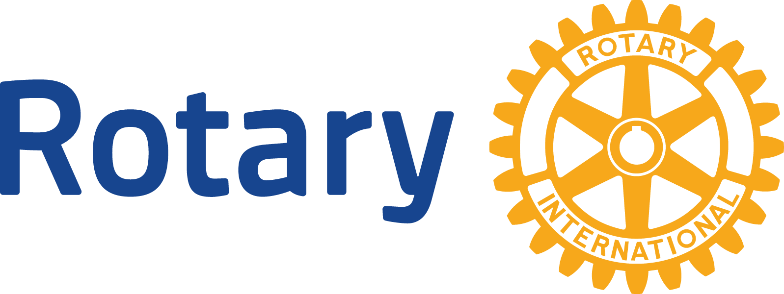

* Telling Rotary’s Story
* Our Club
* Interact

### Connecting Rotary and Youth in our community

Rotary is a global network of 1.2 million neighbors, friends, leaders, and problem-solvers who see a world where people unite and take action to create lasting change – across the globe, in our communities, and in ourselves.

Solving real problems takes real commitment and vision. For more than 110 years, Rotary's people of action have used their passion, energy, and intelligence to act on sustainable projects. From literacy and peace to water and health, we are always working to better our world, and we stay committed to the end.

**TAKE ACTION:** [www.gsvrotary.org](http://www.gsvrotary.org)

In this issue…

Fall 2021

# Greater Spokane Valley Rotary

|  |
| --- |
| Rotary has been working to eradicate polio for over 35 years, and our goal of ridding the earth of this disease is in sight. |

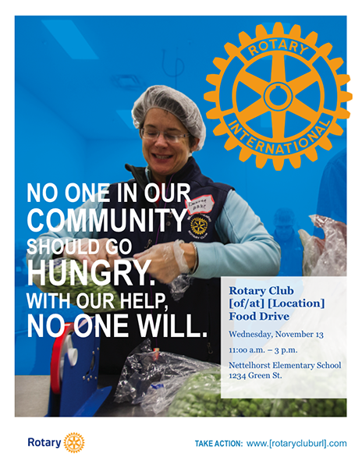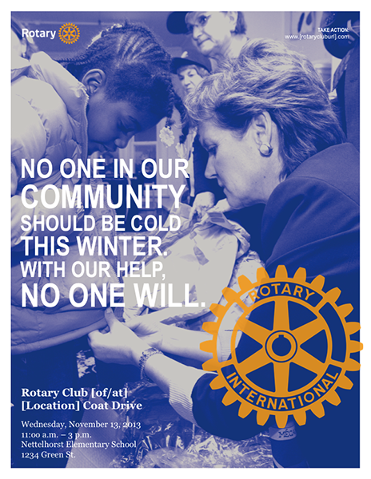

**Our mission**

We provide service to others, promote integrity, and advance world understanding, goodwill, and peace through our fellowship of business, professional, and community leaders.

**Vision statement**

Together, we see a world where people unite and take action to create lasting change — across the globe, in our communities, and in ourselves.

What we do

Rotary members believe that we have a shared responsibility to take action on our world’s most persistent issues. Our 35,000+ clubs work together to:

* Promote peace
* Fight disease
* Provide clean water, sanitation, and hygiene
* Save mothers and children
* Support education
* Grow local economies
* Climate & Environment

Our mission

We provide service to others, promote integrity, and advance world understanding, goodwill, and peace through our fellowship of business, professional, and community leaders.

**Vision** **statement**

Together, we see a world where people unite and take action to create lasting change — across the globe, in our communities, and in ourselves.

Rotary is dedicated to causes that build international relationships, improve lives, and create a better world to support our peace efforts and end polio forever.

|  |  |  |  |  |  |
| --- | --- | --- | --- | --- | --- |
| Promoting Peace | Fighting Disease | Providing clean water, sanitation, and hygiene | Saving mothers and children | Supporting education | Growing local economies  Protecting the Environment |

We collaborate with community leaders who want to get to work on projects that have a real, lasting impact on people’s lives.

We connect passionate people with diverse perspectives to exchange ideas, forge lifelong friendships, and, above all, take action to change the world.

Together, we apply our professional experience and personal commitment to tackle our communities’ most persistent problems, finding new, effective ways to enhance health, stability, and prosperity across the globe.

### Telling Rotary’s Story

Interact clubs bring together young people ages 12-18 to develop leadership skills while discovering the power of Service Above Self. Find out how serious leadership can be seriously fun.

## What are the benefits?

Connect with leaders in your community and around the world to:

* Take action to make a difference in your school and community
* Discover new cultures and promote international understanding
* Become a leader in your school and community
* Have fun and make new friends from around the world

## What’s involved?

Interact clubs organize at least two projects every year, one that helps their school or community and one that promotes international understanding. Rotary club sponsors mentor and guide Interactors as they carry out projects and develop leadership skills.

Celebrate the global impact of Interact by getting involved in:

* World Interact Week
* Interact Video Awards
* Rotary Youth Day at the United Nations
* Global Youth Service Day

**342,953 Interactors, 14,911 Interact clubs, 145 Countries with Interact clubs**

Annually, our Club provides several scholarships to graduating high school students from our endowment funds. We also provide books for kids in the fourth grade within our Spokane Valley School District.

Our Club provides funds to several Social Service Organizations serving youth and elderly including Teen Closet, Spokane Valley Partnership,

This year we are embarking to begin an Interact Club at the new Ridgeline High School. We look forward to providing these students a positive experience while they learn to plan community based service projects, meet new international friends, develop Leadership skills, gain graduation service points, and having fun!

Our Club is committed to youth and the elderly