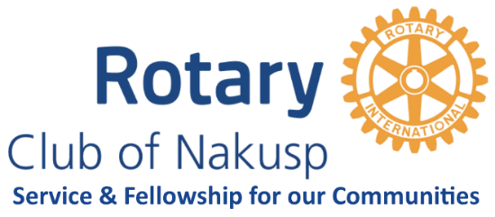
May 9th 2023
Rotary Club of Nakusp
Regular Meeting Minutes
Arrowtarian Phase 4 Lounge

Attendees: Sara Collinson, Andi Gabb, Kees van der Pol, Mayumi van der Pol,
Stu Jones, Lori Mackenzie, Dan Nicholson, Tania Quigley (Zoom)

Zoom Guest: Ann Frisch, Doreen Kelsey, Kay Diebold, Lorne Westnedge

Regrets: Destiny Froom, Graham Froom

  - Call to order at 6:00
  - Program by Ann Frisch on the Treaty on the Prohibition of Nuclear Weapons
  - Treasurer’s report – Andi
No Report

  - Visioning Follow-up - Sara
Need to have a followup: Saturday May 13th at the van der Pols’
This will be from 10 am to noon.

  - Scholarships Update – Lori
There were no applicants from Lucerne.
The Bingo Scholarship (about $2000) – mid-June deadline
The application must be accompanied by a 250-500 word essay:
“What would make your home community a place you would
want to come back to? What skills would you bring?”
Destiny will redo the Bingo form and it will go to both schools.

  - Citizen of the Year – Dan
Changed again…July 8 at the van der Pols with appies by Deb Guest
10 guests per award recipient plus Rotarians and spouses

  - Canada Day Update – Mayumi
We have decided who will do what. Things are well underway.
  - RYLA Update – Lori
Kees and Mayumi said our club received recognition at the Castlegar
Evening Club meeting for sponsoring a Castlegar Youth to attend RYLA.

  - 50-50 draw – No Jim – No draw
  - Adjournment at 7:15 pm
  - Upcoming Programs:
May 23rd - PALS?
June 20 - ?

