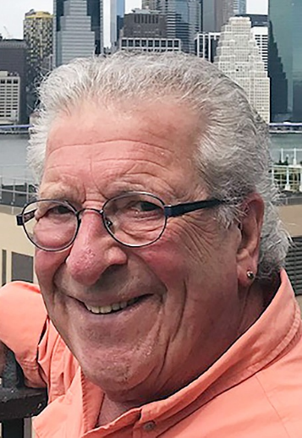
Arthur Jay Pollock Obituary
Arthur Pollock passed away peacefully Aug. 17, 2023, after a short illness at his home in Sandpoint, Idaho, in the company of his wife and family pets.
Arthur and his wife, Annie, moved to Sandpoint in 2016 from Paradise, Calif.
Arthur had a distinguished law career — starting out as a public defender during the Watts riots. He spent 41 years as a family practice attorney.
He was born in Philadelphia on April 25, 1939. At age 11, his family moved to Beverly Hills.
He graduated from Beverly Hills High School and attended UCLA. He received his JD from Hastings Law School in San Francisco.
The life of every party and a man who never knew a stranger, Arthur dedicated his life to being a Rotarian and making a difference.
The hearty laugh, glimmer in his eyes, and piercing attention he gave everyone are missed.
He joined Rotary in 1983 and boasted perfect weekly attendance through August of this year before he became ill. The Sandpoint Rotary Club issued a proclamation, a week before he passed away, that his recent absences were pardoned "until hence time you return to our meetings … looking forward to your return, along with all of the bad lawyer jokes we've missed out on during this time."
Arthur relished meeting new Rotarians and sharing "Rotary is my life" with each and every Rotarian or potential Rotarian whom he made a point to seek out.
Arthur and Annie traveled to China, the Philippines, Mexico, and numerous other locations on missions with Rotary. He was a club president when Rotary admitted women and when Rotary International began its push to eradicate polio.
Arthur was an assistant district governor while a member of the Sandpoint Rotary Club and was the recipient of a Lifetime Achievement Award for International District 5080 in 2022 after being nominated by his club and his Rotary son, David Keyes. Arthur recently stepped down as assistant governor.
Arthur continuously contributed to the success of the club's CHAFE ride, miniRYLA, Food For Our Children, and nearly every activity promoted by the club. He was a constant force of positive energy in Rotary and is missed by many regional and international Rotarians, in addition to the local Rotarians who knew and loved him. He and Annie were also unflagging supporters of Better Together Animal Alliance, Panhandle Alliance for Education, and Shelterbox.
He was a school board president in San Carlos, Calif., and absolutely loved participating in community theater while in California. He recently starred in murder mystery fundraiser for Food For Our Children and Rotary.
Arthur is survived by his wife, Annie; two sons, Matthew (Robyn) of Brooklyn, New York, and Joshua (Robin) of San Francisco; grandsons, Otis and Milo; stepson, Jeff (Sarah) Stabler of Hope; and a granddaughter, Kristin.
A private service is planned at a later date.

