Jerry Allen
Nelsen, 68
October 31, 1954 –
January 17, 2023
Jerry Allen Nelsen was
born October 31, 1954 in
Sandpoint, Idaho beginning
a new chapter for a family
who loved adventure. Proud
parents Wade Nelsen and
Faye Rasmussen Nelsen
welcomed their first-born
baby into the Heron and
Noxon, Montana
communities where he was
the joy of his grandparents,
aunts, and uncles. The
family expanded to include a
brother, Terry, and two
sisters, Susan and Sandra.
The four made countless
memories that led to favorite
stories listeners never grew
tired of hearing – most often
fondly told over spirits,
laughter, and love. The
family moved frequently
during the childhood years
following the dam
construction trade
throughout the Columbia
River system. They settled
in Orofino, Idaho during the
construction of Dworshak
Dam when Jerry was in
junior high.
It was in Orofino that
Jerry found a place to call
home. It was here that he
made lasting friendships
and met the love of his life
and wife of 48 years in high
school German class, Janis
Newman Nelsen. Jerry was
a gifted multisport athlete
performing particularly well
in basketball and football.
He also enjoyed academics
and his love for learning was
ever present. He was well
recognized for these
achievements including the
honor of being named an
All-American high school
athlete for football in 1973.
He led the Maniacs in
scoring, pass receptions,
and had the highest yards
per carry average. He knew
then that he wanted to
pursue a career in coaching.
He was a proud member of
the OHS graduating class of
1973 and was offered
several collegiate
scholarships in both

basketball and football.
Choosing to keep his talent
close to home, he attended
Lewis Clark State College in
Lewiston, Idaho. He played
LCSC Warrior basketball for
the four years he was there
and earned a Bachelor of
Arts degree in education as
a P.E. major with a minor in
History and Health. Jerry
and Janis were married in
June of 1974.
The couple spent a brief
time living in Santa Fe, New
Mexico before returning to
Orofino to build a life. Jerry
began his 34-year service to
District 171 schools. Over
the years he held many
roles as an educator, coach,
and administrator. He spent
summers working in
wildland fire and continued
his own education earning a
master’s degree in
Educational Administration
from the University of Idaho.
He truly loved his career,
colleagues, and students.
Jerry was a devoted,
involved husband and
father. Janis and Jerry’s
unshakable union brought to
the community three
children – Stephanie, Sean,
and Heather. Jerry spent
their childhood coaching
little league teams and
shuttling kids to various
activities. Hunting, fishing,
camping, boating, stocking
the woodshed, motor sports,
road trips, nightly games of
“pig” and “horse” in front of
the old backyard hoop,
movie nights, and board
games…it was always a
family affair. The Nelsen’s
were like the five
musketeers. These bonds
turned into trusted
relationships, and it was not
uncommon for Jerry’s grown
children and cherished
daughter-in-law, Savannah,
to reach out for his
mentorship, advice, and the
benefit of his quick wit and
wonderful sense of humor.
He adored babies –
especially his grandchildren
whom he viewed as perfect
in every way and who felt
the same for him.
Oftentimes a parent who put
a child in a timeout would

find that said child had been
jailbroken by Grandpa and
given a cookie or two. He
never hesitated to tell the
world how proud he was of
Marrin, Adelin, Conner,
Rhett, and Lennyn. There
was no doubt the grandkids
had a champion in Grandpa
Jerry. He also adored
animals and the family pets
could count on him for a lap
to sleep in and extra
milkbones.
After Jerry’s retirement
from his role as principal of
Orofino High School, he and
Janis relaxed into ranch life
near Cavendish, Idaho.
Jerry valued the peace and
tranquility of rural living,
keeping horses and mini
ponies and enjoying a
slower pace. He was still
active in the school system
during this time serving as a
school board member and
substitute teaching at the
nearby towns of Kendrick
and Deary. When his term
on the board ended, he
started substitute teaching
in District 171 schools as
well. He was still actively
involved in many
organizations: Rotary, Board
of Controls, Idaho
Secondary Principals
Association, and the
Freemasons to name a few
– usually holding leadership
offices. Serving his
community through
education and volunteerism
was truly his calling and his
dedication never wavered.
He led by example, always
valued the connections he
made with others, and
taught us to approach
anyone we meet with an
open heart and open hands.
He was preceded in
death by his loving parents
Wade and Faye Nelsen of
Noxon, Montana; uncle Dale
Rasmussen and aunt
Audrey Rasmussen of
Heron, Montana, uncle Don
Rasmussen and aunt
Barbara Rasmussen of
Chico, California; and
cousin Allen Rasor of
Everett, Washington.
He is survived by his wife
Janis Nelsen; children
Stephanie Nelsen of

Spokane, Washington, Sean
Nelsen (Savannah) of
Genesee, Idaho, and
Heather Nelsen of Spokane,
Washington; grandchildren
Marrin Teel, Adelin Nelsen,
Conner Nelsen, Rhett
Nelsen, and Lennyn Nelsen.
His dear aunts Karen “Kay
Kay” Rasor (Lee) of Trout
Creek, Montana and Peggy
“Pinkie” Nelsen of Noxon,
Montana; his brother Terry
Nelsen (Teresa) of Orofino,
Idaho, his sisters Susan
Stade (Ron) of Richland,
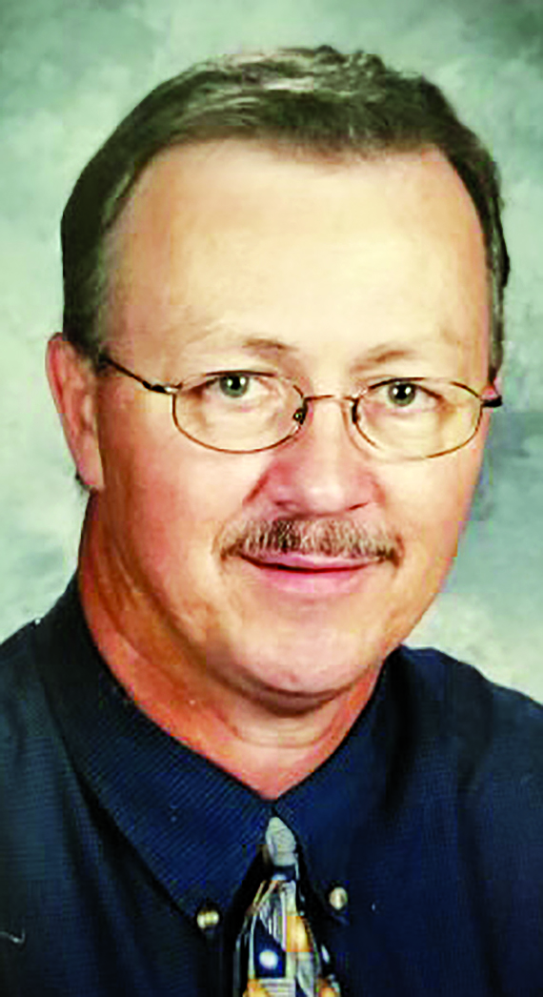
Washington and Sandra
Szambelan (Dave) of
Spokane, Washington. As
well as a great many
beloved cousins, nieces,
nephews, and very good
friends.

A celebration of life will be
held Sunday March 26,
2023 in the Orofino High
School Gymnasium with
reception to follow. Further
details to be announced at a
later date. In lieu of flowers,
donations can be made to
the Orofino Rotary
Foundation and mailed to
PO Box 482, Orofino, Idaho
83544. The funds will be
used for scholarships in
Jerry’s name.

