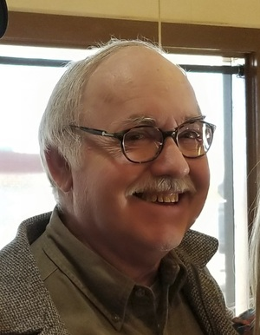

Gregory G Jones
Greg was born to Gerwyn Jones and Elsie Schneidmiller Jones at the "old old" WW General Hospital located on Bonsella and N. Clinton. Greg attended Green Park and Pioneer Jr High. He graduated from Walla Walla High School (1963) belonging to the Fern Street Men's Club. He was a Phi Delt and graduated from Whitman in 1967. He lived his entire life in WW except for the time he worked at Boeing and studied to earn an MBA from Thunderbird Graduate School in AZ. He owned Greg Jones Travel.
He leaves behind his brother Gerwyn (Diane), his brother Brian (Holly) and sister Meredith. Four nephews Brian Jr (Stormy), Bret (Lorna), Dan (Mandy), Bart (Jessica) and one niece Laura(Charles).
Greg was a quiet, private, independent gentleman, loyal to his family and friends. He was a member of Downtown Rotary, Elks, WW Symphony, and the Little Theater of WW. Greg enjoyed honoring family traditions by attending the annual Schneidmiller Christmas Eve party and sharing the traditional Jones Christmas pudding. We are so thankful for every day God allowed Greg in our lives.
Ways to honor Greg. He was passionate about research to find a cure for Type1 diabetes: DiabetesResearchConnection.org; ph#844-484-3372. The Little Theater of WW or Fort WW Museum. Most importantly, Greg would encourage you to invite a friend to share coffee or a meal.

