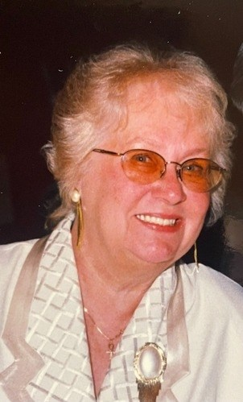
Patricia Garrison
February 12, 1937 - October 9, 2023
Richland, Washington - Patricia "Pat" Garrison passed away peacefully at her home surrounded by loved ones on Monday October 9, 2023. Pat was born in New Haven, Connecticut on February 12,1937 and attended St. Mary Catholic High School in New Haven and was a graduate of the class of 1955.
Pat married young, had 3 children and after 15 years, she left a difficult marriage and moved from Clinton, Connecticut to Norwich, Connecticut where rumor has it that she was the first female car salesman in Connecticut. It was there that she sold a car to a handsome Navy man named Harry. They began dating shortly after and married in June 1975 and began a life together Pat had only dreamed about until they met. It's very difficult to write mom's obituary without including dad in each sentence as they were a team and very rarely apart.
Pat, Harry and daughter Pam, moved to Richland in 1976 where Harry worked at Hanford for FFTF. Pat was the neighborhood Avon lady for many years, she loved meeting new people and seeing her neighbors every few weeks and of course, being a saleswoman! She won many awards for her sales in Avon over the years.
In 1983, in their spare time, Pat & Harry started a small business fixing & refurbishing appliances out of their garage to help defray college costs. After a few years, they opened a small used appliance store called "Northwest Appliance" which continued to grow over the years into two stores, one in Kennewick & one in Hermiston, Oregon, which is now known as "Garrison's Home Appliance Center". Mom was always a people person & absolutely loved her job and meeting new people and helping them choose just the right appliances. Mom was also a member of the Columbia Center Rotary with dad and they enjoyed many trips in foreign countries helping with projects for the less fortunate. She was also on the Board of Directors at the Richland Yacht Club in the early 1990's where they spent many hours enjoying their boat, "The Patty G".
Between their business and serving the community, Pat lived a very fulfilling life. When they weren't working, they managed to carve out time for traveling, camping and enjoying their love of boating. Some of Pat's favorite trips were the cruises they went on and their trips to Hawaii, and in earlier years, summer vacations in Jackson Hole, Wyoming where many lazy days were spent on Jenny Lake fishing and enjoying the outdoors.
It's hard to sum up the life of a mother, especially someone strong enough to know she and her children deserved a better life and lucky enough to find the man to make that happen together as a team. Mom will be greatly missed and I was blessed to be with her as she took her last breath and was welcomed into Heaven where her beloved husband was waiting for her.
Pat is survived by her daughter, Pamela Frick (Glenn), grandsons Justin & Chance Frick, son Daniel Clark, grandchildren Crystal, Corey & Devin Clark, granddaughter Jennifer (Terrio) and great-grandchildren Serenity & King Pearson.

