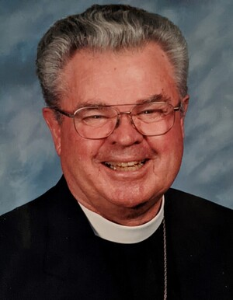

Ernest F. Campbell passed away in Walla Walla on March 27, 2023. He was 95 years old. Ernie was born on August 17, 1927, in Evanston, IL. Ernie graduated from New Trier H.S. in 1946 and earned his bachelor's degree in speech at Northwestern University in 1950. While at Northwestern, he participated in the NROTC and served as a Navel Reserve Officer from 1946 to 1951. He then went on to earn a degree at Seabury Western Theological Seminary. He was ordained into the Episcopal priesthood in December 1953. During his ministry, he served as; Deacon at St. Marks in Evanston, IL--Chaplain at Break School in MN--Associate Rector at St. Georges in MN--Dean of the Cathedral of Our Merciful Savior, Faribault, MN. He then moved in 1969 to Walla Walla, where he was the Rector at St. Paul's Episcopal Church until his retirement in 1990. However, Ernie never truly "retired." He continued to serve as a priest until the age of 90.
The common thread throughout his life was his love of the outdoors. He participated in scouting, wilderness backpacking, sailing, and canoe trips. He also worked at many types of camps, including; Camp Douglas Smith--MI, Teton Valley Ranch--WY, Cass Lake Episcopal Camp--MN, Camp Cross--ID, Lake Wenatchee YMCA Camp, WA--Camp Marshall--MT, and Camp All Saints--TX. He helped countless young people experience God's love in those special places. Ernie's hobbies included photography and woodworking. He loved Walla Walla and never tired of promoting it. He always said, "Leave your campsite better than when you found it." And lived that philosophy by raising his hand and saying, "How can I help?" He gave of himself to: Rotary (a 50-year Rotarian and a Paul Harris Fellow), The Ministerial Association, a Chaplin for Boy Scouts, served on the WW Foundations Board, was a Fort WW Museum docent, and was in the Friends program (five years), to name a few. He said, "I have reached that point in my faith where I can say with Paul, "Nothing in all creation can separate me from the love of Christ."
He is survived by his wife of 67 years, Margaret Campbell; their three surviving children, Kathy, Debbie, and David; eight grandchildren; and three great-grandchildren. He is preceded in death by his daughter Martha.
The funeral service will be held on Saturday, May 13, 2023, at 1:00 PM, at St. Paul's Episcopal Church, Walla Walla.
Memorial contributions to Camp Cross or the St. Paul's Endowment Fund may be made through the Herring Groseclose Funeral Home, 315 W. Alder St., Walla Walla, WA 99362. In addition, friends and family are invited to sign the online guestbook at www.herringgroseclose.com.

