William BRANDENBURG
1932 - 2022
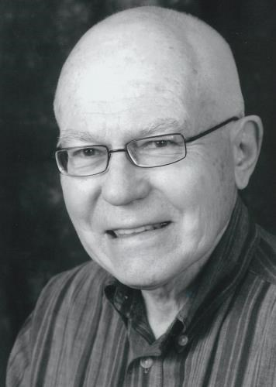

BORN
1932

DIED
2022

WILLIAM BRANDENBURG OBITUARY
After a long struggle with Alzheimer's disease, Bill is now at peace with his Lord and Savior. Bill passed away on October 7, 2022. He was born in Spokane on June 13, 1932, to Jay and Helen Brandenburg. He attended grade school in Spokane and graduated from Spangle High School. He attended and graduated from Washington State College School of Pharmacy. After two years in military service, Bill returned to Spokane and began his pharmacy career at Hart and Dilatush. He then worked at Wylie Carlson Pharmacy where he became the owner. Bill enjoyed gardening, camping with family, and was an avid reader. He was a long time active member of Central Lutheran Church in Spokane and was also a long time member of Rotary Club 21. Over the years he served his community through his involvement on several advisory boards.
He is survived by his wife Kay; his three children Kari, Christopher (Vina), and Stephen (Michelle); his six grandchildren and three great-grandchildren; and his sister Virginia (Donn). His family is very thankful for his time at Providence Senior Home and the dedicated and loving staff who cared for him for these past nine years. We are also thankful for Horizon Hospice care and their supportive and compassionate staff who have watched over him and our family during these past few years.

