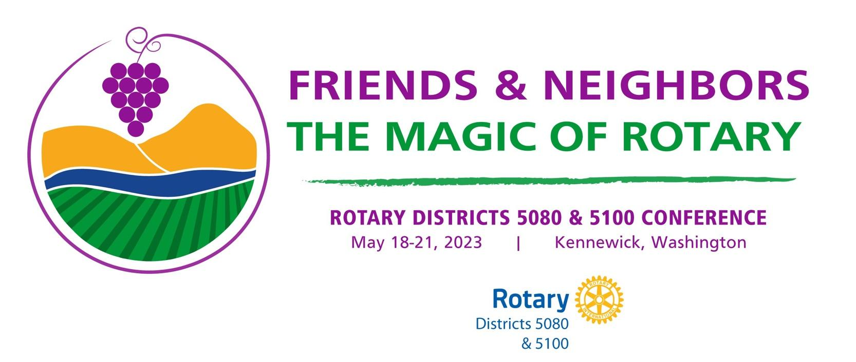

Rotary District 5080 Conference 2023 – Kennewick, Washington
Registration for Booth in the House of Friendship
Deadline is April 30th

Name of Booth:

Name of Committee, Fellowship, Rotary Action Group, Project: associated with booth:

Website link and Social Media tags:

Key Contact Person’s Name: Phone: E-mail:

Description of Proposed Booth eg table top display, floor display, wall mounted display. If you have a picture of what is proposed, please attach it to the file. If a large display is being proposed eg ShelterBox, Iron Lung, please indicate minimum square footage requirements.

Electrical or Internet Hook-ups needed:

Names and contact information (e-mail and phone) of members setting up the booth (which shall be done early on Friday morning)
List of volunteers manning the booth during the conference. There should be at least one person on site prior to the start of sessions each day, on breaks and after the main events for the day, and during eventing receptions:

Names and contact information of members taking down the booth which shall be done on Saturday night or Sunday morning

Will there be hand-outs available throughout the conference?

Will you need to ship any materials to the conference site in advance of the conference ?

Will all materials displayed be compliant with Rotary Visual Brand Compliance (https://brandcenter.rotary.org/) ?

Please send applications to David Keyes, House of Friendship host

Email: davidkeyes09@gmail.com
Due by April 30th, 2023

