Contents
DISTRICT MEMBERSHIP SEMINAR LEADER’S GUIDE
Breakout session options
Session 1: Is Your Club Healthy?
Session 2: Building a Diverse Club
Session 3: Strategies for Attracting New Members
Session 4: Kick-start Your New Member Orientation
Session 5: Best Practices for Engaging Members
Session 6: Practicing Flexibility and Innovation
Session 7: Your Membership Plan
General sessions
Opening: District Membership Overview
Closing: Putting It All Together
PowerPoint template
Evaluation

Your district membership seminar is a chance to inspire and share ideas for growing and engaging your membership. The district membership seminar leader’s guide is yours to edit as you plan your program. The sessions are written for you — the organizers and trainers — to tailor to your training needs.
DISTRICT MEMBERSHIP SEMINAR LEADER’S GUIDE

Purpose
Our members play a vital role in growing the Rotary family. The purpose of this seminar is to support membership activities at the club level.
Planning
Your district membership seminar can be held anytime, preferably for half a day, together with the district Foundation and public image seminars.
These Rotarians are responsible for planning or leading the seminar:
- District governor (oversees the entire program)
- District training committee members (give advice on the seminar’s training details)
- District membership committee chair (plans and leads the seminar)
- Rotary coordinator or other experienced members (lead the individual sessions)
Participants
Seminar attendees for this event can include:
- Club presidents
- Club membership committee members
- Current or incoming district committee members
- Assistant governors
- District governor-nominee
- Other interested Rotarians
Participant materials
Make sure participants receive any necessary materials well before the event. Also ask participants to bring laptops, tablets, or other mobile devices to the seminar.
Sessions
Most training events have general sessions for all participants, with various breakout sessions on specific topics geared to roles.
- General sessions can be used to motivate and inspire participants. These sessions typically include:
  - New information or updates on topics relevant to a large audience
  - Details on breakout sessions
  - Discussion of district business
  - Multimedia presentations
- Breakout sessions allow participants to:
  - Learn more specific information in an interactive environment where they can ask questions
  - Engage in discussion
  - Participate in activities
The breakout sessions present different format options:

Idea exchange | Best for discussing topics participants know  Discussion guided by a trainer to keep talks on topic and make sure everyone has a chance to speak  Activity for participants to apply the ideas being discussed  Seating arranged in a U shape (maximum group size: 30) | room set-up
Workshop | Best for learning practical skills or giving participants a new understanding through an interactive activity  Led by experts  Room arranged for groups to collaborate, with space for facilitator to move freely among participants | 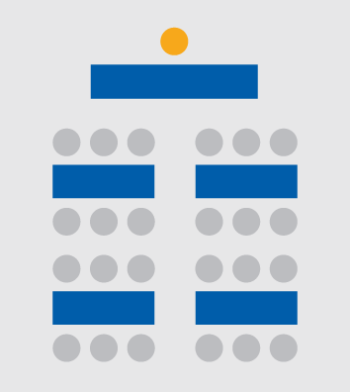  room set-up
Panel  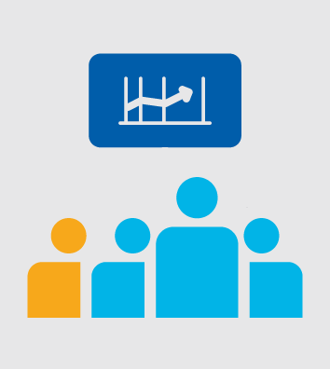 | Best for sharing expert opinions  Can be consecutive presentations and interactive, with questions from participants  Moderated conversations can still be interactive | room set-up  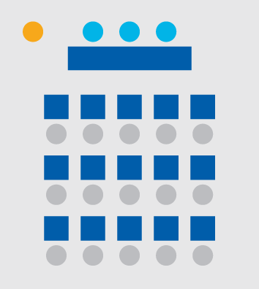
Speedmeet | - Best for sharing ideas and networking  - Series of timed, two-person conversations  - Room arranged in a U-shape, or with chairs on both sides of a line of tables | room set-up
ROUNDTABLE DISCUSSION | - Best for sharing ideas  - Guided by a trainer to keep discussions on topic and allow everyone to speak  - Assistants available at each table to answer questions (optional) | room set-up
Tips for using the leader’s guide
This guide is flexible for organizers, trainers, and participants. You should review the sessions in advance to allow time for planning and rehearsal. They are written for you to adjust to your participants’ needs. Most sessions include all of these sections:
- Relevance statement to clarify why the session is important for your audience
- Recommended format for leading your session
- Learning objectives, the intended outcomes of the session
- Before the session offers suggestions on preparation; you should review all content and make a plan for speaking points, discussion questions, and activities that you find relevant for your audience
- Resources to help you prepare for the session
- During the session describes recommended information to include; the facilitator will decide the flow of the session
- Activities, either separate or integrated into the discussion; adjust the activities to meet participant needs
Your agenda
Build your agenda using the sessions listed above. Several breakout sessions are offered to give you flexibility to meet the interests and needs of your participants. Consider surveying your participants beforehand to see which sessions interest them.
Depending on space and the number of trainers, you can hold sessions at the same time and repeat certain sessions to maximize attendance. If your resources are limited, choose the sessions that are most relevant to your participants.
Though many sessions are designed to last 45 minutes, you can adjust times to meet the needs of your trainers and participants. Allot enough time to complete each part and include breaks so participants can network after sessions.
Consider converting any sessions that do not fit your agenda into an assignment or webinar, either before or after your training event.
It’s important to adapt the program to suit the needs of your participants. Besides the advice already given, consider these tips when crafting your program:
- Use regionally specific examples to illustrate points
- Apply culturally appropriate training techniques
- Vary the format of each session to maximize learning and to maintain participants’ interest
- Change seating to allow participants to work with other people if the group is big enough to do so
- Leave time at the end of the day to address participants’ questions or discuss additional topics
Sample agenda
Here’s an example of an agenda for a half-day training seminar.

08:00-08:30 | Opening General Session
08:30-09:15 | Is Your Club Healthy?
09:15-10:00 | Concurrent Sessions:  Practicing Flexibility and Innovation  Strategies for Attracting New Members
10:00-10:15 | Break
10:15-11:00 | Concurrent Sessions:  Building a Diverse Club  Kick-start Your New Member Orientation  Best Practices for Engaging Members
11:00-11:45 | Your Membership Plan
11:45-12:15 | Closing General Session
Slides
If you include PowerPoint slides, use the template in this guide, and work with your trainers to build the content. Keep the text brief, with no more than seven lines on a slide. When other slides aren’t needed, use photos or other visuals to help participants connect with the content. Consider adding district photos, more slides, and text to make the visuals more relevant for your participants.
Getting started
After reviewing this guide, decide who your breakout facilitators will be. You can schedule time with them in advance to settle the logistics and details for the event. Suggest that they explore My Rotary’s Learning Center, including the Trainer’s Toolkit course, as well as Lead Your District: Training. Rotary offers other training resources, too.
Find experts to lead your panels or technical sessions, then give them the session guides and slides early enough to allow time for planning.
Be sure to encourage your participants to evaluate the sessions they attended (see sample evaluation form). Finally, have fun!
Questions?
If you have questions or comments about this guide, contact Rotary’s Learning and Development team at learn@rotary.org or +1-847-866-3000.

