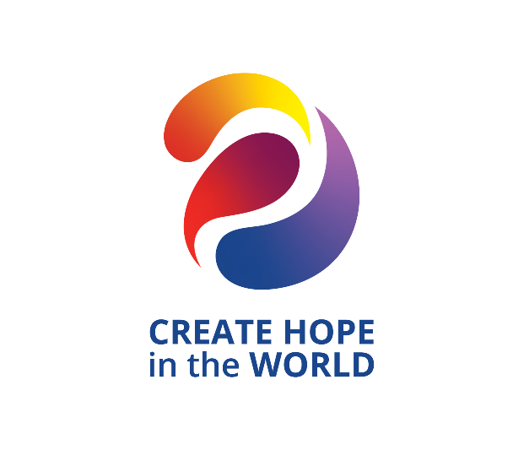

Deadline for Nominations is March 31, 2024

The District 5080 Outstanding Interact Club of the Year Award
Recognizes the Interact Club that has performed in the highest traditions of Rotary during the Rotary year. The winning club will demonstrate high achievement as an effective Interact Club.
Award
The District 5080 Outstanding Interact Club of the Year award will be a glass-etched trophy, engraved with the Interact Club’s name and the date of presentation with the words District 5080 Interact Club of the Year. A list of all Interact Club of the Year recipients will be posted on the district web-site in perpetuity. The award will be presented at the District Conference. A representative of the club will be expected to attend.

Nominations
Nominations may be made by any District 5080 Rotarian or Rotaractor.

Selection
Annually the Governor will select a committee of Rotarians/Rotaractors as the award selection committee. The Governor may choose to be a voting member of the committee. This team will work in conjunction with the chair of the District Awards Committee. When possible, past recipients of the award will be selected to serve on the committee.
Deadline for Nominations is March 31, 2024
Required Criterion -
• It is mandatory that the club show a net increase in club membership between July 1 and March 31 of the current Rotary year.
Additional Criteria - The following also will be considered.
Membership Development:
• Specific membership development programs undertaken by the
club in the current Rotary year
• New member orientation, mentoring and member education
initiatives developed and utilized by the club
• Promotional/Social Media programs undertaken by the club in the current Rotary year

Service Projects
• Current local service project(s)
• Current International Service project(s)
• Level of hands-on club involvement in service projects rather than the dollar value should be considered a key factor
• Active involvement with a Rotary/Rotaract Club
The Rotary Foundation
• Rotary Foundation program presentations at regular club meetings
• Participation in projects supported by TRF grants in the current Rotary year
Service Beyond the Club
• Service on district, zone or RI committees or
task forces
• Club attendance at district training seminars, & other district events
Nomination Form for District 5080 Interact Club of the Year Award
Name of Club Being Nominated:
Rotarian/Rotaractor Making the Nomination:
Please describe the reason this club is being nominated:

Attach Additional Sheet(s) As Needed.
Please refer to Selection Criteria Listed on Previous Page.

Feel free to add additional information or photos to support this
nomination.
Please send to: Steve Roberge, District Awards Chair
Coeur d’Alene Rotary Club
E-mail: stevenroberge25@gmail.com
Nominations must be received by Sunday, March 31, 2024

For the use of the Awards Committee only. Please do not write on this page.
Date Application Received:
Number of Members in Club as of July 1, 2023:
Number of Members in Club as of March 31, 2024:
Comments by Awards Committee:

Recommendation:

